Module 3  Facilitator Guide | Focus on Teaching and Learning

Section 2

Connecticut Core Standards for Mathematics

Grades K–5

Systems of Professional Learning

Connecticut Core Standards Systems of Professional Learning
The material in this guide was developed by Public Consulting Group in collaboration with staff from the Connecticut State Department of Education and the RESC Alliance. The development team would like to specifically thank Ellen Cohn, Charlene Tate Nichols, and Jennifer Webb from the Connecticut State Department of Education; Leslie Abbatiello from ACES; and Robb Geier, Elizabeth O’Toole, and Cheryl Liebling from Public Consulting Group.
The Systems of Professional Learning project includes a series of professional learning experiences for Connecticut Core Standards District Coaches in English Language Arts, Mathematics, Humanities, Science, Technology, Engineering, Mathematics (STEM), and Student/Educator Support Staff (SESS).
Participants will have continued support for the implementation of the new standards through virtual networking opportunities and online resources to support the training of educators throughout the state of Connecticut.
Instrumental in the design and development of the Systems of Professional Learning materials from PCG were: Sharon DeCarlo, Debra Berlin, Jennifer McGregor, Judy Buck, Michelle Wade, Nora Kelley, Diane Stump, and Melissa Pierce.

Published 2014. Available online at http://ctcorestandards.org/

Session at-a-Glance

Section 2: Building a Teaching and Learning Framework through UDL (60 minutes)

Training Objectives:
To articulate a common understanding of Universal Design for Learning (UDL).
To identify the importance of incorporating UDL practices into lessons.
To align UDL practices to the instructional practices and learning implications of the CCS-Math.
Participants will begin by generating a list of the instructional strategies discussed in Modules 1 and 2. These include: the use of multiple representations, providing multiple pathways into the learning through task modification, engaging students in group work, providing opportunities for mathematical discourse, and the use of effective questioning. As a large group, participants will discuss the student benefits of the use of each strategy. Then, the facilitator transitions to adding to this list of strategies by explaining that they will examine additional strategies, but will do so through the lens of applying the principles of Universal Design for Learning (UDL). The facilitator will explain what UDL is and engage participants in the importance of providing flexibility and reducing barriers in instruction. The facilitator will then go over each of the three principles: Provide Multiple Means of Representation, Provide Multiple Means of Action and Expression, and Provide Multiple Means of Engagement. Participants will then work in groups to gather information around one of the nine UDL Guidelines and record their information on chart paper. As they review their guideline, participants are determining how they would explain this guideline to teachers and will create 2‒3 examples of beginning strategies that teachers can incorporate into their lessons to address this Guideline. Section 2 wraps up with groups presenting their information so that all participants receive tangible strategy ideas for each of the nine Guidelines.
Note: Information will be presented in such a way as to not lead participants to think that they must include all nine guidelines in every lesson every day. By connecting the UDL principles and guidelines to work that has been completed already around CCS-Math instructional practices, many participants are already applying or promoting UDL in their classroom and schools.

Supporting Documents:
- What is Universal Design for Learning?
- Universal Design for Learning Guidelines
- Universal Design for Learning Guidelines Worksheet

Materials:
Chart paper, markers

PowerPoint Slides:
20–29

Session Implementation
Section 2

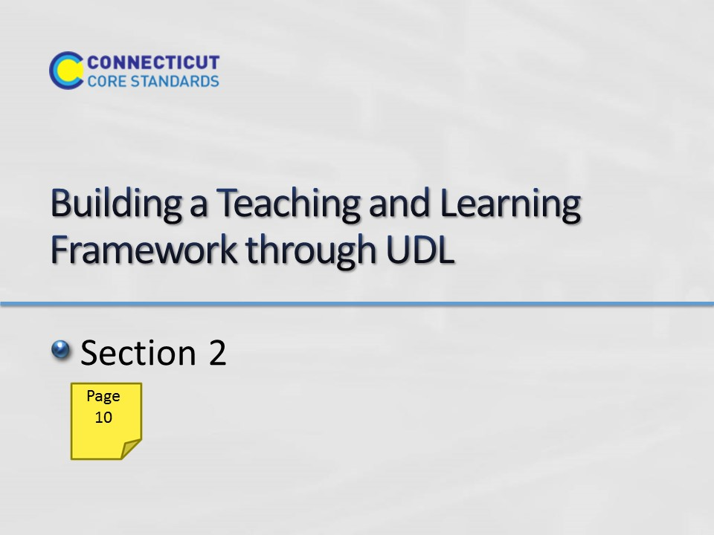Slide 20
Section 2: Building a Teaching and Learning Framework through UDL
Section 2 Time: 60 minutes
Section 2 Training Objectives:
- To articulate a common understanding of Universal Design for Learning (UDL).
- To identify the importance of incorporating UDL practices into lessons.
- To align UDL practices to the instructional practices and learning implications of the CCS-Math.
Section 2 Outline:
- Participants will begin by generating a list of the instructional strategies discussed in Modules 1 and 2. These include: the use of multiple representations, providing multiple pathways into the learning through task modification, engaging students in group work, providing opportunities for mathematical discourse, and the use of effective questioning. As a large group, participants will discuss the student benefits of the use of each strategy. (10 minutes)
- Then, the facilitator transitions to adding to this list of strategies by explaining that they will examine additional strategies, but will do so through the lens of applying the principles of Universal Design for Learning. The facilitator will explain what UDL is and engage participants in the importance of providing flexibility and reducing barriers in instruction. The facilitator will then go over each of the three principles: Provide Multiple Means of Representation, Provide Multiple Means of Action and Expression, and Provide Multiple Means of Engagement. (10 minutes)
- Participants will then work in groups to complete a graphic organizer around one of the nine UDL Guidelines. Using information given on the assigned guideline, participants will complete the graphic organizer by defining the guideline, identifying examples of specific strategies that can be used to fulfill the guideline, making a connection to their work with the CCS-Math, identifying student benefits, and creating at least one example of how this guideline might be met at a particular grade level. (20 minutes)
- This activity concludes with groups presenting the information included in their graphic organizer. (20 minutes)
Note: Information will be presented in such a way as to not lead participants to think that they must include all nine guidelines in every lesson every day and that by connecting the UDL principles and guidelines to work that has been completed already around CCS-Math instructional practices, many participants are already applying or promoting UDL in their classroom and schools.
Supporting Documents
What is Universal Design for Learning
Universal Design for Learning Guidelines
Universal Design for Learning Guidelines Worksheet
Materials
Chart paper
Markers
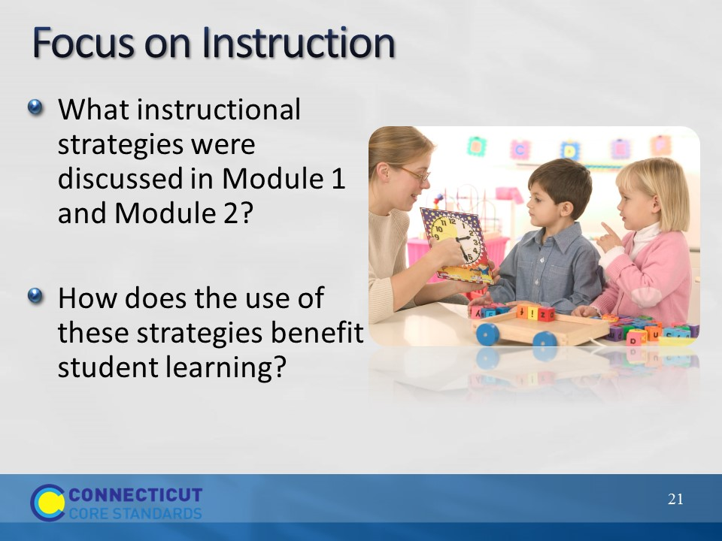Slide 21
Focus on Instruction
Begin by asking participants to think about the instructional strategies that were discussed in Modules 1 and 2. Depending on the group discussions that took place in each module these may vary, but those explicitly addressed include:
Module 1:
- Effective questioning
- Multiple representations
- Student discourse
Module 2:
- The use of cognitively rigorous tasks
- Task modification
- Parallel tasks
- Open questions
- Scaffolding
- C-R-A continuum
- Journals
- Strategies for developing fluency
- Group work and decision making
- Use of graphic organizer for developing mathematical language
As participants name these strategies, chart their responses so that as this section continues, this list can be referenced. After the list is generated, briefly discuss, as a large group, how students benefit from the use of these strategies. For example, the use of parallel tasks, open questions, scaffolding, and the C-R-A continuum allow for multiple entry points into a cognitively rigorous task. The use of math journals and providing opportunities for students to engage in mathematical discourse allow students’ thinking to become visible assisting the teacher in learning what the student understands, helps to uncover student misconceptions, etc.
Transition from this discussion by explaining to participants that they are now going to expand on this list of strategies by examining the principles of Universal Design for Learning, or UDL as it is commonly referred to, but first they will take a few minutes to understand what UDL is and how it supports teaching and learning of the CCS-Math.
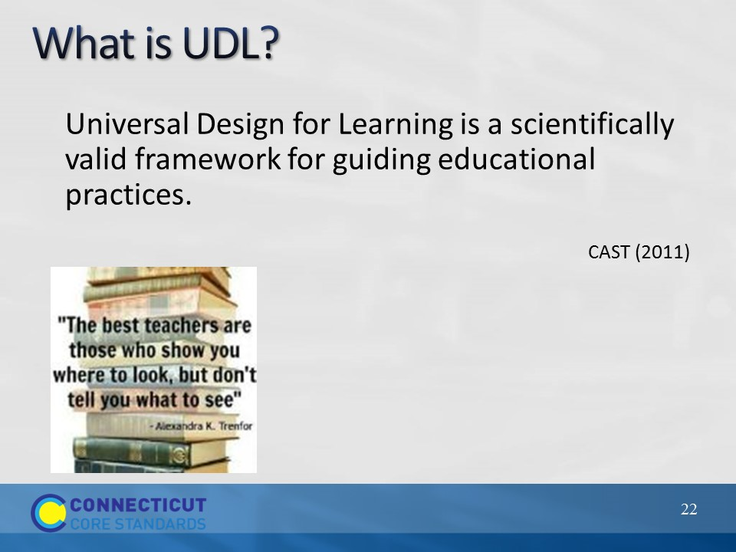Slide 22
What is UDL?
Begin the discussion of UDL by explaining to participants that Universal Design for Learning is a framework, developed by CAST,that includes a set of three principles that were developed with the goal of providing all individuals equal opportunities to learn. Mention that in Module 2, we discussed differentiating the mathematics tasks in order to provide multiple entry points into the mathematics. Here we will build off of that idea because UDL and differentiation are closely linked. The main difference to highlight at this point is that differentiation typically looks at a specific subset of a lesson, the task for example, and asks teachers to modify that aspect in order to meet the needs of all students. UDL, on the other hand, looks at modifying the whole learning process, not just one aspect.
Note: This understanding will continue to unfold throughout this module, and will become even clearer in Module 4, during which participants are involved in learning design.
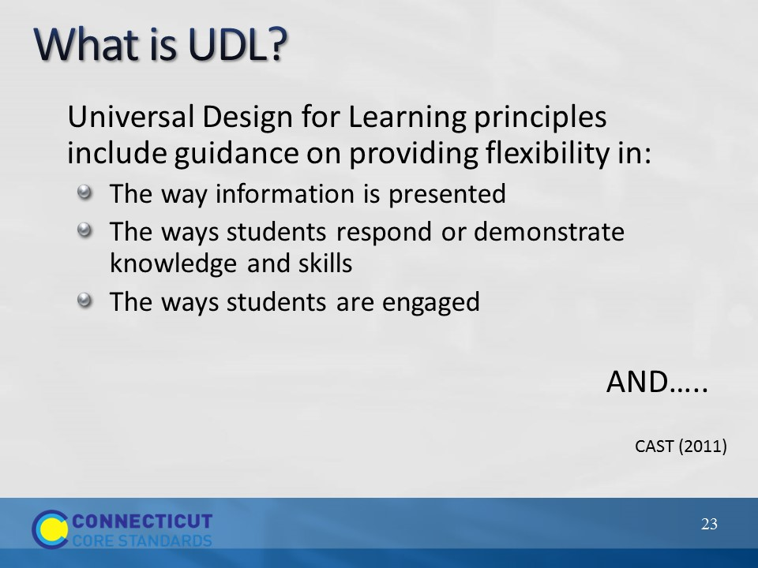Slide 23
What is UDL?
Remind participants that in Module 2 they discussed the importance of providing multiple entry points into cognitively rigorous tasks so that all students had the opportunity to learn mathematics as a deeper level. UDL takes this a step further by providing guidance in the principles that focuses on providing students with flexibility in the way information is presented, in the way students respond or demonstrate knowledge and skills, and in the ways students are engaged within a lesson.
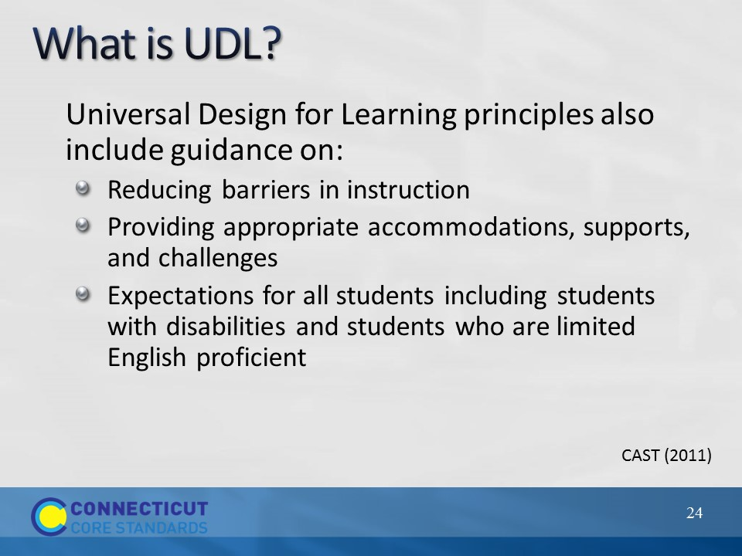Slide 24
What is UDL?
Through the UDL principles guidance is also provided that helps teachers to reduce barriers to instruction, provide appropriate accommodations, supports, and challenges, and to maintain high expectations for all students, including students with disabilities and students who are limited English proficient.
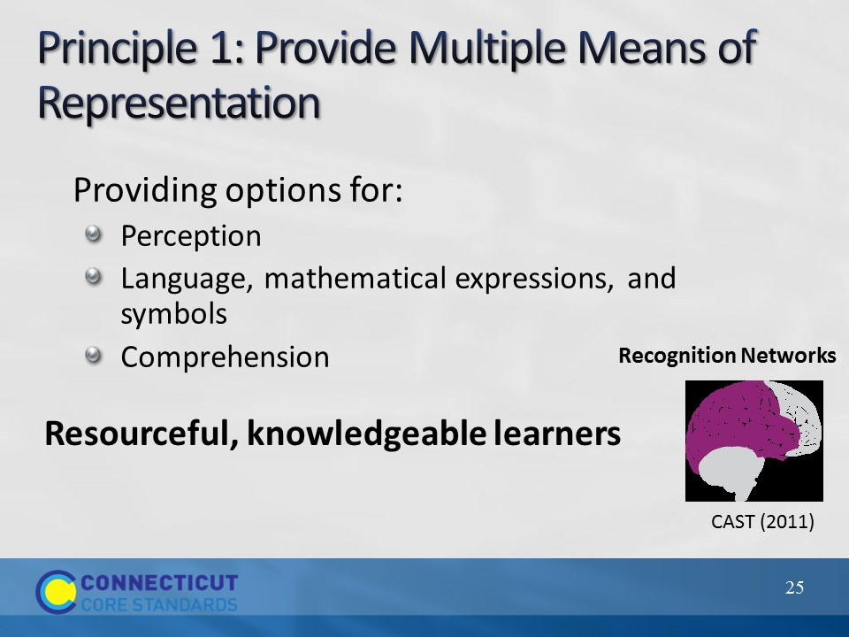Slide 25
Principle 1: Provide Multiple Means of Representation
Begin the discussion of each of the three UDL principles by having participants turn to the Universal Design for Learning Guidelines chart on page 11 in their Participant Guide. Go over Principle 1. Explain that providing multiple means of representation focuses on recognition tasks that include how students gather facts and categorize what they see, hear, and read. To help students with these types of tasks, teachers can present content in different ways. Pause and have participants examine the Principle 1 column of the chart. Provided within the column is an overview of guidelines and checkpoints that teachers can follow when addressing Principle 1. Ask participants to look back at the list of instructional strategies created at the beginning of this section and to think about how those strategies can be applied to Principle 1. Ask for volunteers to provide examples. Examples that can be brought up if participants do not:
Guideline 1: Provide options for perception
- The use of multiple representations
- The use of the C-R-A continuum
Guideline 2: Provide options for language, mathematical expressions, and symbols
- The use of graphic organizers to clarify understanding of mathematical language and symbols
Guideline 3: Provide options for comprehension
- The use of the C-R-A continuum
As examples are shared, ask participants how each strategy provides individuals equal opportunities to learn using multiple representations.
Also point out that as teachers implement strategies connected to the UDL checkpoints under Guideline 3, they will also be implementing strategies that will assist in helping students develop the mathematical habits of mind laid out in the Standards for Mathematical Practice. (Note: Participants will examine these strategies in more depth in the second part of this section.)
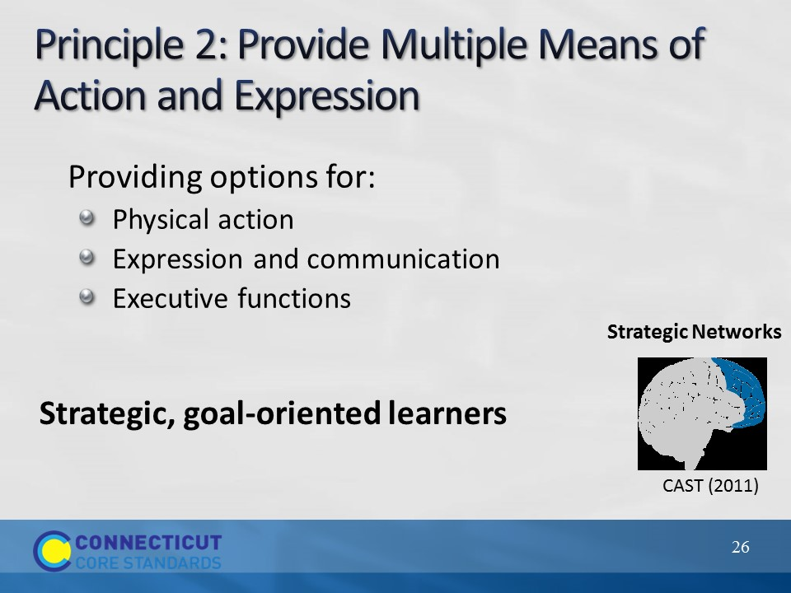Slide 26
Principle 2: Provide Multiple Means of Action and Expression
Go over Principle 2. Explain that providing multiple means of action and expression focuses on planning and performing tasks that include how students organize and express ideas. To help students with these types of tasks, teachers can differentiate the ways that students can express what they know. Point out that planning and performing tasks activate the strategic network of the brain and that solving mathematics problems are, in themselves, strategic tasks.
Pause and have participants examine the Principle 2 column of the chart. Provided within the column is an overview of guidelines and checkpoints that teachers can follow when addressing Principle 2. Ask participants to look back at the list of instructional strategies created at the beginning of this section and to think about how those strategies can be applied to Principle 2, also ask them to think about the connection between the guidelines and principles and the Standards for Mathematical Practice. Ask for volunteers to provide examples. Again, as examples are shared, ask participants how each strategy provides individuals equal opportunities to learn using multiple means of action and expression. Examples that can be brought up if participants do not:
Guideline 4: Provide options for physical action and Guideline 5: Provide options for expression and communication
- The use of multiple representations
- The use of the C-R-A continuum
- The use of journals
- The use of groups
- Providing opportunities to engage students in mathematical discourse (highlight the opportunity for students to develop solution strategies and to share those strategies with others)
- Connected to SMP 4: Model with mathematics and SMP 5: Use appropriate tools strategically
Guideline 6: Provide options for executive functions
While specific strategies have not been discussed that would support this guideline, participants will examine these strategies in more depth in the second part of this section.
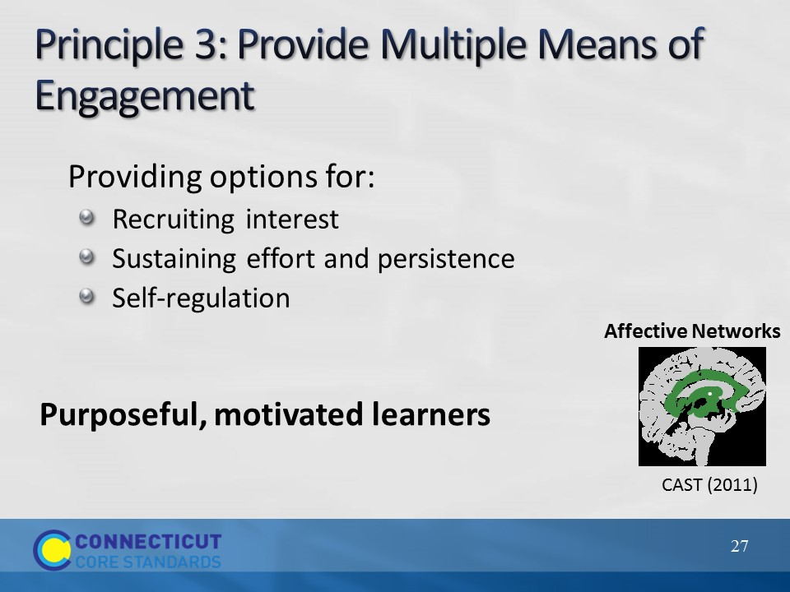Slide 27
Principle 3: Provide Multiple Means of Engagement
Go over Principle 3. Explain that providing multiple means of engagement focuses on how learners get engaged, stay motivated; and include how students are challenged, excited, or interested by learning. Each of these are affective dimensions and work to provide the “why” of learning. The teachers’ role here is to design learning that stimulates students’ interest and motivation for learning.
Pause and have participants examine the Principle 3 column of the chart. Provided within the column is an overview of guidelines and checkpoints that teachers can follow when addressing Principle 3. Ask participants to think about the discussions had in Modules 1 and 2 and connections that can be made to the guidelines and checkpoints of Principle 3. Ask for volunteers to provide examples. Again, as examples are shared, ask participants how each strategy provides individuals equal opportunities to learn using multiple means of engagement.
Examples of connections that can be brought up if participants do not:
- Discussions on SMP1: Make sense of problems and persevere in solving them.
- Discussions on the type of tasks and the context provided within the task.
- Discussions on group work, decision making, and engaging students in mathematical discourse.
- Discussions on the classroom environment that promotes perseverance.
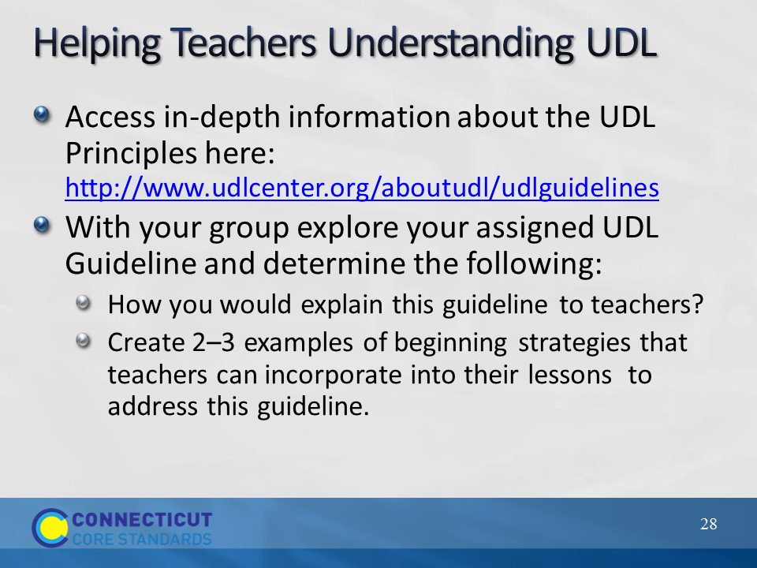Slide 28
Helping Teacher Understand UDL
Explain to participants that they will now work in groups to examine one of the nine UDL guidelines in more depth and think about how they will bring this initial understanding of UDL back to their teachers. Assign each group of participants one of the nine UDL guidelines. In their groups they will access the UDL Principles at the website provided and determine how they would explain that particular guideline to their teachers. Also, they will create 2–3 examples of beginning strategies that teachers can incorporate into their lessons to address their assigned guideline. As participants work to create their examples explain that they will want to make connections, wherever possible to the work and information that they have already brought back to teachers so that teachers are able to see the connections between UDL and their implementation of the CCS-Math Standards. Have participants place their work on chart paper as it will be used to present their guideline to the larger group. Allow participants 20 minutes to work.
After participants have completed their work, each group will present their information allowing for all participants to hear information and ideas around each of the nine guidelines. Space has been provided on page 12 in the Participant Guide for participants to take notes during the presentation. Allow 20 minutes for the presentations as each group should need no more than 2 or 3 minutes present. Hang each piece of chart paper around the room so that while participants are on break they can further examine the information provided on each guideline.
Note: If, when you get to this activity, issues arise with internet connections, have participants center their discussion and work around the Universal Design for Learning Guideline Chart provided in their Participant Guide and provide the link to the UDL center as a resource that can be used with their teachers back at their school. Also, it is suggested that each facilitators access the complete set of UDL Principles and Guidelines here: http://www.udlcenter.org/aboutudl/udlguidelines/downloads in order to provide support for participants as they compete this activity.
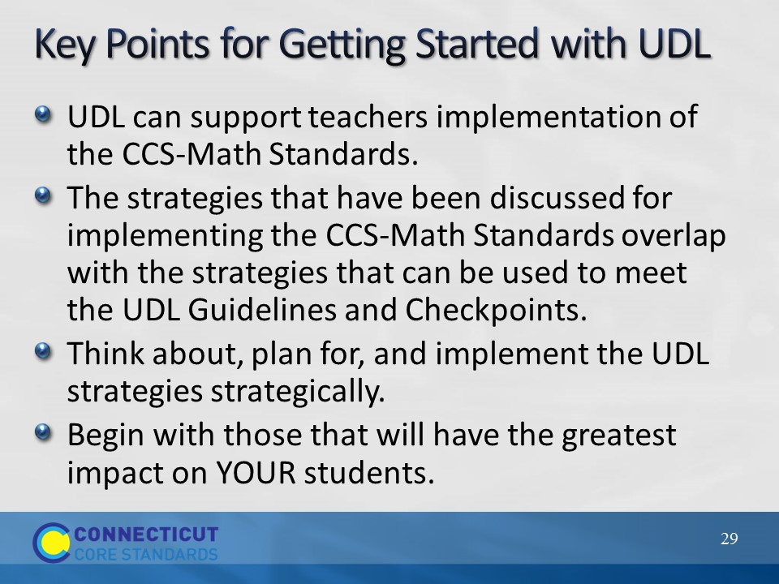Slide 29
Key Points for Getting Started with UDL
Wrap up Section 2 by explaining to participants that as they help teachers begin to implement UDL strategies as a framework for teaching and learning the CCS-Math standards, they will want to communicate four key points:
- UDL can support teachers implementation of the CCS-Math Standards. They will want participants to see UDL as a way to teach the CCS-Math Standards to all students, not as something separate that needs to be implemented.
- The strategies that have been discussed for implementing the CCS-Math Standards parallel the strategies that can be used to meet the UDL Guidelines and Checkpoints. They will want to bring out, just as was done during the discussion of each of the UDL Principles, the connections to work that has already been covered on implementing the CCS-Math Standards as this will help to clarify that the relationship between UDL and the CCS-Math implementation.
- Think about, plan for, and implement the UDL strategies strategically. This idea is important in that teachers may feel overwhelmed at the idea that there are nine guidelines with thirty-one checkpoints. The goal is not for the checkpoints to become a list of “things” that a teacher does, but that they should be used to provide the flexibility and options as described in order to meet the needs of their students and every lesson will not call for every checkpoint to be addressed.
- Begin with those that will have the greatest impact on YOUR students. As they work with teachers on incorporating UDL strategies, participants will want to help teachers examine their lessons, learning targets, and the needs of their students to determine which checkpoints will be used as a guide for planning their mathematics instruction. Learning targets are important here because, participants will need to make sure that teachers understand that the strategies they choose to implement may differ depending on the learning target. They will also want to keep in mind teachers readiness levels and help them choose the checkpoints and associated strategies that will have the greatest impact on their students’ learning and those that teachers can easily manage. These beginning strategies can be used as a foundation for further strategy introduction later on as teachers get more comfortable with UDL and the CCS-Math standards themselves.
Transition into the break by explaining to participants that after the break they will begin to look at and plan for instruction that incorporates UDL strategies during a mathematics lesson.

