Module 3  Facilitator Guide | Focus on Teaching and Learning

Section 3

Connecticut Core Standards for Mathematics

Grades 6–12

Systems of Professional Learning

Connecticut Core Standards Systems of Professional Learning
The material in this guide was developed by Public Consulting Group in collaboration with staff from the Connecticut State Department of Education and the RESC Alliance. The development team would like to specifically thank Ellen Cohn, Charlene Tate Nichols, and Jennifer Webb from the Connecticut State Department of Education; Leslie Abbatiello from ACES; and Robb Geier, Elizabeth O’Toole, and Cheryl Liebling from Public Consulting Group.
The Systems of Professional Learning project includes a series of professional learning experiences for Connecticut Core Standards District Coaches in English Language Arts, Mathematics, Humanities, Science, Technology, Engineering, Mathematics (STEM), and Student/Educator Support Staff (SESS).
Participants will have continued support for the implementation of the new standards through virtual networking opportunities and online resources to support the training of educators throughout the state of Connecticut.
Instrumental in the design and development of the Systems of Professional Learning materials from PCG were: Sharon DeCarlo, Debra Berlin, Jennifer McGregor, Judy Buck, Michelle Wade, Nora Kelley, Diane Stump, and Melissa Pierce.

Published 2014. Available online at http://ctcorestandards.org/

Session at-a-Glance

Section 3: Teaching and Learning with the UDL Principles (90 minutes)

Training Objectives:
To provide participants with an opportunity to observe a mathematics lesson in order to identify UDL Principles in use.
To provide participants with an opportunity to think about the implementation of a mathematics task in order to address the UDL Principles.
To provide participants with an opportunity to practice planning portions of a lesson in order to incorporate UDL strategies using specific planning questions as a guide.
Section 3 begins with participants viewing the Teaching Channel video Conjecturing About Functions with a focus on the UDL strategies being used. While they watch, participants will make notes of the strategies they observe on the Video Observation page in their Participant Guide. After the video, participants will discuss the strategies observed, the benefit for students, and any additional opportunities to apply additional strategies.
Participants will then examine a high school geometry performance task. After reading the CCS-M standards addressed, participants will work through the task keeping mindful of the role a geometry teacher would play when implementing the task. A large group discussion will follow on how each of the UDL Principles and how their corresponding guidelines might be addressed while using the task. This discussion takes place in order to model the type of thinking needed when planning a lesson and to provide additional ideas for addressing the guidelines within a lesson. The task used in the lesson is Company Logo from NYC Department of Education is found here: http://www.oercommons.org/courses/hs-geometry-company-logo.
The final activity of this section involves participants having the opportunity to practice planning a lesson outline that includes the application of UDL strategies within a specific grade level. Participants are asked to work in groups to first select the standard(s) they wish to address. After making their selection, participants go online and select a task that aligns with their standard(s). Groups then use specific questions for planning UDL lessons (http://schools.nyc.gov/Academics/CommonCoreLibrary/ProfessionalLearning/UDL/default.htm) to determine where, when, and which strategies they would use within the lesson. Note: Participants are given a choice in standards and tasks in order to model a flexible strategy and to also provide guided experience with selecting tasks that align to standards. The activity will conclude with volunteers sharing what their group has planned.

Supporting Documents:
- Video Observation worksheet
- Geometry Performance task
- Company Logo
- Questions to Guide Your Thinking worksheet
Video:
Conjecturing About Functions found here: https://www.teachingchannel.org/videos/conjecture-lesson-plan

Materials:
Chart paper, markers

PowerPoint Slides:
31–35

Session Implementation
Section 3
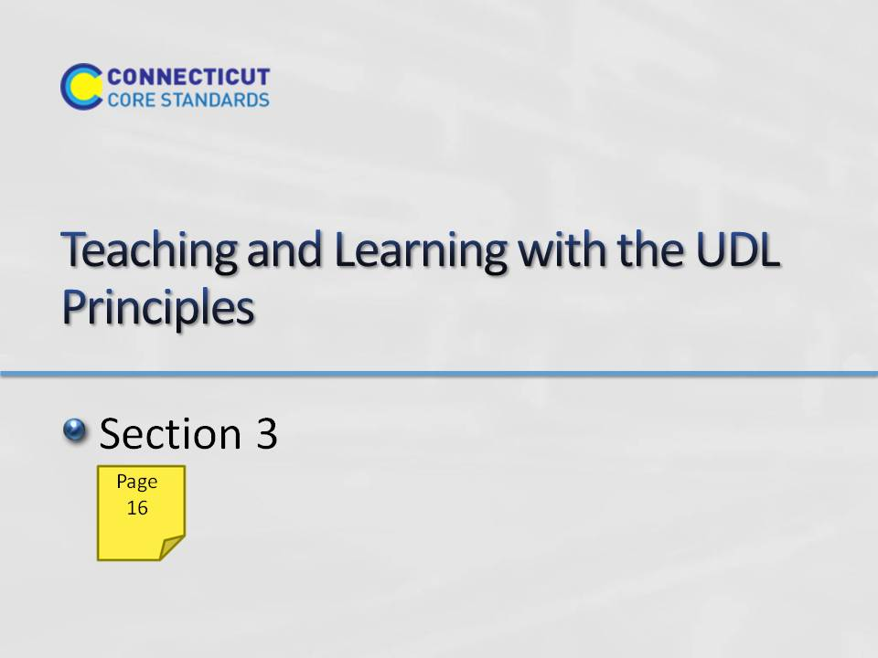Slide 31
Section 3: Teaching and Learning with the UDL Principles
Section 3 Time: 90 minutes
Section 3 Training Objectives:
- To provide participants with an opportunity to observe a mathematics lesson in order to identify UDL Principles in use.
- To provide participants with an opportunity to examine a mathematics lesson outline in order to identify UDL Principles in use.
- To provide participants with an opportunity to practice planning a lesson outline in order to incorporate UDL strategies using specific planning questions as a guide.
Section 3 Outline:
- Section 3 begins with participants viewing the Teaching Channel video Conjecturing About Functions with a focus on the UDL strategies being used. While they watch, participants will make notes of the strategies they observe on the Video Observation page in their Participant Guide. After the video, participants will discuss the strategies observed, the benefit for students, and any additional opportunities to apply additional strategies. (15 minutes)
- Participants will examine a high school geometry performance task. After reading the CCS-M standards addressed, participants will work through the task keeping mindful of the role a geometry teacher would play when implementing the task. (5 minutes) A large group discussion will follow on how each of the UDL Principles and how their corresponding guidelines might be addressed while using the task. (10 minutes) This discussion takes place in order to model the type of thinking needed when planning a lesson and to provide additional ideas for addressing the guidelines within a lesson. The task used in the lesson is Company Logo from NYC Department of Education is found here: http://schools.nyc.gov/NR/rdonlyres/49162FEC-37E2-4A96-93C1-6671664FACD5/0/NYCDOEHSMathCompanyLogo_Final.pdf
- The final activity of this section involves participants having the opportunity to practice planning a lesson outline that includes the application of UDL strategies within a specific grade level. Participants are asked to work in groups to first select the standard(s) they wish to address. After making their selection, participants go online and select a task that aligns with their standard(s). Groups then use specific questions for planning UDL lessons (adapted from NYC Department of Education and found here: http://schools.nyc.gov/NR/rdonlyres/7276C57A-AD49-4C87-B080-4B02557D3410/0/OptionOneQuestionstoguideourthinkingwhencreatinguniversallydesignedcurriculum.pdf ) to determine where, when, and which strategies they would use within the lesson. Note: Participants are given a choice in standards and tasks in order to model a flexible strategy and to also provide guided experience with selecting tasks that align to standards. (40 minutes)
- The activity will conclude with volunteers sharing what their group has planned. (20 minutes)
Supporting Documents:
Video Observation worksheet
Outlining a Lesson, Questions to Guide Your Thinking worksheet
Chart paper, markers
Materials
Chart paper, markers
Video
Conjecturing About Functions found here: https://www.teachingchannel.org/videos/conjecture-lesson-plan
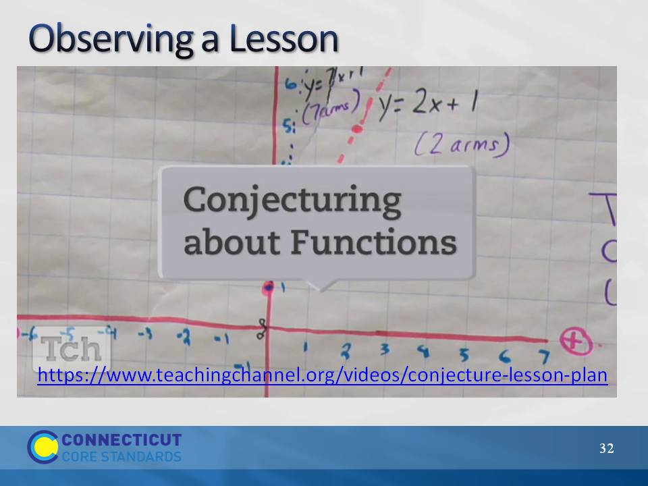Slide 32
Observing a Lesson
Begin the discussion of incorporating UDL Principles into classroom lessons by having participants first watch the Teaching Channel video Conjecturing About Functions (about 9 minutes long). Explain to participants they are to focus on the UDL strategies being used. While participants watch, have them take notes on each of the three UDL Principles using the Video Observation page in their Participant Guide. After the video has been watch, debrief the strategies that participants highlighted in their notes and discuss any additional strategies or opportunities to apply strategies that participants would suggest to this teacher. Examples of strategies to point out if they are not highlighted by participants include:
Principle 1: Provide Multiple Means of Representation
- Guideline 2: Provided guidelines for development of a strong conjecture
- Guideline 3: Connected the current task to previous work, suggested use of color-coding
- Guideline 1: Students representing functions in a variety of ways (table, equation, graph), open-ended task that allowed students to use representations of choice
Principle 2: Provide Multiple Means of Action and Expression
- Guideline 4: Students thought about problem individually, in large groups, and then in small groups, had access to graph paper and markers
- Guideline 5: Students were writing and verbalizing what they noticed, used exit cards
- Guideline 6: Students created their own conjecture, coach emphasized importance of structure in making that conjecture
Principle 3: Provide Multiple Means of Engagement
- Guideline 7: The coach engaged many students in sharing with the class what they noticed or sharing in small groups what they noticed
- Guideline 8: Students worked in groups to make a conjecture
- Guideline 9: Had students stop and think about their own thinking relative to the SMP
Transition to the next activity by explaining to participants that they will now go through an example of a lesson and examine its alignment with UDL principles.
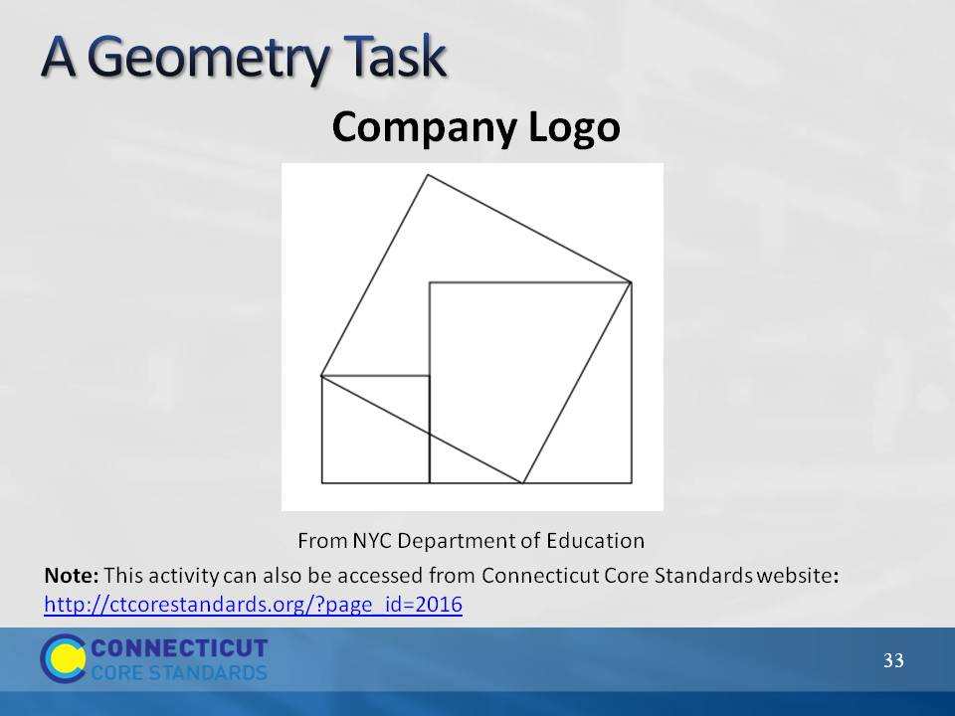Slide 33
A Geometry Lesson
Participants may recognize this geometry task as it was selected by Connecticut’s content team as an example of a 9–12 unit aligned to the CCSS (http://ctcorestandards.org/?page_id=1031#9to12). To help participants gain a better understanding of what the UDL strategies look like when implemented in a CCS-Math-aligned lesson, have participants put themselves in the role of a geometry teacher as they consider students engaged in this performance task. Explain that as a geometry teacher they want to plan a lesson around the standards listed on page 17. They will also incorporate SMP 1: Make sense of problems and persevere in solving them, SMP 3: Construct viable arguments and critique the reasoning of others, and SMP 6: Attend to precision. Give participants 5 minutes to look at these standards and get a feel for the task.
Have participants work on the task that is being used to address the identified standards. They should work individually on it for about 3 minutes.
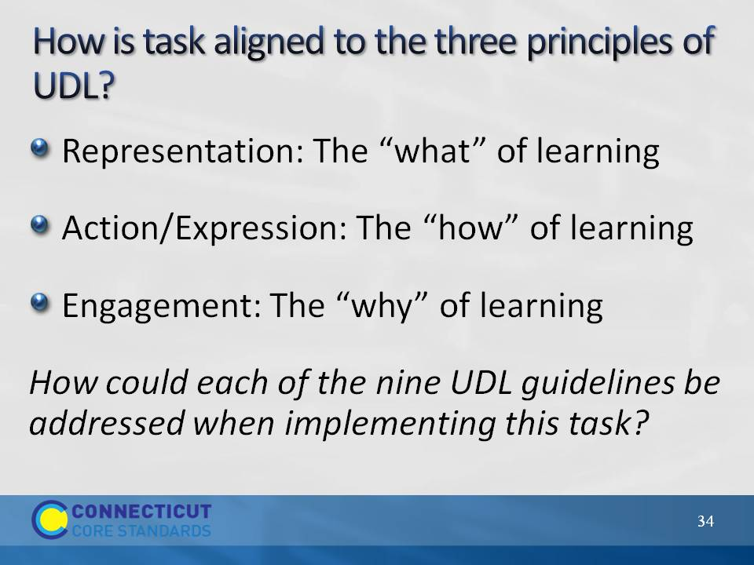Slide 34
A Geometry Performance Task (10 minutes)
In preparation for the next activity, as a large group have participants think of at least one way that each of the nine UDL guidelines could be addressed through this task. Participants can record these ideas on page 20 in their participant guide. Examples:
Guideline 1: Provide different versions of the problem.
Guideline 2: Clarify vocabulary
Guideline 3: Activate prior knowledge and problem solving
Guideline 4: Discuss tools and strategies that may be used
Guideline 5: Allow students to solve the problem in their own way
Guideline 6: Provide options for expressing their ideas
Guideline 7: Discuss various solution strategies
Guideline 8: Allow students to work in groups
Guideline 9: Provide checklist for self-assessment
Before moving on, have participants think about and discuss whether or not addressing the guidelines in the manner they were addressed decreased the level of rigor of the problem. If participants say that the level of rigor was decreased, ask how an alternative action might maintain the level of rigor. If participants say that the level of rigor was not decreased, ask in what ways addressing the guidelines in the manner they were addressed provided all students with equal access to the learning.
Finally, wrap up this part of Section 3 by asking participants if it was necessary to address all nine Guidelines. The answer here is that it really depends on the students. Some teachers may find that their students do not need all nine Guidelines addressed as the implementation of any UDL strategy for any of the Guidelines is based on the needs of the students. Transition to the next part of Section 3 by explaining that participants will now have the opportunity to create a similar lesson outline around standards and a task that they will choose.
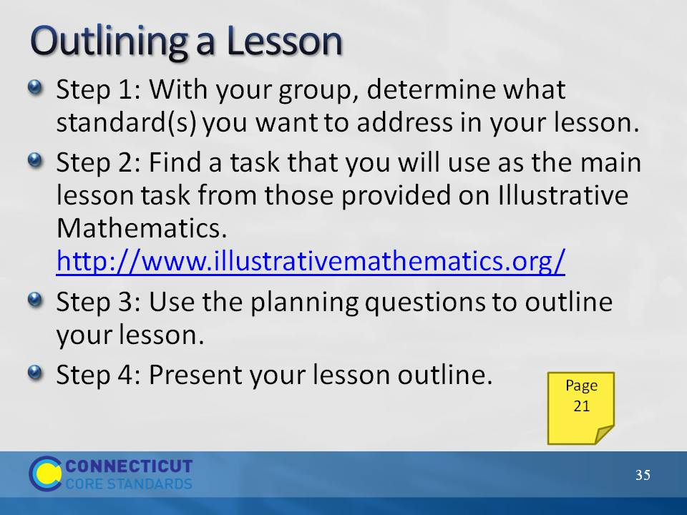Slide 35
Outlining a Lesson
In this activity, participants will work in grade level groups so that there is at least one group per grade level. Participants can either self-select into a group or be assigned a specific grade level group. Explain that with their group they will be outlining a lesson similar to the lesson outline that was just discussed. As groups work, they will first determine what standard(s) they want to address in their lesson. Remind participants to include both Content and Practice Standards. Then, participants will go online and find a task that they will use as the main lesson task. Participants can choose a task from those provided on Illustrative Mathematics. http://www.illustrativemathematics.org/ After identifying their task, participants will answer the planning questions provided in the Participants Guide. These questions will help participants think through how they will address the UDL Principles and, as answers are generated, will develop the lesson outline. Allow participants 40 minutes to work. Note: While groups are planning, hang three pieces of chart paper with one labeled “Provide Multiple Means of Representation,” one labeled “Provide Multiple Means of Action and Expression,” and one labeled “Multiple Means of Engagement.” These three pieces of chart paper will be used to capture strategies discussed during group presentations of their outlines.
Once the lesson outlines are completed, each group will have the opportunity to present their outline. While groups present each part of their outline, chart their suggested strategies for each Principle so that participants have a master list for each from which to pull additional ideas when they complete the work in Section 4. Allow 20 minutes for presentations as each group should only need 3–4 minutes to discuss their outline.
Wrap up Section 3 and transition to Section 4 by explaining to participants that after lunch they will use their work generated in Sections 2 and 3 to begin making plans for how they will introduce teachers to Universal Design for Learning. As the discussion begins to come to a close remind participants that, as they work with teachers, it is important to understand that every guideline may not be addressed in every lesson. It is beneficial to think through each guideline to determine if addressing that guideline will benefit students, as this is the ultimate goal. We do not want teachers to look at the UDL guidelines as a check point, but to be very purposeful in those that they address within any given lesson. This is similar to the way that we think about the Standards for Mathematical Practice. Each practice is extremely important, however not every lesson will explicitly address every Practice Standard.
Dismiss participants for lunch.

