Module 3  Facilitator Guide | Supporting All Students in Writing and Research

Introductory Activities

Connecticut Core Standards for English Language Arts and Literacy

Grades K–5

Systems of Professional Learning

Connecticut Core Standards Systems of Professional Learning
The material in this guide was developed by Public Consulting Group in collaboration with staff from the Connecticut State Department of Education and the RESC Alliance. The development team would like to specifically thank Ellen Cohn, Charlene Tate Nichols, and Jennifer Webb from the Connecticut State Department of Education; Leslie Abbatiello from ACES; and Robb Geier, Elizabeth O’Toole, and Cheryl Liebling from Public Consulting Group.
The Systems of Professional Learning project includes a series of professional learning experiences for Connecticut Core Standards District Coaches in English Language Arts, Mathematics, Humanities, Science, Technology, Engineering, Mathematics (STEM), and Student/Educator Support Staff (SESS).
Participants will have continued support for the implementation of the new standards through virtual networking opportunities and online resources to support the training of educators throughout the state of Connecticut.
Instrumental in the design and development of the Systems of Professional Learning materials from PCG were: Sharon DeCarlo, Debra Berlin, Jennifer McGregor, Judy Buck, Michelle Wade, Nora Kelley, Diane Stump, and Melissa Pierce.
Published 2014. Available online at http://ctcorestandards.org/

Session at-a-Glance

Introductory Activities (15 minutes)
- Welcome
- You Are Here
- Module outcomes and session agenda
- Quick write (sharing the materials and messages from Module 2 with school and district colleagues)
- Pre-Assessment

Supporting Documents:
- Pre-Assessment
- Notepad in Participant Guide

PowerPoint Slides:
- 1-7

Session Implementation
Module 3
Slide 1
Slides 1-7 will take about 15 minutes.
Facilitator:
Introduce yourself. Welcome participants to Module 3.
Remind participants that regardless of which session they attended for Modules 1 and 2, they learned the same information, and had similar conversations. They are all part of the same community of coaches with a goal of deepening understanding of the CT Core Standards and instructional shifts across the entire state
(Be sure that everyone is wearing a nametag. Since participants are now in their third module, it is likely that many of them will have met each other in earlier modules. There will be no full group introductions this time. They will have the opportunity to introduce themselves during various activities. However, as facilitator, you may want to read the room with regard to who is here from the same district so that you can plan to mix up groups; you may also want to ask if there is anyone who did not attend M1 and M2.)
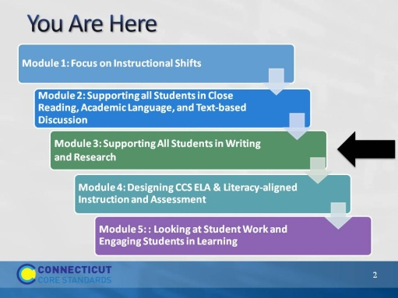Slide 2
This slide provides a visual showing how the topics for the professional development modules fit together. Briefly explain to participants.
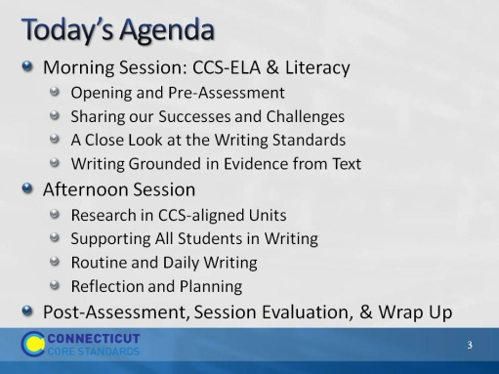Slide 3
Review the agenda, noting there will be a break for lunch as well as a short morning and afternoon break. You may want to add the importance of coming back from breaks on time to ensure enough time to complete all the work of the day.
Introductory Activities
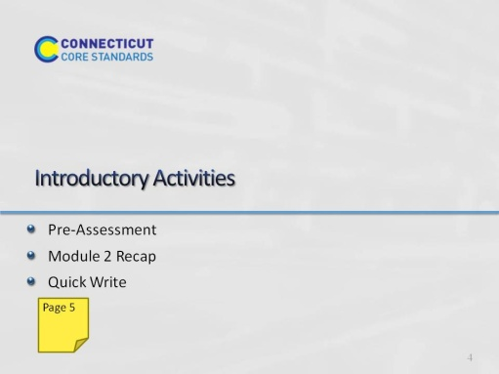Slide 4
Ask participants to complete the Pre-Assessment.
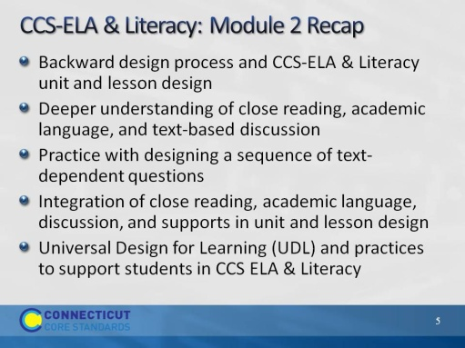Slide 5
The purpose of this slide is just to remind participants of the topics in Module 2. Be very brief with this slide, just naming the topics:
Unit and lesson design overview, close reading, text-dependent questions, academic language, discussion, and Universal Design for Learning.
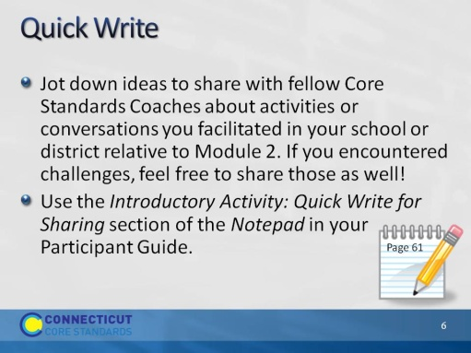Slide 6
Facilitator: You will distribute cards from the deck in your supply box. Count the number of participants. Remove as many cards as needed to distribute evenly–or somewhat evenly–in matched fours among participants. For example, if you have 28 participants, you will remove all 8’s‒Kings from your deck and keep all Aces‒7s to make 28 cards. If you have 32 participants, you would distribute Aces‒8’s to make 32 cards and so on. If you have an uneven number that would leave one or two participants alone, add a few more cards from the next number up. Shuffle well. As participants are writing in their Notepads, circulate among them, distributing cards. If you have a large district group, break them up for the first activity, by being deliberate in how you distribute the cards.
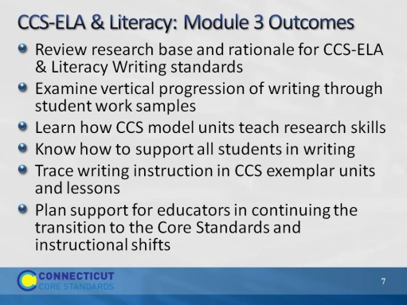Slide 7
Review the expected outcomes briefly. This module will focus on the CC writing standards, writing instruction, and support.

