Module 3  Facilitator Guide | Supporting All Students in Writing and Research

Activity 7

Connecticut Core Standards for English Language Arts and Literacy

Grades K–5

Systems of Professional Learning

Connecticut Core Standards Systems of Professional Learning
The material in this guide was developed by Public Consulting Group in collaboration with staff from the Connecticut State Department of Education and the RESC Alliance. The development team would like to specifically thank Ellen Cohn, Charlene Tate Nichols, and Jennifer Webb from the Connecticut State Department of Education; Leslie Abbatiello from ACES; and Robb Geier, Elizabeth O’Toole, and Cheryl Liebling from Public Consulting Group.
The Systems of Professional Learning project includes a series of professional learning experiences for Connecticut Core Standards District Coaches in English Language Arts, Mathematics, Humanities, Science, Technology, Engineering, Mathematics (STEM), and Student/Educator Support Staff (SESS).
Participants will have continued support for the implementation of the new standards through virtual networking opportunities and online resources to support the training of educators throughout the state of Connecticut.
Instrumental in the design and development of the Systems of Professional Learning materials from PCG were: Sharon DeCarlo, Debra Berlin, Jennifer McGregor, Judy Buck, Michelle Wade, Nora Kelley, Diane Stump, and Melissa Pierce.
Published 2014. Available online at http://ctcorestandards.org/

Session at-a-Glance

Part 5: Supporting Students in Writing (55 minutes)
Participants will reflect on what they have learned so far today about the writing standards and shifts and consider what kinds of support students will need in writing. They will review the concept of gradual release of responsibility and will consider the various practices they have seen today that demonstrate a gradual release. In Activity 7, they will return to the video lesson they viewed in Module 2, “Analyzing Text,” and will look at a third segment of the lesson in which students begin to write. They will discuss how the teacher supports all students in being prepared to write.
In Activity 8a, coaches will have the opportunity to dig deeply into a writing framework from the Basal Alignment Project, designed to support students in becoming more proficient writers. In Activity 8b, coaches will practice writing a focusing question and structuring a writing task for the text they have been worked with in Module 2.
They will also be briefly introduced to a second writing framework from the Literacy Design Collaborative that previously existed only for grades 6-12, but has been extended to lower grades. Afterwards, coaches will engage in a brief discussion about the benefits and challenges of using a scaffolded writing framework.

Activity 7: Viewing a Video (10 minutes)
In Module 2, K–5 coaches viewed several segments of a video lesson in which Stacy Brewer, a fifth grade teachers, skillfully led her students through close reading, note taking, discussing in small groups, and then engaging in an evidence-based discussion as a class. These activities were carefully structured to prepare them to write independently to standards-based questions. Coaches will view the video and then discuss with their tables: In what ways did the lesson sequence prepare students to be confident and competent in evidence-based writing?

Supporting Documents:
- Brewer, S. Analyzing Texts: Putting Thoughts on Paper. Retrieved from https://www.teachingchannel.org/videos/analyzing-text-writing

PowerPoint Slides:
- 63-68

Session Implementation
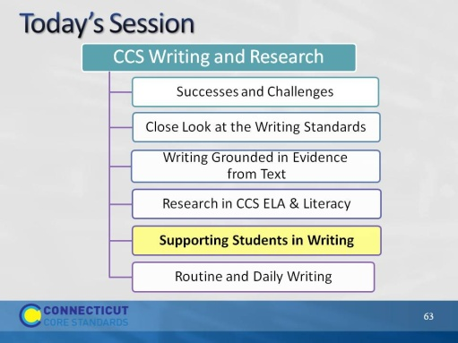Slide 63
In Module 2, we considered ways to support students in reading closely and drawing evidence from text. Because of the integrated nature of the CCS, many of those supports address writing as well as reading.
Part 5
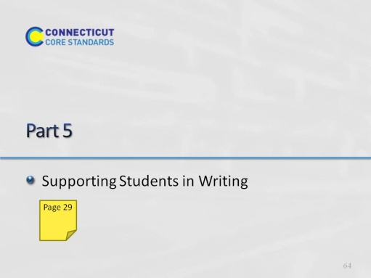Slide 64
Part 5 will take about 55 minutes:
Intro: 5
Activity 7: 10
Activity 8a: 20
Activity 8b: 20
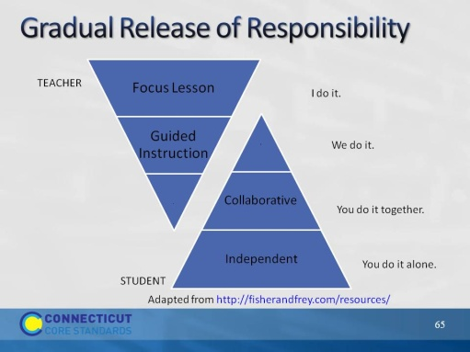Slide 65
Fisher & Frey. Literacy for Life http://fisherandfrey.com/resources/
Fisher and Frey have created a graphic to illustrate gradual release of responsibility. For most coaches, this is really a review, not new information. However, it is important to emphasize that given the rigor of the writing standards, it is important to model, guide, and provide practice for students before expecting individual mastery of writing.
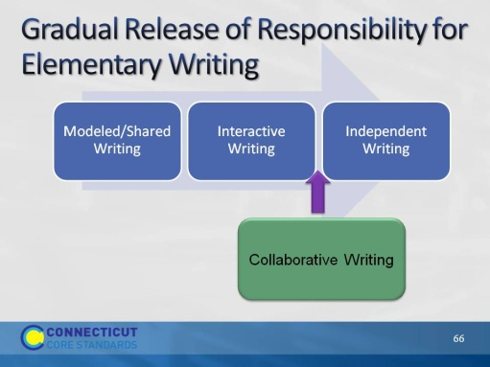Slide 66
Many coaches will be familiar with writing in a balanced literacy program. In modeled writing, the teacher thinks aloud and writes. In shared writing, the teacher and students compose together and the teacher scribes. In interactive writing, the pen is shared with students doing some of the writing. The CCS would add another step to this: Collaborative writing. There is a strong emphasis on collaboration in the CCS, and it aligns with the Fisher and Frey model as well.
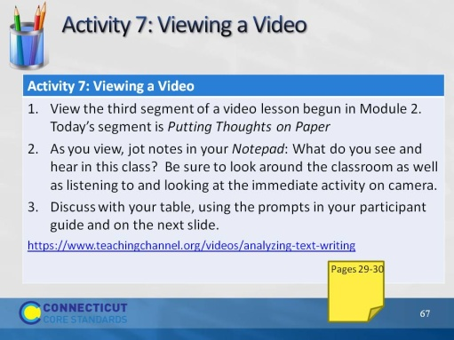Slide 67
Remind participants that in Module 2, we saw a video of a fifth grade class (teacher Stacey Brewer). Ms. Brewer explained that she had a very diverse class and that she planned her lessons in such a way that all students could participate, contribute, and be prepared, regardless of their independent reading level. They read a text about Lewis and Clarke, took individual notes with post-its, discussed in a small group, and then as a whole class. Today we will see the last piece of that video, where Ms. Brewer supports students in preparing to respond in writing.
https://www.teachingchannel.org/videos/analyzing-text-writing - 00:00 – 05:00
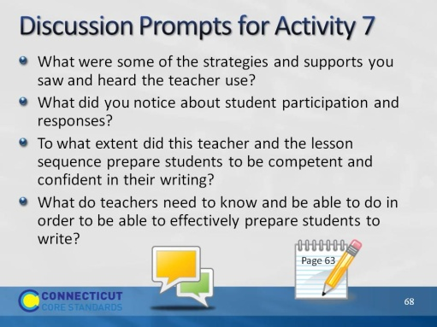Slide 68
After discussion, be sure to elicit responses from volunteers. Or, let tables know that you will be calling on someone to answer each question. The last question is particularly important for coaches.

