Module 3  Facilitator Guide | Supporting All Students in Writing and Research

Activity 5a

Connecticut Core Standards for English Language Arts and Literacy

Grades K–5

Systems of Professional Learning

Connecticut Core Standards Systems of Professional Learning
The material in this guide was developed by Public Consulting Group in collaboration with staff from the Connecticut State Department of Education and the RESC Alliance. The development team would like to specifically thank Ellen Cohn, Charlene Tate Nichols, and Jennifer Webb from the Connecticut State Department of Education; Leslie Abbatiello from ACES; and Robb Geier, Elizabeth O’Toole, and Cheryl Liebling from Public Consulting Group.
The Systems of Professional Learning project includes a series of professional learning experiences for Connecticut Core Standards District Coaches in English Language Arts, Mathematics, Humanities, Science, Technology, Engineering, Mathematics (STEM), and Student/Educator Support Staff (SESS).
Participants will have continued support for the implementation of the new standards through virtual networking opportunities and online resources to support the training of educators throughout the state of Connecticut.
Instrumental in the design and development of the Systems of Professional Learning materials from PCG were: Sharon DeCarlo, Debra Berlin, Jennifer McGregor, Judy Buck, Michelle Wade, Nora Kelley, Diane Stump, and Melissa Pierce.
Published 2014. Available online at http://ctcorestandards.org/

Session at-a-Glance

Activity 5a: Viewing a Video and Having a Written Conversation (35 minutes)
Coaches watch a video lesson on developing argument writing in a third grade classroom. They have a “Written Conversation,” following directions in the Participant Guide.

Supporting Documents:
- Written Conversation, adapted from Expeditionary Learning. “Written conversation protocol,” from “Teaching Practices and Protocols,” Grades 3-5 ELA Curriculum: Appendix 1 http://www.engageny.org/resource/grades-3-5-ela-curriculum-appendix-1-teaching-practices-and-protocols
- Written Conversation Notes Sheet
Video:
- “Text Evidence to Support an Argument,” http://commoncore.americaachieves.org/module/17

PowerPoint Slides:
- 43-46

Session Implementation
Activity 5a
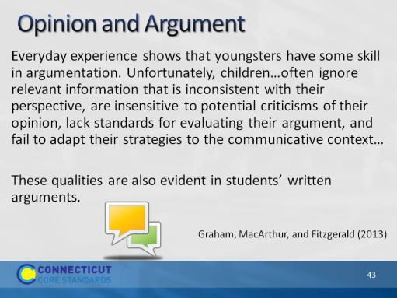Slide 43
The purpose of this slide is to address a particular kind of writing with evidence–argument. Although argument does not start until grade 6, it is really just a matter of semantics and formality. Students begin expressing opinions in Kindergarten and build toward formal argumentation.
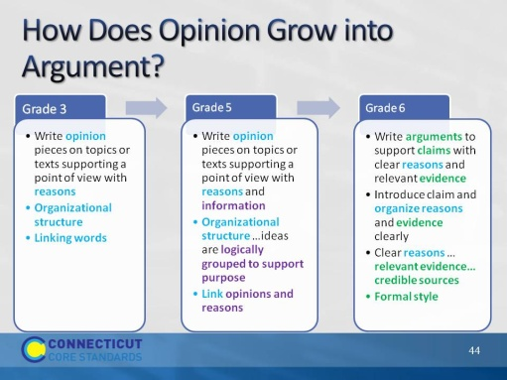Slide 44
This slide is reminiscent of an earlier slide when we were discussing text types. This one shows how opinion builds to argument, so that fifth graders are prepared to begin writing argument in sixth grade.
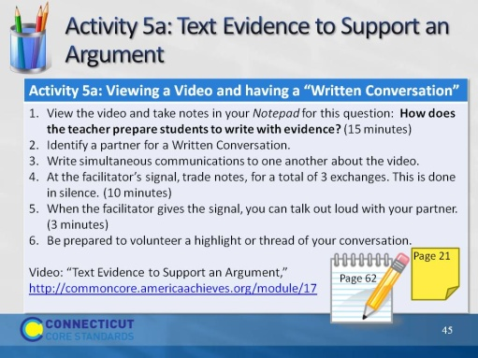Slide 45
This activity will take about 45 minutes.
The purpose of this activity is to illustrate that young students can write well-developed arguments if given scaffolding and support. Briefly review the directions. Explain to participants that after they view the video and take individual notes, they will engage in a protocol, Written Conversation, that is a powerful discussion protocol to use with students. Direct participants to the appropriate pages in their Participant Guides. Have them review the directions for the activity.

Explain that they will be watching 3 clips from a longer video that are representative of the entire lesson. The video is called Text Evidence to Support an Argument. This teacher is actually focusing on Reading, Speaking and Listening, and Language standards, not W.1. She is teaching students about finding evidence in text. Participants are likely to notice that the teacher is using a basal anthology; since this realization may interfere with the lesson for some participants, it is better to acknowledge up front that they will notice she is using a piece of authentic literature from a reading series. This is a fairly long video. It will be about 9 minutes: Minutes 1- 3:50; 7:30- 10:30; and 12- 13:40.
http://commoncore.americaachieves.org/module/17
After the video, be certain that each participant has a partner. If there are odd numbers, there can be a trio. Be sure to watch the time and signal when partners should trade. After partners have had an opportunity to speak aloud, be sure to ask them why or how Written Conversation would be an effective strategy to use as a discussion protocol with students.
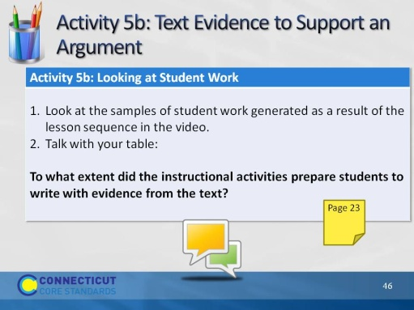Slide 46
Blank.

