Module 3  Facilitator Guide | Supporting All Students in Writing and Research

Activity 4

Connecticut Core Standards for English Language Arts and Literacy

Grades K–5

Systems of Professional Learning

Connecticut Core Standards Systems of Professional Learning
The material in this guide was developed by Public Consulting Group in collaboration with staff from the Connecticut State Department of Education and the RESC Alliance. The development team would like to specifically thank Ellen Cohn, Charlene Tate Nichols, and Jennifer Webb from the Connecticut State Department of Education; Leslie Abbatiello from ACES; and Robb Geier, Elizabeth O’Toole, and Cheryl Liebling from Public Consulting Group.
The Systems of Professional Learning project includes a series of professional learning experiences for Connecticut Core Standards District Coaches in English Language Arts, Mathematics, Humanities, Science, Technology, Engineering, Mathematics (STEM), and Student/Educator Support Staff (SESS).
Participants will have continued support for the implementation of the new standards through virtual networking opportunities and online resources to support the training of educators throughout the state of Connecticut.
Instrumental in the design and development of the Systems of Professional Learning materials from PCG were: Sharon DeCarlo, Debra Berlin, Jennifer McGregor, Judy Buck, Michelle Wade, Nora Kelley, Diane Stump, and Melissa Pierce.
Published 2014. Available online at http://ctcorestandards.org/

Session at-a-Glance

Part 3: Writing Grounded in Evidence from Text (105 minutes)
Participants listen to a brief review of Instructional Shift 2, Reading, Writing, and Discussion grounded in evidence from text, and examine the meaning of “writing, grounded in evidence from text.” They see the types of writing that will be required from third grade on in the SBAC assessments. In Activity 4, they participate in a Jigsaw Protocol, using a chapter from Best Practices in Writing Instruction (2013). In Activity 5, they watch excerpts from a video of a third grade lesson series and view the resulting student work samples as they discuss how opinion/argument writing can be addressed and supported in the early grades.

Activity 4: Writing About Text (50 minutes)
Working in teams, participants use a Jigsaw Protocol to read and debrief Tim Shanahan’s chapter, (2013) “Best Practices in Writing about Text.” Participants, in table groups, read one section of the text, highlighting key ideas (please remind participants not to write on the handout). Together they summarize the section, and decide how they will teach that section to other participants. They create a graphic to help them do so. Each participant makes a copy of the graphic.
Participants re-organize into groups of 5 and each read a different section of the chapter. They take turns “teaching” the other participants about their section.
Participants return to their original table groups, discuss, and record their take-ways for this session in the Notepad section of the Participant Guide.

Supporting Documents:
- Shanahan, T. (2013). Best practices in writing about text. In S. Graham, C. A. MacArthur, & J. Fitzgerald (Eds.), Best practices in writing instruction (2nd ed., ch. 14, pp. 334-350). New York: Guilford Press

PowerPoint Slides:
- 30-42

Session Implementation
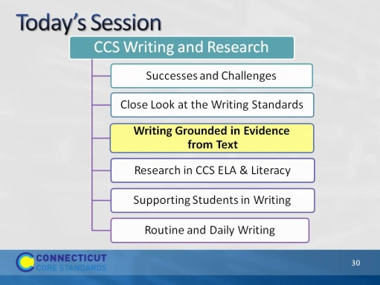Slide 30
This part of the module will focus on Shift 2, writing, grounded in evidence from the text, and how that develops in elementary school.
Part 3 is allotted 105 minutes in total. This includes introductory slides and Activities 4 and 5. Activity 4 is 50 minutes, and Activity 5 is 45 minutes. That leaves about 10 minutes for introduction and conclusion of this part.
Part 3
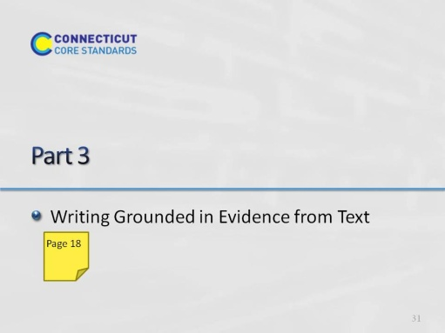Slide 31
Part 3 is allotted 105 minutes in total. This includes introductory slides and Activities 4 and 5. Activity 4 is 50 minutes, and Activity 5 is 45 minutes. That leaves about 10 minutes for introduction and conclusion of this part.

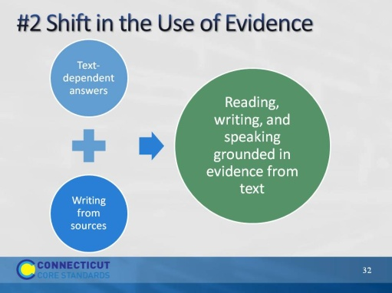Slide 32
Remind participants that in Module 1, we saw that one of three significant instructional shifts required by the CCS is “Reading, writing, and speaking, grounded in evidence from text.” With regard to writing, where in the standards do we find that?
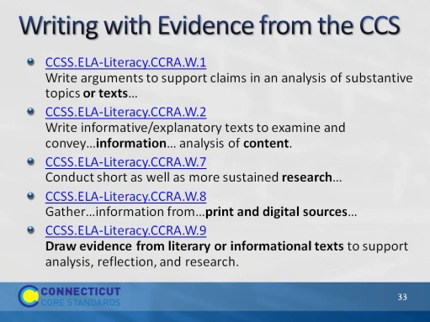Slide 33
The purpose of this slide is to show that writing from sources/writing with evidence is spread throughout the writing standards. Standard 9 also refers back explicitly to the reading standards at each grade level.
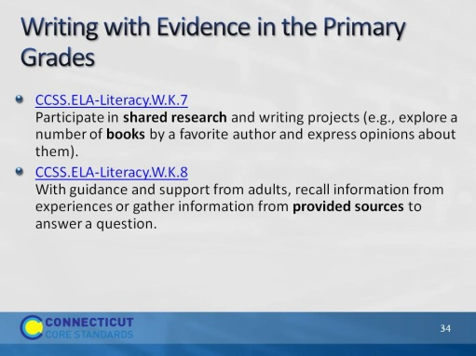Slide 34
These are the Kindergarten standards.
W.9 does not begin until Grade 4, primarily because of the independent and sophisticated nature of both reading and writing required to be successful.
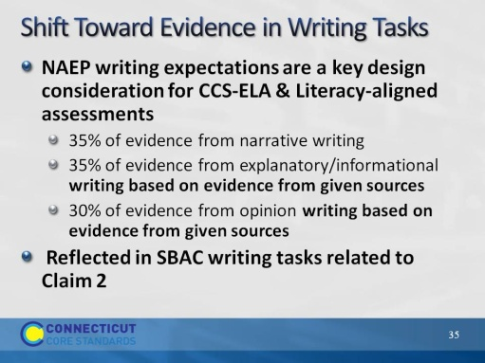Slide 35
“It follows that writing assessments aligned with the Standards should adhere to the distribution of writing purposes across grades outlined by NAEP.” http://www.corestandards.org/ELA-Literacy/introduction/key-design-consideration/
This instructional shift is reflected on the Smarter Balanced assessments as well. Grade 3-5 Summative Assessment Targets, Claim #2
Students can produce effective writing for a range of purposes and audiences. 65% of grade 3-5 writing tasks related to Claim 2 on SBAC will include writing from sources.
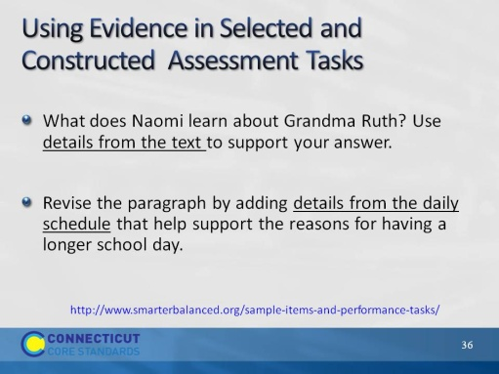Slide 36
The use of evidence is reflected in both writing tasks and revision tasks, and requires evidence from a variety of kinds of text, fiction and informational, graphic and video.

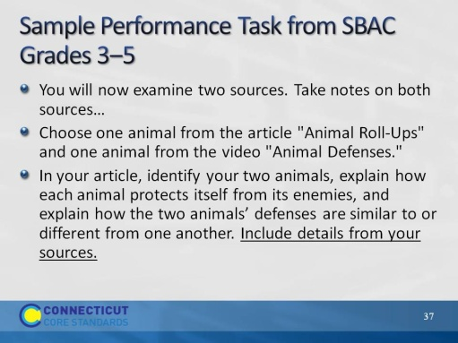Slide 37
Although the writing task does not use the word “evidence” which is associated with argument and explanation, beginning in grade 6, there is a clear expectation that information will be grounded in text.
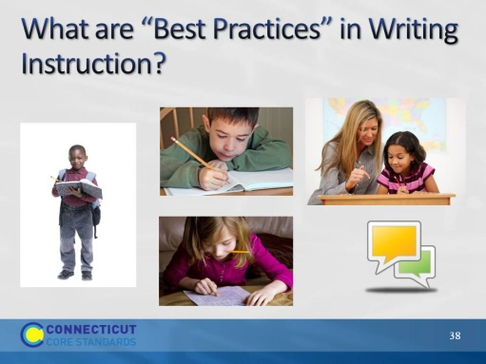Slide 38
Remind participants that earlier today we learned that “best practices” to teach writing from text are drawn from two sources: common practices of exemplary teachers of writing, and scientific studies.
Direct participants to turn and talk with a neighbor about practices they believe to be best practices in writing instruction. Then show the next slide and read the details in the facilitator’s notes. Ask participants to listen for the practices they named. Ask them if they are surprised by any, or if they named any they think should have been there and are not.

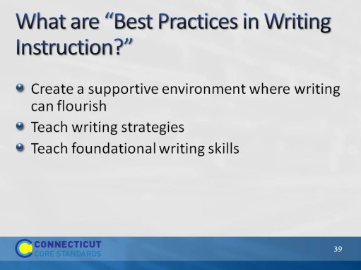Slide 39
Create a supportive environment where writing can flourish
Clear, specific, and challenging goals
Arrangements in which students work together
Write often, and for a variety of purposes
Real audiences
Personal choices
Write for extended periods
Teach writing strategies
Strategies for writing process – planning, drafting, revising, and editing
Pre-writing activities
Graphic organizers
Characteristics of text types and genres
Teach foundational writing skills
Handwriting, typing, spelling
Syntax
Conventions
Graphic organizers
Sentence and paragraph structure
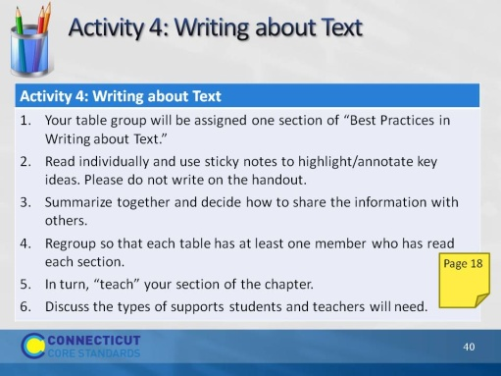Slide 40
This activity will take 50 minutes. Directions for this activity are in the Participant Guide.
Say: “The purpose of this activity is to become familiar with four research-supported approaches to writing about text.”
Direct participants to turn to the correct page in their guide, then briefly review the directions. When step 6 is completed, move to the next slide.

Assign a number to each table group, reorganizing the tables as needed to even out the size of the groups.
- Assign each table one section of “Best Practices in Writing about Text.”
Sections are as follows:
- Intro - pp. 334–335
- Writing to Text Models – pp 336–338
- Summarizing Text – pp. 338–340
- Writing about Text – bottom p. 340–343
- Text Synthesis – pp. 343–347
- Direct participants to read individually use sticky notes to highlight/annotate key ideas. (10 minutes) Remind participants not to write on the handout as these will collected and reused at future sessions.
- Each table summarizes their section together, and decides how to best share the information with others in a 3-minute presentation. (10 minutes)
- Regroup so that each table now has at least one member who has read each section.
- In turn, “teach” your section of the chapter. (15 minutes – 3 minutes per group)
- Discuss: How can these research-based practices be adapted for early elementary students? What support will students need in order to do the types of writing described in this chapter? What support will teachers need? (10 minutes)
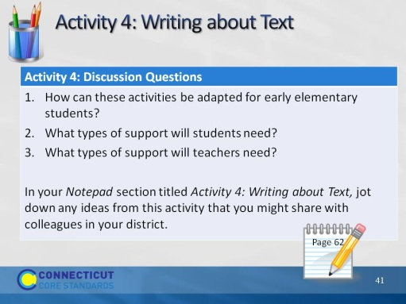Slide 41
Discuss: How can these research-based practices be adapted for early elementary students? What support will students need in order to do the types of writing described in this chapter? What support will teachers need? (10 minutes)
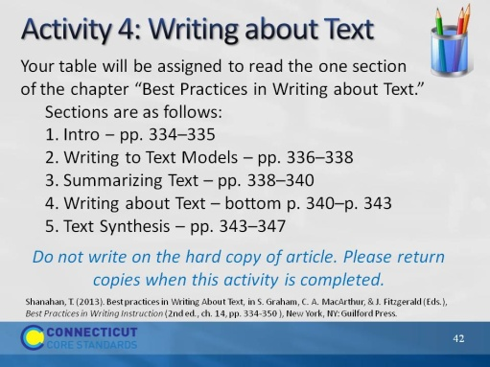Slide 42
Blank.

