Module 3  Facilitator Guide | Supporting All Students in Writing and Research

Activity 3

Connecticut Core Standards for English Language Arts and Literacy

Grades K–5

Systems of Professional Learning

Connecticut Core Standards Systems of Professional Learning
The material in this guide was developed by Public Consulting Group in collaboration with staff from the Connecticut State Department of Education and the RESC Alliance. The development team would like to specifically thank Ellen Cohn, Charlene Tate Nichols, and Jennifer Webb from the Connecticut State Department of Education; Leslie Abbatiello from ACES; and Robb Geier, Elizabeth O’Toole, and Cheryl Liebling from Public Consulting Group.
The Systems of Professional Learning project includes a series of professional learning experiences for Connecticut Core Standards District Coaches in English Language Arts, Mathematics, Humanities, Science, Technology, Engineering, Mathematics (STEM), and Student/Educator Support Staff (SESS).
Participants will have continued support for the implementation of the new standards through virtual networking opportunities and online resources to support the training of educators throughout the state of Connecticut.
Instrumental in the design and development of the Systems of Professional Learning materials from PCG were: Sharon DeCarlo, Debra Berlin, Jennifer McGregor, Judy Buck, Michelle Wade, Nora Kelley, Diane Stump, and Melissa Pierce.
Published 2014. Available online at http://ctcorestandards.org/

Session at-a-Glance

Activity 3: Examining the Grade Level Demands of the Writing Standards (30 minutes)
Participants examine the differences in grade level expectations of the CCS Writing Standards for Opinion/Argument, Informative/Explanatory, or Narrative writing, by looking at a progression of On-Demand student writing from the In Common collection and annotating with the language of the standards.

Supporting Documents:
- “Learning by Example – PD Activity” from Achieve the Core. Retrieved from http://achievethecore.org/page/507/in-common-effective-writing-for-all-students
- Vertical Progression of the CCS-ELA & Literacy Writing Standards
- Student writing samples from the Collection of All In Common Writing Samples, K-12 (separate handouts) http://achievethecore.org/page/507/in-common-ee-writing-for-all-students

PowerPoint Slides:
- 21-28
Activity 3
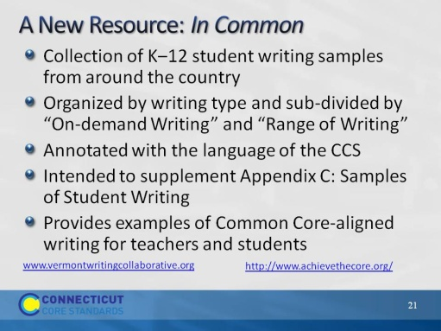Slide 21
Slides 18-27, which include Activity 3, will take about 30 minutes.
The purpose of the next two slides is to introduce In Common as a resource. Most participants will have heard of In Common but may not have had an opportunity to explore it.

There are two types of writing in In Common. “On-demand Writing,” written to a common prompt and illustrates developmental spectrum. “Range of writing,” illustrates examples of writing for different tasks, audiences, and purposes over different time frames.
Created by Vermont Writing Collaborative and Student Achievement Partners.
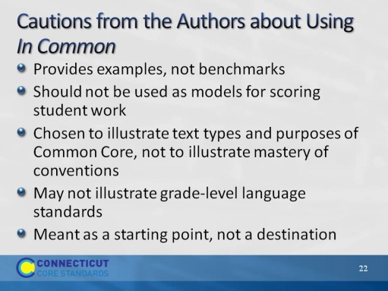Slide 22
The authors make it clear that these are authentic writing samples to be used for a variety of purposes, but they are not intended to be models. They were intended to supplement Appendix C, which was not sufficient for its intended purpose. This is an ongoing project.
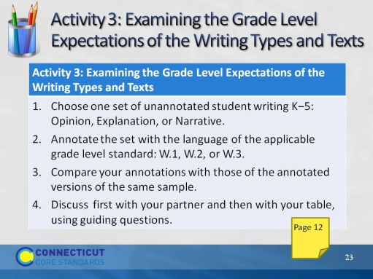Slide 23
Approximately 25 minutes for this activity and discussion that follows.
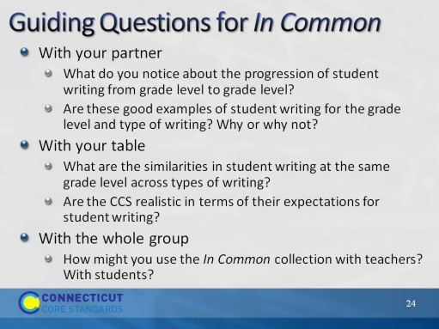Slide 24
Blank.
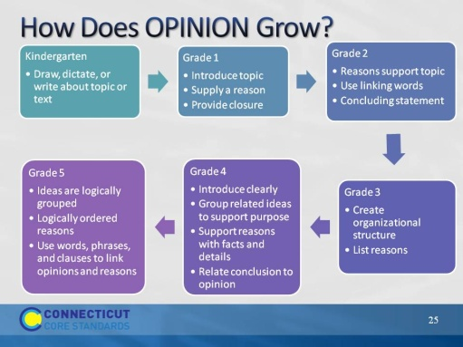Slide 25
The purpose of this slide and the next two is to reinforce the preceding conversations by looking at the patterns of writing. CC acknowledges the developmental nature of writing. Notice how 5th grade moves toward argument, which begins in Grade 6. Don’t spend a lot of time on these slides, but do point out the similarities across writing types in each grade. There is a lot of instruction that will be similar for each writing type.
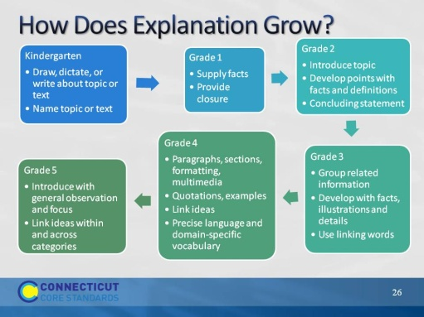Slide 26
Note that it is in grade 3 where students begin to create an organizational structure that leads the reader. This is true in all three kinds of writing. There is horizontal consistency.
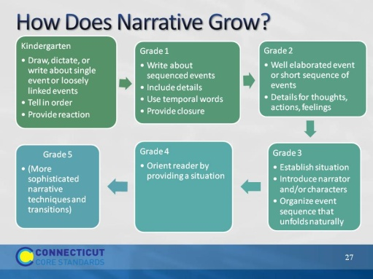Slide 27
Invite participants to comment: Why might there be no change in grade 5? What does this say about the decreased importance of narrative?
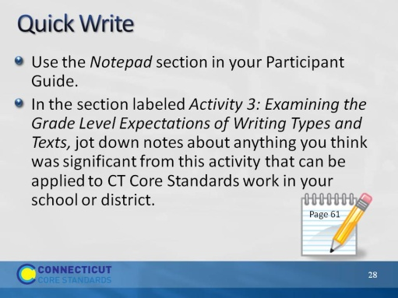Slide 28
3 minutes.

