Module 3  Facilitator Guide | Supporting All Students in Writing and Research

Activity 10

Connecticut Core Standards for English Language Arts and Literacy

Grades K–5

Systems of Professional Learning

Connecticut Core Standards Systems of Professional Learning
The material in this guide was developed by Public Consulting Group in collaboration with staff from the Connecticut State Department of Education and the RESC Alliance. The development team would like to specifically thank Ellen Cohn, Charlene Tate Nichols, and Jennifer Webb from the Connecticut State Department of Education; Leslie Abbatiello from ACES; and Robb Geier, Elizabeth O’Toole, and Cheryl Liebling from Public Consulting Group.
The Systems of Professional Learning project includes a series of professional learning experiences for Connecticut Core Standards District Coaches in English Language Arts, Mathematics, Humanities, Science, Technology, Engineering, Mathematics (STEM), and Student/Educator Support Staff (SESS).
Participants will have continued support for the implementation of the new standards through virtual networking opportunities and online resources to support the training of educators throughout the state of Connecticut.
Instrumental in the design and development of the Systems of Professional Learning materials from PCG were: Sharon DeCarlo, Debra Berlin, Jennifer McGregor, Judy Buck, Michelle Wade, Nora Kelley, Diane Stump, and Melissa Pierce.
Published 2014. Available online at http://ctcorestandards.org/

Session at-a-Glance

Part 7: Reflection and Planning (30 minutes)
Coaches will individually reflect on the elements of today’s presentation and activities. They will then meet with their school or district colleagues, or with a small group of coaches who are “solo” at today’s workshop, to develop a strategy for sharing Module 3’s key messages with colleagues.

Activity 10: Reflection (10 minutes)
Working independently, participants review their notes in the Participant Guide and the Notepad section from today’s activities and then jot down some key points they think are important.

Supporting Documents:
- Key Points Template

PowerPoint Slide:
- 82-83

Session Implementation
Part 7
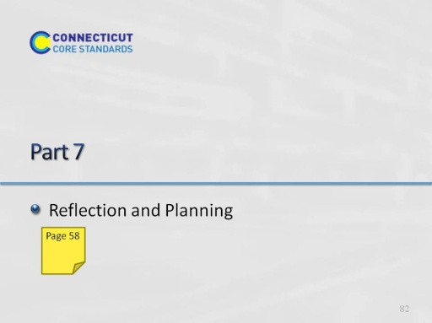Slide 82
Blank.
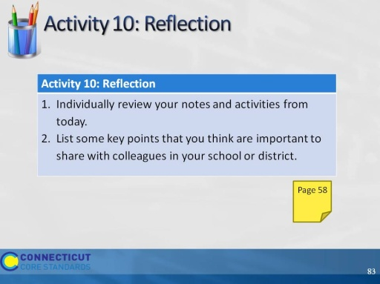Slide 83
Allow 10 minutes for this activity; adjust time as needed.

