Module 3  Facilitator Guide | Supporting All Students in Writing and Research

Activity 8

Connecticut Core Standards for English Language Arts and Literacy

Grades 6–12

Systems of Professional Learning

Connecticut Core Standards Systems of Professional Learning
The material in this guide was developed by Public Consulting Group in collaboration with staff from the Connecticut State Department of Education and the RESC Alliance. The development team would like to specifically thank Ellen Cohn, Charlene Tate Nichols, and Jennifer Webb from the Connecticut State Department of Education; Leslie Abbatiello from ACES; and Robb Geier, Elizabeth O’Toole, and Cheryl Liebling from Public Consulting Group.
The Systems of Professional Learning project includes a series of professional learning experiences for Connecticut Core Standards District Coaches in English Language Arts, Mathematics, Humanities, Science, Technology, Engineering, Mathematics (STEM), and Student/Educator Support Staff (SESS).
Participants will have continued support for the implementation of the new standards through virtual networking opportunities and online resources to support the training of educators throughout the state of Connecticut.
Instrumental in the design and development of the Systems of Professional Learning materials from PCG were: Sharon DeCarlo, Debra Berlin, Jennifer McGregor, Judy Buck, Michelle Wade, Nora Kelley, Diane Stump, and Melissa Pierce.
Published 2014. Available online at http://ctcorestandards.org/

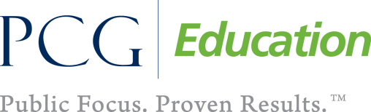 |  | 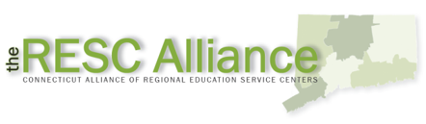

Session at-a-Glance

Part 6: Supporting Students in Writing (55 minutes)
Participants will reflect on what they have learned so far today about the writing standards and shifts and consider what kinds of support students will need in writing. They will review the concept of gradual release of responsibility and will consider the various practices they have seen today that demonstrate a gradual release.

Activity 8: Viewing a Video (10 minutes)
In Activity 8, participants will view a segment of a video lesson and analyze student writing activities, observing the ways in which students are supported. Participants will also note student supports in reading, speaking, and listening.

Video:
Teaching Channel Writing and Delivering Persuasive Speeches. https://www.teachingchannel.org/videos/teaching-persuasive-speeches

PowerPoint Slides:
- 80–88

Session Implementation
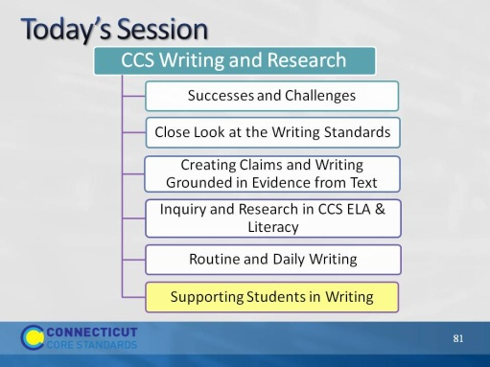Slide 80
In Module 2, we considered ways to support students in reading closely and drawing evidence from text. Because of the integrated nature of the CCS, many of those supports address writing as well as reading.

Part 6
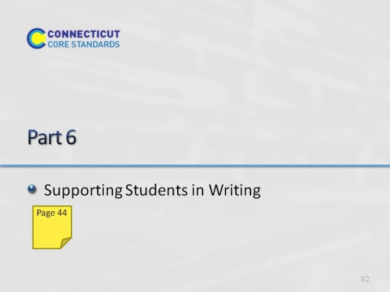Slide 81
Part 6 will take about 10 minutes.
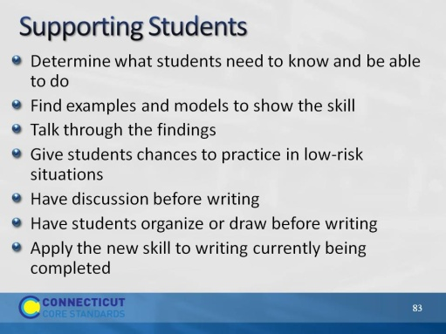Slide 82
Blank.
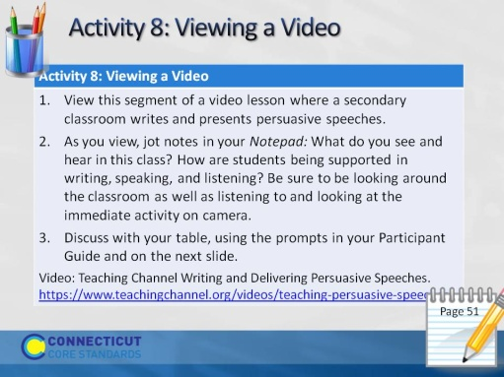Slide 83
Tell participants that they will be viewing a class writing and delivering persuasive speeches. Ask them to look for supports in reading, speaking, writing, and even listening.
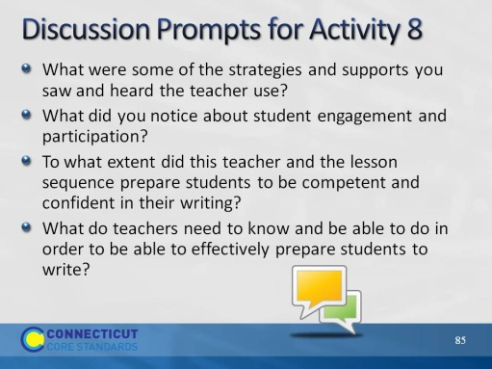Slide 84
After discussion, be sure to elicit responses from volunteers. Or, let tables know that you will be calling on someone to answer each question. The last question is particularly important for coaches.
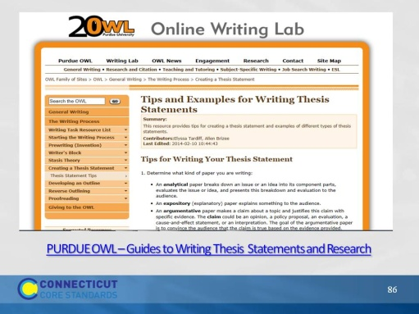Slide 85
The Online Writing Lab (OWL) at Purdue University houses writing resources and instructional material, provides a free service e-learning from the Writing Lab at Purdue (https://owl.english.purdue.edu/owl/resource/545/01/). Students, members of the community, and users worldwide can find information to assist with many writing projects. Teachers and trainers can use this material for in-class and out-of-class instruction.
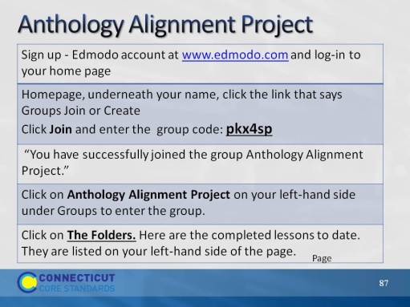Slide 86
Blank.
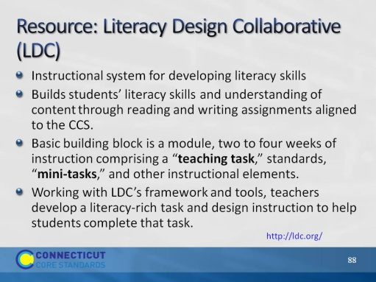Slide 87
The purpose of this slide is to briefly introduce a powerful resource. LDC is a national community of educators providing a teacher-designed and research-proven framework, online tools, and resources for creating literacy-rich assignments and courses across content areas. They have developed an entire system of templates to create instruction leading to literacy performance tasks in every discipline. These templates and tasks have recently been extended to lower grades.
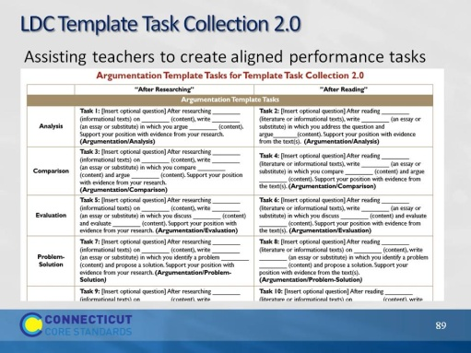Slide 88
Encourage participants to explore this website if they have not done so. There are examples of full units of study leading to these types of performance tasks. The Literacy Design Collaborative is committed to equipping middle and high school students with the literacy skills they need to succeed in their later education, their careers, and their communities, working through many different partnerships to meet that literacy challenge. Teachers should choose from these collections the templates that work best for them for any given task.
This collection aims to help teachers craft tasks that engage students in writing in response to reading. It provides template tasks for implementing the Literacy Design Collaborative (LDC) strategy by drawing directly from the language and skills articulated in each Common Core Anchor Standards. When filled in, a template task becomes a teaching task that sets up a context for teaching the specific skills and demands embedded in the standard.
All LDC template tasks are designed for tasks that involve students in writing in response to reading or research. They are clustered by the writing modes described in the CCSS: argumentative, informative/explanatory, and narrative. Teachers should choose the mode and template that best suits their instructional purpose.

