Module 3  Facilitator Guide | Supporting All Students in Writing and Research

Activity 6b

Connecticut Core Standards for English Language Arts and Literacy

Grades 6–12

Systems of Professional Learning

Connecticut Core Standards Systems of Professional Learning
The material in this guide was developed by Public Consulting Group in collaboration with staff from the Connecticut State Department of Education and the RESC Alliance. The development team would like to specifically thank Ellen Cohn, Charlene Tate Nichols, and Jennifer Webb from the Connecticut State Department of Education; Leslie Abbatiello from ACES; and Robb Geier, Elizabeth O’Toole, and Cheryl Liebling from Public Consulting Group.
The Systems of Professional Learning project includes a series of professional learning experiences for Connecticut Core Standards District Coaches in English Language Arts, Mathematics, Humanities, Science, Technology, Engineering, Mathematics (STEM), and Student/Educator Support Staff (SESS).
Participants will have continued support for the implementation of the new standards through virtual networking opportunities and online resources to support the training of educators throughout the state of Connecticut.
Instrumental in the design and development of the Systems of Professional Learning materials from PCG were: Sharon DeCarlo, Debra Berlin, Jennifer McGregor, Judy Buck, Michelle Wade, Nora Kelley, Diane Stump, and Melissa Pierce.
Published 2014. Available online at http://ctcorestandards.org/

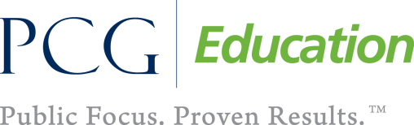 |  | 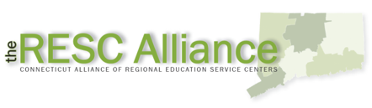

Session at-a-Glance

Activity 6b: Reviewing the Unit ‒ Hosted Gallery Walk (50 minutes)
Participants will review CCS exemplar units to see how research is developed. Each group will create a poster to describe their unit and participate in a Hosted Gallery Walk to view the posters.

Supporting Documents
- Exemplar Units (Downloaded onto laptop or other internet connected device). Available from the EngageNY, Common Core Curriculum & Assessments, Common Core Curriculum, English Language Arts website: http://www.engageny.org/english-language-arts
- Grade 6: Module 4 Unit 1: Read for Research and Writing an Argument http://www.engageny.org/resource/grade-6-ela-module-4
- Grade 7: Module 4B: Water is Life http://www.engageny.org/resource/grade-7-ela-curriculum-map
- Grade 8: Module 4: Sustainability of World’s Food http://www.engageny.org/resource/grade-8-english-language-arts
- Grade 9 Unit 4: Analyzing Text to Write Arguments http://www.engageny.org/sites/default/files/resource/attachments/9.4.pdf
- Grade 9-10: Researching to Deepen Understanding: Music http://www.engageny.org/resource/grades-9-10-ela-researching-to-deepen-understanding-unit-music
- Grade 11-12: Researching to Deepen Understanding: Design http://www.engageny.org/resource/grades-11-12-ela-researching-to-deepen-understanding-unit-design
- Odell Education. Student Research Plan. Available from http://odelleducation.com/wp-content/uploads/2013/09/Student-Research-Plan.pdf
- Odell Education. Developing Core Proficiencies Curriculum: Unit 3: Researching to Deepen Understanding. Available from http://odelleducation.com/literacy-curriculum/research
- “Developing Research” Organizer
- Hosted Gallery Walk Protocol adapted from Expeditionary Learning. www.engageny.org/.../attachments/hosted_gallery_walk_protocol.doc

PowerPoint Slides:
- 67-69

Session Implementation
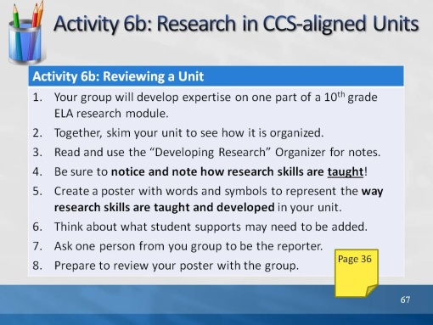Slide 67
The review of the units and the whole group activity are allotted 45 minutes. Allow 20 minutes to review the units, another 10 to create the poster, and 15 for the group sharing. Exemplar Units:
Grade 10 ELA Module 3 http://www.engageny.org Researching Multiple Perspectives to Develop a Position
Student Research Plan Protocol, Odell Education http://odelleducation.com/literacy-curriculum/research
Researching to Deepen Understanding: Developing Core Proficiencies, Research Framework Odell Education http://odelleducation.com/literacy-curriculum/research
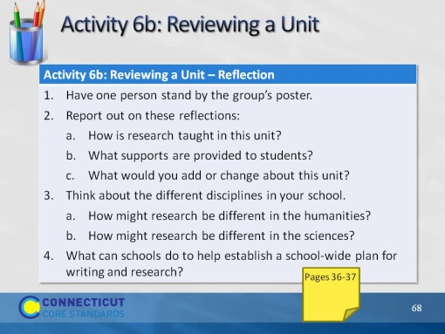Slide 68
Facilitate each group presenting their finding and discussing these questions:
- Report out on these reflections:
  - How is research taught in this unit?
  - What supports are provided to students?
  - What would you add or change about this unit?
- Think about the different disciplines in your school.
  - How might research be different in the humanities?
  - How might research be different in the sciences?
What can schools do to help establish a school-wide plan for writing and research?
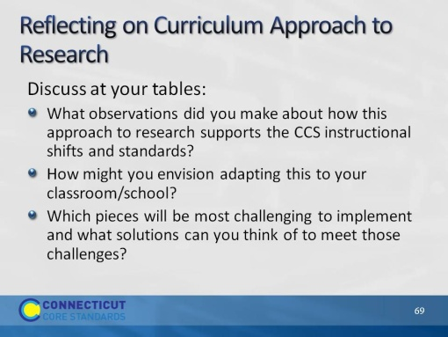Slide 69
Have participants debrief what they learned from this activity as well as discuss the questions above.

