Module 3  Facilitator Guide | Supporting All Students in Writing and Research

Activity 6a

Connecticut Core Standards for English Language Arts and Literacy

Grades 6–12

Systems of Professional Learning

Connecticut Core Standards Systems of Professional Learning
The material in this guide was developed by Public Consulting Group in collaboration with staff from the Connecticut State Department of Education and the RESC Alliance. The development team would like to specifically thank Ellen Cohn, Charlene Tate Nichols, and Jennifer Webb from the Connecticut State Department of Education; Leslie Abbatiello from ACES; and Robb Geier, Elizabeth O’Toole, and Cheryl Liebling from Public Consulting Group.
The Systems of Professional Learning project includes a series of professional learning experiences for Connecticut Core Standards District Coaches in English Language Arts, Mathematics, Humanities, Science, Technology, Engineering, Mathematics (STEM), and Student/Educator Support Staff (SESS).
Participants will have continued support for the implementation of the new standards through virtual networking opportunities and online resources to support the training of educators throughout the state of Connecticut.
Instrumental in the design and development of the Systems of Professional Learning materials from PCG were: Sharon DeCarlo, Debra Berlin, Jennifer McGregor, Judy Buck, Michelle Wade, Nora Kelley, Diane Stump, and Melissa Pierce.
Published 2014. Available online at http://ctcorestandards.org/

Session at-a-Glance

Part 4: Inquiry and Research in CCS-ELA & Literacy (60 minutes)
Participants will review the vertical progression of standards related to research. In groups, they will review several CCS exemplar units to see how research is developed. Each group will create a poster to describe their unit. Participants will participate in a hosted gallery walk to view the posters.

Activity 6a: Reviewing a Research Framework (10 minutes)
Participants review the “Teacher Research Unit Guide” with a partner. The guide can be found in the Appendix of the Participant Guide.

Supporting Documents
- Odell Education. “Teacher Research Unit Guide.” Retrieved from http://www.engageny.org/resource/developing-core-proficiencies-program-units-in-ela-literacy

PowerPoint Slide:
- 59-66

Session Implementation
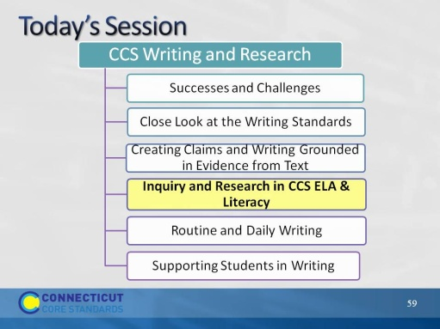Slide 59
One group of writing standards is focused on research skills. However the CCS are explicit in pointing out that research is integrated throughout the standards.
Part 4
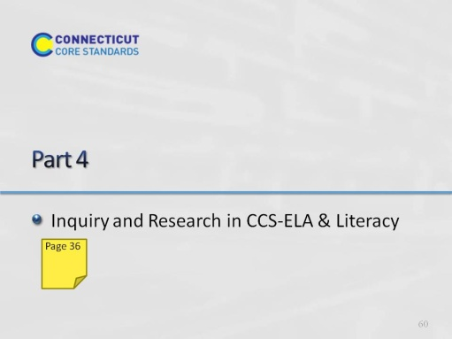Slide 60
Part 4 is allotted 60 minutes.
In this section, we’ll look at the standards related to research and technology, and think about the demands of these standards. One of the best ways to do this is to look at units that have been developed by teachers and writers who have worked closely with the authors of the CCS.
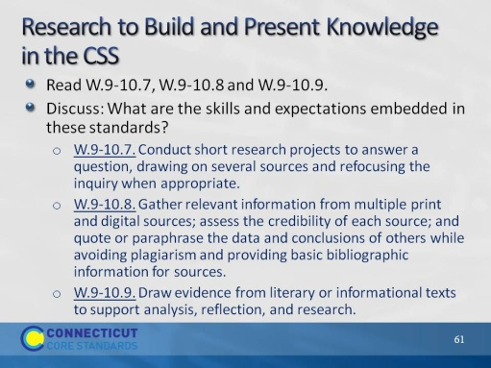Slide 61
The purpose of this slide is to show the writing standards that focus on research skills.
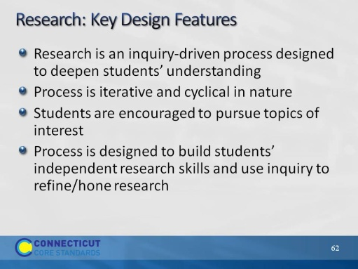Slide 62
Review the design features of research.
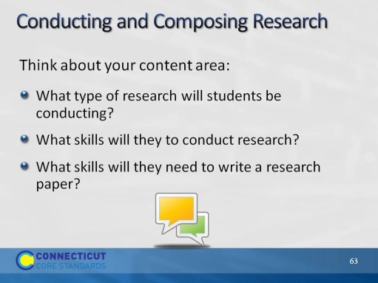Slide 63
Use this as a whole group discussion. You may choose to have 2 recorders from the audience stand at chart paper (one chart paper for Conduct and one for Writing).
Generate lists of ideas on the skills students will need to both conduct and write research.
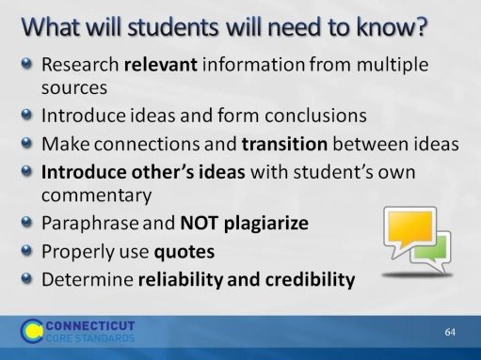Slide 64
Compare this list of possible skills with the one generated from the participants. Skills like these can best be developed over time; however, how well students are taught a research process and how often they produce research with feedback will help students to master the research process. Models of well-written research and collaboration can assist this process.
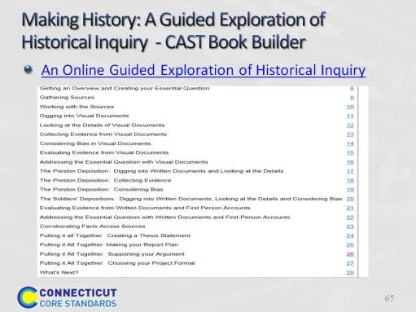Slide 65
This online book models the process of historical inquiry by stepping students through a sample inquiry. Students find the model inquiry and coaching support for creating their own inquiry. Teachers find tips, techniques, and resources.
Found on CAST Book Builder, the hyperlink is embedded in the slide.
If there is time to explore this source, the pages can be forwarded at the very bottom of the right side of the screen.
This book has text-to-speech functions as well as modeling and coaching of the inquiry process.
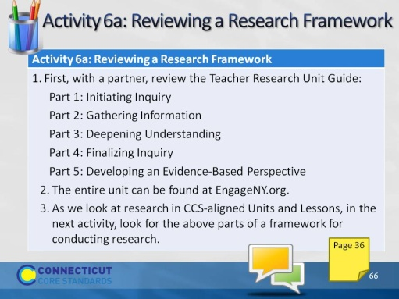Slide 66
Participants review the Teacher Research Unit Guide from EngageNY.org.

