Module 3  Facilitator Guide | Supporting All Students in Writing and Research

Activity 5c
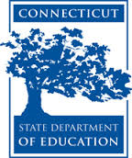

Connecticut Core Standards for English Language Arts and Literacy

Grades 6–12

Systems of Professional Learning

Connecticut Core Standards Systems of Professional Learning
The material in this guide was developed by Public Consulting Group in collaboration with staff from the Connecticut State Department of Education and the RESC Alliance. The development team would like to specifically thank Ellen Cohn, Charlene Tate Nichols, and Jennifer Webb from the Connecticut State Department of Education; Leslie Abbatiello from ACES; and Robb Geier, Elizabeth O’Toole, and Cheryl Liebling from Public Consulting Group.
The Systems of Professional Learning project includes a series of professional learning experiences for Connecticut Core Standards District Coaches in English Language Arts, Mathematics, Humanities, Science, Technology, Engineering, Mathematics (STEM), and Student/Educator Support Staff (SESS).
Participants will have continued support for the implementation of the new standards through virtual networking opportunities and online resources to support the training of educators throughout the state of Connecticut.
Instrumental in the design and development of the Systems of Professional Learning materials from PCG were: Sharon DeCarlo, Debra Berlin, Jennifer McGregor, Judy Buck, Michelle Wade, Nora Kelley, Diane Stump, and Melissa Pierce.
Published 2014. Available online at http://ctcorestandards.org/

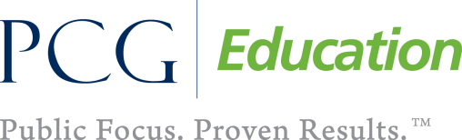 |  | 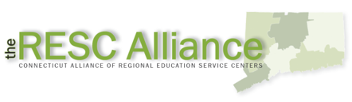

Session at-a-Glance

Activity 5c: Finding Evidence to Support an Argument ‒ Looking at Student Work (10 minutes)
Participants review samples of student writing generated from the lesson in the video Developing Evidence-based Arguments and will discuss the effect of instructional activities on the writing.

Supporting Documents:
- Student work samples from Developing Evidence-based Arguments, http://commoncore.americaachieves.org/module/1

PowerPoint Slide:
- 57

Session Implementation
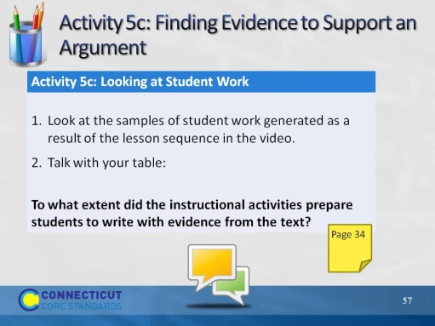Slide 57
Blank.

