Module 3  Facilitator Guide | Supporting All Students in Writing and Research

Activity 5b

Connecticut Core Standards for English Language Arts and Literacy

Grades 6–12

Systems of Professional Learning

Connecticut Core Standards Systems of Professional Learning
The material in this guide was developed by Public Consulting Group in collaboration with staff from the Connecticut State Department of Education and the RESC Alliance. The development team would like to specifically thank Ellen Cohn, Charlene Tate Nichols, and Jennifer Webb from the Connecticut State Department of Education; Leslie Abbatiello from ACES; and Robb Geier, Elizabeth O’Toole, and Cheryl Liebling from Public Consulting Group.
The Systems of Professional Learning project includes a series of professional learning experiences for Connecticut Core Standards District Coaches in English Language Arts, Mathematics, Humanities, Science, Technology, Engineering, Mathematics (STEM), and Student/Educator Support Staff (SESS).
Participants will have continued support for the implementation of the new standards through virtual networking opportunities and online resources to support the training of educators throughout the state of Connecticut.
Instrumental in the design and development of the Systems of Professional Learning materials from PCG were: Sharon DeCarlo, Debra Berlin, Jennifer McGregor, Judy Buck, Michelle Wade, Nora Kelley, Diane Stump, and Melissa Pierce.
Published 2014. Available online at http://ctcorestandards.org/

Session at-a-Glance

Activity 5b: Finding Evidence to Support an Argument ‒ Viewing a Video (10 minutes)
Participants review the Odell Evidence-Based Argument Criteria Checklist 6‒12 (found in the Appendix at the end of the Participant Guide) and will then view the video Developing Evidence-based Arguments and consider how students were supported in developing and supporting arguments and finding evidence, and the role of discussion in crafting arguments and gathering evidence. Participants will then discuss the effect of instructional activities on student writing generated by the lesson.

Supporting Documents:
- Odell Evidence-Based Argument Criteria Checklist 6‒12
Video
- Developing Evidence-based Arguments, 9th grade history class. Retrieved from America Achieves (sign-in required) http://commoncore.americaachieves.org/module/1

PowerPoint Slides:
- 51-56

Session Implementation
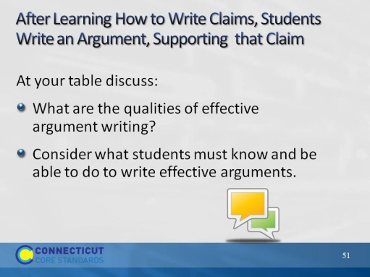Slide 51
Once a claim has been made and the evidence has been gathered, the next step is to teach students how to provide this information in a structured, cohesive, and compelling essay. Have participants discuss the qualities of an effective written argument and the skills students need.
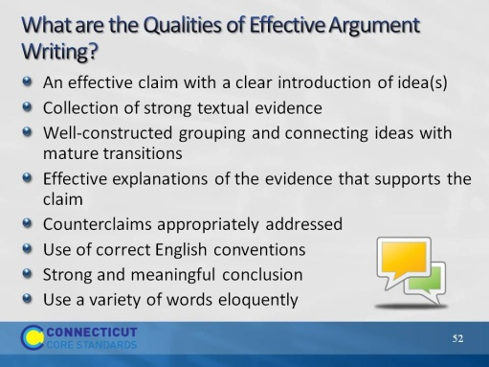Slide 52
These are just some of the qualities needed for effective argument writing. Have participants compare this list to what they considered in their discussions.
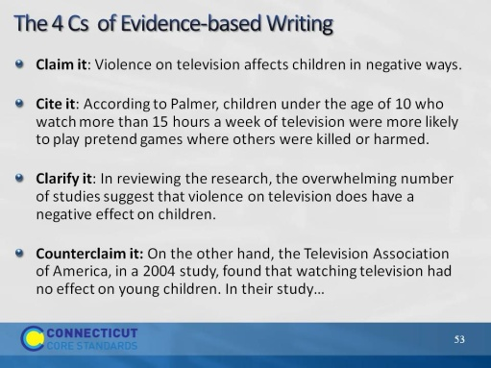Slide 53
The 4Cs (counterclaim may be optional in younger grades) is one way for teacher’s to gain evidence of learning. It is a simply formula to use initially as students unwrap the pieces of making claims and creating arguments. This can be used as an initial introduction to this process or as a ”ticket out the door” activity wherein teachers can assess if students are able to produce a rudimentary beginning of argumentative writing. This can be used for explanation as well as argument. The difference is, in explanation, we start with the premise that the claim is true, not arguable, and that we are just going to explain it. Teachers could use the terminology Explain/Cite/Clarify.
Note: The information in these next 2 pieces are fictional so no citing from sources for its content was necessary.
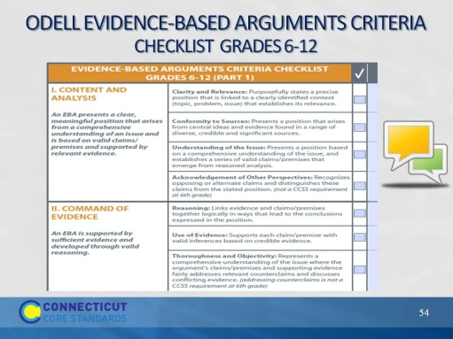Slide 54
Have participant’s open to the Odell Education’s Evidence-based Argument Criteria Checklist in the Appendix of their Participant Guide.
Have participants review each section with a partner. Partners discuss how this tool can help support argument writing.
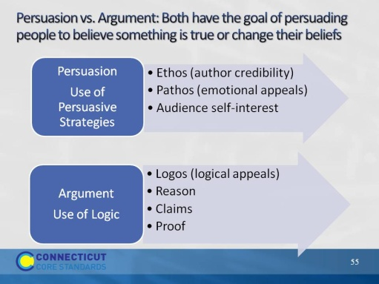Slide 55
This is an important distinction for students to understand. Students will conduct both types of writing and there is a fine but important distinction between logical argument and persuasive writing, even though persuasion is the goal of each. The distinction lies in the appeal each makes: Persuasion may rely on persuasive techniques such as appealing to self interest or emotion. Argument, on the other hand, always relies on a logical case that persuades by convincing the reader of the merits of the claims and proofs.
For instance, when asked to write a short paper “persuading a parent” to do something, we have all seen instances when one or more students will resort to flattery, bargaining, even pleading–which may in fact be very persuasive at home, but certainly does not represent progress toward‒or understanding of‒the ability to write a reasoned, logical argument that is required to be college and career ready.
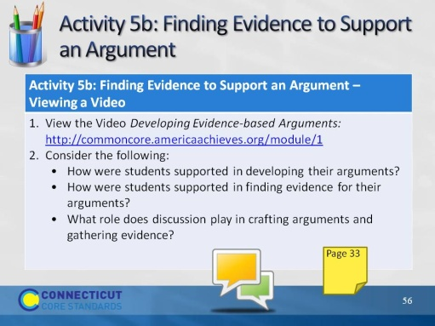Slide 56
Blank.

