Module 3  Facilitator Guide | Supporting All Students in Writing and Research

Activity 5a

Connecticut Core Standards for English Language Arts and Literacy

Grades 6–12

Systems of Professional Learning

Connecticut Core Standards Systems of Professional Learning
The material in this guide was developed by Public Consulting Group in collaboration with staff from the Connecticut State Department of Education and the RESC Alliance. The development team would like to specifically thank Ellen Cohn, Charlene Tate Nichols, and Jennifer Webb from the Connecticut State Department of Education; Leslie Abbatiello from ACES; and Robb Geier, Elizabeth O’Toole, and Cheryl Liebling from Public Consulting Group.
The Systems of Professional Learning project includes a series of professional learning experiences for Connecticut Core Standards District Coaches in English Language Arts, Mathematics, Humanities, Science, Technology, Engineering, Mathematics (STEM), and Student/Educator Support Staff (SESS).
Participants will have continued support for the implementation of the new standards through virtual networking opportunities and online resources to support the training of educators throughout the state of Connecticut.
Instrumental in the design and development of the Systems of Professional Learning materials from PCG were: Sharon DeCarlo, Debra Berlin, Jennifer McGregor, Judy Buck, Michelle Wade, Nora Kelley, Diane Stump, and Melissa Pierce.
Published 2014. Available online at http://ctcorestandards.org/

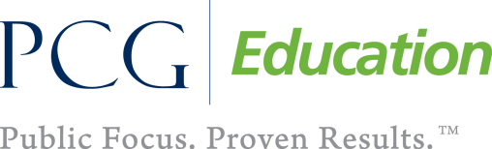

Session at-a-Glance

Activity 5a: Writing Claims ‒ Viewing a Video and Having a Written Conversation (30 minutes)
Participants watch a video lesson on developing a claim in a middle school classroom. They have a “Written Conversation,” following directions in the Participant Guide.

Supporting Documents:
- Written Conversation, adapted from Expeditionary Learning. “Written conversation protocol,” from “Teaching Practices and Protocols,” Grades 3-5 ELA Curriculum: Appendix 1 http://www.engageny.org/resource/grades-3-5-ela-curriculum-appendix-1-teaching-practices-and-protocols
- Written Conversation Notes Sheet
- Odell Forming a Claim, Making a Claim, Organizing a Claim and Writing a Claim Protocols
Video:
- Developing a Claim Using Two Informational Texts. Retrieved from http://www.engageny.org/resource/common-core-instruction-developing-a-claim-using-two-informational-texts

PowerPoint Slides:
- 45-50

Session Implementation
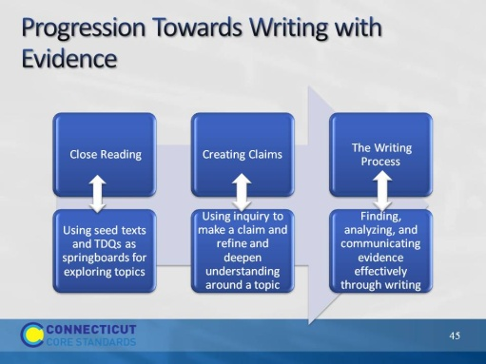Slide 45
This illustrates a progression of writing with evidence. In Module 2, we looked at close reading and text dependent questions. This is the springboard to being able to write from sources. After close reading, students now must learn to make claims and finally they must seek evidence for those claims and communicate effectively through writing.
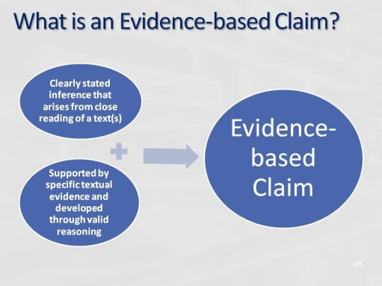Slide 46
Making evidence-based claims about texts is a core literacy and critical thinking proficiency that lies at the heart of the CCSS standards and shifts. The skill consists of two parts:
- The ability to extract detailed information from texts and grasp how it is conveyed and connected across multiple texts. This requires real exposure to new information from a variety of media. Instruction should push students beyond general thematic understanding of texts into deep engagement with textual content and authorial craft.
- The ability to make valid claims about the new information. This involves developing the capacity to analyze texts, connecting information in literal, inferential, and sometimes novel ways. Instruction should lead students to do more than simply restate the information they take in through close reading. Students should come to see themselves as creators of meaning as they engage with texts. It is essential that students understand the importance and purpose of making evidence-based claims, which are at the center of many fields of study and productive college and career experience.
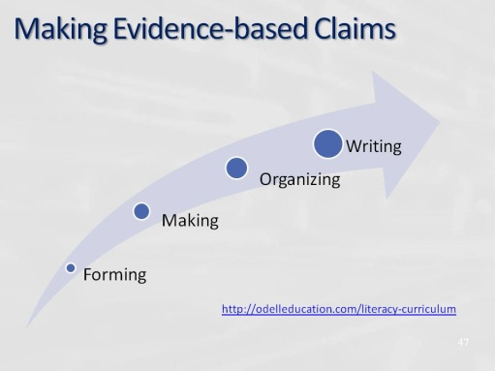Slide 47
This illustrates Odell Education’s process from asking claims

It comes from Unit 2 of the curriculum below. This curriculum is comprised of a series of four units at each grade level that provide direct instruction on a set of literacy proficiencies at the heart of the Common Core State Standards.
Unit 1: Reading Closely for Textual Details
Unit 2: Making Evidence-Based Claims
Unit 3: Researching to Deepen Understanding
Unit 4: Building Evidence-Based Arguments
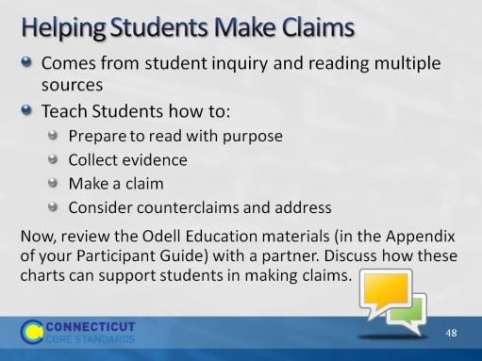Slide 48
Have participants turn to the Appendix (p. 53) in the Participant Guide. Here they will find charts from Odell Education that demonstrate the 4 parts of Creating Claims: Making a Claim, Organizing a Claim, Writing a Claim, and Reviewing a Claim. Have partners discuss how these can be used and how they can support students.
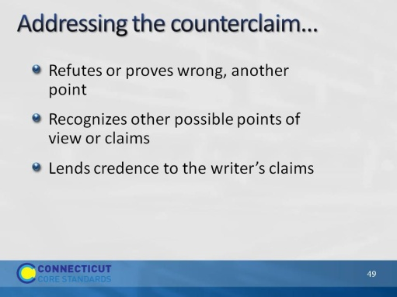Slide 49
Blank.
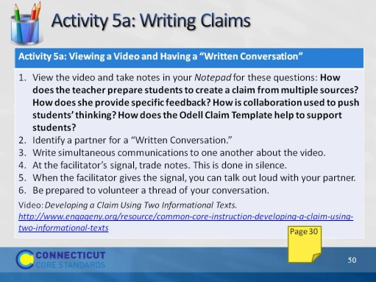Slide 50
This activity will take about 45 minutes.

Direct participants to the appropriate pages in their Participant Guide. Have them briefly review the directions for the activity. Lead participants to the discussion prompts on page 50 in their Notepad.
- How does the teacher prepare students to create a claim from multiple sources?
- How does the teacher provide specific feedback?
- How is collaboration used to push students’ thinking?
- How does the Odell Claim Template help to support students?

After the video, be certain that each participant has a partner. If there are odd numbers, there can be a trio. Be sure to watch the time and signal when partners should trade. After partners have had an opportunity to speak aloud, be sure to ask them why or how Written Conversation would be an effective strategy to use as a discussion protocol with students.

