Module 3  Facilitator Guide | Supporting All Students in Writing and Research

Activity 3

Connecticut Core Standards for English Language Arts and Literacy

Grades 6–12

Systems of Professional Learning

Connecticut Core Standards Systems of Professional Learning
The material in this guide was developed by Public Consulting Group in collaboration with staff from the Connecticut State Department of Education and the RESC Alliance. The development team would like to specifically thank Ellen Cohn, Charlene Tate Nichols, and Jennifer Webb from the Connecticut State Department of Education; Leslie Abbatiello from ACES; and Robb Geier, Elizabeth O’Toole, and Cheryl Liebling from Public Consulting Group.
The Systems of Professional Learning project includes a series of professional learning experiences for Connecticut Core Standards District Coaches in English Language Arts, Mathematics, Humanities, Science, Technology, Engineering, Mathematics (STEM), and Student/Educator Support Staff (SESS).
Participants will have continued support for the implementation of the new standards through virtual networking opportunities and online resources to support the training of educators throughout the state of Connecticut.
Instrumental in the design and development of the Systems of Professional Learning materials from PCG were: Sharon DeCarlo, Debra Berlin, Jennifer McGregor, Judy Buck, Michelle Wade, Nora Kelley, Diane Stump, and Melissa Pierce.
Published 2014. Available online at http://ctcorestandards.org/

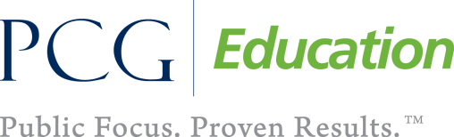 |  | 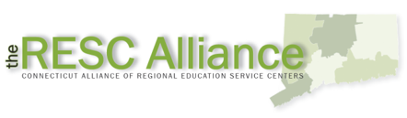

Session at-a-Glance

Activity 3: Examining the Grade Level Demands of the Writing Standards (30 minutes)
Participants examine the differences in grade level expectations of the CCS Writing Standards for Opinion/Argument, Informative/Explanatory, or Narrative writing, by looking at a progression of On-Demand student writing from the In Common collection and annotating with the language of the standards.

Supporting Documents:
- “Learning by Example – PD Activity” from Achieve the Core. Retrieved from http://achievethecore.org/page/507/in-common-effective-writing-for-all-students
- Vertical Progression of the CCS-ELA & Literacy Writing Standards
- Student writing samples from the Collection of All In Common Writing Samples, K-12 (separate handouts) http://achievethecore.org/page/507/in-common-ee-writing-for-all-students

PowerPoint Slides:
- 21-25

Session Implementation
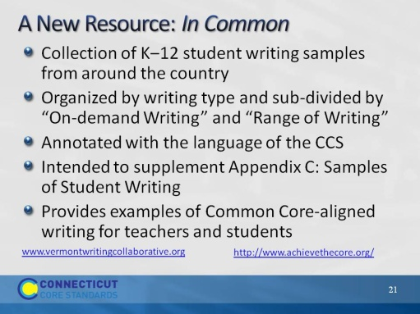Slide 21
Slides 21-25, which include Activity 3, will take about 30 minutes.
The purpose of the next two slides is to introduce In Common as a resource. Most participants will have heard of In Common but may not have had an opportunity to explore it.

There are two types of writing in In Common. “On-demand Writing,” written to a common prompt and illustrates developmental spectrum. “Range of writing,” illustrates examples of writing for different tasks, audiences, and purposes over different time frames.
Created by Vermont Writing Collaborative and Student Achievement Partners.
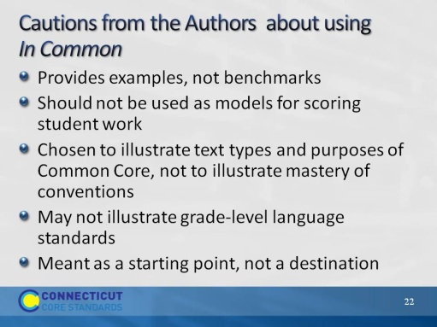Slide 22
The authors make it clear that these are authentic writing samples to be used for a variety of purposes, but they are not intended to be models. They were intended to supplement Appendix C, which was not sufficient for its intended purpose. This is an ongoing project.
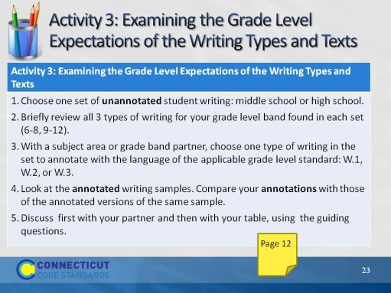Slide 23
Approximately 25 minutes for this activity and discussion that follows.
Have secondary participants choose a writing sample from the type and grade level that they would most likely support.
Have them find a teacher who has chosen the same writing type (argument, explanatory, or narrative) and the same grade level sample.
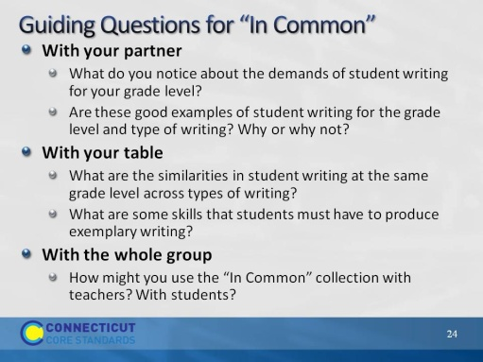Slide 24
Blank.
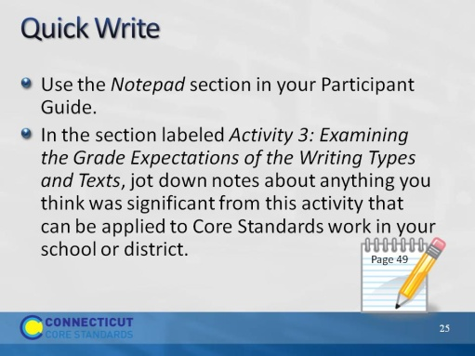Slide 25
3 minutes.

