Module 3  Facilitator Guide | Supporting All Students in Writing and Research

Activity 2

Connecticut Core Standards for English Language Arts and Literacy

Grades 6–12

Systems of Professional Learning

Connecticut Core Standards Systems of Professional Learning
The material in this guide was developed by Public Consulting Group in collaboration with staff from the Connecticut State Department of Education and the RESC Alliance. The development team would like to specifically thank Ellen Cohn, Charlene Tate Nichols, and Jennifer Webb from the Connecticut State Department of Education; Leslie Abbatiello from ACES; and Robb Geier, Elizabeth O’Toole, and Cheryl Liebling from Public Consulting Group.
The Systems of Professional Learning project includes a series of professional learning experiences for Connecticut Core Standards District Coaches in English Language Arts, Mathematics, Humanities, Science, Technology, Engineering, Mathematics (STEM), and Student/Educator Support Staff (SESS).
Participants will have continued support for the implementation of the new standards through virtual networking opportunities and online resources to support the training of educators throughout the state of Connecticut.
Instrumental in the design and development of the Systems of Professional Learning materials from PCG were: Sharon DeCarlo, Debra Berlin, Jennifer McGregor, Judy Buck, Michelle Wade, Nora Kelley, Diane Stump, and Melissa Pierce.
Published 2014. Available online at http://ctcorestandards.org/

Session at-a-Glance

Part 2: A Close Look at the Writing Standards (65 minutes)
After reviewing the organization of the CCS-ELA & Literacy Writing Standards, coaches will read and debrief an excerpt from Common Core State Standards ELA & Literacy Appendix A, which includes a definition of the three text types and the special place of argument in the standards. Participants will then be introduced to the extensive collection of student writing in, “In Common: Effective Writing for all Students.” They will examine the differences in grade level expectations of the writing standards for Opinion/Argument, Explanation, and Narrative, by looking at and annotating a progression of On-Demand student writing from the collection.

Activity 2: Types of Writing in the CCS-ELA & Literacy (30 minutes)
Working in teams of 4, each participant reads about one type of writing from Appendix A of the CCSS document (these pages are located in the Appendix of the Participant Guide). Teams discuss, using a Text-rendering Protocol, and synthesize the information by answering questions provided in the participant guide.

Supporting Documents:
- Excerpt (pp. 23-25) from CCSSO & NGA. (2010). Common Core State Standards for English Language Arts & Literacy in History/Social Studies, Science, and Technical Subjects. Washington, DC. http://www.corestandards.org/assets/Appendix_A.pdf
- Directions for Text-rendering Protocol

PowerPoint Slides:
- 11-20

Session Implementation
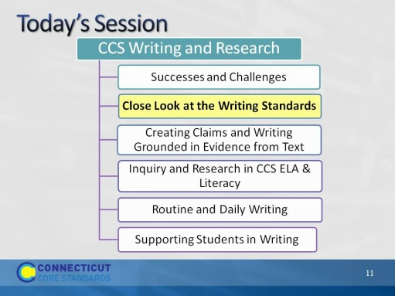Slide 11
The purpose of the morning is to look closely at parts of effective units and lessons that align with the CCS-ELA & Literacy.
Part 2
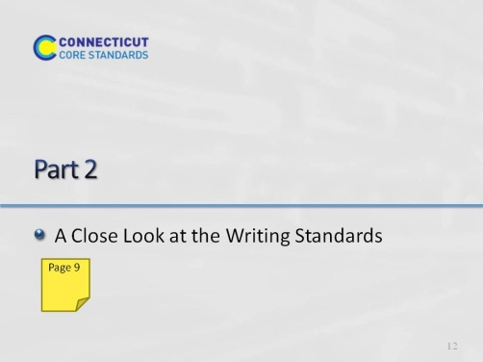Slide 12
65 minutes for all of Part 2, including Activities 2 and 3. Introductory slides should take no more than 5 minutes, leaving 1 hour for the remaining activities.
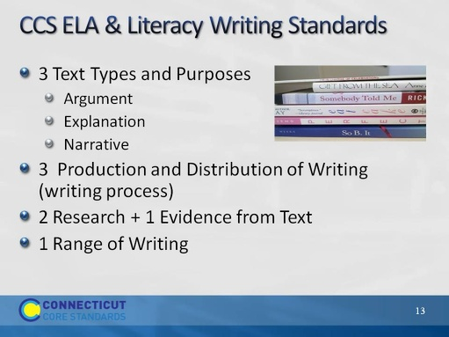Slide 13
Review the types of writing standards.
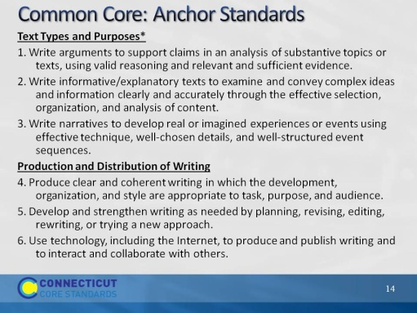Slide 14
These are the standards in greater depth. These match to individual grade-level standards, but the grade-level standards differentiate in qualities: for example, Grade 6 transitions to clarify relationships, but grade 7 adds to create cohesion.
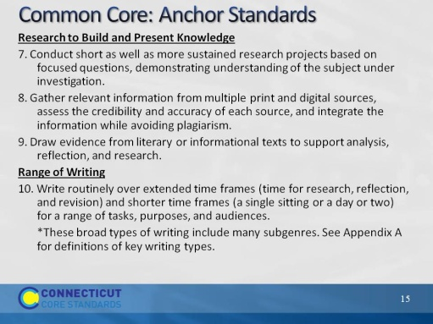Slide 15
Same as previous slide.
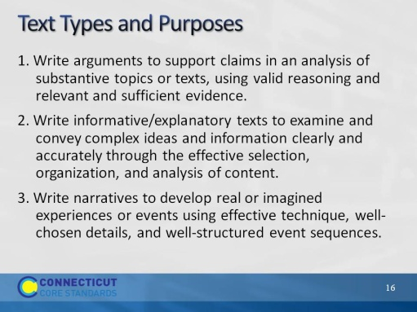Slide 16
Blank.
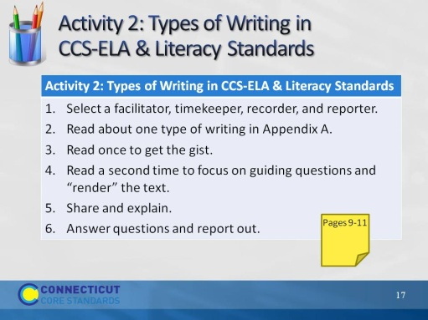Slide 17
Activity 2 will take 30 minutes.
For this activity, group participants in 4’s in any way that works for the groups you have. It’s OK for them to stay with their district if that works out. If there are an odd number, it is better to have a group of 3 than a 5. Direct them to the page in their Participant Guide, then briefly explain on the next slide. They will definitely need their Participant Guide for this.
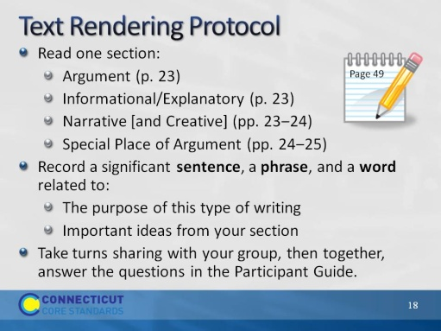Slide 18
Remind participants that full directions, including the questions to answer, are in the Participant Guide.
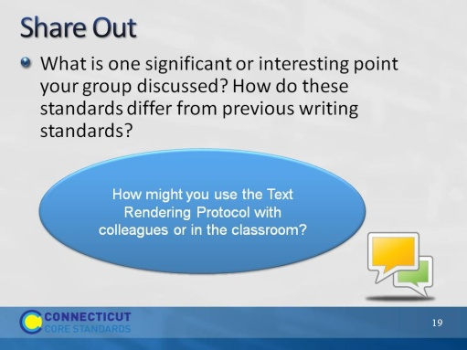Slide 19
Blank.
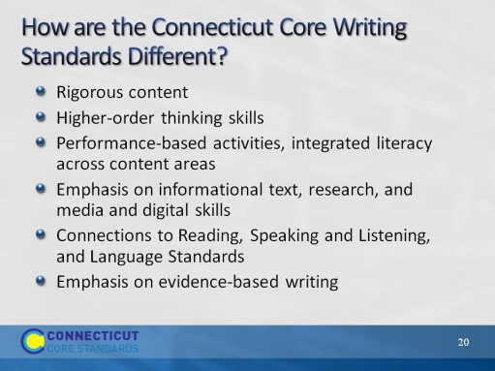Slide 20
Blank.

