Module 2  Facilitator Guide | Focus on Content Standards

Section 3

Connecticut Core Standards for Mathematics

Grades K–5

Systems of Professional Learning

Connecticut Core Standards Systems of Professional Learning
The material in this guide was developed by Public Consulting Group in collaboration with staff from the Connecticut State Department of Education and the RESC Alliance. The development team would like to specifically thank Ellen Cohn, Charlene Tate Nichols, and Jennifer Webb from the Connecticut State Department of Education; Leslie Abbatiello from ACES; and Robb Geier, Elizabeth O’Toole, and Cheryl Liebling from Public Consulting Group.
The Systems of Professional Learning project includes a series of professional learning experiences for Connecticut Core Standards District Coaches in English Language Arts, Mathematics, Humanities, Science, Technology, Engineering, Mathematics (STEM), and Student/Educator Support Staff (SESS).
Participants will have continued support for the implementation of the new standards through virtual networking opportunities and online resources to support the training of educators throughout the state of Connecticut.
Instrumental in the design and development of the Systems of Professional Learning materials from PCG were: Sharon DeCarlo, Debra Berlin, Jennifer McGregor, Judy Buck, Michelle Wade, Nora Kelley, Diane Stump, and Melissa Pierce.

Published 2014. Available online at http://ctcorestandards.org/
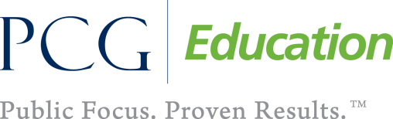

Session at-a-Glance

Section 3: The Progression of the Content Standards (80 minutes)

Training Objectives:
- To provide participants with information on and experience with identifying standards that address conceptual understanding, procedural skill and fluency, and application of mathematics.
- To have participants experience how concepts are developed within and across grade levels.
- To provide participants practice with identifying concept progressions.
- To provide participants with an understanding of how standards within a grade level can be grouped, or are “connected” across content domains.
- To provide participants practice with connecting standards.
The definitions of “conceptual understanding,” “fluency,” and “application” developed in the previous section are used to help participants analyze the content standards in three different ways.
In Exploring the Standards Part 1, participants explore the content standards for one domain, at one grade level, and determine which standards focus on conceptual understanding, procedural skill and fluency, and application of mathematics.
In Exploring the Standards Part 2, participants explore the content standards for one domain across grade levels and record five general observations about the progression of the concepts and two connections to the practice standards.
In Exploring the Standards Part 3, participants explore all of the domains for one grade level to “connect” standards across multiple domains that can be taught together in a lesson or unit.
Participants will then discuss and reflect as a large group on the importance and instructional implications of the progressions and any new insights they now have into the standards.
The activity will conclude with having participants view the video Gathering Momentum for Algebra in order to see where the K–5 content progressions impact the larger K–12 learning pathway.
For more information about this activity, please refer to page 10 of this Facilitator Guide.

Supporting Documents:
- Standards for Mathematical Practice (Participants will bring a copy or access online.)
- Exploring the Content Standards Observation Sheet

Materials:
- Chart paper, markers
- Sets of Standard Progression Cards (one set per five table groups)
Signs made for tables: K, 1, 2, 3, 4, and 5
Video:
- Gathering Momentum for Algebra
http://www.youtube.com/watch?v=ONPADo_Nt14

PowerPoint Slides:
- 30–40

Session Implementation
Section 3
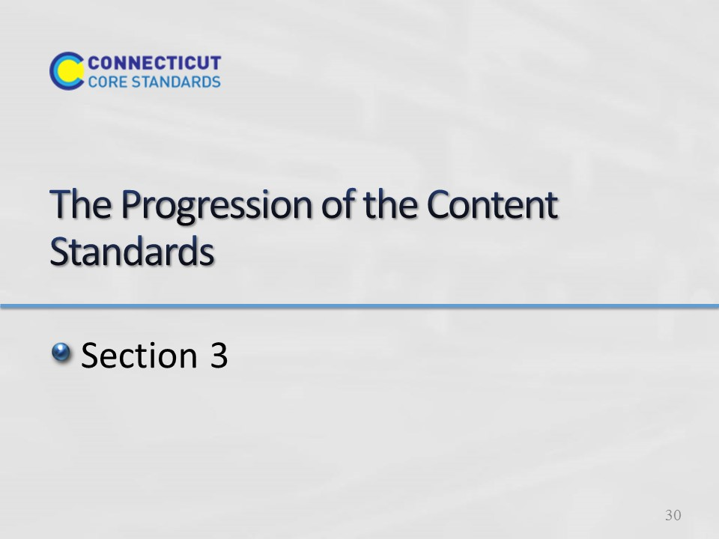
Slide 30
Section 3: The Progressions of the Content Standards
Section 3 Time: 80 minutes
Section 3 Training Objectives:
- To provide participants with information on and experience with identifying standards that address conceptual understanding, procedural skill and fluency, and application of mathematics.
- To have participants experience how concepts are developed within and across grade levels.
- To provide participants practice with identifying concept progressions.
- To provide participants with an understanding of how connections between standards across multiple domains can be made to support the deepening of mathematical understanding.
Section 3 Outline:
- The definitions of “conceptual understanding”, “fluency”, and “application” developed in the previous session are used to help participants analyze the content standards in three different ways. In Exploring the Standards Part 1 participants explore the content standards for one domain, at one grade level, and determine which standards focus on developing conceptual understanding, procedural skill and fluency, and application of mathematics.
- In Exploring the Standards Part 2, participants explore the content standards for one domain across grade levels and record five general observations about the progression of the concepts and two connections to the Practice Standards.
- In Exploring the Standards Part 3, participants explore all of the domains for one grade level to identify connections across domains that can be referenced in a lesson or unit in order to support the deepening of mathematical understanding.
- Participants will then discuss and reflect as a large group on the importance and instructional implications of the progressions and any new insights they now have into the standards.
- The activity will conclude with having participants view the video Gathering Momentum for Algebra in order to see where the K-5 content progressions impact the larger K-12 learning pathway.
Supporting Documents:
Standards for Mathematical Practice (participants should have their own copy or access them online)
Exploring the Content Standards Observations Sheet
Materials
Chart paper, markers
Sets of Standards Progression Cards (one color per domain) (1 full domain color set per table group)
Signs made for tables: K, 1, 2, 3, 4, 5
Video
Gathering Momentum for Algebra
Notes: In this activity you will have full sets of content standards with one standard per card. You begin by giving a table one grade level set that has all of the domains for that grade level and with that set they complete part 1. Then ask participants to give all of a particular domain to one table, so one table will have all of the Number and Operations – Fractions standards, one table will have all of the Geometry standards, etc. With that domain they complete part 2. Then, have participants separate the domain by grade level again and give each table the full grade level set again so that they can complete part 3. While participants should have a full set of print-based standards, having them work with the standards in this card format allows them to physically manipulate the standards and create connects and see the progressions side-by-side rather than having to flip through multiple pages.
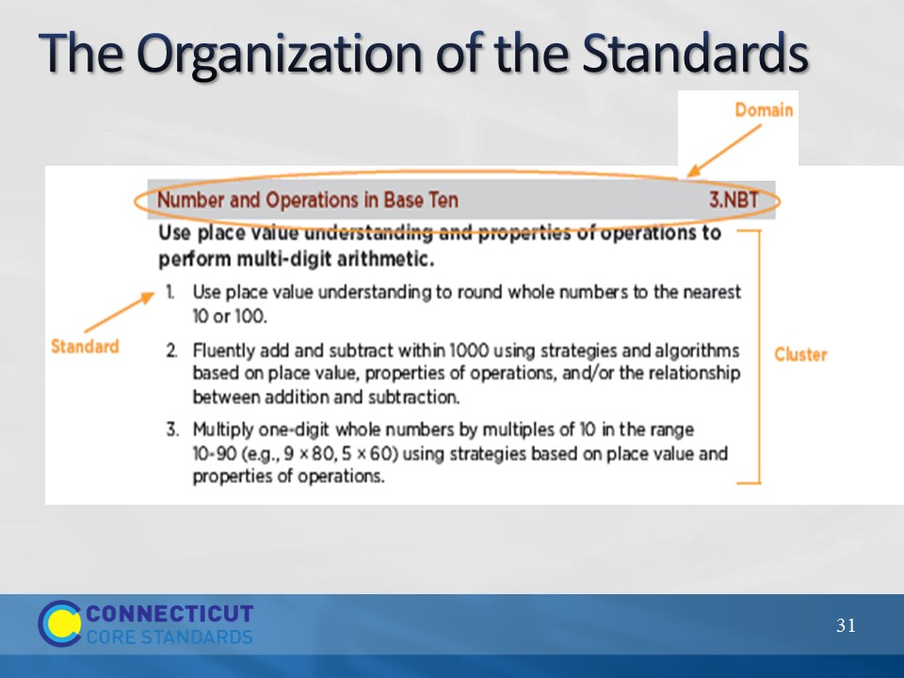
Slide 31
The Organization of the Standards
Quickly go through the organization of the Content Standards with the participants. Each grade level is organized by domains and within each domain there are associated groups of standards that make up a cluster. There can be multiple clusters within a domain. Transition to the next slide by explaining that domains span several grade levels.
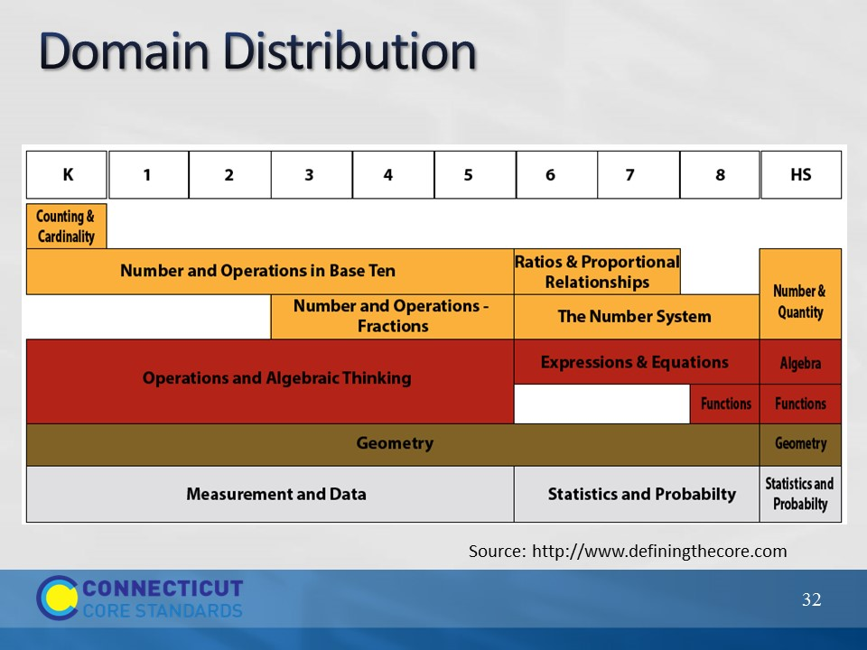
Slide 32
Domain Distribution
Explain that in K-5 there are four domains that span all of the grade levels: Number and Operations in Base Ten, Operations and Algebraic Thinking, Geometry, and Measurement and Data.
Kindergarten has a unique domain of Counting and Cardinality which includes standards that are foundational to both Number and Operations in Base Ten and Operations and Algebraic Thinking.
When students are developmentally ready and have a solid foundation in Number and Operations in Base Ten, Number and Operations – Fractions is layered on beginning in third grade.
Transition to the next slide by reminding participants that the domains were determined based on a very specific and coherent roadmap for learning called a progression.
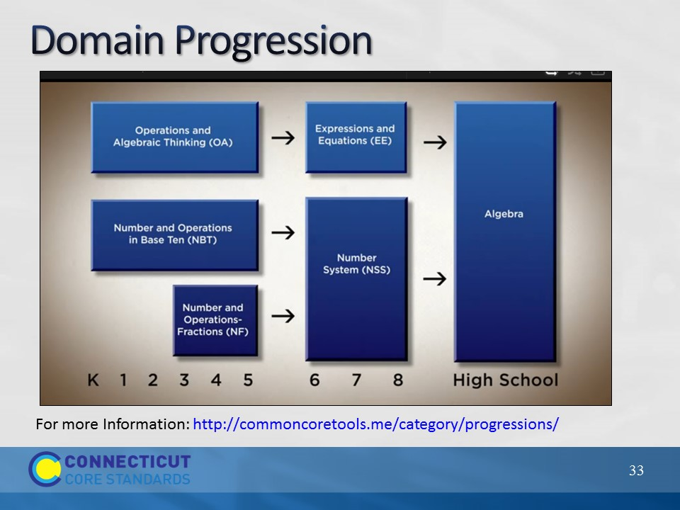
Slide 33
Domain Progression
Remind participants that the domains were written so concepts build on each other grade after grade so that, in this particular progression, there is a clear pathway to high school Algebra. The video at the end of this section is an explanation of the progressions from CCSS-Math Co-Author, Bill McCallum.
More information about specific domain progressions can be found at the Common Core Tools Website: http://commoncoretools.me/category/progressions/. Have participants make a note of this resource.
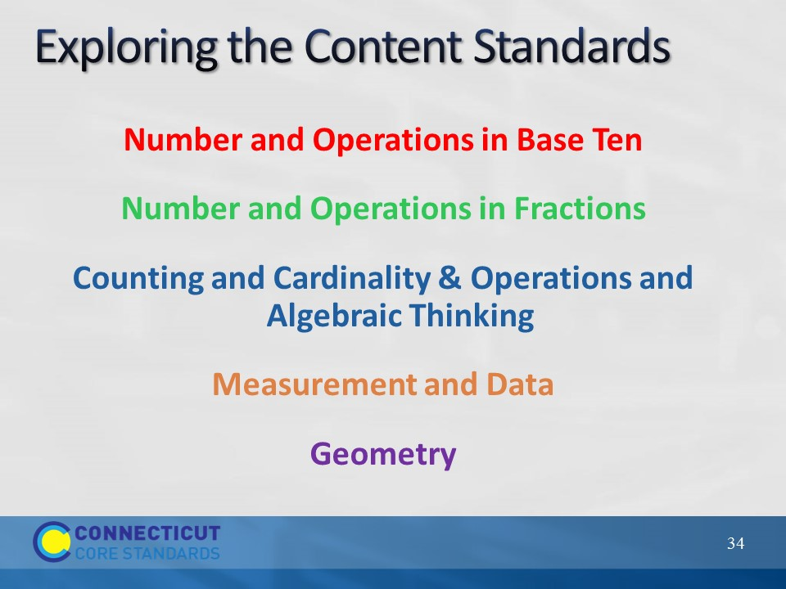
Slide 34
Exploring the Content Standards
Participants will work in grade level alike groups to complete the three parts of Exploring the Standards. Signs for each grade, K-5, should be posted around the room. Assign each table one of the K-5 Content Standard domains and pass out the color coded domain cards to each group.
Note: Participants may choose whichever grade level group they want in order to further explore the standards from that grade, however try to ensure that there is a balanced number of participants in each group.
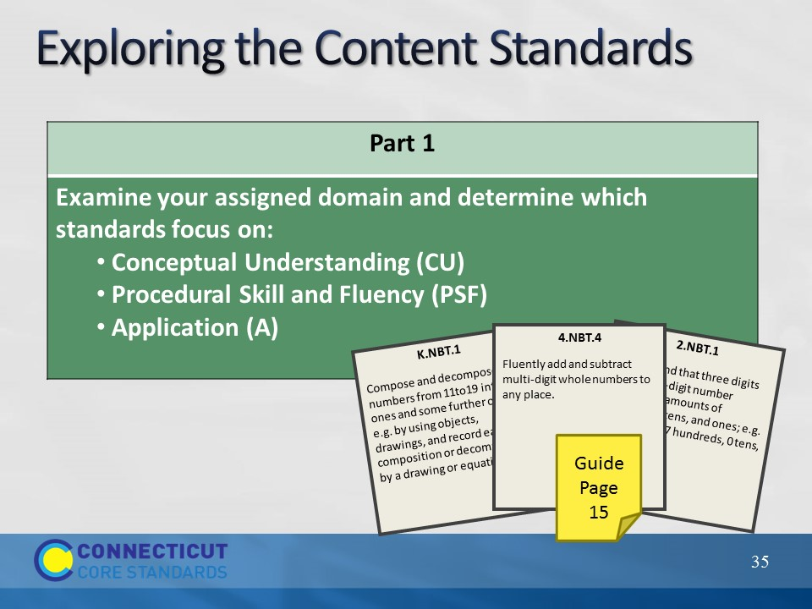
Slide 35
Exploring a Progression
For Part 1 of Exploring the Content Standards ask participants to examine their assigned domain and determine which standards focus on developing Conceptual Understanding, Procedural Skill and Fluency, and Application of Mathematics. Participants should use sticky notes to mark the card with either CU, PSF, or A according to how they sorted the cards. After sorting and marking the cards, have participants answer the following questions on page 15 in their Participant Guide:
- What are the expectations around conceptual understanding at your grade level?
- What are the fluency expectations at your grade level?
- What are the opportunities for application at your grade level?
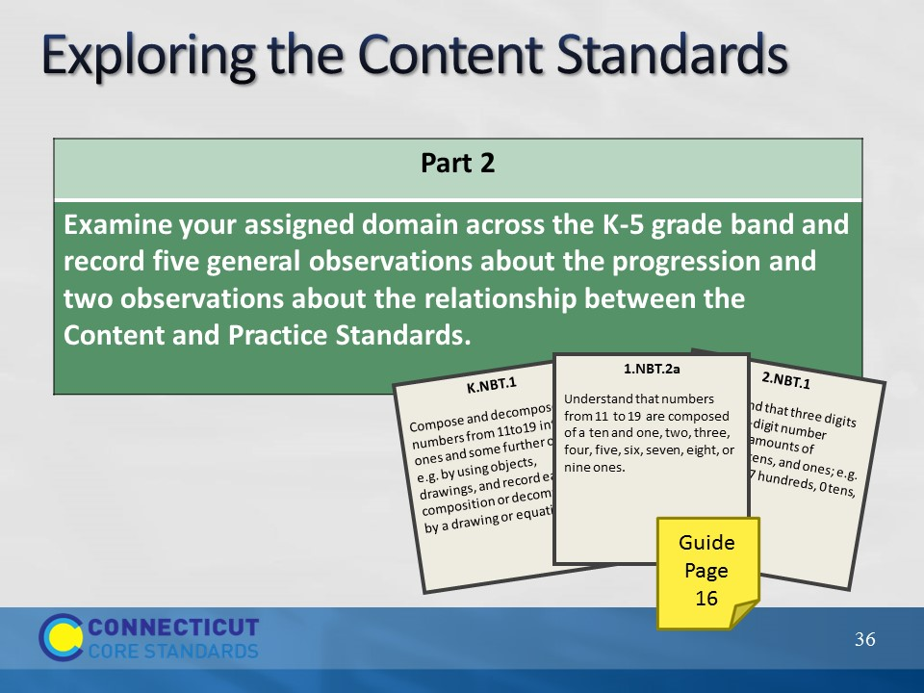
Slide 36
Exploring a Progression
Now, ask participants to examine the Content Standards in their assigned domain across grade levels and, on page 16 in the Participant Guide, complete the observation worksheet on which they record five general observations about the progression and two observations about how the Practices are integrated into the content. Allow each domain group to share their observations.
The goal here is for participants to see the progression of and how conceptual understanding, procedural skill and fluency, and application of mathematics are developed and addressed across grade levels. Because they are using the cards, participants should be able to line up the grade level domain standards side by side so that the vertical alignment can be seen horizontally across their table allowing for a continuous comparison. Some key points to make sure to bring out in the discussion are that participants should be able to see the build-up to Procedural Skill and Fluency (PSF) and to make the point that some students may develop PSF within a standard during their exploration and development of understanding around the concept. As long as the student understands their procedure and the mathematics behind what they are doing this is fine and should be encouraged. However, if students do not reach this point during a year prior to the year in which PSF is an expectation, the student is not ‘behind’. The expectation of PSF provides us with an end goal and not a specific spot on a student learning timeline that PSF should be addressed. In other words, the when of PSF is not the focal point, rather the build up to PSF with or from conceptual understanding should be.
Transition to Part 3 of the activity by explaining to participants that teaching the standards is not just about understanding how the Content Standards progress across a domain, but also about understanding how the standards of different domains work together.

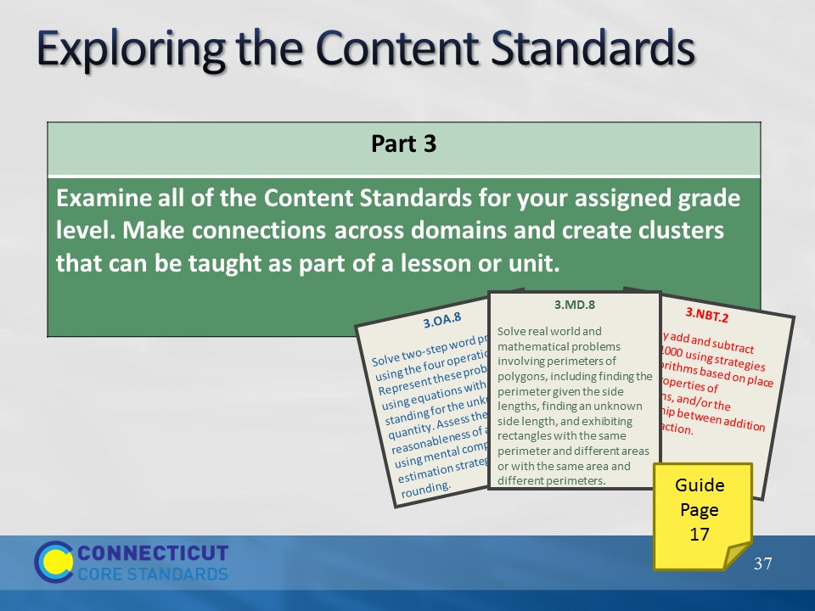
Slide 37
Making Connections
Ask participants to separate their domain cards by grade level. Direct participants to the areas around the room designated for each grade, K-5. They should take the cards for their grade level from the table to the designated area. For each grade, the cards for all five domains will be combined so there is a complete set of Content Standards for each grade level. In larger groups there may be several complete sets so the grade groups can be broken into two or three smaller groups.
Once they have their complete set of standards ask participants to examine all of the Content Standards for their grade level and make connections across the domains that can be referenced as part of a lesson or unit. Allow participants 10 minutes to create and record the connections and then take 10 minutes to allow each grade level the opportunity to share one or two of their connections. They can record their thoughts on page 17 in the Participant Guide.
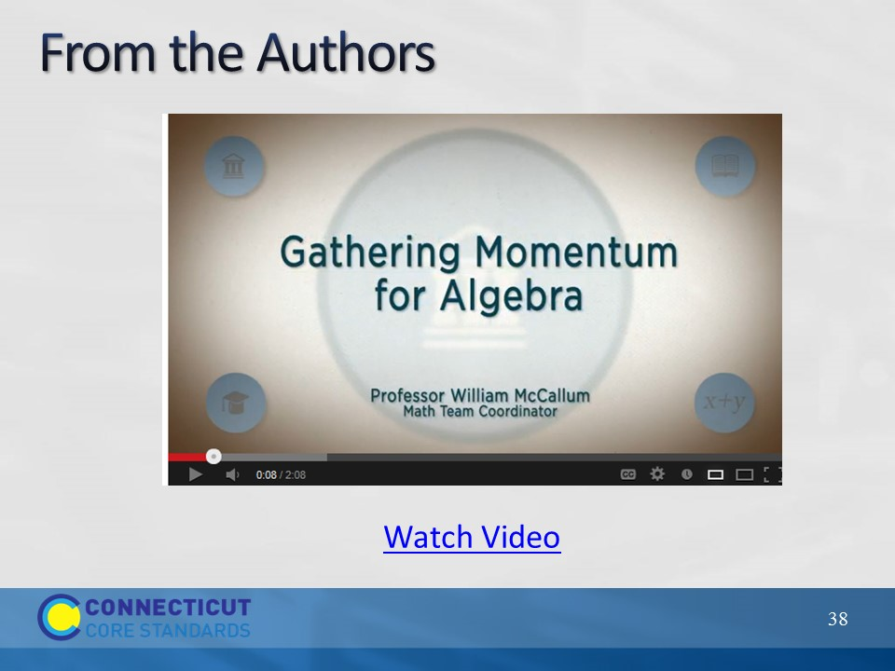
Slide 38
To being to wrap up this section click on “Watch Video” to play the video Gathering Momentum for Algebra from here: http://www.youtube.com/watch?v=ONPADo_Nt14. The video is 2:08 long.
Use this video to transition to the next slide.
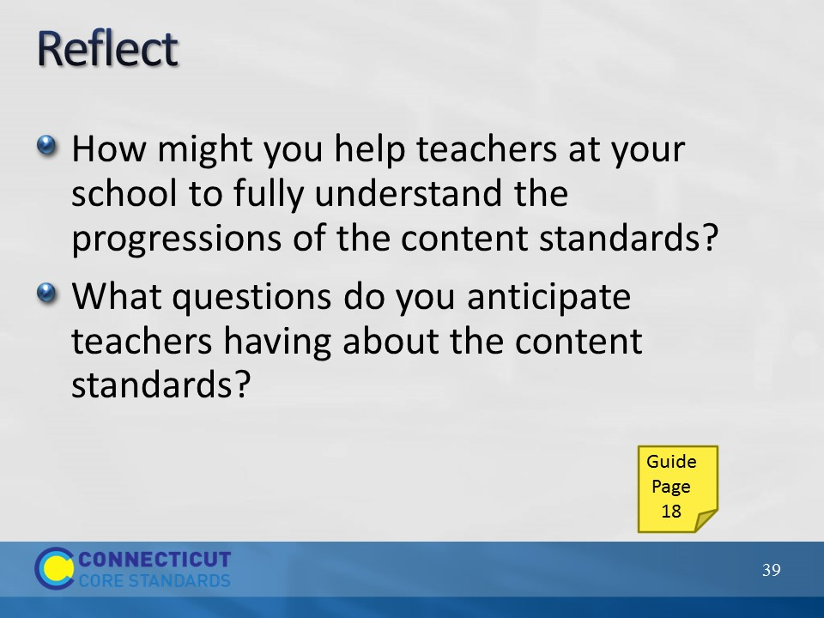
Slide 39
Reflect
Now that participants have a deeper understanding of the CCSS-Math expectations around conceptual understanding, procedural skill and fluency, and application of mathematics at their grade level, ask them to reflect on the two questions on the slide and record their answers on page 18 in their Participant Guide. As time permits ask for volunteers to share their responses. Allow 5 minutes.
Then, set-up the after lunch activities by explaining to participants that they will build off of their understanding of the Content Standards to explore the implications for teaching and learning in the classroom.

