Module 2  Facilitator Guide | Focus on Content Standards

Section 1

Connecticut Core Standards for Mathematics

Grades K–5

Systems of Professional Learning

Connecticut Core Standards Systems of Professional Learning
The material in this guide was developed by Public Consulting Group in collaboration with staff from the Connecticut State Department of Education and the RESC Alliance. The development team would like to specifically thank Ellen Cohn, Charlene Tate Nichols, and Jennifer Webb from the Connecticut State Department of Education; Leslie Abbatiello from ACES; and Robb Geier, Elizabeth O’Toole, and Cheryl Liebling from Public Consulting Group.
The Systems of Professional Learning project includes a series of professional learning experiences for Connecticut Core Standards District Coaches in English Language Arts, Mathematics, Humanities, Science, Technology, Engineering, Mathematics (STEM), and Student/Educator Support Staff (SESS).
Participants will have continued support for the implementation of the new standards through virtual networking opportunities and online resources to support the training of educators throughout the state of Connecticut.
Instrumental in the design and development of the Systems of Professional Learning materials from PCG were: Sharon DeCarlo, Debra Berlin, Jennifer McGregor, Judy Buck, Michelle Wade, Nora Kelley, Diane Stump, and Melissa Pierce.

Published 2014. Available online at http://ctcorestandards.org/

Session at-a-Glance

Section 1: Sharing Implementation Experiences (35 minutes)

Training Objectives:
- To review the foundations of the CCS-Math and the key shifts of focus, coherence, and rigor.
- To share, discuss, and address experiences with and common challenges of supporting teachers in implementing the Standards for Mathematical Practice.
The facilitator will begin by reviewing the key shifts of focus, coherence, and rigor. Then, in groups, participants will share experiences and describe any “aha moments” from attempts to implement the Standards for Mathematical Practice (SMP). Participants will look for themes or choose one or two important successes, challenges, and/or insights to share with the larger group. These will be recorded on chart paper so that common themes and additional strategies can be discussed. Participants can record new ideas on the handout, Moving Forward with the Practices. The facilitator will wrap up Section 1 by explaining that to build upon their knowledge and experience with the SMP, they will begin to connect these to the Standards for Mathematical Content.

Supporting Documents:
- Moving Forward with the Practices

Materials:
- Chart paper, markers

PowerPoint Slides:
- 6–13

Session Implementation
Section 1
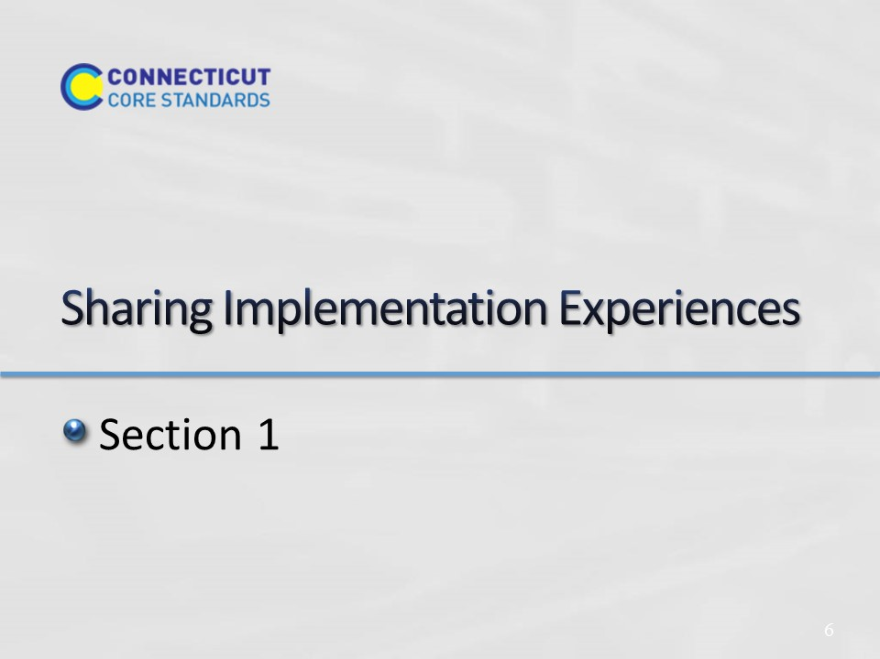
Slide 6
Sharing Implementation Experiences
Section 1 Time: 35 minutes
Section 1 Training Objectives:
- To review the foundations of the CCS-Math and the key shifts of focus, coherence, and rigor.
- To share, discuss, and address experiences with, and the common challenges of, supporting teachers in implementing the Standards for Mathematical Practice.
Section 1 Outline:
- The facilitator will begin by reviewing the key shifts of focus, coherence, and rigor. (5 minutes)
- Then, in groups, participants will share experiences and describe any “aha moments” from attempts to implement the Standards for Mathematical Practice (SMP). Participants will look for themes or choose one or two important successes, challenges, and/or insights to share with the larger group. These will be recorded on chart paper so that common themes and additional strategies can be discussed as a large group. Participants can record new ideas on the handout Moving Forward with the Practices. (30 minutes)
- The facilitator will wrap up Section 1 by explaining that to build upon their knowledge and experience with the SMP they will begin to connect the SMP to the Standards for Mathematical Content.
Supporting Documents
Moving Forward with the Practices

Materials
Chart paper, markers
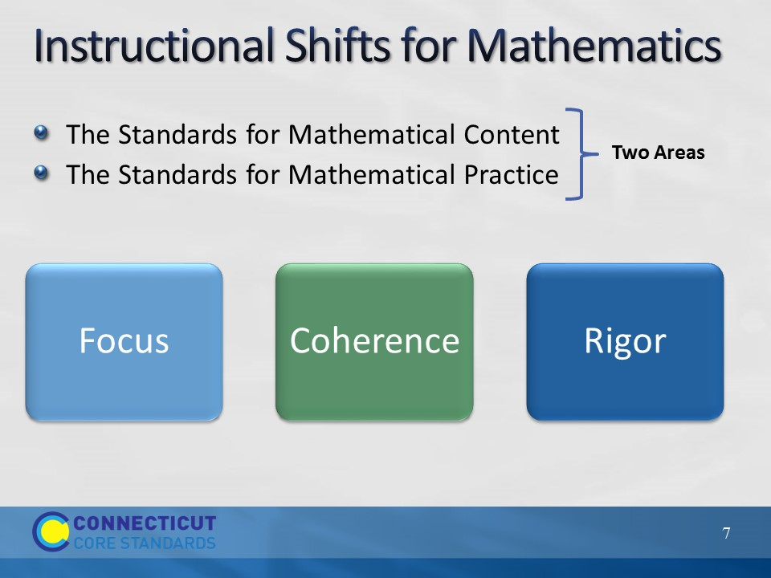
Slide 7
Begin by review key ideas from Module 1 using the next five slides:
There are two parts to the Common Core Standards for Mathematics, Standards for Mathematical Content and Standards for Mathematical Practice. Together they define what students should understand and be able to do in their study of mathematics in order to be college and career ready.
The Standards for Mathematical Practice are often simply called the Practice Standards or the Practices. The Practices include the mathematical habits of mind and mathematical expertise that students should develop such as reasoning, communication, making arguments, and modeling. These were the focus of Module 1, delivered in March.
The Standards for Mathematical Content are very specific about concepts, procedures, and skills that are to be learned at each grade level, and contain a defined set of endpoints in the development of each. This will be the focus of this session.
What’s New About the CSS-Math?
In order to meet both the Content Standards and the Practice Standards, the writers of the Common Core explicitly based the standards on three very important fundamentals of mathematics that were missing from or were not as explicit in different versions of mathematics standards. Those are: Focus, Coherence, and Rigor.
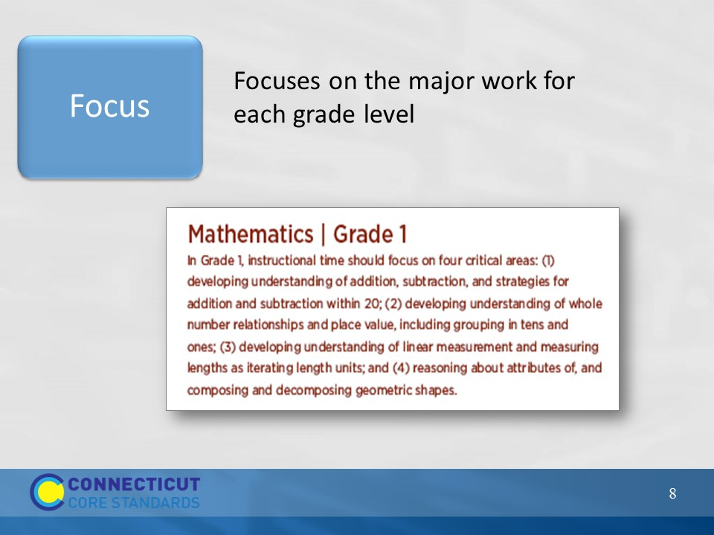
Slide 8
Focus: The writers of the Standards worked very hard to reduce the number of expectations at each grade level. This work was not done arbitrarily. They focused on the different domains of mathematics, such as Operations and Algebraic Thinking, Number and Operations in Base Ten, Geometry, and Measurement and Data, and determined what work was critical for students at each grade level to address in order to develop the concepts in each domain over time. This change allows teachers to shift their instruction to focus on the major work at their grade and to spend more time in each of these critical areas in order for students to develop a deep understanding through investigation, inquiry and problem solving.
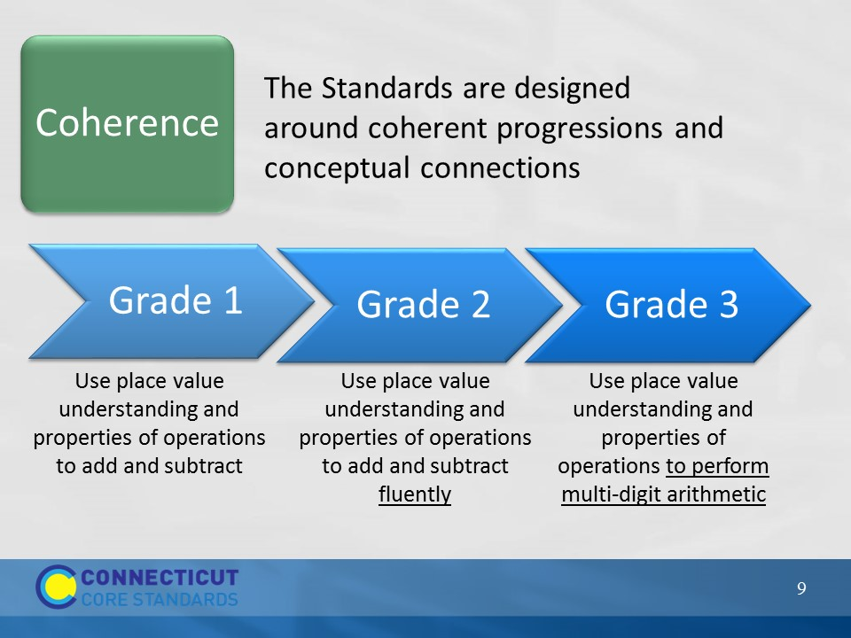
Slide 9
Coherence: Coherence means ensuring that there is a clear sequence of concepts and skills that build on each other across the grades.
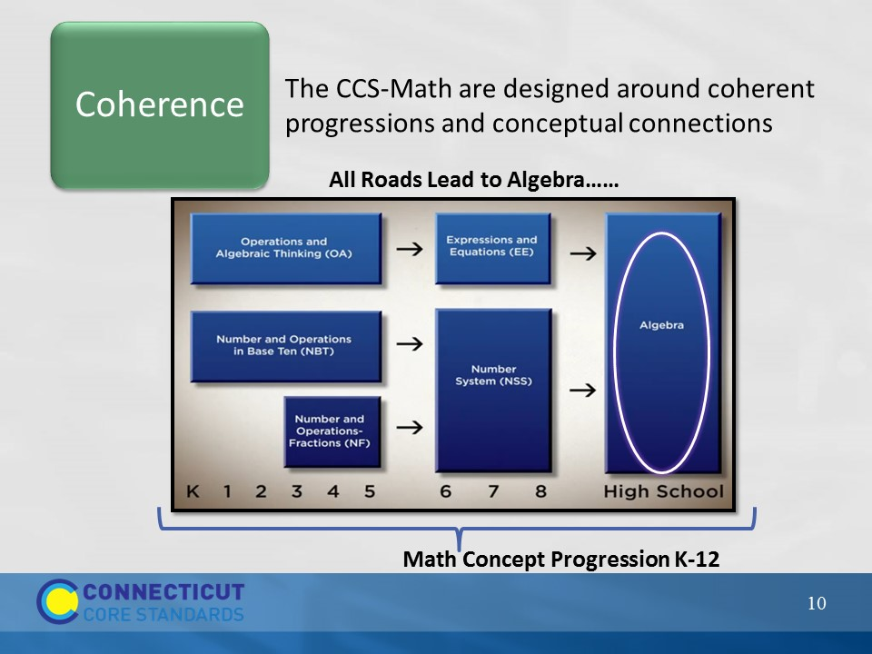
Slide 10
Coherence: The chart on the slide shows one of the progressions in the CCS-Math that builds up to the formal study of upper level Algebra in High School. Note that the Operations and Algebraic Thinking standards in grades K–5 lead up to and are designed to help middle school students work with Expressions and Equations, which will then help students to be successful in high school Algebra. This same progression takes place with the Number and Operations domains. In K–5 the Number and Operations standards are split over two domains, Base Ten and Fractions. This does not mean that the standards within the domains are not connected, but that there is a focus on each. The intent of the coherence and progressions is that students will all be ready for algebra at either the 8th grade or high school level. Section 3 of this module will include an in-depth examination of coherent progressions.
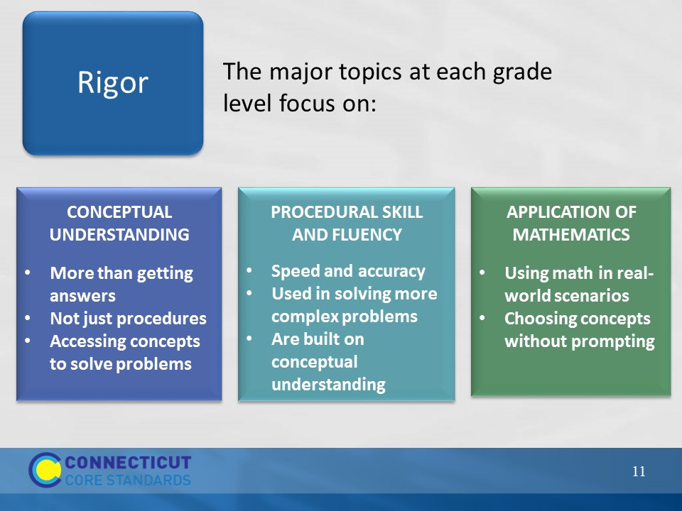
Slide 11
Rigor: Rigor means learning that is based in the deep understanding of ideas AND fluency with computational procedures AND the capacity to use both to solve a variety of real-world and mathematical problems. Section 2 of this module will include an in-depth examination of the three aspects of rigor.
Note: We are not talking about a three-pronged balance of conceptual understanding, procedural skill and fluency, and application of mathematics here. Rather, we are focusing on the expectation that students are able to flexibly work with the mathematics content in each of the three areas. This will become more apparent as participants explore the Content Standards in Section 3.
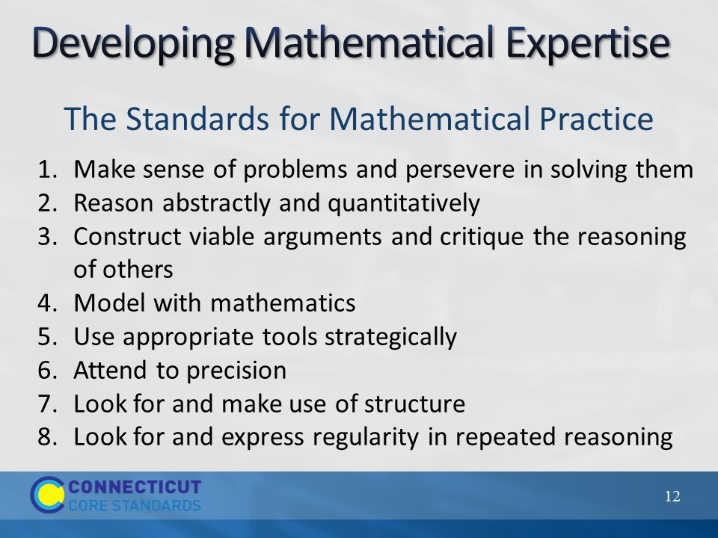
Slide 12
The Standards for Mathematical Practice describe varieties of expertise that mathematics educators at all levels should seek to develop in their students. These practices rest on important “processes and proficiencies” with longstanding importance in mathematics education. The first of these are the National Council of Teachers of Mathematics process standards of problem solving, reasoning and proof, communication, representation, and connections. The second are the strands of mathematical proficiency specified in the National Research Council’s report Adding It Up: adaptive reasoning, strategic competence, conceptual understanding (comprehension of mathematical concepts, operations and relations), procedural fluency (skill in carrying out procedures flexibly, accurately, efficiently and appropriately), and productive disposition (habitual inclination to see mathematics as sensible, useful, and worthwhile, coupled with a belief in diligence and one’s own efficacy).
Developing these mathematical expertise is important so that students are better able to solve problems and reason quantitatively both within a classroom and throughout life outside of the classroom.
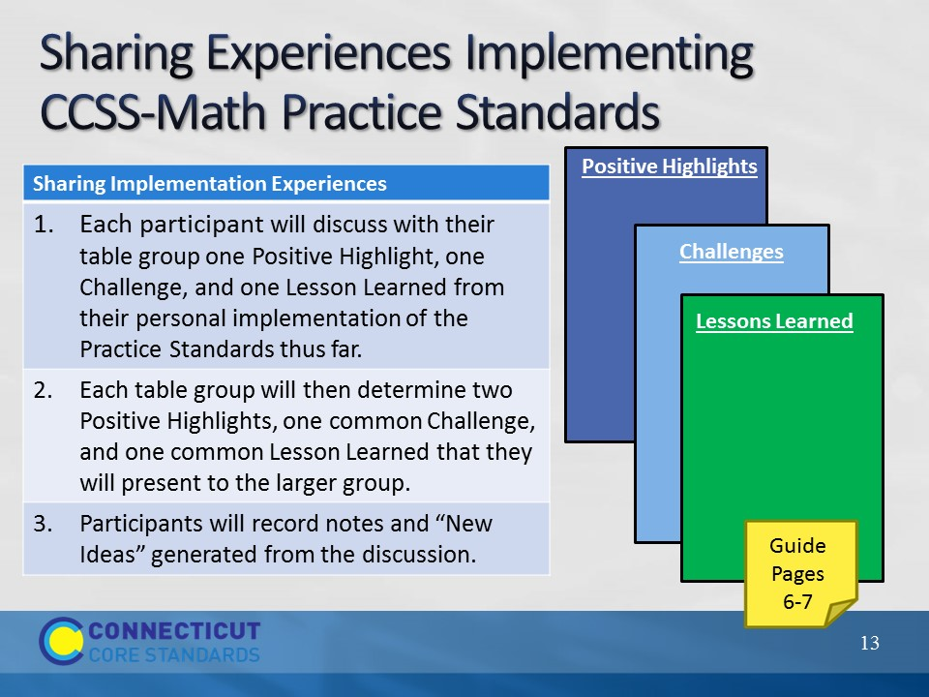
Slide 13
Now that you have quickly reviewed the key points from Module 1, ask participants to now reflect on the work that they have done back at their school, in their role as a Core Standards Coach, with helping teachers learn more about and implement the CCS-Math. Have each participant discuss with their table group one positive highlight, one challenge, and one lesson learned from their personal implementation of the Practice Standards thus far. Each table group will then determine two positive highlights, one common challenge, and one common lesson learned that they will present to the larger group. They can record notes from their discussion on page 6 in the Participant Guide.
As table groups present, record the participants’ responses on the chart paper titled Positive Highlights, Challenges, and Lessons Learned. After all groups have presented, summarize what has been charted and then ask the large group if anyone has a solution to any of the common challenges. Encourage participants to record “New Ideas” on page 7 in the Participant Guide.
Wrap up the activity by explaining that the challenges will be revisited periodically throughout the day as the discussion of the Content Standards ensues. Note: Be sure that the connections are made when discussing how to teach the Content Standards so that participants understand how implementing the Practice Standards go hand-in-hand with implementing the Content Standards in a rigorous, focused, and coherent lesson.
Transition to the next activity by explaining that participants will now start looking at the connections of the Content and Practice Standards by looking at the language of the Content Standards.
Note: If teachers have not had the time between the previous module and this module to begin their implementation, have them instead focus on things that they have seen and heard back at their school, including positive highlights of where their school is, challenges that they now recognize they may be facing, and any lesson learned in terms of the outcomes of the first module and where they think they need to go next with the implementation.

