Module 2  Facilitator Guide | Focus on Content Standards

Introductory Activity

Connecticut Core Standards for Mathematics

Grades K–5

Systems of Professional Learning

Connecticut Core Standards Systems of Professional Learning
The material in this guide was developed by Public Consulting Group in collaboration with staff from the Connecticut State Department of Education and the RESC Alliance. The development team would like to specifically thank Ellen Cohn, Charlene Tate Nichols, and Jennifer Webb from the Connecticut State Department of Education; Leslie Abbatiello from ACES; and Robb Geier, Elizabeth O’Toole, and Cheryl Liebling from Public Consulting Group.
The Systems of Professional Learning project includes a series of professional learning experiences for Connecticut Core Standards District Coaches in English Language Arts, Mathematics, Humanities, Science, Technology, Engineering, Mathematics (STEM), and Student/Educator Support Staff (SESS).
Participants will have continued support for the implementation of the new standards through virtual networking opportunities and online resources to support the training of educators throughout the state of Connecticut.
Instrumental in the design and development of the Systems of Professional Learning materials from PCG were: Sharon DeCarlo, Debra Berlin, Jennifer McGregor, Judy Buck, Michelle Wade, Nora Kelley, Diane Stump, and Melissa Pierce.

Published 2014. Available online at http://ctcorestandards.org/

Session at-a-Glance

Introductory Activity (10 minutes)
The facilitator will review project goals and activities, module outcomes, and the agenda for the session. Participants will complete a Pre-Assessment.

Supporting Documents:
- Session Agenda
- Pre-Assessment

PowerPoint Slides:
- 1–5

Session Implementation
Introduction
Slide 1
(Slides 1-5, including the pre-assessment, will take about 10 minutes total.)
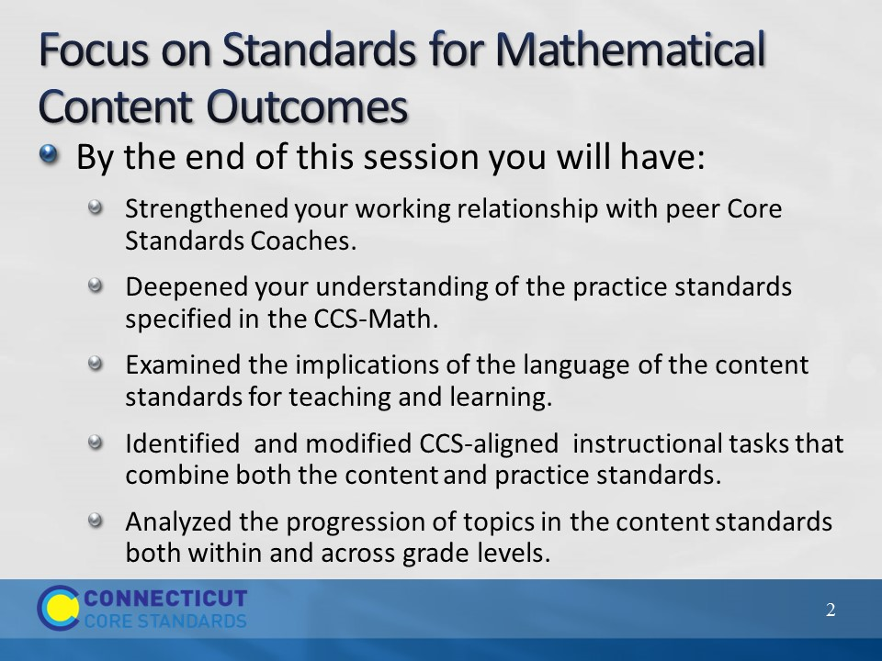
Slide 2
Review the outcomes for the day, sharing what you hope to accomplish throughout the full day session. There are nine outcomes for this session. These are presented to the participants over two slides.
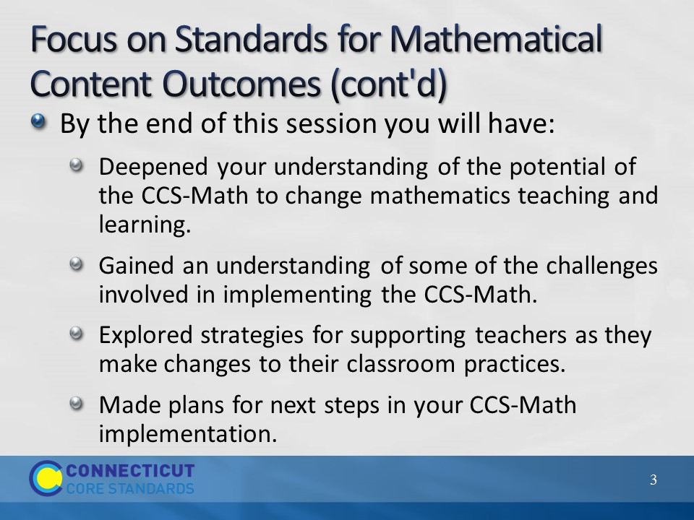
Slide 3
There are nine outcomes for this session. These are presented to the participants over two slides.
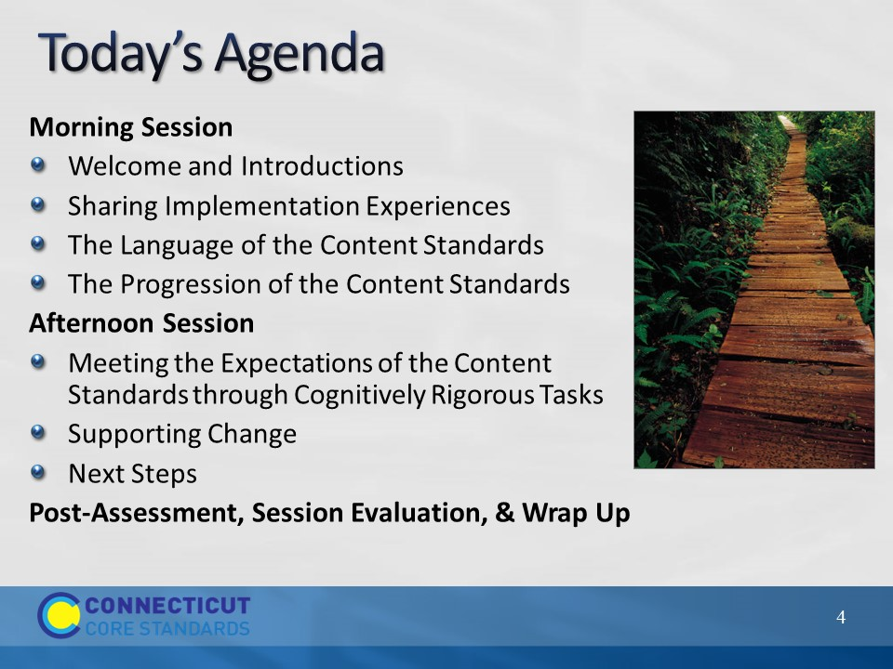Slide 4
Review the agenda letting participants know that this is the pathway they will travel in order accomplish the nine outcomes discussed earlier. Note that in addition to the break for lunch there will also be shorts breaks throughout the day, but participants should feel free to take a personal break as needed. Emphasize the importance of coming back from lunch and breaks on time to ensure enough time to complete all the work of the day.
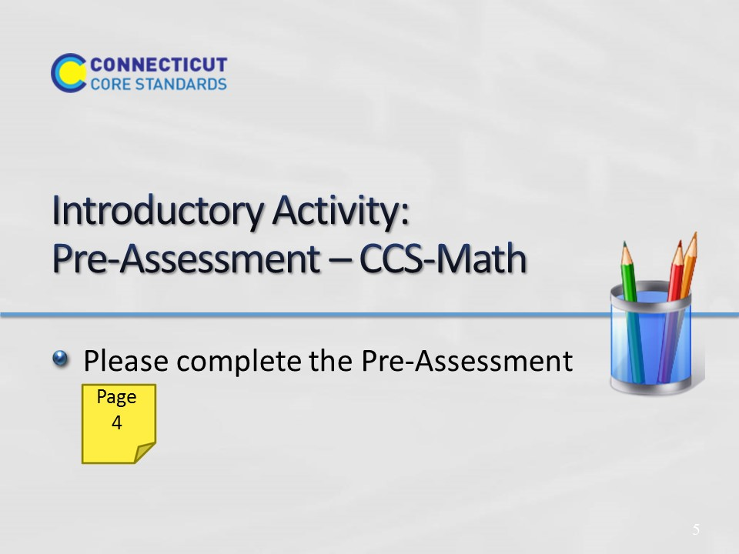
Slide 5
This will be a short self-assessment, which will be found in the Participant Guide on page 4. It will assess where the coaches are now with understanding the implementing the Practice Standards that were introduced in Module 1, and assess where they are in understanding the Content Standards. The participants will complete the same assessment at the end of the session. Allow 3-4 minutes to complete.

