Module 2  Facilitator Guide | Focus on Content Standards

Section 2

Connecticut Core Standards for Mathematics

Grades 6–12

Systems of Professional Learning

Session at-a-Glance

Section 2: The Language of the Content Standards (45 minutes)

Training Objectives:
- To define conceptual understanding, procedural skill and fluency, and application of mathematics.
- To understand the differences between conceptual understanding, procedural skill and fluency, and application of mathematics.
- To begin to understand how procedural skills and fluency build upon conceptual understanding.
- To demonstrate how application of mathematics can support students’ development of conceptual understanding.
The Language of the Content Standards: In groups, participants will complete the first part of the Who Knows Math exercise, examine short examples of student work, and together will answer questions about what the student knows based on the answers given. After a brief large group discussion, small groups will watch the video Mathematics Fluency: A Balanced Approach and develop working definitions of “conceptual understanding,” “fluency,” and “application” as addressed in the content standards. Groups will then work through short, basic examples on how students can demonstrate conceptual understanding and then discuss current strategies used now to develop procedural skill and fluency. The wrap-up of the section takes place as participants complete the second part of the Who Knows Math exercise and revise their first round of answers given their new understandings.

Supporting Documents:
- Who Knows Math

Materials:
- Chart paper, markers
Video:
- Mathematics Fluency: A Balanced Approach
http://www.youtube.com/watch?v=ZFUAV00bTwA

PowerPoint Slides:
- 14–29

Session Implementation

Section 2
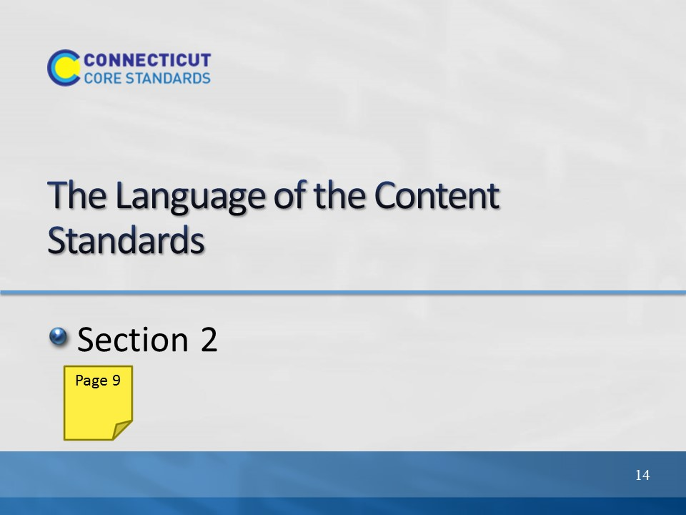
Slide 14
Section 2: The Language of the Content Standards
Section 2 Time: 45 minutes

Section 2 Training Objectives:
- To define conceptual understanding, procedural skill and fluency, and application of mathematics.
- To understand the differences between conceptual understanding, procedural skill and fluency, and application of mathematics.
- To begin to understand how developing conceptual understanding can lead to the development of procedural skill and fluency.
- To demonstrate how application of mathematics can support students’ development of conceptual understanding.

Section 2 Outline:
- In groups, participants will complete the first part of the Who Knows Math exercise during which they will examine short examples of student work and make observations about what the student knows based on the answers given.
- After a brief large group discussion, small groups will watch the video Mathematics Fluency: A Balanced Approach and develop working definitions of “conceptual understanding,” “fluency,” and “application” as addressed in the content standards.
- Groups will then work through short, basic examples on how students can demonstrate conceptual understanding, and then discuss current strategies used now to develop procedural skill and fluency. The discussions will continue with how those strategies will benefit students first developing a conceptual understanding of the mathematics.
- The wrap-up of the session takes place as participants complete the second part of the Who Knows Math exercise in which they revise their first round of answers given their new understandings.

Supporting Documents
Who Knows Math exercise worksheet

Materials
Chart paper, markers
Individual copy of the mathematics standards

Video
Mathematics Fluency: A Balanced Approach
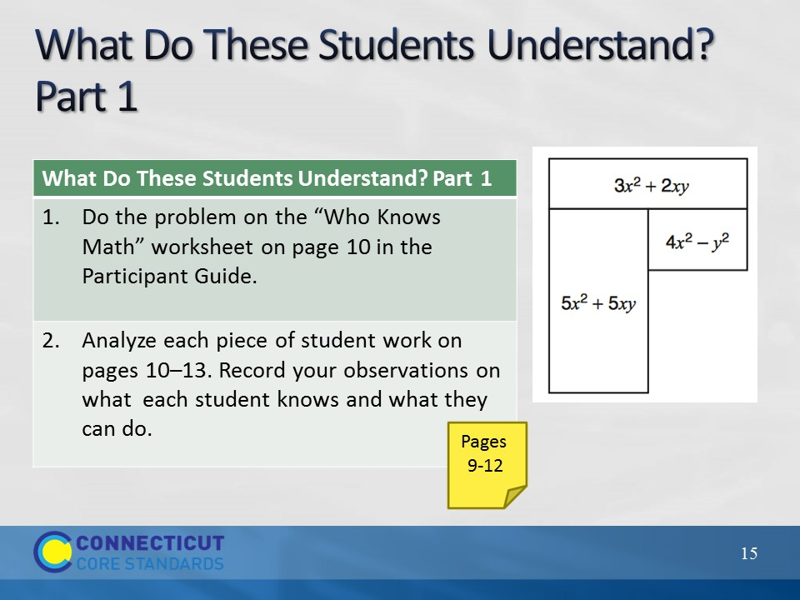
Slide 15
What do these students understand?
- Ask table groups to read and analyze the “Who Knows Math” worksheet on pages 9-12 in the Participant Guide. Ask them to think about what each student on the sheet knows and doesn’t know. Also have them think about what is unknown about what the students know. Participants can record their observations on the worksheet. Briefly discuss participants’ observations and explain that they will return to this after exploring the language of the content standards in more detail.

Note: If time is an issue at the start of this activity, you may choose to have groups focus on only one student. If you have five groups, assign each group a different student.
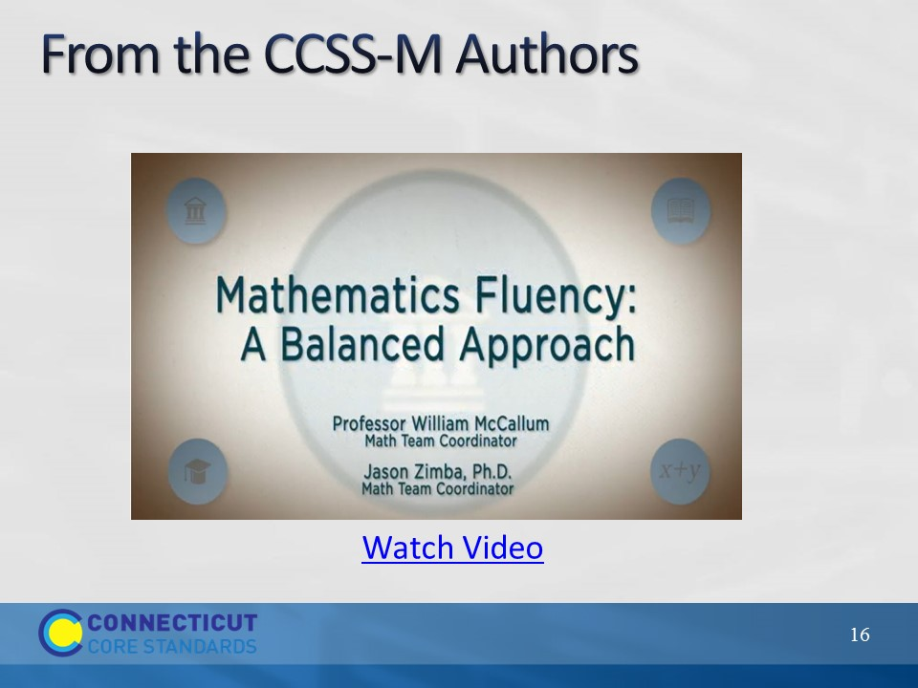
Slide 16
From the Authors
Click on “Watch Video” to play the video Mathematics Fluency: A Balanced Approach from here: http://www.youtube.com/watch?v=ZFUAV00bTwA. The video is 1:57 long.

After the video has played, ask participants for their thoughts.

Transition to the next part of this section by explaining to participants that they will now look more closely at conceptual understanding, procedural skills and fluency, and application of mathematics in more depth.
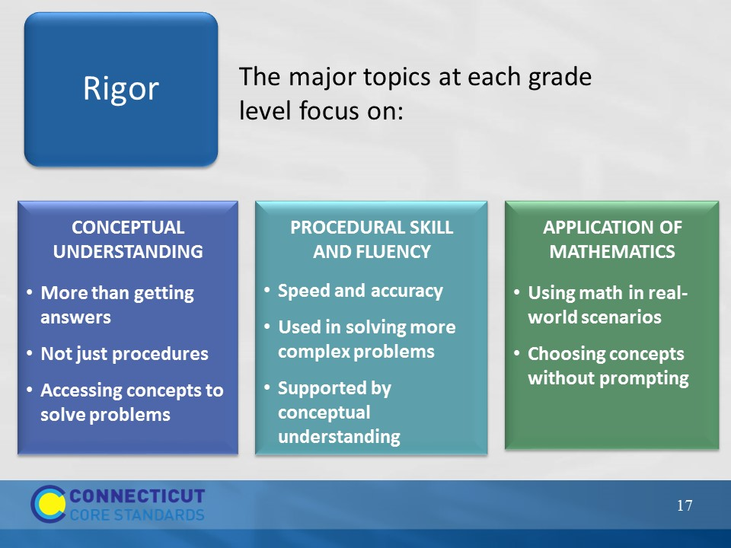
Slide 17
Rigor: Remind participants that one of the big shift in the content standards is that at all ages, students are to be taught with rigor as defined on the slide. Review the three aspects of rigor: conceptual understanding, procedural skill and fluency, and application of mathematics. Repeat that rigor means learning based in the deep understanding of ideas AND fluency with computational procedures AND the capacity to use both to solve a variety of real-world and mathematical problems. Explain to participants that you will now go over each aspect of rigor in more depth.
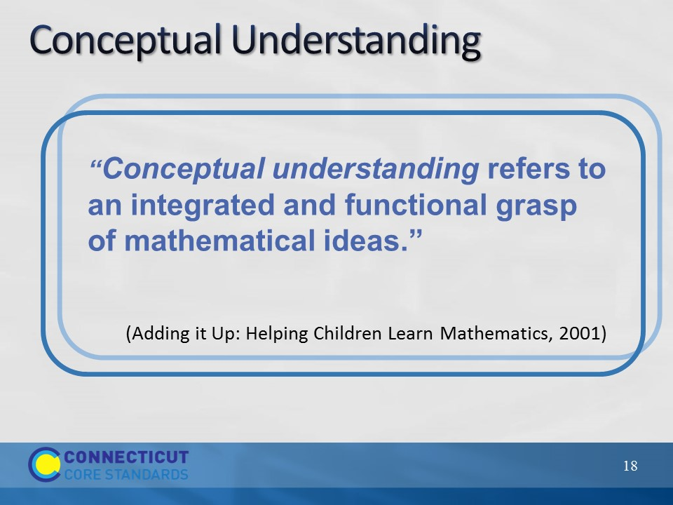
Slide 18
Ask participants to turn to pages 13-14 in the Participant Guide where space is provided for them to take notes on Conceptual Understanding, Procedural Skill and Fluency, and Application of Mathematics.

Conceptual Understanding
As participants read the quote on the slide, explain that conceptual understanding can be difficult to define. Ask participants to read the description on page 13 in the Participant Guide that is an overlap of the National Research Council and NCTM definitions of conceptual understanding:

“Students demonstrate conceptual understanding in mathematics when they provide evidence that they can recognize, label, and generate examples of concepts; use and interrelate models, diagrams, manipulatives, and varied representations of concepts; identify and apply principles; know and apply facts and definitions; compare, contrast, and integrate related concepts and principles; recognize, interpret, and apply the signs, symbols, and terms used to represent concepts. Conceptual understanding reflects a student’s ability to reason in settings involving the careful application of concept of definitions, relations, or representations of either.” (Balka, Hull, & Harbin Miles, n.d.)

Just as they looked at “I Can” statements with each of the Practices, use the next slides to show examples of student responses that demonstrate conceptual understanding.
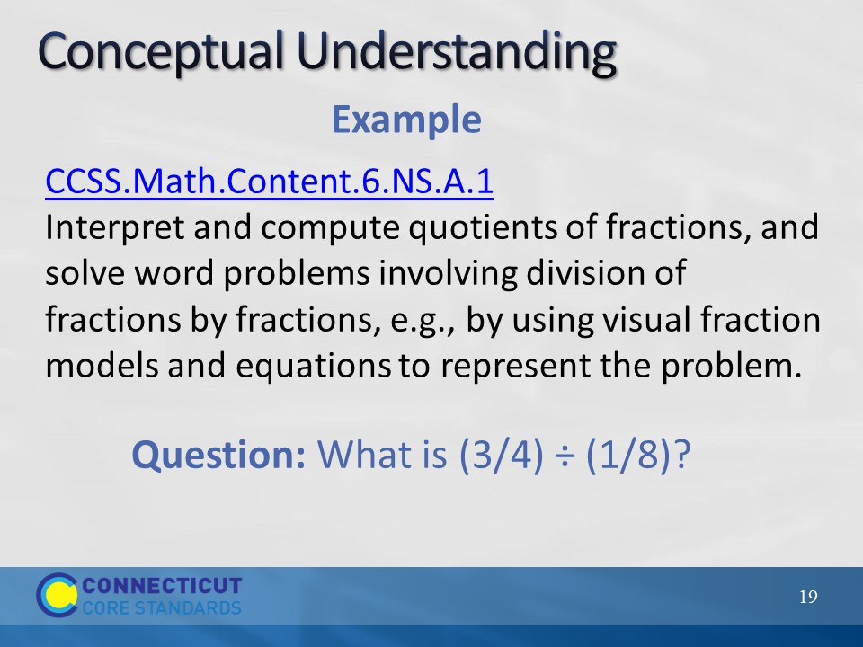
Slide 19
Conceptual Understanding
Ask participants to look at the example on the slide and discuss with their group how a student might demonstrate conceptual understanding if asked the question What is (3/4) ÷ (1/8)? Allow participants to discuss this briefly, 2-3 minutes, and then transition to the next slide.
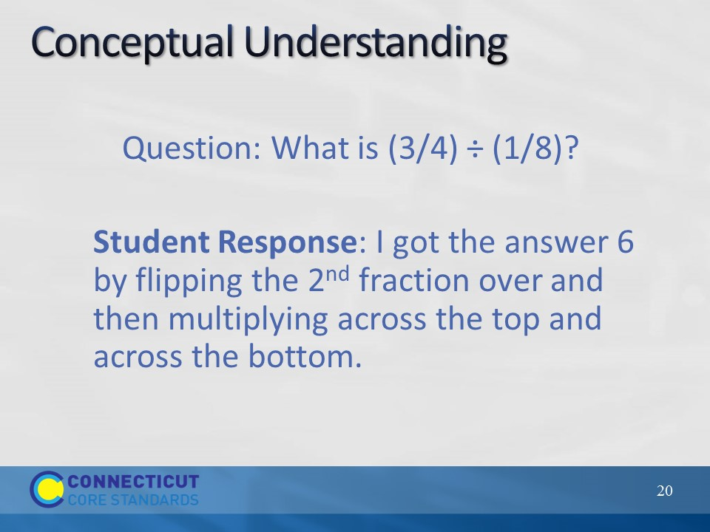
Slide 20
Ask participants to now consider the student response to the question and have them determine if this student has developed a conceptual understanding.

This student has demonstrated knowledge of an algorithm to do a procedure - it is unclear whether he/she has a conceptual understanding. Have a participant show on the flip chart a visual fraction model a student could use to demonstrate conceptual understanding. Ways in which a student may show understanding:
Creating a story context: How many 1/8 cup servings of trail mix are in ¾ cup of trail mix?
Using a number line: How many segments of length 1/8 unit are contained in a segment of length ¾ units?
Using the relationship between multiplication and division: What can I multiply 1/8 by to get 3/4? i.e., 1/8 • X = 3/4
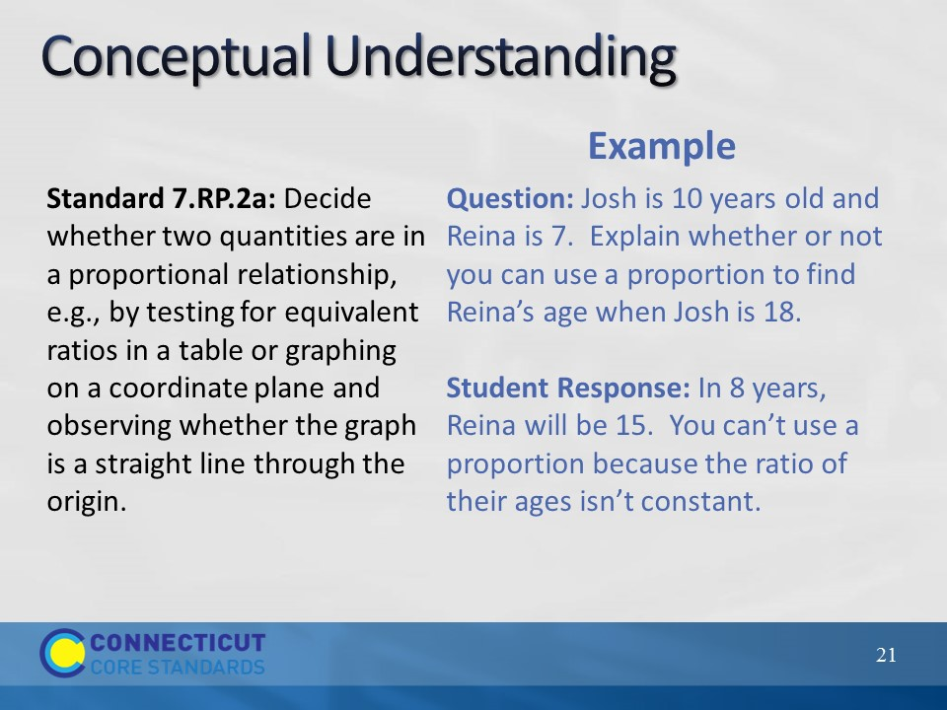
Slide 21
Conceptual Understanding
Go over the example on the slide and ask participants how the student’s response relates to Standard 7.RP.2a. Here we want participants to see that a student is demonstrating a conceptual understanding of determining whether two quantities are in a proportional relationship. They may need to see multiple responses of this students’ work to make a final determination of this, so ask what else, if anything, they might ask or look for from this student. And, to support the idea that there is no one right way for a student to demonstrate conceptual understanding, what other ways might they expect to see students answer this question.

Transition to the next slide by explaining that, as they have seen, not all standards explicitly focus on conceptual understanding so they will now look at procedural skill and fluency.

Example adapted from: http://commoncoretools.files.wordpress.com/2012/02/ccss_progression_rp_67_2011_11_12_corrected.pdf
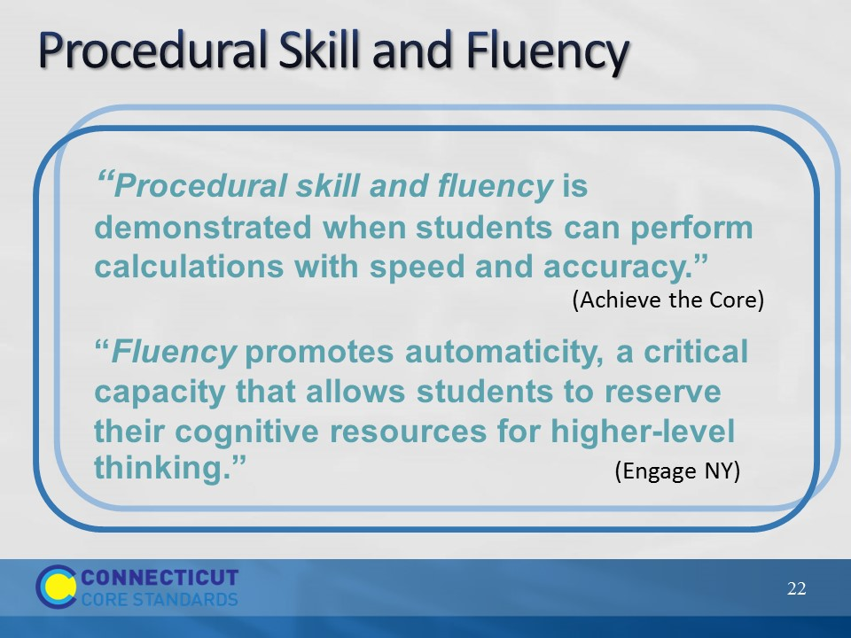
Slide 22
Procedural Skill and Fluency
Focus on the two key points on the slide. Ask participants for their thoughts on Bill McCallum’s statements in the video (shown on slide 16) in which he talks about the design of the standards being such that there is a build up to procedural skill and fluency. Ask why they think this is the case. If it does not come out in the conversation, have participants think back to the video of CCSS-Math co-author, Phil Daro’s, video that was viewed in Module 1 about teaching students to get answers. Ask participants what connections might be made between Bill McCallum’s and Phil Daro’s videos.

Then, transition to the next slide by explaining that teaching students procedures and how to use an algorithm or any type of short cut or trick without developing some level of conceptual understanding for why those things work mathematically is akin to teaching answer getting vs. learning mathematics.

Note: For a deeper look at Phil Daro’s discussion on answer getting, review the video of his longer discussion here: http://vimeo.com/79916037
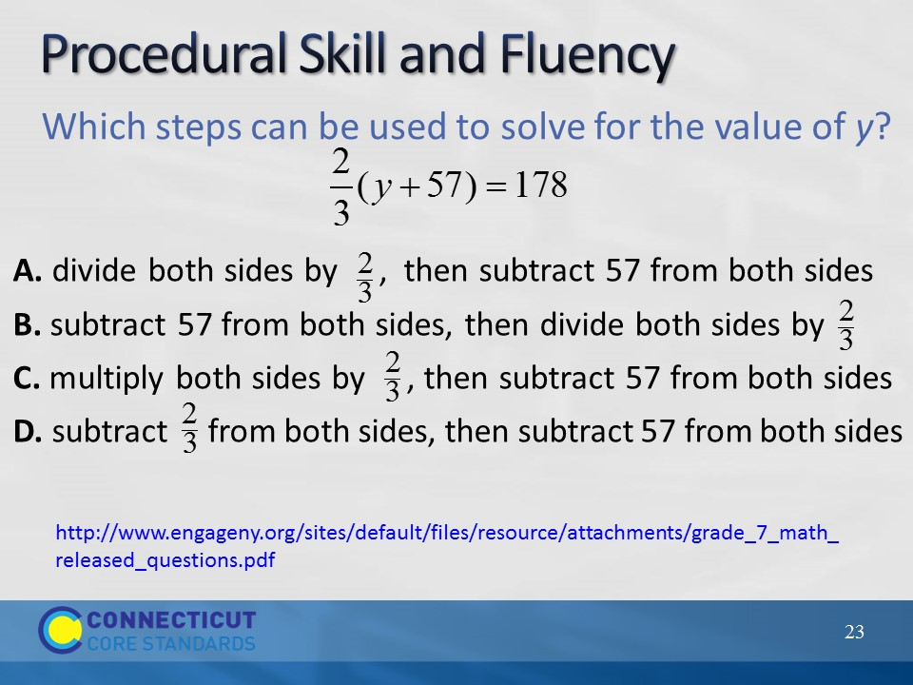
Slide 23
Procedural Skill and Fluency
A fluency required in Grade 7 is solving equations of the form px + q = r and p(x+q) = r, where p, q, and r are specific rational numbers (7.EE.4a). Ask if there is anything more that they would want to see to determine if students’ fluency is based in conceptual understanding.
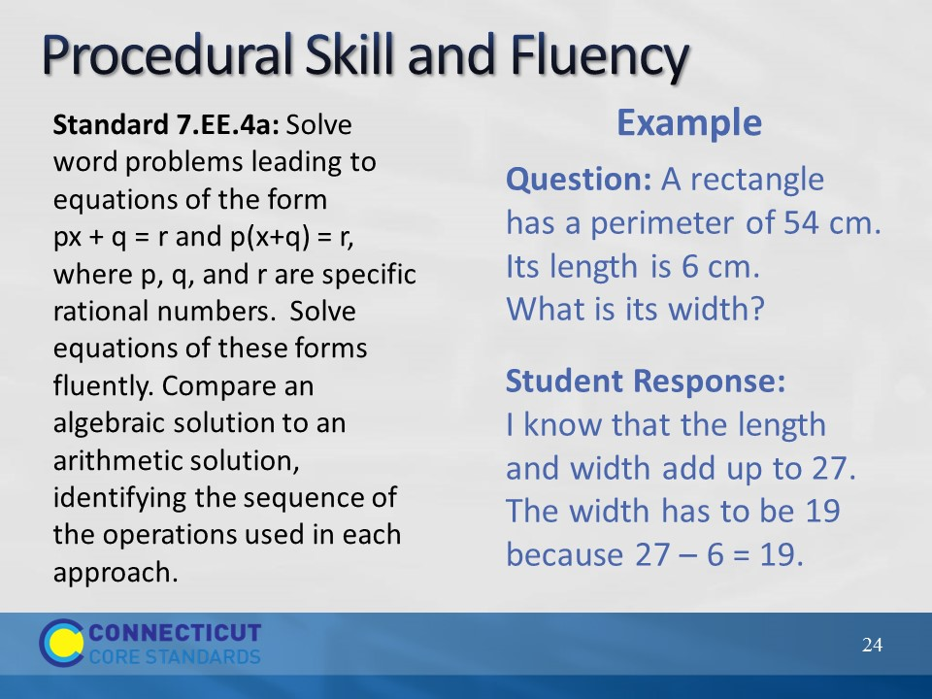
Slide 24
Have participants think about the example on the slide and ask them to explain how the student’s response relates to Standard 7.EE.4a. Ask why, at this grade level, they may want students to provide their strategy rather than just the answer.
After the discussion of the standard, transition to the next slide by explaining to participants that there are many standards, like this one, that ask students to apply their mathematical understanding and skills within a given context.
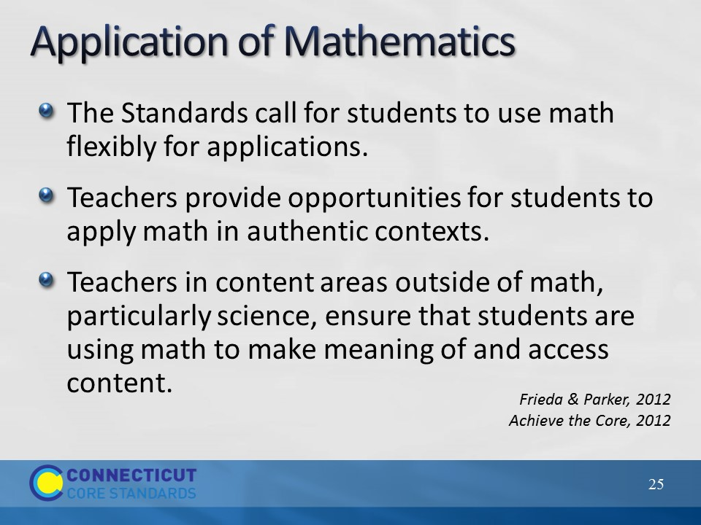
Slide 25
Application of Mathematics
Go through points on the slide. Ask participants how they have had students apply mathematics. Get two or three examples. Ask participants why this is important.

Application of mathematics is important because without this step or expectation, students are learning math as a set of rules, procedures, etc. that have no real meaning in the world outside of the classroom. Students need to learn how math works and how it is used. Note here that when the conversation of application of mathematics typically comes up, the phrase ‘real-world problems’ is usually somewhere in the conversation. As teachers think about the types of problems that students will solve in order to apply their mathematical understanding, have them think about problems that would be ‘real world’ to their students. This means that the problems should be contextually relevant, engaging, and easily understood by the students at their particular grade level. Also note that, just as we saw with the fluency standard, not all standards focus on application. But, when the standard does point to solving problems through an application of mathematics, we really want to see how students can flexibly use what they know and understand. Finally, ask participants to briefly discuss how they can engage students in authentic problem-solving scenarios.

Before moving to the next slide that has examples of contextually relevant problems, highlight the third bullet on the slide and ask for one or two volunteers to give examples of how the CCS-Math standards can be supported and are connected with the standards from other content areas in order for students to see and apply mathematics outside of their typical math lesson time.

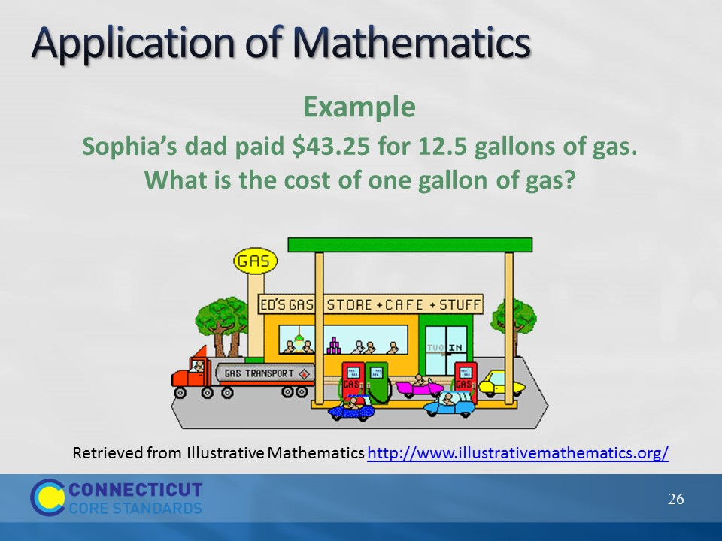
Slide 26
Application of Mathematics
Have participants examine the example on the slide and discuss ways that conceptual understanding and procedural skill and fluency can be applied when solving this problem. Then, have participants look at their standards to determine which standard is being addressed in this problem.

Standard addressed by the problem: CCSS.Math.Content.6.NS.B.3
Fluently add, subtract, multiply, and divide multi-digit decimals using the standard algorithm for each operation.

Example of Participant Response:
To address the standard, students should not be allowed to use a calculator when doing this problem. They should see this as a division problem even though the word divide, nor the division symbols are present and be able to divide the two decimals to get the correct answer of $3.46. They should be able to determine if the answer they get is reasonable given the context. This problem is an example of partitive division (sharing $43.25 over 12.5 groups) and relates to further work with unit rate (CCSS.Math.Content.7.RP.1).
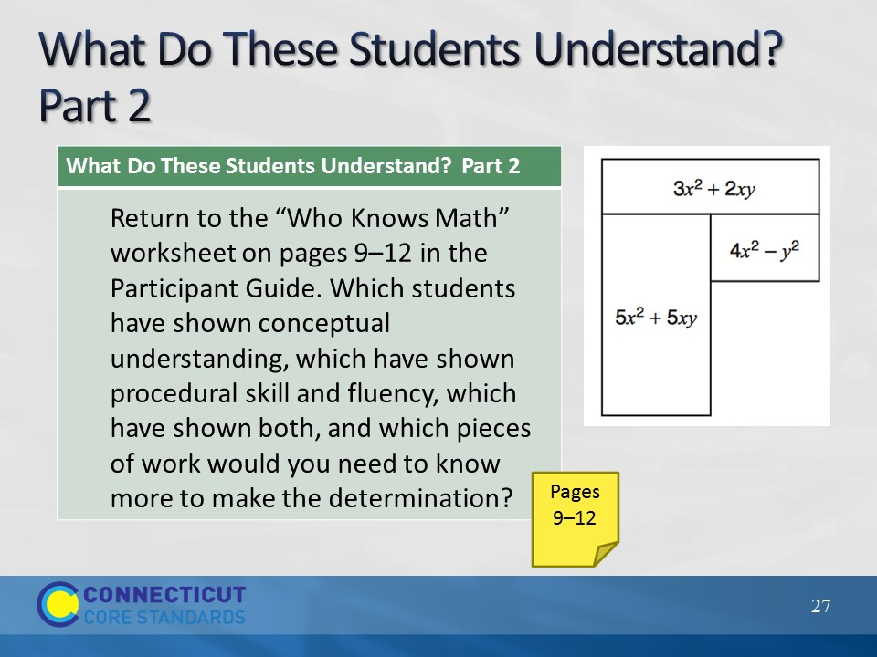
Slide 27
Have participants look back at the “Who Knows Math” student work and ask them to make assumptions about which students have shown conceptual understanding, which have shown procedural skill and fluency, which have shown both, and which pieces of work they would need to know more about in order to make the determination. Have volunteers share their thinking.

An important point to bring up here is that we are asking participants to make assumptions only because the student is not present to find out more. However, teachers should try not to make a determination of what students know and understand based on an assumption. They need to probe deeper to really determine where students are with their understanding.
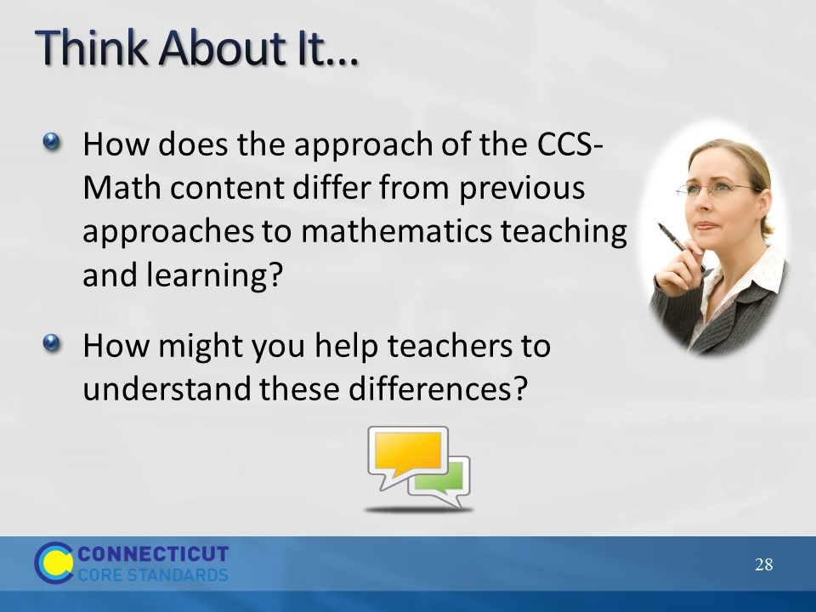
Slide 28
Think About It
Finally, wrap up this section by asking participants to reflect on the questions on the slide. Allow 5 minutes for discussion. You can also use this question to transition to the next activity after the break by linking this discussion on the CCS-Math approach to rigor and now looking specifically at the standards to see how conceptual understanding, procedural skill and fluency, and application of mathematics is developed over and within grade levels.

As time permits, ask for volunteers to share their responses to the question.

