Module 2  Facilitator Guide | Focus on Content Standards

Closing Activity

Connecticut Core Standards for Mathematics

Grades 6–12

Systems of Professional Learning

Session at-a-Glance

Closing Activities (15 minutes)
Participants will complete a Post-Assessment and an online Session Evaluation.

Supporting Documents:
- Post-Assessment
- Session Evaluation (online)

PowerPoint Slides:
- 64–67
Closing Activities
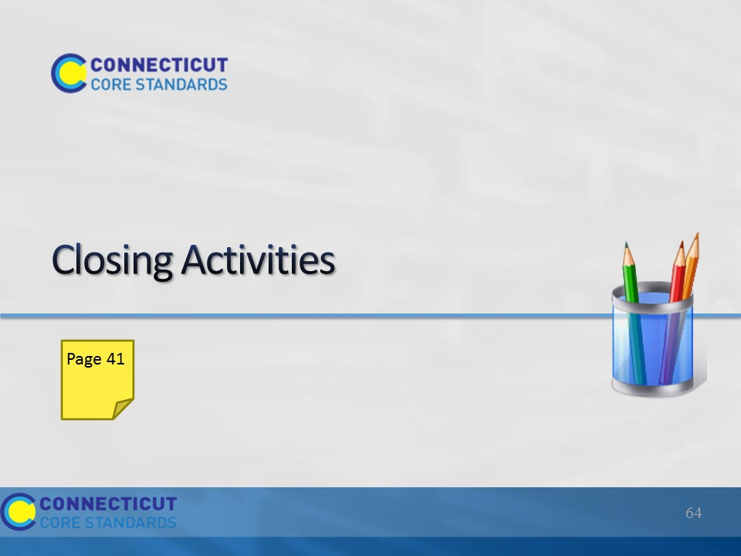
Slide 64
The goal of the Closing Activities is for participants to determine how they will take the key information back to their peers at their school so that everyone gains a shared understanding.

Total Time on Closing Activities 5 minutes

Section 6 at a Glance:
1. Review the Module 2 Outcomes.
2. Have participants complete the Post-Assessment.
3. Have participants complete the online Session Evaluation located here:
http://surveys.pcgus.com/s3/CT-Math-Module-2-6-12
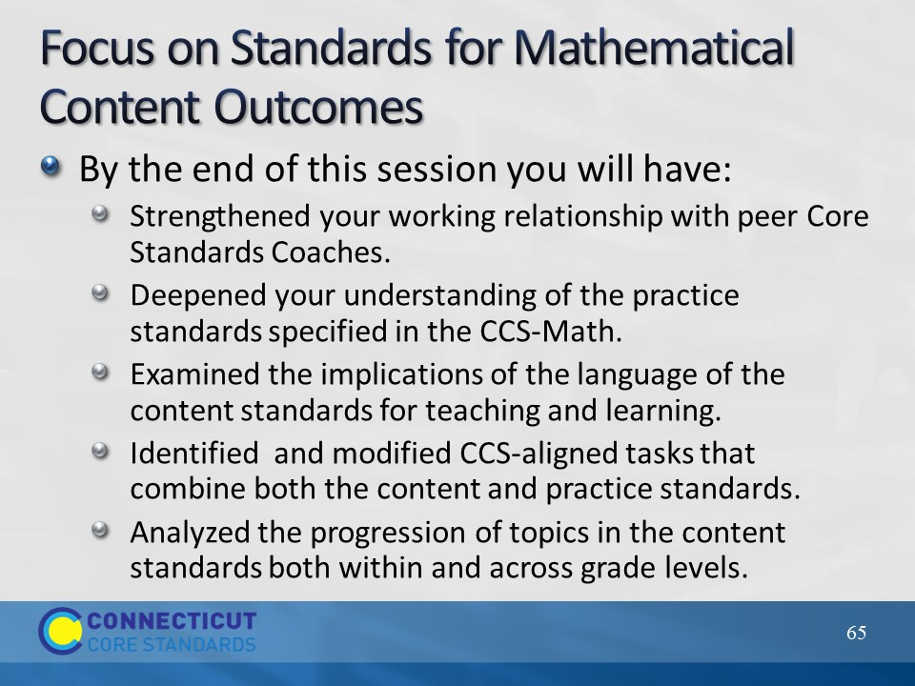
Slide 65
Review the outcomes for the day.
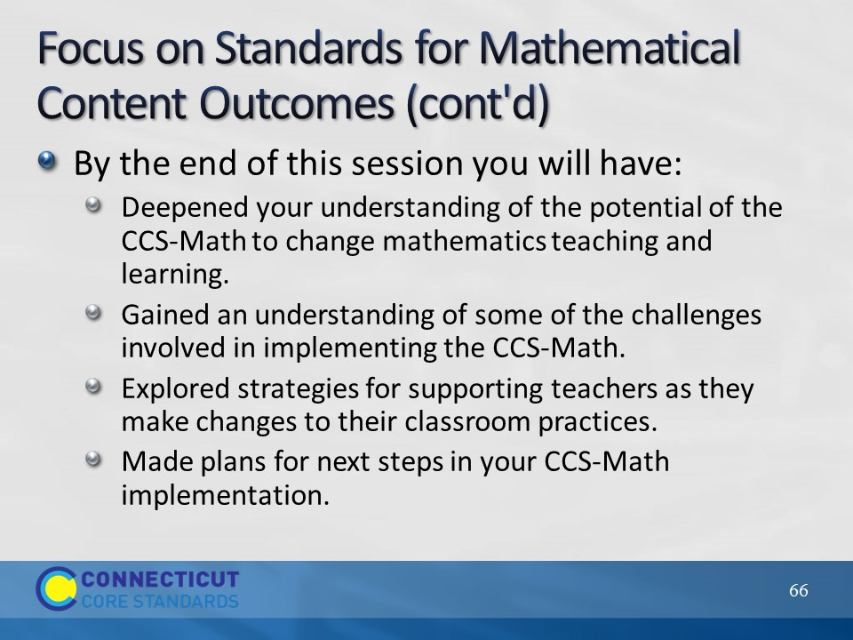
Slide 66
Review the outcomes for the day, continued.
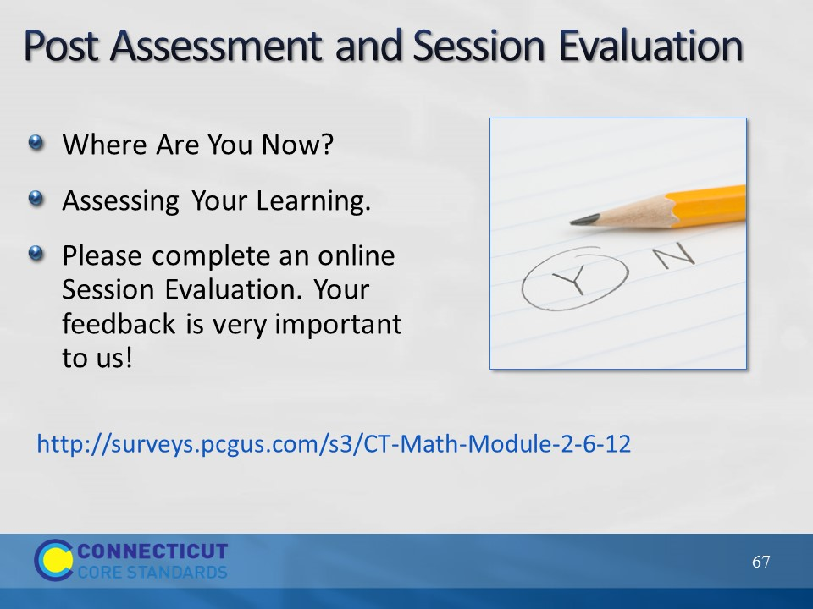
Slide 67
This Post-Assessment is the same as the Pre-Assessment they took in the beginning of the session. This assessment is to gauge their learning based on the activities of the full day session. Remind the participants to fill out their online Session Evaluation forms as well.

