Module 2  Facilitator Guide | Supporting All Students in Close Reading, Academic Language, and Text-Based Discussion

Closing Activity

Connecticut Core Standards for English Language Arts and Literacy

Grades K–5

Systems of Professional Learning

Session at-a-Glance

Closing Activities (10 minutes)
Participants will complete a Post-Assessment and an online Session Evaluation.

Supporting Documents:
- Post-Assessment
- Session Evaluation

PowerPoint Slides:
- 101–105

Session Implementation
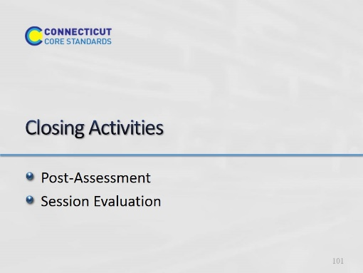Slide 101
Adjusting for time, you may want to ask groups to share some of their ideas from Activity 10.
Closing Activities
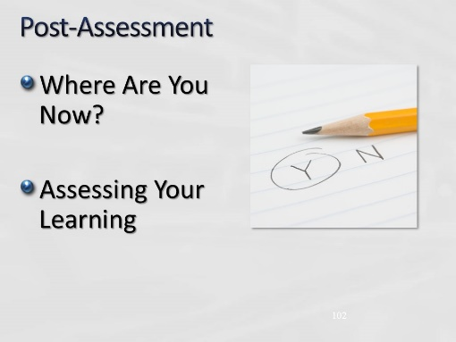Slide 102
The Post-Assessment will be the same as the Pre-Assessment they took in the beginning of the session. This assessment is to gauge their learning based on the activities of the morning. They will find the Post-Assessment in the Participant Guide (3-4 minutes).

Ask for further thoughts, questions.
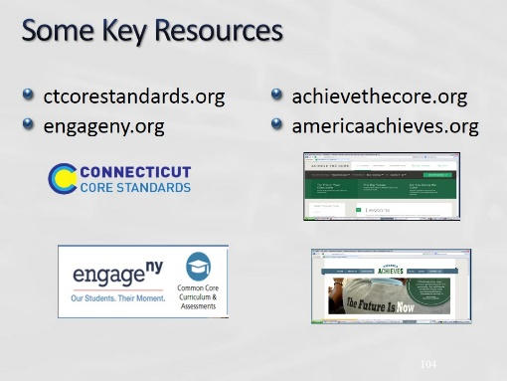Slide 104
Blank.
Slide 105
Blank.

