Module 2  Facilitator Guide | Supporting All Students in Close Reading, Academic Language, and Text-Based Discussion

Activity 9

Connecticut Core Standards for English Language Arts and Literacy

Grades K–5

Systems of Professional Learning

Session at-a-Glance

Activity 9: Reflection (15 minutes)
Participants meet with a small group (three pairs of partners) and share the lessons they wrote today. In these groups, they reflect on the presentation, videos, activities, and lesson planning by using discussion prompts.

Supporting Documents:
- Notes in the notepad section
- Draft close reading lesson
- Examples of instructional practices that align with the CCS-ELA & Literacy and instructional shifts and UDL supports
- Discussion Prompt

PowerPoint Slides:
- 95–98

Session Implementation
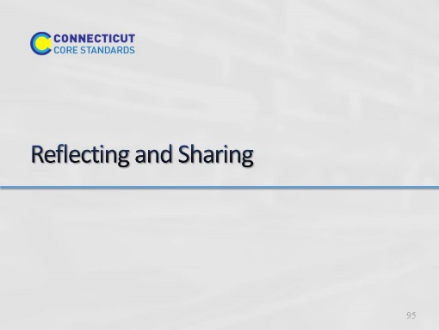Slide 95
Blank.

Activity 9
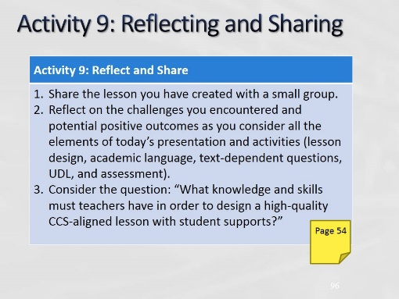Slide 96
Divide into groups by grade levels (of lessons). Ideally, a group will have three sets of partners or 6 people. (Allow 15 minutes for this activity; adjust time as needed.)
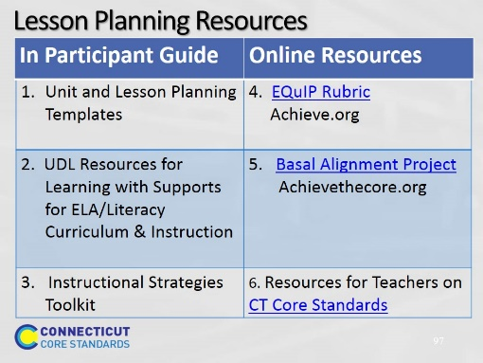Slide 97
Point out the different resources participants have for planning lessons.
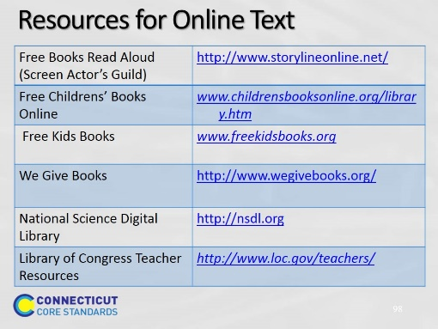Slide 98
Blank.

