Module 2  Facilitator Guide | Supporting All Students in Close Reading, Academic Language, and Text-Based Discussion

Activity 7

Connecticut Core Standards for English Language Arts and Literacy

Grades K–5

Systems of Professional Learning

Session at-a-Glance

What is Universal Design for Learning? (70 minutes)
Participants view the video UDL: Principles and Practices. Dr. David Rose, the co-founder and former director of CAST, explains the three principles of UDL. After viewing the video, participants share thoughts with a partner, then share at their table. Participants review UDL resources and framework over several slides and are introduced to Analytic Graphic Organizers and Word Sorts.

Supporting Documents:
- UDL resources and framework
- Discussion prompts
- Analytic Graphic Organizers
- Word Sorts

Videos:
- UDL Principles and Practice http://www.youtube.com/watch?v=pGLTJw0GSxk
- Interactive Word Wall from Expeditionary Learning http://vimeo.com/84900192 http://vimeo.com/84900192

PowerPoint Slides:

Videos:
- UDL Principles and Practice http://www.youtube.com/watch?v=pGLTJw0GSxk
- Precision Teaching: Word Sort http://www.youtube.com/watch?v=zhW-H7iHXEY

PowerPoint Slides:
- 63–88

Activity 7: Viewing and Discussing Lessons with UDL Supports (20 minutes)
Participants watch video clips and discuss the supports that are built into the lessons.

Supporting Documents
- Directions
- Discussion prompts

Videos:
- Analyzing Text: Brainstorming from Teaching Channel https://www.teachingchannel.org/videos/analyzing-text-brainstorming
- Analyzing Text as a Group from Teaching Channel https://www.teachingchannel.org/videos/analyzing-text-as-a-group

PowerPoint Slides:
- 61–91

Session Implementation
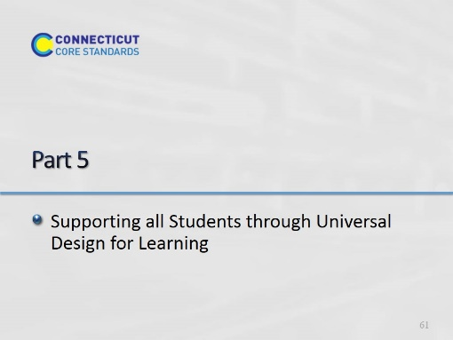Slide 61
Blank.
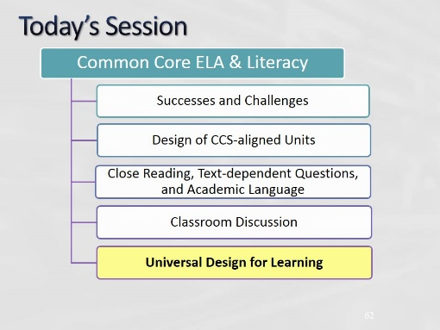Slide 62
There is a total of 105 minutes for the UDL Section of today’s module. There are an additional 40 minutes for reflection and planning.
Although there is no specified break in the afternoon, take a 5-minute break as needed.
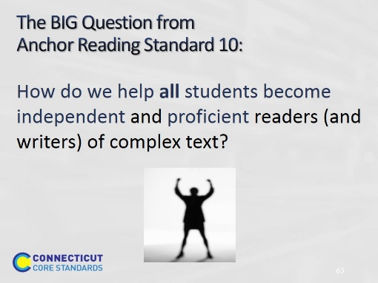Slide 63
The purpose of this slide is to engage participants in thinking about supporting all students.

- Ask a participant to read the question. Ask participants to share ideas on how this can be accomplished.
- Explain to participants that this is the essence of Connecticut Core Standards for ELA & Literacy: Engagement in reading content-rich text; reading, writing, speaking with evidence; and attentiveness to academic language will all lead to Standard 10.
- Point out that students need to be guided towards becoming independent, efficient, and proficient readers.
- The next section of this module focuses on increasing student success.
- How well teachers align, design, and deliver lessons will impact how well students learn.
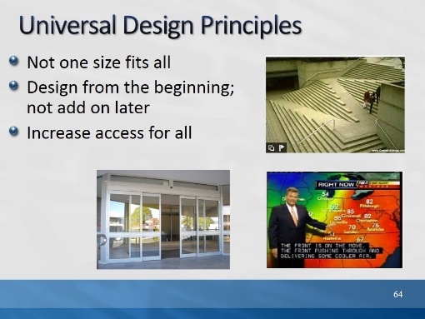Slide 64
The purpose of this slide is to explain the big idea of Universal Design. Ask participants, “Who benefits?”

Beside the intended beneficiary with a disability, who else benefits from preplanned accessibility?

Listen for answers such as, “Mothers with strollers, bicyclists, workers with hand trucks, folks with heavy groceries, folks who are trying to sleep while others are watching TV.”
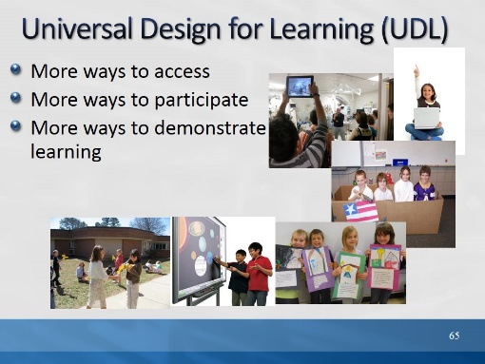Slide 65
The purpose of this slide is to explain UDL in relation to UD. Explain that like UD, UDL gives more all students more ways to access and express learning.
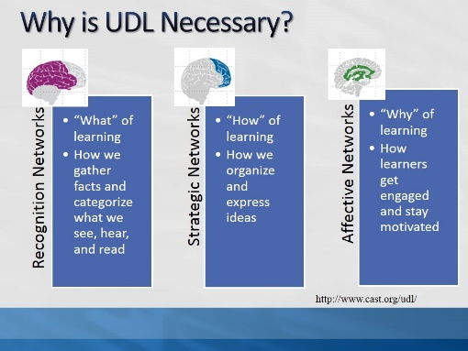Slide 66
Why is UDL necessary?
Individuals bring a huge variety of skills, needs, and interests to learning. Neuroscience reveals that these differences are as varied and unique as our DNA or fingerprints. Three primary brain networks come into play: Recognition, Strategic, and Affective http://www.cast.org/udl/

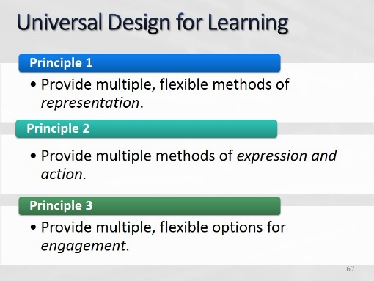Slide 67
Based on brain information on previous slide, UDL is a set of principles for curriculum development that give all learners equal opportunities to learn.
It provides a blueprint for creating instructional goals, methods, materials, and assessments that work for every learner.
It is not a single, one-size-fits-all solution but rather flexible approaches that can be customized for individual learner needs.
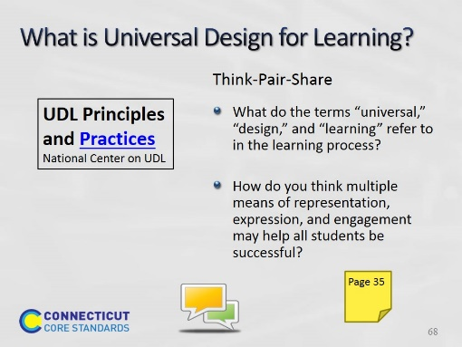Slide 68
10 minutes total Click “Practices” to open link to http://www.youtube.com/watch?v=pGLTJw0GSxk.
The video is 6 minutes and 36 seconds.

The presenter is Dr. David Rose, former co-founder and Chief Educational Officer of CAST. As an introduction to the facilitator’s presentation on UDL, participants will listen to the overview. Ask them to consider the questions on the slide as they listen to Dr. Rose. After viewing the video have participants take about 5 minutes to discuss the questions on the slide. Share out the responses to “How do you think multiple means of representation, expression and engagement may help more students be successful?”

Note for Presenter - Possible Responses
How do you think multiple means of representation, expression, and engagement may help more students be successful?
- Providing options and flexibility will support diverse learner needs.
What do each of the terms (Universal, Design, and Learning) refer to in structuring learning?
- Universal – Referring to all students
- Design – Designing curriculum, goals, methods, materials, and assessments that help students overcome barriers to learning
- Learning – The outcome for all students with universally designed lessons
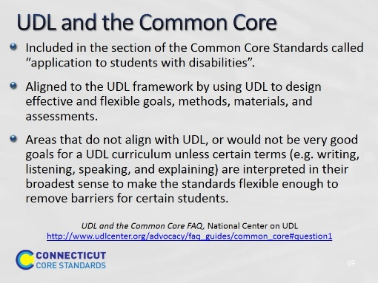Slide 69
From http://www.udlcenter.org/advocacy/faq_guides/common_core#question1
Is UDL included in the common core?
UDL is included in the section of the Common Core Standards called “application to students with disabilities.” In this section the authors referred to the definition laid out in the Higher Education Opportunity Act of 2008 (PL 110-135). UDL not only applies to students with disabilities, it applies to all other learners as well. All students can benefit from the types of instruction used to reach learners “on the margins,” as the learning needs of all individuals vary a great deal. As such, UDL should be used within inclusive general education.
What aligns with UDL?
Curricula (goals, methods, materials, and assessments) designed using UDL, put an emphasis on creating effective, flexible goals, and the Common Core Standards provide an important framework for thinking about what goals will be most effective. UDL emphasizes that an effective goal must be flexible enough to allow learners multiple ways to successfully meet it. To do this, the standard must not embed the means (the how i.e., write, speak, etc.) with the goal (the what).
What might not align with UDL?
There are also areas of the Common Core Standards that do not align with UDL, or would not be very good goals for a UDL curriculum unless certain terms (e.g., writing, listening, speaking, and explaining) are interpreted in their broadest sense to make the standards flexible enough to remove barriers for certain students. UDL stresses that teachers should not confuse the means and the goals. There are certain standards that do just that. For example: "Tell and write time in hours and half-hours using analog and digital clocks." This presents some learners with a barrier because the act of writing is difficult for them. In this case, express would be more appropriate than write, as it allows flexibility and avoids confounding the expectation with tasks that are superfluous to the actual goal. Or, the standard would align with UDL if “write” were interpreted to permit other forms of expression.
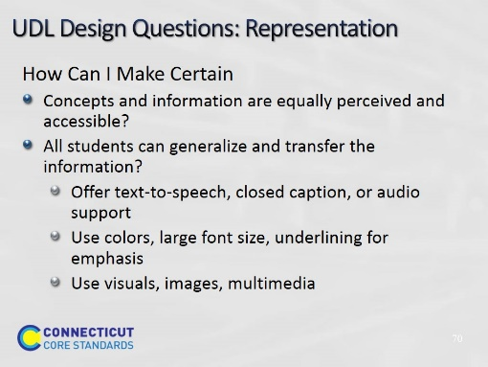Slide 70
Review these questions. They can be used to guide teachers’ thinking when designing lessons using the UDL Framework.

The examples are a partial list of ways teachers can provide multiple means of presenting information. Include in your explanation how technology has increased teachers’ abilities to provide many different types of representation including images, video, PowerPoint, interactive whiteboards, etc.

Ask participants to add additional ways of representing and presenting information.
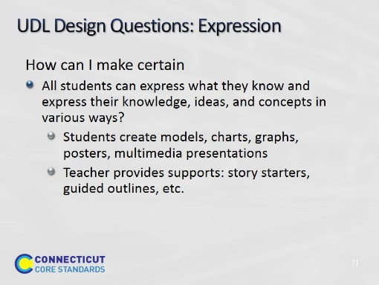Slide 71
Review these questions. They can be used to guide teachers’ thinking when designing lessons using the UDL Framework.
Students can express what they have learned in multiple ways. Ask participants to think about all the ways technology has helped to expand how we can express and assess student learning; i.e., students can produce video and PowerPoint presentations, use word processing, record information, use images, clickers, etc.

Ask participants to add additional actions students can take to express what they know and able to do.
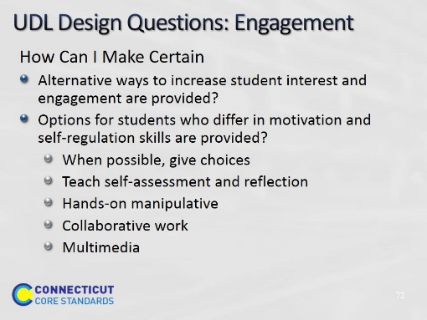Slide 72
Review these questions. They can be used to guide teachers’ thinking when designing lessons using the UDL Framework. Review these methods of engagement.

Ask participants to think about one of their most engaging lessons. What did they do in planning and executing that lesson to make it engaging? What other type of flexible methods can be provided to engage students?
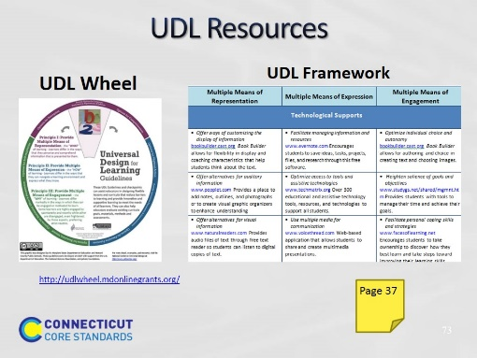Slide 73
Ask participants to review the UDL Resources for Learning at http://udlwheel.mdonlinegrants.org/

Point out the different categories for support on the wheel and that these supports are used for the entire lesson design and delivery including goals, materials, and methods for accessing instruction, guided practice, and independent practice.

Have participants review the UDL Framework in the Participant Guide during this time as well. Point out that they can use these resources later to add student supports to their close reading lesson.
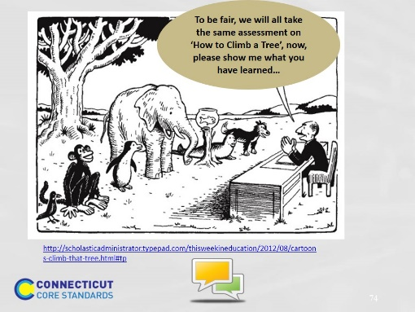Slide 74
Have participants take a few moments to discuss this cartoon. Ask participants, “How do you think this may be related to Universal Design? “

This is an illustration of the need for universal design, a framework that considers all students’ needs during instruction, guided, and independent practice as well as a variety of ways for assessing the learning.
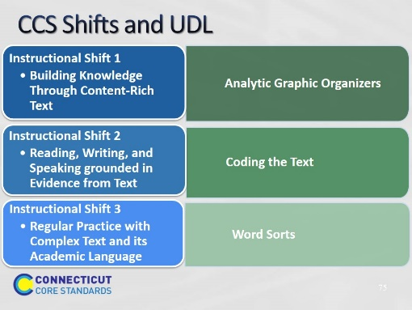Slide 75
The purpose of this slide is to show several types of UDL strategies that do not require technology. We now discuss several instructional strategies that align well with the Connecticut Core Standards instructional shifts. Participants will experience and apply several strategies to support learning that are aligned to the three shifts and provide UDL supports.

Why these instructional practices and routines?
The Connecticut Core Standards for ELA & Literacy require teachers to coach students to develop the reading, writing, and thinking habits we want them to have. These following instructional practices and collaborative routines can help many more students read and write at higher, more sophisticated levels.

Participants explore three strategies that can help increase student achievement. As they review each strategy, have them think about its alignment to the Connecticut Core Standards shifts and to UDL. After reviewing these practices, participants will apply them to grade level text.

Reference: Thinkquiry Toolkits 1 and 2.
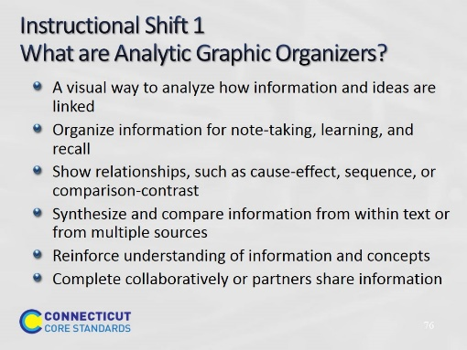Slide 76
Introduce Analytic Graphic Organizers (AGOs) by sharing their purpose and how they can enhance learning. Although Analytic Graphic Organizers (AGOs) are extremely useful tools, their usefulness is entirely determined by how the AGOs are utilized. How teachers select, teach, and support the use of an AGO can result in a powerful learning experience for students or can end up as an exercise in filling in boxes.

Have participants reflect on and share their own experiences using AGOs. Ask participants to respond to question of, “How might well-designed organizers support Shift 1?”
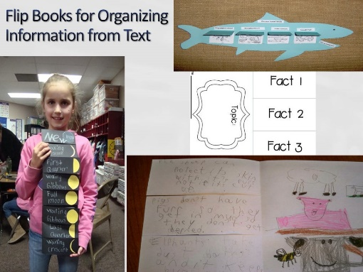Slide 77
Early readers and writers can organize information from the text by creating flip books.
They can be used for sequencing a story, life cycles, (such as butterfly and frog) phases of the moon and key ideas and details from a story.
Upper right - ocean food chain
Far left - phases of the moon
Right and center - 3 facts about animals from a read aloud.
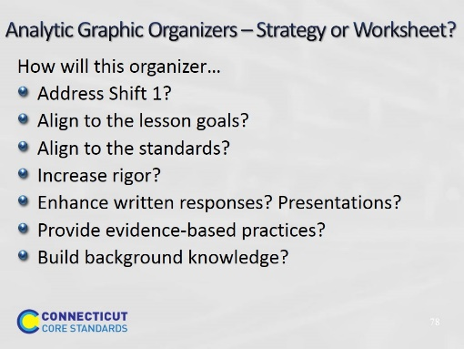Slide 78
Although Analytic Graphic Organizers (AGOs) are extremely useful tools, their usefulness is entirely determined by how the AGOs are utilized. How you select, teach, and support the use of an AGO can result in a powerful learning experience for your students or can end up as an exercise in filling in boxes.

To ensure that the AGO is a strategy and not a worksheet, make certain it:
- Addresses a Connecticut Core Standards shift.
- Is aligned to the lesson goals and objectives.
- Increases rigor by adding an area where students can write how they know or why this is true.
- Helps formulate or enhance written responses by having students use the AGO to organize a summary or written response with evidence.
- Provides for evidence-based practices. Have students show the evidence in the text for their responses. To do this add: why?, how do you know?, and where is the evidence? to the AGO.
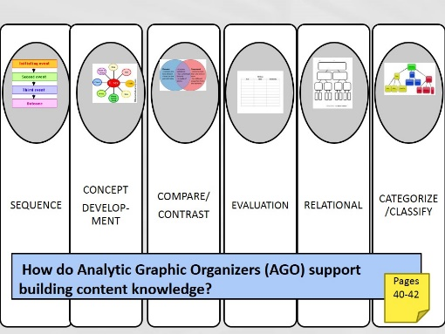Slide 79
10 minutes. There are many different types of organizers. Participants will review the AGOs in their Participant Guide and consider which of these AGO’s might support building knowledge in their lesson.
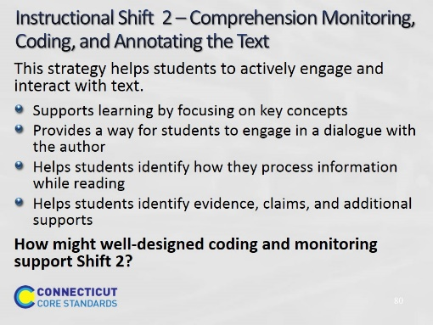Slide 80
Direct participants to examples of instructional strategies that align with instructional Shift 2 on pages 43 of the Participant Guide.
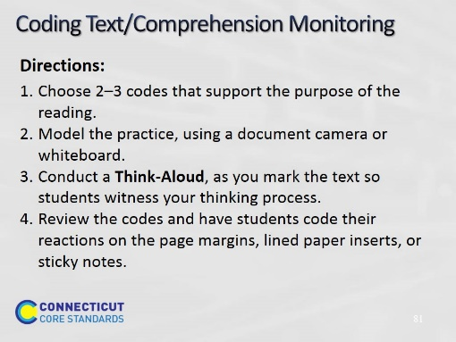Slide 81
Ask participants if they find that their students sometimes race through an assigned reading and at the end can't tell them about anything that they read? With the Connecticut Core Standards, repeated readings and conducting close readings, students will need a way to slow down and deeply focus on the content of the assigned reading. Coding the text will help students read more carefully and closely. Set a minimum number of codes they should have on the text to encourage use.

Review with participants what coding of the text might look like:
- Begin with short texts on interesting topics that are worth re-reading.
- Ask students to read a text 3 times.
- The first time, students should read independently while using three codes to mark up the text: I know/agree with this (!), I disagree with this (x), I am confused (?). Students should also underline words they do not know. Students can rate their understanding on a scale from one to ten.
- Then, with a partner, they should read through the text again and compare their coding and share meanings of words or suppositions about what is meant in places where one or both partners were confused.
- After reading the piece twice, ask students to rate their understanding again on a scale from one to ten to see if it has improved.
- Then, have the partners meet in a small group to read through and discuss the piece, their understanding, and any questions they still have. After the third reading, students write or audio-record about how their understanding of the text changed from the first to third reading, noting questions or problems they still have with it.

These steps facilitate the growth of students’ metacognitive skills as well as comprehension because students engage in gauging their understanding of text before they read, while they read, and after they read.
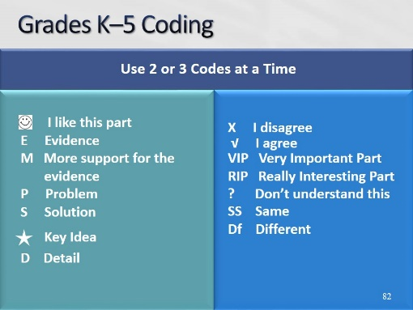Slide 82
Ask participants if they find that their students sometimes race through an assigned reading and at the end can't tell them about anything that they read? With the Connecticut Core Standards, repeated readings and conducting close readings, students will need a way to slow down and deeply focus on the content of the assigned reading. Coding the text will help students read more carefully and closely. Set a minimum number of codes they should have on the text to encourage use.

Review with participants what coding of the text might look like:
- Begin with short texts on interesting topics that are worth re-reading.
- Ask students to read a text 3 times.
- The first time, students should read independently while using three codes to mark up the text: I know/agree with this (!), I disagree with this (x), I am confused (?). Students should also underline words they do not know. Students can rate their understanding on a scale from one to ten.
- Then, with a partner, they should read through the text again and compare their coding and share meanings of words or suppositions about what is meant in places where one or both partners were confused.
- After reading the piece twice, ask students to rate their understanding again on a scale from one to ten to see if it has improved.
- Then, have the partners meet in a small group to read through and discuss the piece, their understanding, and any questions they still have. After the third reading, students write or audio-record about how their understanding of the text changed from the first to third reading, noting questions or problems they still have with it.

These steps facilitate the growth of students’ metacognitive skills as well as comprehension because students engage in gauging their understanding of text before they read, while they read, and after they read.
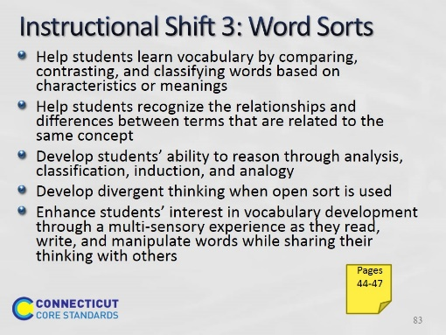Slide 83
Direct participants to examples of instructional strategies that align with instructional Shift 3 on page 44 of the Participant Guide.
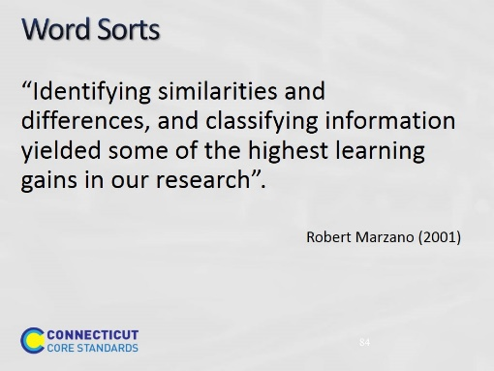Slide 84
Ask a participant to read the quote aloud. Point out that the research is clear that classifying information helps students to think about how things are alike, how they may be different, and how they may be connected.

Adapted from the book: Classroom Instruction that Works: Research-based Strategies for Increasing Student Achievement, by Robert Marzano (2001).

Word Sort is a classification routine where the teacher provides lists of words that students cluster together in meaningful ways to evolve main ideas or determine conceptual relationships (closed sort). The students may also sort the words by characteristics and meanings and then label the categories (open sort) (Gillet & Kita, 1979).

Note: Words Sorts are most effective when used as a collaborative routine because students can discuss multiple ways that the words on the list are related, thereby developing a more robust understanding of the terms. Discussing and classifying are two effective ways to help students learn and remember academic vocabulary.
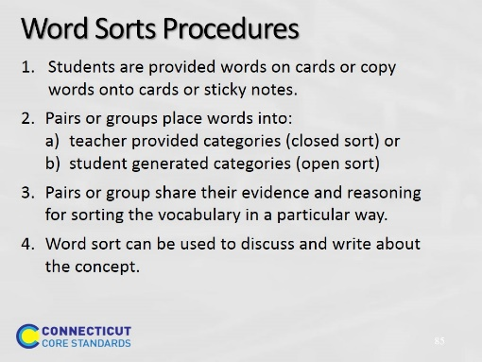Slide 85
To start using word sorts, state that the purpose of a Word Sort is to develop and remember deeper understandings of vocabulary terms and learned concepts.
PURPOSE: for use after reading, helps students to:
- learn vocabulary by classifying words based on characteristics or meanings
- recognize the relationships between terms that are related to the same concept
- reason, analyze, classify and form analogies
- enhance interest in vocabulary development through a multi-sensory experience as they manipulate words while sharing their thinking
- develop divergent thinking when open sort is used
To start using Word Sorts, state that the purpose of a Word Sort is to develop and remember deeper understandings of vocabulary terms and learned concepts.
PURPOSE: for use after reading, helps students to:
- learn vocabulary by classifying words based on characteristics or meanings
- recognize the relationships between terms that are related to the same concept
- reason, analyze, classify and form analogies
- enhance interest in vocabulary development through a multi-sensory experience as they manipulate words while sharing their thinking
- develop divergent thinking when open sort is used

There are 2 types of Word Sorts: closed and open.
When using Word Sorts, teachers may use this sequence for scaffolding this process after reading text.

- Provide a word bank and the categories (closed)
- Provide the categories, have student take words from the text (closed) (This gets students to read the text closely.)
- Provide words, have students create the categories (open)

Tell participants that the next two slides illustrate a closed sort and an open sort. After these have been reviewed they will work on both Word Sorts with a partner.
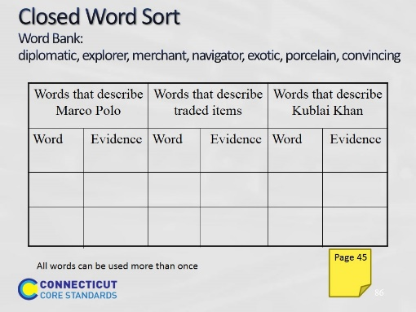Slide 86
5 minutes. This is a sample closed Word Sort. Point out to participants that this word sort includes a column to relate where they found the evidence for placing the word in this category. This can be a quote from the text. Make certain to mention that words can be used more than once. Remind them that the Participant Guide page 46 will provide the information they need about Marco Polo to complete the closed sort.
All answers are acceptable as long as they can be backed up with evidence.
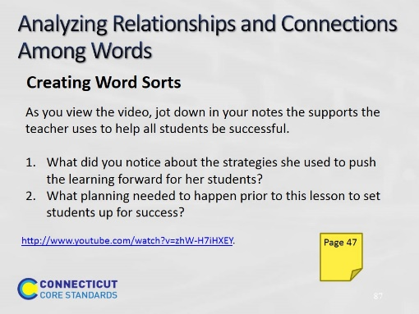Slide 87
8 minutes. In this video segment, you will see students involved in a Word Sort that is open-ended enough to engage every learner. The goal is to help students develop vocabulary that describes the characteristics of people and animals they meet in their reading. The task also develops students' understanding of how root words, prefixes, and suffixes work. This knowledge will help students read and write independently. They draw on their schema and prior experiences and build on the ideas of others as they collaborate to solve the problem at hand. As you view this video, look for supports that the teacher infuses into the lesson.
During the Word Sort, students negotiated with group members as they built their understanding of the relationship between the words.
The teacher played an essential role during this work and think time.
- What did you notice about the strategies she used to push the learning forward for her students?
- How did she help make all students successful?
- Which of these strategies might you use with your students to support their learning?
- What planning needed to happen prior to this lesson to set students up for success?
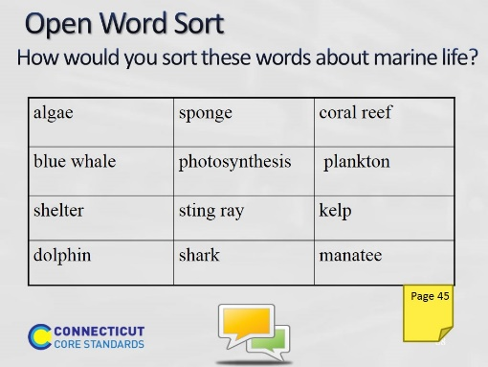Slide 88
5 minutes. This is an example of an open Word Sort. For instructions to complete the open sort, have participants talk about/write down some potential ways of categorizing these words. Tell the participants that they should be able to explain how they categorized these words and analyze how they reached their conclusions. Explain that when using this technique, all categories are acceptable as long as students can explain why and provide evidence. Some words may not be able to be classified under any of the categories. In this case, always give students a ‘leftovers’ category in an open Word Sort for words that don’t fit. Also, some words can be used in more than one column.

Stop here and have participants read and discuss the information about Word Sorts on page 44 in the Participant Guide and complete both sample Word Sorts on page 45. Ask how they have used these strategies in the past, if there are other ways they can think of to use or increase the rigor of these strategies, and if they know of any online resources for strategies.
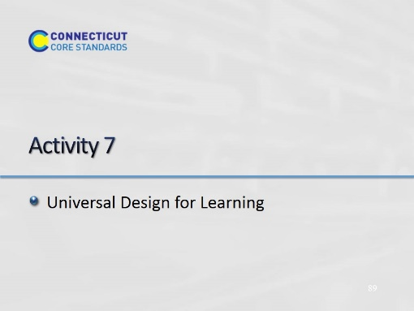Slide 89
Blank.

Activity 7
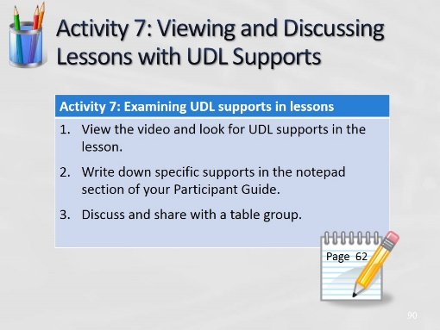Slide 90
(Allow 15 minutes for this activity; adjust time as needed.)

Have participants look for multiple methods of representation, expression, or engagement that the teachers use in each of these videos.
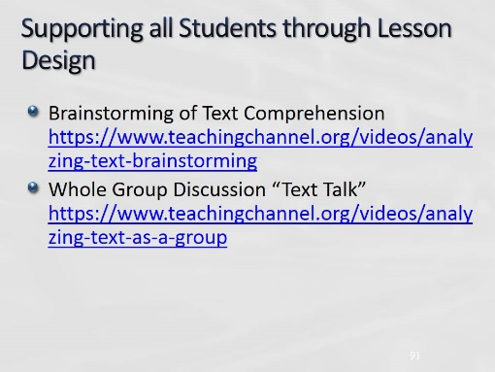Slide 91
In these two videos, which are part of the same lesson sequence, 5th grade teacher, Stacey Brewer carefully plans her lesson so that students are supported in close reading and discussion to be prepared and have confidence for the written task.

