Module 2  Facilitator Guide | Supporting All Students in Close Reading, Academic Language, and Text-Based Discussion

Activity 5

Connecticut Core Standards for English Language Arts and Literacy

Grades K–5

Systems of Professional Learning

Session at-a-Glance

Activity 5: Reading about Classroom Discussion (30 minutes)
Participants will read, annotate, and discuss Close reading and far reaching classroom discussion: a vital connection, an article from the International Reading Association.

Supporting Documents:
- Gray, J. (2005) "Four A’s Text Protocol." National School Reform Faculty. Harmony Education Center. http://www.nsrfharmony.org/protocol/doc/4_a_text.pdf
- Snow, C. & O’Connor, C. (2013). Close reading and far reaching classroom discussion: a vital connection. International Reading Association http://www.reading.org/Libraries/lrp/ira-lrp-policy-brief--close-reading--13sept2013.pdf
Video
- Catherine O’Connor on Discussion The Big Picture http://ccdd.serpmedia.org/index.php

PowerPoint Slides:
- 53–56

Session Implementation
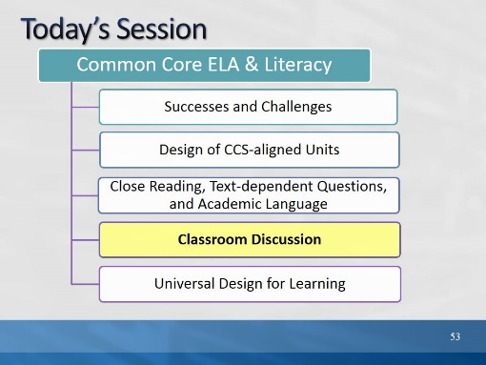Slide 53
Blank.
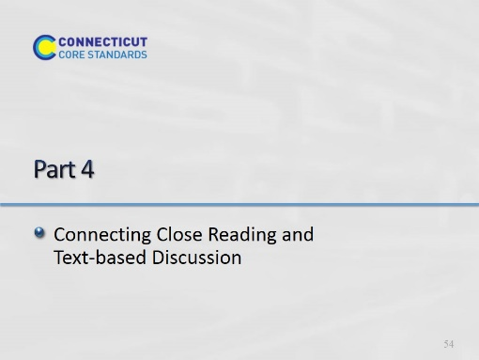Slide 54
(60 minutes total for Part 4) This backward design portion is meant only as general information and guidance so that participants will understand where a close reading lesson might fit into an overall unit. Module 4 will go more deeply into unit design.
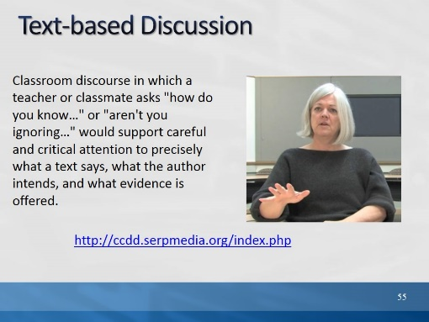Slide 55
Read the quote and show the video as a prelude to the article handout.
In this brief video, Catherine O’Connor, professor at Boston University and researcher, discusses a project in which she is involved through SERP. SERP is an organization that provides a structure for research and research based programs carried out in field sites – schools and school districts, who work in partnership with SERP. In this video, Catherine O’Connor explains the importance of text-based discussion while explaining a new project, CCDD, “Catalyzing Comprehension through Discussion and Debate.”

http://ccdd.serpmedia.org/index.php
Segment: 2:40 – 5:45

Activity 5
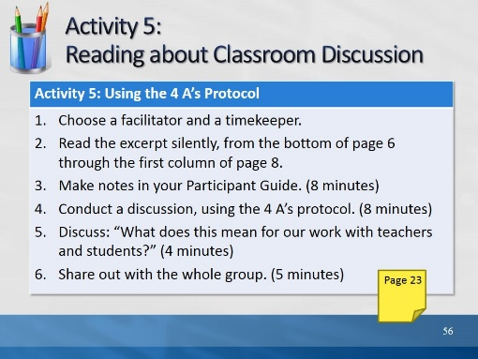Slide 56
Description of the Activity:
Participants read and annotate a handout excerpt from an IRA policy brief, “Close Reading and Far-Reaching Classroom Discussion: Fostering a Vital Connection” (Snow & O’Connor, 2013 retrieved from: http://www.reading.org/Libraries/lrp/ira-lrp-policy-brief--close-reading--13sept2013.pdf). In groups of 4, they use the 4 A’s Protocol, to discuss the article, and prepare to answer the question, What implications does this excerpt have for our work with teachers and students?
Gray, Judith. "Four 'A's Text Protocol." National School Reform Faculty. 2005. Harmony Education Center. http://www.nsrfharmony.org/protocol/doc/4_a_text.pdf

1. Point out the location of the activity in their Participant Guide. This summary (below) is in the Participant Guide. Explain that they are going to read an excerpt from a longer article and discuss it. You will summarize the parts of the article they are not reading.

2. Read this summary: The authors, Snow and O’Connor examine close reading and consider the advantages, as well as the limitations of close reading. They suggest ways in which close reading might be usefully supplemented by other classroom practices, to ensure that it supports comprehension and to avoid problems from an excessive focus on close reading, such as student frustration, a decline in motivation to read, and reduction in opportunities to learn content.

3. Review the directions and point out the location of the protocol grid in their Participant Guide. The sections of the article participants will read address the relationship between classroom discussion and close reading. They read, beginning at the bottom of page 6 through the first column on page 8: “Narrow Close Reading Undermines Valuable Classroom Discussion,” and, “Productive Close Reading.”
Choose a timekeeper and facilitator.
Read the excerpt silently, making notes in the table for each of the 4 A’s and highlighting sentences, phrases, or words in the text as evidence. (8 minutes)
• What Assumptions does the author of the text hold?
• What do you Agree with in the text?
• What do you want to Argue with in the text?
• What part of the text do you want to Aspire to or Act upon?
In a round, have each person identify one assumption in the text, citing the text as evidence. (1 minute per person, 4 minutes total)
In the second round, each participant may choose any one of the remaining 3 A’s to share. (1 minute per person, 4 minutes total) Please note, this is a variation on the original 4 A’s which continues in rounds for each of the remaining A’s.
End the session with an open discussion framed around the questions: What does this mean for our work with teachers and students? (4 minutes)
One person from each table will share briefly about his/her table’s discussion. (5 minutes total)

