Module 2  Facilitator Guide | Supporting All Students in Close Reading, Academic Language, and Text-Based Discussion

Activity 4

Connecticut Core Standards for English Language Arts and Literacy

Grades K–5

Systems of Professional Learning

Session at-a-Glance

Activity 4: Creating a Sequence of Text-Dependent Questions (35 minutes)
Participants create a series of text dependent questions for their selected grade level texts that scaffolds students toward general understanding of their text and the selected standards.

Supporting Documents:
- Creating Questions for Close Analytic Reading Exemplars: A Brief Guide (Student Achievement Partners) http://achievethecore.org/page/45/short-guide-to-creating-text-dependent-questions
- Lesson Template in the Appendix of the Participant Guide
- Academic Vocabulary Organizer
- Close Reading Organizer

PowerPoint Slides:
- 48–51

Session Implementation
Activity 4
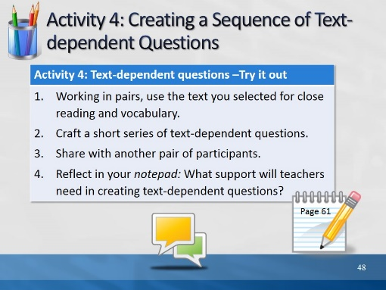Slide 48
Direct participants to write a short series of TDQ’s, based on the content and vocabulary they identified. Remind them that TDQ’s can address academic language challenges. These may go into the “work time” section of the lesson template. Remind them that this is by no means a full lesson, and that these questions could be posed in any number of ways – not necessarily as an ask and answer routine. Allow 30 minutes for Activity 4
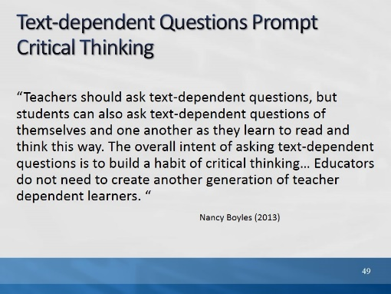Slide 49
The purpose of this slide is to address a question that has been asked by many folks who are concerned that close reading and TDQ’s is a very teacher directed process.

Teacher-created TDQ’s serve two purposes; they scaffold readers toward understanding complex text, and they serve as models for the kinds of questions good readers ask themselves. It is important to remember as you craft TDQ’s, that they are not always asked as a series of questions. They may be asked on different readings and re-readings of text. They may be asked as Quick Writes, or be structured into graphic organizers.

This quote and the information on the next two slides is from the same source as the earlier quote on Slide 32: “Closing in on Close Reading.” December 2012/January 2013 | Volume 70 | Number 4
Common Core: Now What? Pages 36-41
Closing in on Close Reading
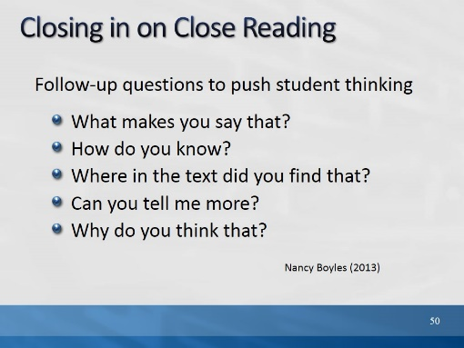Slide 50
The purpose of this slide is to suggest ways that teachers can encourage students to refer to the text and elaborate on their answers.
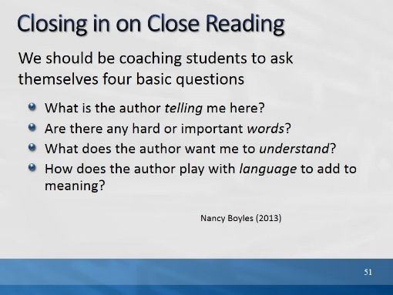Slide 51
It is important to always keep in mind that the purpose of creating and asking text-dependent questions goes beyond helping students to understand the text or text in front of them; the purpose is to help them become independent readers of complex text.
Nancy Boyles asks: How can we ensure that students both reap the requisite knowledge from each text they read and acquire skills to pursue the meaning of other texts independently? I suggest we coach students to ask themselves four basic questions as they reflect on a specific portion of any text:

Nancy Boyles is the graduate reading program coordinator for Southern Connecticut State University in New Haven
December 2012/January 2013 | Volume 70 | Number 4
Common Core: Now What? Pages 36-41
Closing in on Close Reading
Nancy Boyles

