Module 2  Facilitator Guide | Supporting All Students in Close Reading, Academic Language, and Text-Based Discussion

Activity 3a and 3b

Connecticut Core Standards for English Language Arts and Literacy

Grades K–5

Systems of Professional Learning

Session at-a-Glance

Activity 3a and 3b: Digging Deeply –Close Reading, Text-Dependent Questions, and Academic Language (60 minutes)
Participants choose and read an appropriately complex (may be read aloud) text, noting the central idea of the text, content knowledge, and academic language and vocabulary challenges in the text. Concentrating on the vocabulary they select, they divide the words into quadrants for instruction using a graphic organizer.

Supporting Documents:
- Text Excerpts in the Appendix of the Participant Guide
- Directions
- Close Reading Organizer
- Academic Vocabulary Organizer

PowerPoint Slides:
- 32–47

Session Implementation
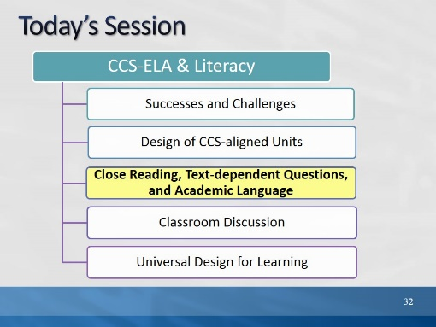Slide 32
Blank.
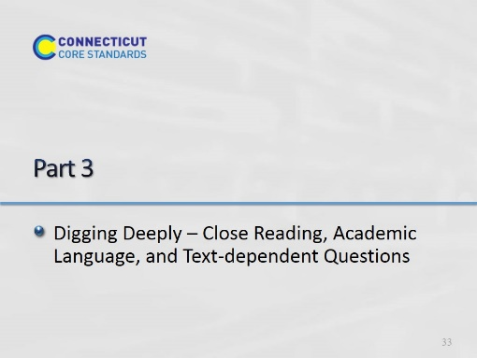Slide 33
(100 minutes) In Part 3, participants will learn more about specific elements of close reading and will practice those elements.

Building on Module 1, participants come to a deeper understanding of the relationship of academic language to close reading. They review the sequencing of text-dependent questions introduced in Module 1. They will learn more about types and purposes of text-dependent questions, including questions for general understanding, key details and inferences, academic language, craft and structure, and to discern author’s purpose. They begin to build a close reading lesson by selecting and reading a short text.
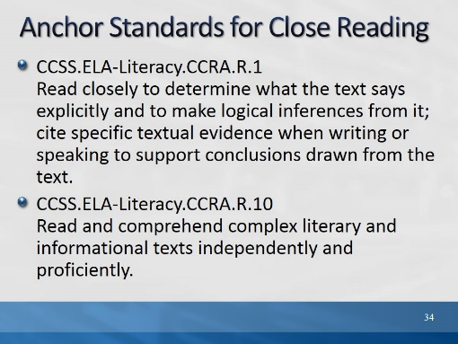Slide 34
Remind participants of these two bookend standards for reading. While all of the reading standards require reading closely, these two summarize both the purpose and the requirement for close reading.
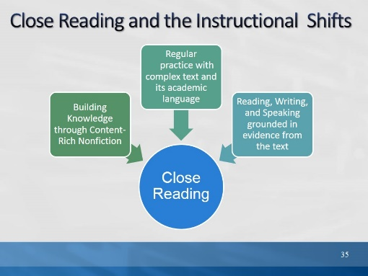Slide 35
The purpose of this slide is to explain how close reading relates to the 3 instructional shifts introduced in Module 1.
- The practice of close reading is a way in which readers are able to address all of the shifts.
- We read closely to build knowledge from text;
- we find evidence by reading text closely;
- Close reading is a way to scaffold students toward independence in reading complex text and building vocabulary and language skills.
- In order for teachers to scaffold students toward independently reading and comprehending complex text, teachers must first read the text themselves.
- Teachers read the text thoroughly, identify big ideas and key details in the text, determine the organizing structure of the text, and identify potential barriers in terms of vocabulary and academic language.
- Text-dependent questions serve as models for the kinds of questions good readers ask themselves.
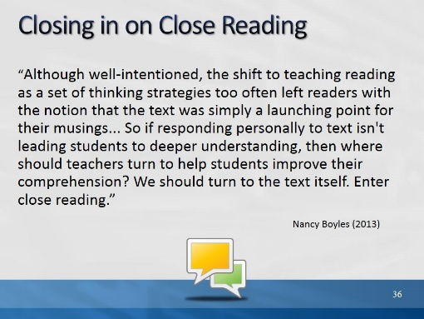Slide 36
The purpose of this slide is to provide a context for WHY close reading has become a symbol of CCSS. Like the shifts, it is really how literacy instruction in the CCSS differs from previous practice. In this article, Nancy Boyles discusses how something good – a focus on metacognition – can become something that takes students away from the text and toward personal response - connecting, visualizing, etc.

December 2012/January 2013 | Volume 70 | Number 4
Common Core: Now What? Pages 36-41
Closing in on Close Reading
Nancy Boyles
In this article, Nancy Boyles comments on the origin and purpose of close reading. She argues that the focus on teaching (metacognitive) reading strategies in elementary school has in many cases moved students away from comprehension of the text itself, and toward a focus on personal connections.

After reading this quote and explaining its context, ask participants to turn and talk. Have you seen evidence in classrooms that a focus on metacognitive strategies has sometimes moved students away from having to deeply understand the text?
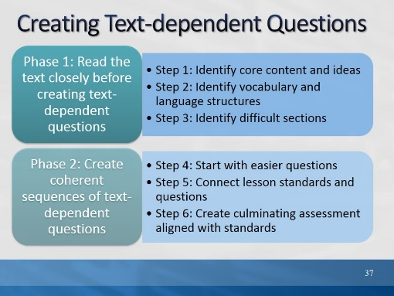Slide 37
Remind participants that they saw this slide in Module 1. Let them know that we will be practicing creating text-dependent questions today. Remind them of the two big steps in creating text-dependent questions (Phase 1 and Phase 2).

Activity 3a
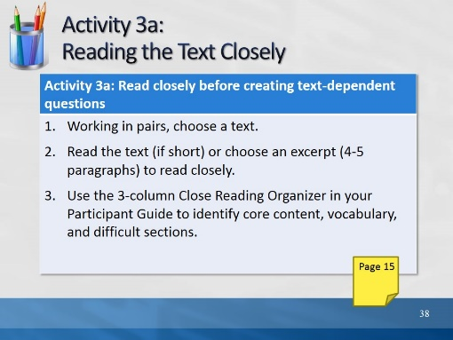Slide 38
Direct participants to choose a text that they will continue to use throughout the remainder of the day’s activities. They may choose from the following:
- One that you brought with you today, or
- One of the texts in our nonfiction collection (box of books from Module 1, or
- One of the selections from the SBAC practice test in the Appendix of the Participant Guide
Direct participants to the appropriate page in their Participant Guide and review the 3-column Close Reading Organizer. Allow 25 minutes for Activity 3a.
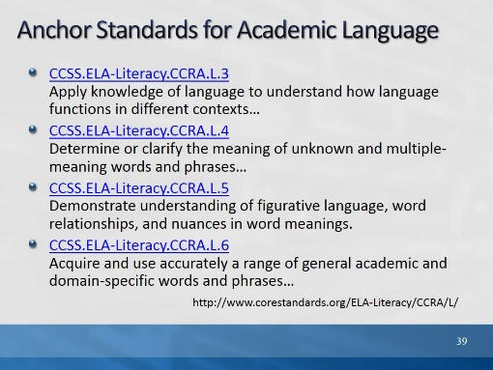Slide 39
Explain that now they have identified core content, challenging parts of the text, and key vocabulary, we are going to dig a little more deeply into the choice and treatment of vocabulary.

These college and career ready anchor standards relate to vocabulary. Point out that there is more to academic language than identifying unknown words or phrases.
CCSS.ELA-Literacy.CCRA.L.3
Apply knowledge of language to understand how language functions in different contexts, to make effective choices for meaning or style, and to comprehend more fully when reading or listening.
CCSS.ELA-Literacy.CCRA.L.4
Determine or clarify the meaning of unknown and multiple-meaning words and phrases by using context clues, analyzing meaningful word parts, and consulting general and specialized reference materials, as appropriate.
CCSS.ELA-Literacy.CCRA.L.5
Demonstrate understanding of figurative language, word relationships, and nuances in word meanings.
CCSS.ELA-Literacy.CCRA.L.6
Acquire and use accurately a range of general academic and domain-specific words and phrases sufficient for reading, writing, speaking, and listening at the college and career readiness level; demonstrate independence in gathering vocabulary knowledge when encountering an unknown term important to comprehension or expression.
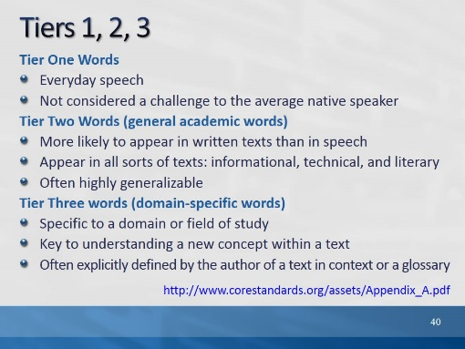Slide 40
- Remind participants that in Module 1, we learned about the 3 tiers of vocabulary, and that both tiers 2 and 3 were important to teach.
- We also discussed that Tier 2 words are often overlooked in instruction because they are not domain specific, nor easily defined. Yet they are important for instruction because they carry meaning of the text and help carry content.
- Ask participants to look at the vocabulary words they chose for their close reading lesson. Consider whether the words are general academic words (Tier 2) or domain specific (Tier 3).

(Found in Appendix A. Tiers are credited to Beck, I. L., McKeown, M. G., & Kucan, L. (2008). Creating robust vocabulary: Frequently asked questions and extended examples. New York, NY: Guilford.)
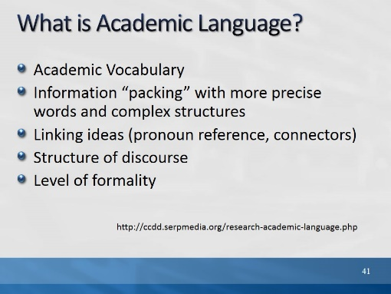Slide 41
The purpose of this slide is to differentiate academic language from vocabulary.
- We often hear the terms Academic Vocabulary and Academic Language used interchangeably.
- Academic language is more than just the unfamiliar vocabulary that students encounter in their content area classes, or the texts that they are required to read.
- While academic vocabulary is a component of academic language, there are other aspects of the language of school that are crucial predictors for academic success–some of which are not easily defined.
Read the examples, below:
Information “packing”: As we learn more precise words and structures, we are able to express complex ideas in shorter ways. E.g., “Water being turned into steam by heat and then going into the air,” becomes “evaporation.” A feature of academic texts is that more information is compacted into fewer words. It is dense language.

Linking ideas (pronoun reference, connectors): More complex texts use pronoun references, or shift the words used to refer to the same person or thing within a text, e.g. “she”/”Mary”, or calling a cruel king “the tyrant” in another part of the text. Also, more complex texts use connectors that may be unfamiliar to students, for example, “however,” “therefore,” or “consequently.”

Structure of discourse: Different kinds of text are structured differently, and students may not understand the text because they don’t understand the structure. For example, the structure of an argumentative text is different than that of a narrative. Texts are organized differently in different domains as well.

Level of formality: Academic language, in general, is more formal than everyday speech. In addition, different types of contexts require different kinds of speech. Students need to be able to recognize this within texts so that they are better able to understand what they are reading. Is this a business proposal? Or is it a dialogue in everyday informal language? This extends to writing as well, so that students understand that the level of formality must match the audience, purpose, and occasion.

(SERP = Strategic Education Research Partnership: SERP is designed to provide the infrastructure to make a coherent and sustained research, development, and implementation program possible.)
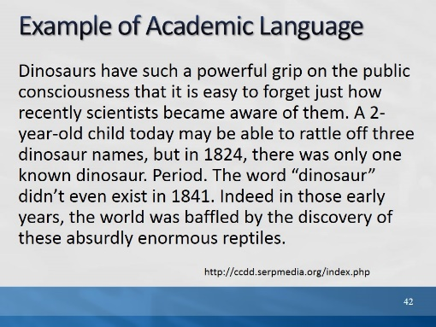Slide 42
Point out the word, Period, in the middle of the paragraph. Ask, “What purpose does it serve?” (A: to emphasize how limited the knowledge was about dinosaurs.)
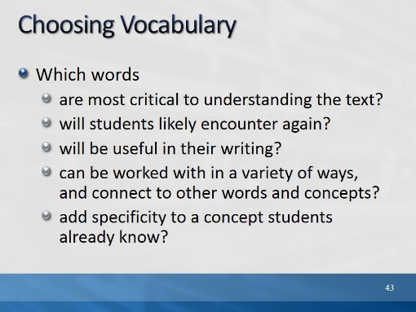Slide 43
The purpose of this slide is to remind participants of how we choose and prioritize vocabulary for instruction within and beyond a text-based lesson.

Remind participants that, as they are choosing vocabulary for TDQ’s, they should also be attending to other academic language challenges that will likely interfere with students’ comprehending the text at hand.
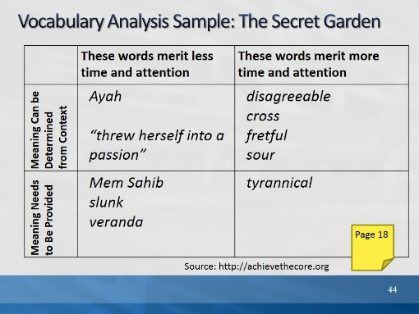Slide 44
The purpose of this slide is to introduce the vocabulary quadrant activity.

Vocabulary Quadrant: http://achievethecore.org/content

This vocabulary quadrant is helpful for making decisions about how to treat the vocabulary we have identified.

The Secret Garden is a CC Appendix B exemplar text. Help participants locate this excerpt in their Participant Guide. They do not need to read it – only to have it available.

Explain how and why these words were chosen.
- Ayah and Mem Sahib are both really Tier 3 words in this text. They are important to understanding the setting, but will not continue in importance throughout the text.
- Disagreeable, cross, fretful, and sour, are all Tier 2 words. They help to describe Mary’s character. Since she will change throughout the book, they will also serve as evidence of that change. They can be used in a word sort or on a word wall, and they are closely related.
- Tyrannical also fits into this category, but it would be hard to define in context.
- “Threw herself into a passion,” is an example of academic language (“threw herself” is idiomatic). However, it is also archaic, and for that reason was not included in column 2 as meriting more time and attention.
Ultimately, if the list gets too long, the teacher may just decide to define the words in column 1 and move on.
In Activity 3b, participants will try this activity with their own close reading selection.

Activity 3b
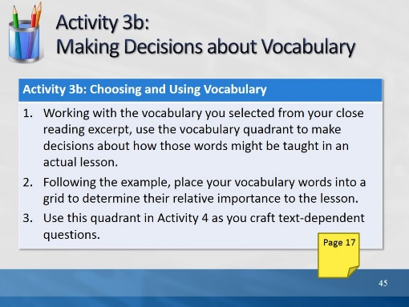Slide 45
Directions for this activity are in the Participant Guide. Participants will use the vocabulary they selected for their close reading lesson and, using the vocabulary quadrant, make decisions about how that vocabulary might be treated in the lesson and beyond. Allow 10 minutes for Activity 3b.
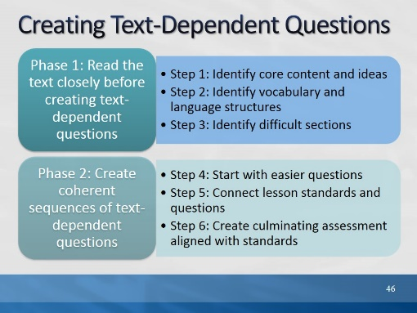Slide 46
The purpose of this slide is to remind participants of where we are in this process. They have completed Phase 1. Now we are moving on to Phase 2. Read Phase 2. Let participants know that the standards have already been selected for today.
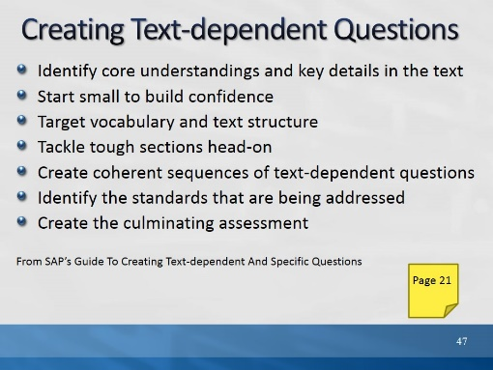Slide 47
The purpose of this slide is to review one order in which TDQ’s can be created. While there is no set process for generating a complete and coherent body of text-dependent questions for a text, this process is a good guide that can serve to generate a core series of questions for close reading of any given text. Please note that this is a recursive not a straightforward process; in backward design, we may select the text to match standards or learning goals we have already determined, and we may create the assessment first. This will help guide the TDQ’s we use!

Read the details for each bullet, below:
Step One: Identify the Core Understandings and Key Ideas of the Text
As in any good reverse engineering or “backwards design” process, teachers should start by identifying the key insights they want students to understand from the text—keeping one eye on the major points being made is crucial for fashioning an overarching set of successful questions and critical for creating an appropriate culminating assignment.
Step Two: Start Small to Build Confidence
The opening questions should be ones that help orientate students to the text and be sufficiently specific enough for them to answer so that they gain confidence to tackle more difficult questions later on.
Step Three: Target Vocabulary and Text Structure
Locate key text structures and the most powerful words in the text that are connected to the key ideas and understandings, and craft questions that draw students’ attention to these specifics so they can become aware of these connections. Vocabulary selected for focus should be academic words “(Tier Two”) that are abstract and likely to be encountered in future reading and studies.
Step Four: Tackle Tough Sections Head-on
Find the sections of the text that will present the greatest difficulty and craft questions that support students in mastering these sections (these could be sections with difficult syntax, particularly dense information, and tricky transitions or places that offer a variety of possible inferences).
Step Five: Create Coherent Sequences of Text-Dependent Questions
The sequence of questions should not be random but should build toward more coherent understanding and analysis to ensure that students learn to stay focused on the text to bring them to a gradual understanding of its meaning.
Step Six: Identify the Standards That Are Being Addressed
Take stock of what standards are being addressed in the series of questions and decide if any other standards are suited to being a focus for this text (forming additional questions that exercise those standards).
Step Seven: Create the Culminating Assessment
Develop a culminating activity around the key ideas or understandings identified earlier that reflects (a) mastery of one or more of the standards, (b) involve writing, and (c) is structured to be done independently.

Refer participants to the “Creating Questions for Close Analytic Reading Exemplars: A Brief Guide” in their Participant Guide.

