Module 2  Facilitator Guide | Supporting All Students in Close Reading, Academic Language, and Text-Based Discussion

Activity 2a and 2b

Connecticut Core Standards for English Language Arts and Literacy

Grades K–5

Systems of Professional Learning

Session at-a-Glance

Activity 2a and 2b: Reviewing an Exemplar Unit (50 minutes)
In pairs by grade level or discipline preference, participants will review the design of an exemplar unit, noting text selection and alignment of standards, learning goals, and assessment evidence. They will scan the lessons in the unit to find evidence of close reading with text-dependent questions, vocabulary development, and text-based discussion. They will note how formative assessment is integrated, and where recommendations are made for student support and differentiation. Afterwards, they will join another pair that reviewed the same unit, sharing observations.

Supporting Documents:
- Directions
- Exemplar Units (separate handouts)
- Annotation codes
- Notepad section of the Participant Guide

PowerPoint Slides:
- 14–30

Session Implementation
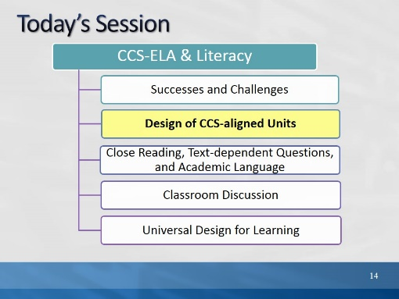Slide 14
In Part 2, we will examine units that have been deemed exemplary by reviewers on the CT Core Standards website.
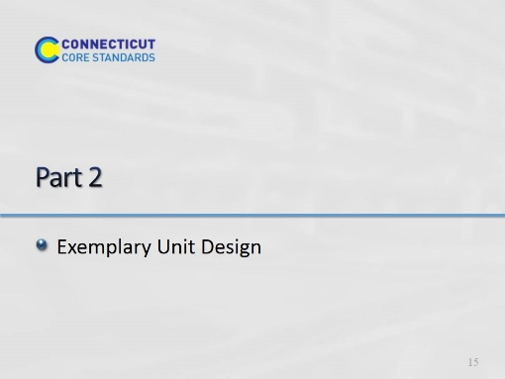Slide 15
55minutes total. This backward design portion is meant only as general information and guidance so that participants will understand where a close reading lesson might fit into an overall unit. Module 4 will go more deeply into unit design.

Facilitator, preview Part 2 for participants:
- This activity is meant to introduce exemplary unit and lesson design–the big picture–before we look closely at various components of a core standards-aligned unit in Modules 2 and 3.
- We will review design principles.
- We will examine several exemplar units for elements of those design principles and key elements.
- These are units that have been vetted and approved on your Ctcorestandards website.
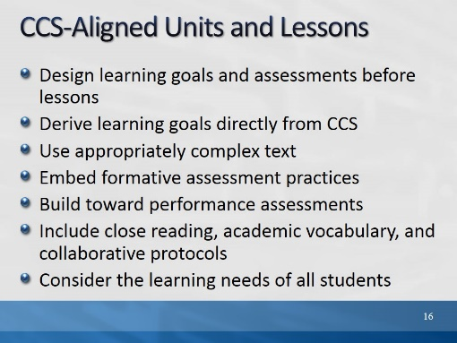Slide 16
10 minutes for the next 5 slides
The purpose of this slide is to introduce the big ideas of CCS curriculum design.
- Most exemplary units, even before the era of Common Core, contained elements of backward design. In backward design, the desired results are established before designing assessments and learning activities.
- CCS exemplary units are aligned with the standards and shifts (introduced in Module 1).
- Texts are selected based on purpose, standards, content, and grade. We are not teaching the book, but rather the goals of the unit through the book and other resources.
- Regular checks for student understanding during lessons and at the end of lessons.
- Assessments that require students to show progress toward, and achievement of, unit goals.
- Attention to individual components of the lesson which scaffold students toward independent understanding of complex text.
- Supports and extensions for students anticipated and built into the unit/lesson.
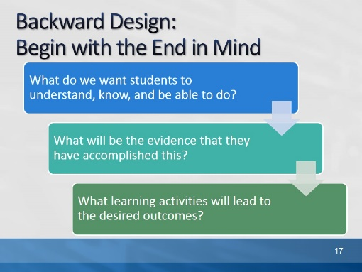Slide 17
The purpose of this slide is to give the big picture of backward design without focusing on the “understanding” aspect of UbD.

Backward design is a method of designing educational curriculum by setting goals before choosing instructional methods and forms of assessment. Backward design of curriculum typically involves three stages:
- identify the results desired
- determine acceptable levels of evidence that support that the desired results have occurred
- design activities that will make desired results happen

The idea in backward design is to teach toward the "end point" or learning goals, which typically ensures that content taught remains focused and organized. Although the idea of backward design has been around for a long time and is used in various industries, the term "backward design" was introduced to curriculum design by Jay McTighe and Grant Wiggins (Understanding by Design). Understanding by Design (UbD) is both a curriculum process and a model. In “pure” UbD, there are two distinct parts: a goal of student understanding, and the process of backward design. Most of the exemplar curriculum units that we will see today are designed using a backward design processes and some also include elements of UbD.
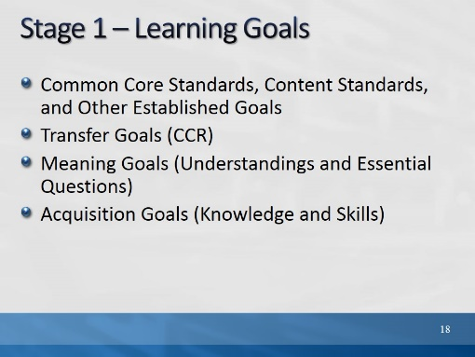Slide 18
- As you review exemplary units, you are likely to see variations on each of these elements of Stage 1, Understanding by Design.
- The MA unit exemplars are designed with the newer version of UbD which includes transfer goals, meaning goals, and acquisition goals. (The purpose for explaining those kinds of goals in this slide is so that participants will recognize them in the MA unit if they review a MA unit.)
- Other units will reflect UbD or backward design, but may not use UbD language.

- Established Goals: In ELA units, the CCS-ELA & Literacy will likely comprise the learning goals. In History/SS and Sci/Technical subjects, content area standards will likely be included. Some districts have other established goals, such as 21st century skills.
- Transfer Goals: These have recently been added to the 2011 version of UbD. They are long term goals that apply to students’ future life and learning. Exemplar units from MA all include selected CCR anchor standards as transfer goals.
- Meaning Goals: Most exemplar units will have some meaning goals, although they may not be called by that name. They may be called Enduring Understandings or Key Understandings, or Big Ideas. These may be content or thematic goals, e.g. “Citizens have rights and responsibilities,” or “All living things interact with each other and the environment.” “How are the structures of organisms related to their functions?”
- Acquisition Goals: These were formerly (pre 2011) called Knowledge and Skills. Usually stated as “Students will know…” and “Students will be able to…” Now stated as “Students will know….” and “Students will be skilled at….” These are the discrete knowledge and skills that students will accomplish in this unit, based on the Established Goals. You will see variations on this in exemplar units. They may be stated as “I can” goals or student learning objectives. Nonetheless, these are the goals that students will progress toward or be held accountable for, and will be assessed. They may be assessed in performance assessments, or in other assessments throughout the unit. Some exemplar units will not break the standards into discrete learning goals.
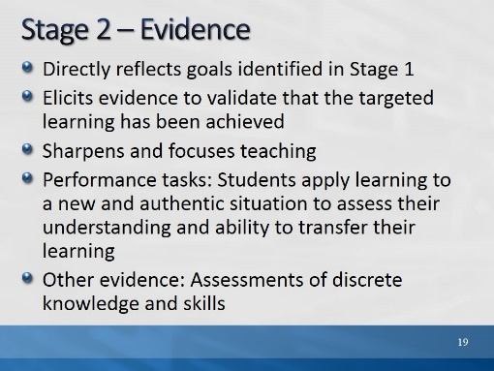Slide 19
After determining learning goals, the unit designer asks him/herself: If a student has achieved the desired goals, what would be evidence of that? The summative assessments for the unit or parts of the unit should provide that evidence. Most well-designed units include at least one performance assessment (CEPA in MA units) that ask students to show their learning by applying newly acquired skills and knowledge to new contexts or situations.
We will learn much more about performance tasks and other types of assessments in Module 4.
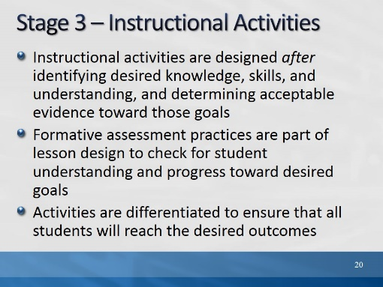Slide 20
Once the goals are established and the evidence has been identified, learning activities are created that help students acquire the knowledge and skills needed to be successful on the assessment or performance task.

Formative assessment is part of the instructional activities and allows teachers and students know if they are accomplishing goals.

Activity 2a
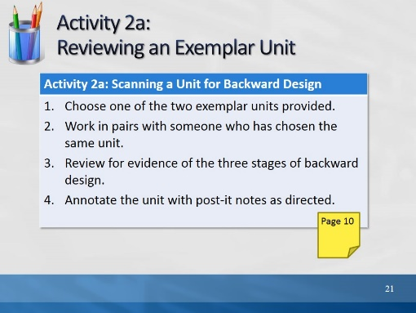Slide 21
15 minutes for this part of Activity 2. (Annotation directions appear on next slide)
The purpose of this slide is to introduce the activity. Have participants choose a unit, but move to the next slide for annotations.

- Explain that participants will be looking at the same unit for both parts a and b of activity 2, but they will be looking for different elements each time.
- The units chosen for this activity have been reviewed by experts using rigorous protocols, have been found to be in alignment with the CCSS, and appear on the CT Core Standards website under “materials for teachers.” They can be accessed, in full, for free.
- We have chosen 2nd and 5th grade units, to provide an example of a unit that has much “read-aloud” material, and one in which students do much of the reading with support.
- Each participant should choose just one unit for this activity.
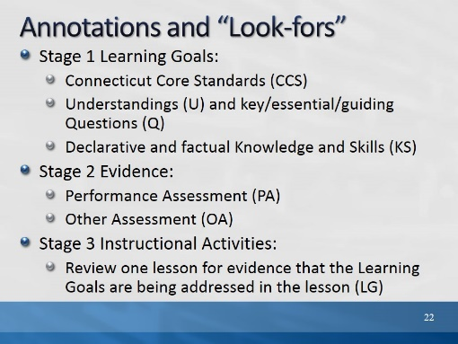Slide 22
The purpose of this slide is to have annotations visible for participants. These directions are also provided in the Participant Guide.
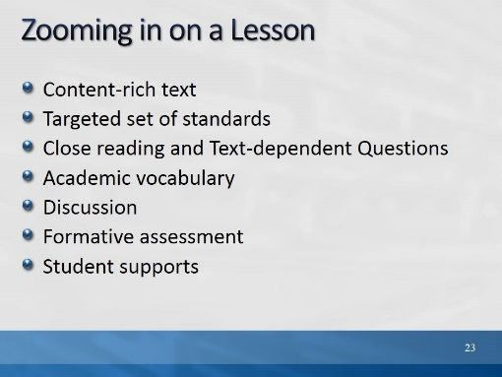Slide 23
Explain to participants that we will move directly into the next part of reviewing the unit and they will have an opportunity to share what they found with others after.
Explain that now we will review a lesson in the unit to identify some of the elements we discussed in Module 1 and will examine more closely in Module 2: Content-rich text, Close reading, text-dependent questions, focus on vocabulary/academic language, discussion, and student supports. Before we do that, we just want to clarify 2 items on this list: Academic Language and Formative Assessment.
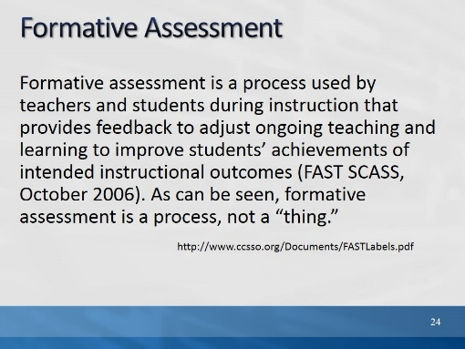Slide 24
The purpose of this slide is to introduce the term “formative assessment” as it is used in CT, so that participants know what they are looking for in a lesson.

This definition is found in “Distinguishing Formative Assessment from other Labels,” prepared by the Formative Assessment For Students and Teachers (FAST) State Collaborative on Assessment and Student Standards (SCASS) for the Council of Chief State School Officers (CCSSO). Copyright © 2012 by the Council of Chief State School Officers, Washington.

Read, or have a participant read the quote.

Since participants will be looking for examples of formative assessment, it is important to have this definition first. Remind participants that they may be looking at instructional activities or teacher moves that provide opportunities to gauge student understanding. These will not necessarily be labeled “formative assessment.”

Activity 2b
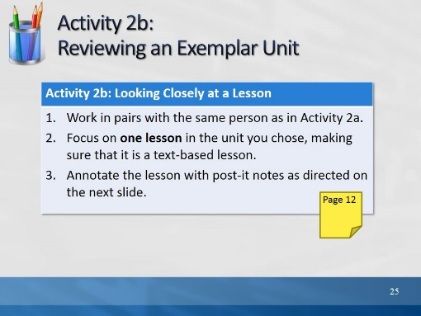Slide 25
10 minutes for this part of Activity 2. (Annotation directions appear on next slide.)
- Explain that participants will be looking at the same unit for both parts a and b of Activity 2, but they will be looking for different elements each time.
- The units chosen for this activity have been reviewed by experts using rigorous protocols, have been found to be in alignment with the CCSS, and appear on the Ctcorestandards website under “materials for teachers.” They can be accessed, in full, for free.
- We have chosen 2nd and 5th grade units, to provide an example of a unit that has much “read-aloud” material, and one in which students do much of the reading with support.
- Each participant should choose just one unit for this activity.
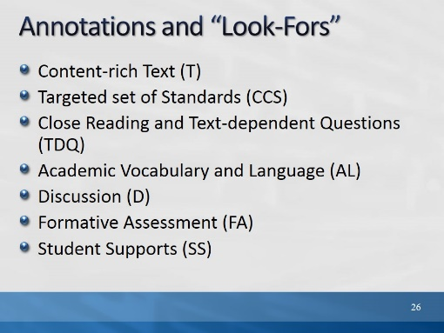Slide 26
These directions are also found in the Participant Guide.
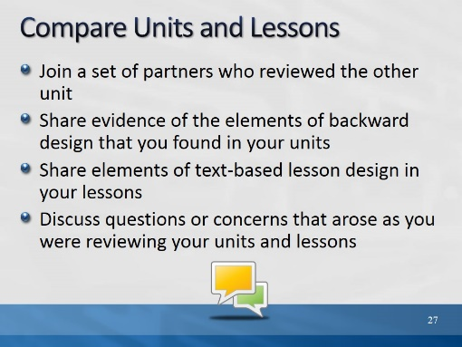Slide 27
The purpose of this slide is to give participants a few minutes to compare units with other participants who reviewed a different unit.

10 minutes: Direct partners to join another pair for an unstructured discussion of what they found, and didn’t find, in their units and lessons. If questions arise during this portion of the workshop, ask them to post the questions on a chart paper labeled “Parking lot.” (During the break, the facilitator should look at these questions. If they will not be answered later in the presentation, and if they have a bearing on activities, the facilitator should take time to address them.)
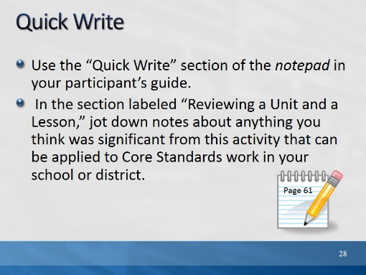Slide 28
5 minutes
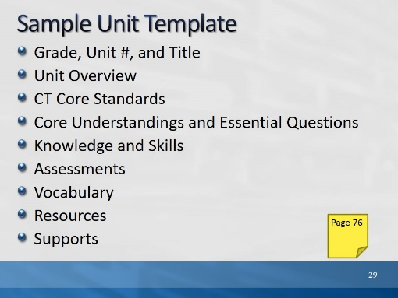Slide 29
The purpose of this slide is to let participants know that we have created a sample unit template based on the elements we see in exemplary CCS-aligned units. We will use this template in a later module.

Review these items VERY briefly, as they will not be working with the unit template in this module. Remind participants that formative assessment occurs at the lesson level, and is integrated into instruction. Show them where this unit template is located in their Participant Guide.
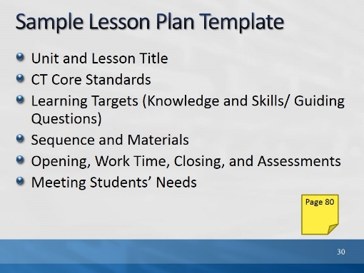Slide 30
The purpose of this slide is to show participants where the sample lesson template is located that they will use in the next few activities. Explain that not all lessons follow this pattern (of the template), but the template provides guidance. Show them where the template is located in their Participant Guide. Point out that for today’s activities, 3 standards have been placed in the template. At the lesson level, there should not be more than a few standards for any given lesson.

