Module 2  Facilitator Guide | Supporting All Students in Close Reading, Academic Language, and Text-Based Discussion

Activity 1

Connecticut Core Standards for English Language Arts and Literacy

Grades K–5

Systems of Professional Learning

Session at-a-Glance

Activity 1: Sharing about Module 1 (20 minutes)
Using a protocol, participants will meet in groups of 3 with others in similar roles (e.g. classroom teacher, principal, literacy coach) and will take turns presenting to the others in their group (2 minutes) how they shared the messages of Module 1 with others in their school or district. They will frame their brief presentation as “Here’s what I did; here’s what worked; and here’s what didn’t. Colleagues will ask questions of the presenter to clarify their own understanding or to help them think about the “Here’s what didn’t” statements. The presenter may choose to respond by reflecting on how the questions asked by their group helped them to think further about their work.

Supporting Documents:
- Directions
- Protocol for Sharing
- Quick Writes that participants produce during the Introductory Activities

PowerPoint Slides:
- 11–13

Session Implementation
Part 1
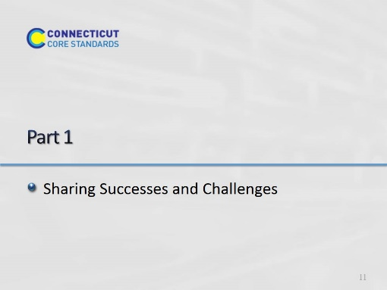Slide 11

Activity 1
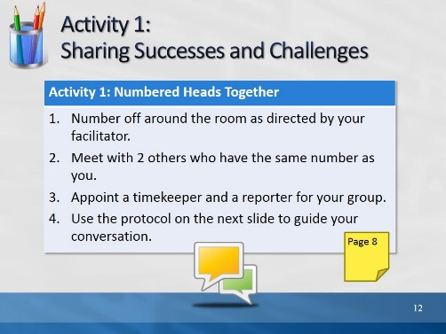Slide 12
This slide gives full directions for Activity 1, with prompts on the next slide. Remind the timekeeper that it is really important to keep everyone to the time limits. The reporter will summarize the conversation at the end when the groups come back together.

Facilitator: Ideally, you’d like 3 members in a group, not from the same district. Count the number of participants in the room and divide by 3. Whatever number results, have participants number off by that number. For example, if you have 21 participants, and you divide by 3, the result is 7. Have participants number off by 7’s. That way, when all the participants have numbered off, you can have all the 1’s, 2’s etc. form a group, and there will be 3 participants in each group. If you have an uneven number, it is better to end up with four in some groups than with groups of two.
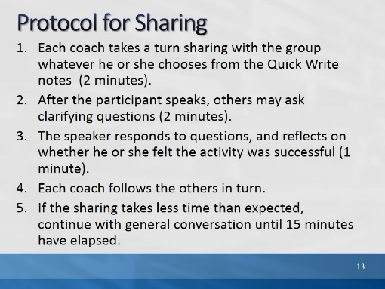Slide 13
Facilitator: Explain that clarifying questions are questions that seek "nuts-and-bolts" information about the information shared. Example: How much time did it take? How were participants grouped?
After 15 minutes have elapsed, bring the group back together and ask each reporter to briefly summarize highlights of the conversation.

