Module 1  Facilitator Guide | Focus on Practice Standards

Section 3

Connecticut Core Standards for Mathematics

Grades K–5

Systems of Professional Learning

Session at-a-Glance

Section 3: Understanding the Standards for Mathematical Practice: Developing Mathematical Expertise (90 minutes)
Section 3 begins with participants solving problems that are each aligned to one of the Standards for Mathematical Practice. The facilitator then provides information on each of the eight practices, including information about the standard, what the standard means, instructional supports for helping students to develop the practice, and sample “I Can” statements. Throughout the presentation, participants will answer questions and work in groups to determine which of the problems was an example of the practice, and to create grade level “I Can” statements for each of the practices based on their new understanding of each practice.
The section wraps up with teachers discussing how they would pair the practices based on their attributes and then viewing Bill McCallum’s Mathematical Practices Grouping Chart.

Supporting Documents:
- Problem Set: Practice Standards Alignment
- Understanding the Mathematical Practices

Materials:
- Chart paper and markers

PowerPoint Slides:
- 21–65

Session Implementation
Section 3
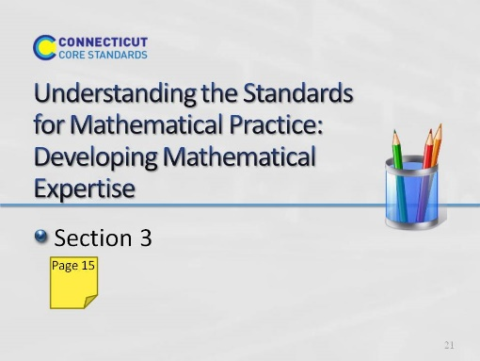
Slide 21
Section 3: Understanding the Standards for Mathematical Practice: Developing Mathematical Expertise
Section 3 Training Objectives:
- To introduce all eight of the Standards for Mathematical Practice and adapting the language of the practices to make each grade level appropriate without reducing rigor.
Section 3 Outline:
- Section 3 begins with participants solving problems that are each aligned to one of the Standards for Mathematical Practice.
- The facilitator then provides information on each of the eight practices, including information about the standard, what the standard means, instructional supports for helping students to develop the practice, and sample “I Can” statements. Throughout the presentation, participants will answer questions and work in groups to determine which of the problems was an example of the practice, and to create grade level “I Can” statements for each of the practices based on their new understanding of each practice.
- The section wraps up with teachers discussing how they would pair the practices based on their attributes and then being shown Bill McCallum’s Mathematical Practices Grouping Chart.
Supporting Documents
Problem Set: Practice Standards Alignment
Understanding the Mathematical Practices
Materials
Chart paper, markers
Key Implementation Notes:
In this activity participants will work sample problems that will help them to understand what each of the Standards for Mathematical Practice look like in a classroom situation. Participants will work the problems without knowing the practice standard they are most aligned with and the alignment is revealed later during the presentation.
Begin the activity by asking participants to form eight GRADE LEVEL table groups. Once grade level groups have been formed, ask participants to turn to the Problem Set in their Participant Guide on pages 15-16. Number the groups. Teachers should work the problem that coincides with their group number. Participants should work the problem individually and hold off on the group discussion until directed to do so during the presentation of each of the practice standards.
While participants are working the problems, hang eight pieces of chart paper around the room. Each piece of chart paper should be labeled with one of the practices. After participants finish working the problems in the Problem Set, tell them to move around the room and rate their personal understanding of each of the practices. They should use a rating scale of 1–5 with 1 having little or no understanding and 5 having a deep understanding of the practice. This exercise will allow you to gauge participants’ understanding of the practices and help you to determine the pace of the Practices Presentation.
During the interactive presentation on all eight of the practices, participants will need their copy of the Standards for Mathematical Practice. Suggest that participants use the Understanding the Mathematical Practices to make notes and answer questions in each of the designated areas.
Note: You should spend approximately 5-7 minutes per practice for the first four practices, and then 20-25 minutes on the small group discussions of the last four practices and 5-10 minutes debriefing the small group discussions.
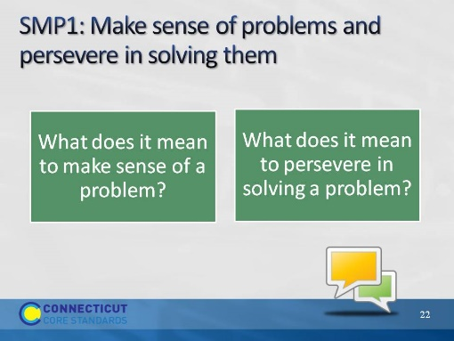
Slide 22
SMP1: Have participants think for a moment about the questions on the slides. Ask for one or two volunteers to share their answer to the questions. Responses that you want to listen for include points such as:
- Making sense of a problem means that students are able to break the problem into usable parts and determine how each part will be used to answer the question.
- Making sense of a problem means that students are able to use the information in the problem to determine the final questions to be answered.
- Persevering in solving a problem means that students ‘stick with it’ and do not give up when they find themselves challenged.
- Persevering in solving a problem means that students are able to ask questions about the problem that will help them clarify points of the problem and make the final problem question make sense rather than wait for someone to tell them how to solve the problem. These two questions are answered in more depth over the next four slides.
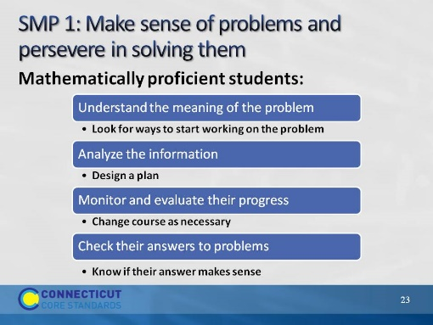
Slide 23
- SMP1: Review the check list of attributes on the slide. As you get to the end of the list, ask participants who had a problem that required them to do a number of these things as they came up with a solution. Allow groups a minute to discuss with their group to determine if their problem was the one aligned to this practice.
- Note: Participants may say that all of the problems had some element of this practice, however, the problem on the next slide was chosen because it exemplified this practice more than any of the others.
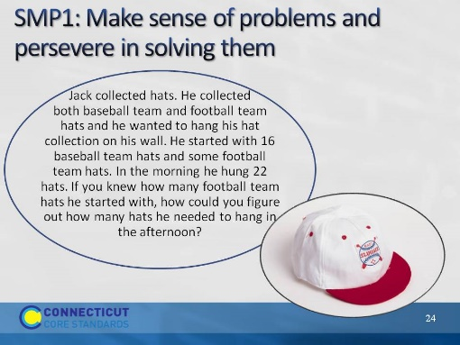
Slide 24
- SMP1: Explain that this problem was chosen as the most closely aligned to this practice. Ask for a volunteer from the group who worked this task to walk through this alignment. Key things to bring out:
- There is an amount that is unknown so participants have to understand all of the elements of the problem to determine how that unknown amount would be used.
- Students may be uncomfortable thinking about a problem that has this level of ambiguity. They will have to work through this discomfort in order to successfully answer the question in the problem. Note that this means that to be successful, we need to provide frequent opportunities to deal with ambiguous problems as well as strategies for how to approach such problems.
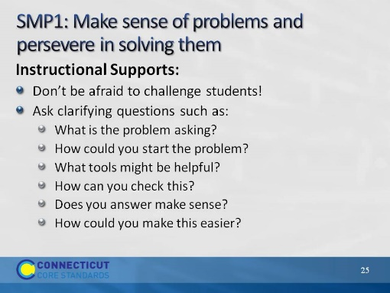
Slide 25
SMP1: Review the instructional supports on the slide. Note that the first support or idea “don’t be afraid to challenge students” will be seen throughout the practices. Ask participants what they think it means to challenge students. As participants discuss, focusing their thinking on how to challenge students by requiring students to really think about the mathematics. The Common Core is not about learning how to get an answer as we heard Phil Daro discuss. The Common Core is about learning to solve problems. Solving problems is much more rigorous than getting answers. Students need to be challenged to gain conceptual understanding of the mathematics being taught to reach a point of being able to recognize, on their own without prompting, when to apply the mathematics that they have learned to solve problems in new situations. This will be challenging and possibly uncomfortable for many students. However students will need to be challenged, and supported, in order to develop their mathematical expertise.
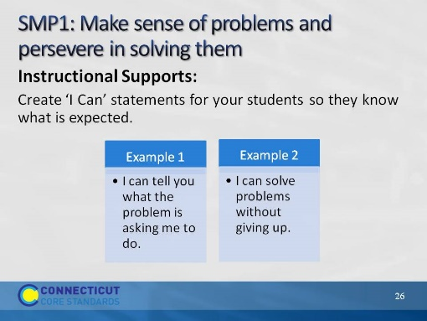
Slide 26
SMP1: Review the ‘I Can” statements on the slide. Ask participants if they would add any statements here that would better fit students at their grade level. As volunteers provide their statements, make sure that they align with the practice so that students are receiving the correct information.
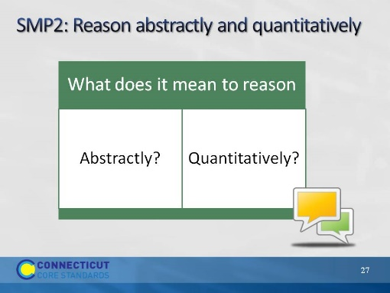
Slide 27
- SMP2: Review the questions on the slide. Allow participants to think for a moment and then ask for volunteers to share their answers. As you listen to participants’ answers, listen for things such as:
- Reasoning abstractly means to reason within a context or within a situation, form theories, understanding problems on a complex level through analysis and evaluation, and having the ability to know what and when to apply knowledge when solving problems.
- Reasoning quantitatively means to apply their mathematical skills to solve a problem. Students understand the values that they are working with and are able to relate those to the problem itself.
- Again these questions will be answered in more depth over the next four slides.
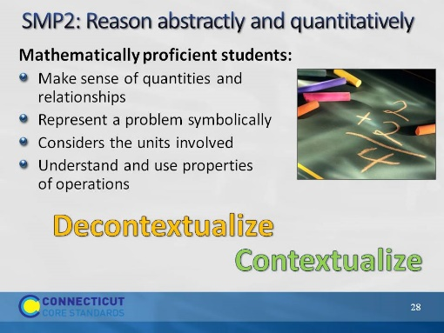
Slide 28
SMP2: Review the points on the slide. At the end of the list, know that some participants may not understand what it means for students to able to decontextualize and contextualize. To decontextualize means to be able to pull the values out of the problem situation and do the work with them that needs to be done. For example, in the problem Olivia has 4 apples and Sophia has 6 apples. If they both give their apples to Anna, how many apples will Anna have? When decontextualizing students are able to represent the problem as 4+6=10. And then to contextualize they are able to put the final values back in to the problem situation. If students were given the number sentence 4+6=10 and are able to create a problem situation that makes the number sentence, this would be considered contextualizing as well.
Before moving to the next slide, ask participants to look at the problems they solved and determine whose problem would be aligned with this practice.
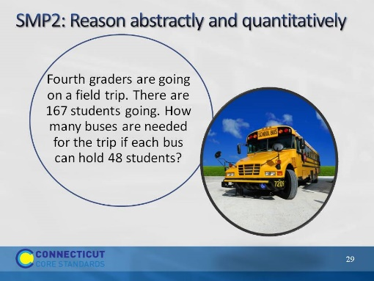
Slide 29
SMP2: Reveal that the ‘field trip’ problem was chosen as most aligned to this practice because not only do students need to apply the practice when working the problem, but they must also think about their answer within the context of the problem itself. While 167 divided by 48 gives us an answer of 3.47 or 3 with a remainder of 23, a student cannot use their calculated answer to solve the problem because the problem is not asking them to solve 167 divided by 48. The problem is asking them to determine how many buses are needed. Division is one tool that can be used to determine this. Others are estimating, rounding, etc. The final answer is that 4 buses are needed.
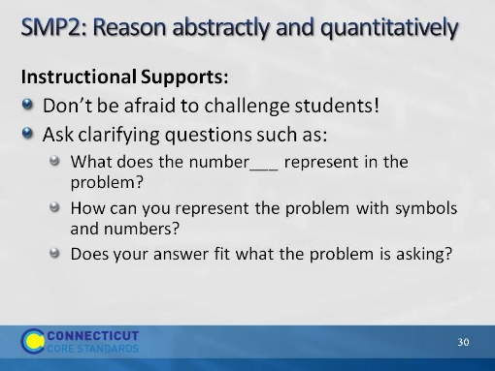
Slide 30
SMP2: Review the instructional supports on the slide.
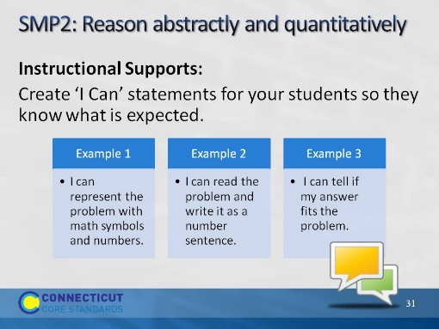
Slide 31
SMP2: Review the ‘I Can” statements on the slide. Ask participants if they would add any statements here that would better fit students at their grade level. As volunteers provide their statements, make sure that they align with the practice so that students are receiving the correct information.
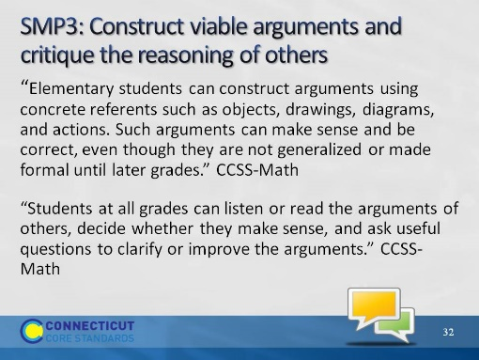
Slide 32
SMP3: Ask volunteers to read the two quotes on the slide aloud. Ask participants to tell you some thoughts or key words that jump out at them and to chart their responses so that there is a visual to discuss. Some things to watch and listen for are: construct arguments, arguments of others, decide, ask useful questions, improve arguments. As participants look at the completed list of their responses on the chart paper, have them think about what is not said. After a 30 second wait time, explain that this practice is not just about students just explaining their work. It is about students telling why what they did works, or didn’t work. Remember, it is important for students to know and understand where something went wrong. Not knowing why something did or did not work can lead to misconceptions. Critiquing the reasoning of others does not mean to simply tell if another student got the answer right or wrong. It means that a student has to understand a peer’s approach and be able to tell why the mathematics behind that approach worked or did not work.
Use the next four slides to support these two quotes.
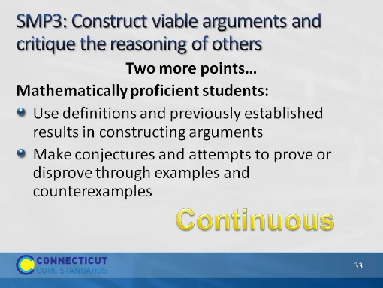
Slide 33
SMP3: Go over the points on the slide and further emphasize to participants that this practice is continuous as in “ongoing.” Constructing viable arguments and critiquing the reasoning of others is something that should be done in small and large group discussions, in students’ own work, etc. This should happen all the time! Before moving on, have participants determine which of the problems best align with this practice.
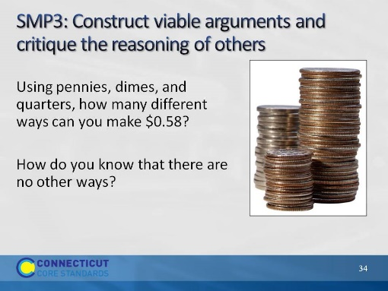
Slide 34
SMP3: Explain that this problem was chosen because students have to justify their answer using mathematics. In a classroom situation, this would be a good problem to have students compare answers and strategies for answering the question. If different answers are given, have students examine each other’s approach and determine whose was correct and why. Ask participants if anyone currently does this in their classroom and if so, have them describe the strategies that they use. Allow other participants to ask questions. The next two slides provide additional instructional supports.
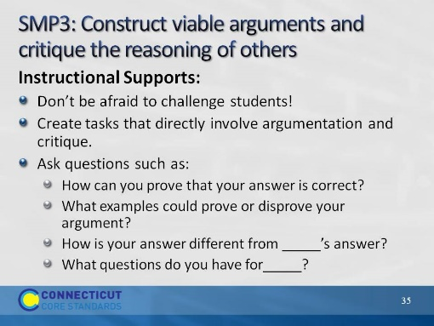
Slide 35
SMP3: Review the instructional supports on the slide.
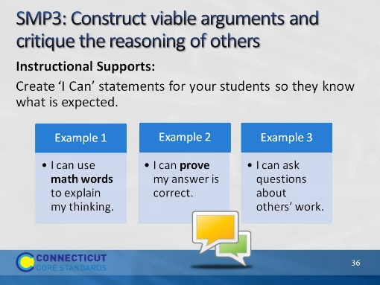
Slide 36
SMP3: Go over the ‘I Can’ statements on the slide and ask participants if they would add anything to the list. Allow volunteers to share their ideas and then move to the next practice.
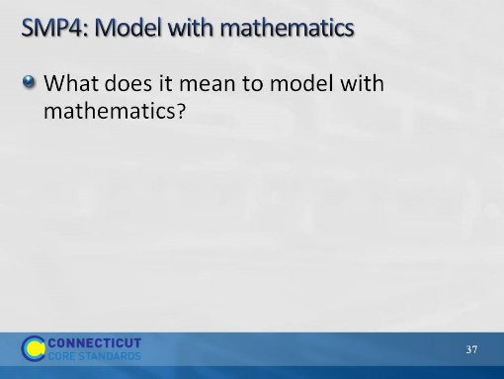
Slide 37
SMP4: Ask participants to think about the question on the slide and explain that Practice 4 is one that tends to be interpreted rather narrowly. Modeling with mathematics is not just about building a concrete model or drawing a picture. It is more about doing those things to diagnose a mathematical problem and, based on the model, develop an equation or number sentence that makes sense for the problem. There is more on this over the next four slides. Before moving on, ask participants which of the problems in the Problem Set best aligns to the Practice of Model with Mathematics.
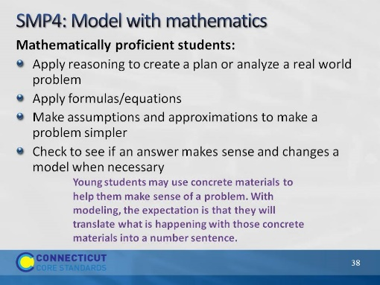
Slide 38
SMP4: Review the points on the slide and have participants look hard at the purple text at the bottom of the screen as this is an extremely important point.
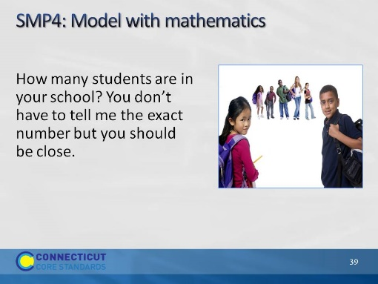
Slide 39
SMP4. Explain that in this problem students will generally have to come up with some type of model that will help them determine how to solve the problem. It also requires them to make assumptions and estimations which are also an important part of this practice.
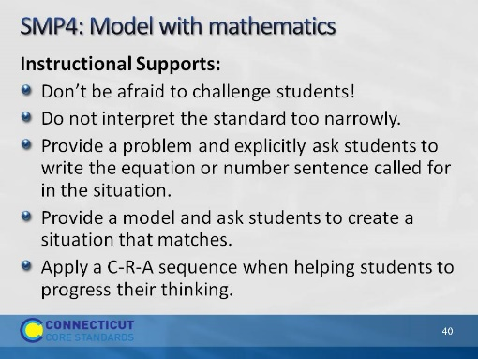
Slide 40
SMP4: Review the instructional supports on the slide. When you get to the last point ask participants if they have heard of a C-R-A approach? If some have, ask them to explain this approach to the others. If no one has, explain that it is a continuum that they should use with students as they work through problems. Start with the concrete (C) such as using counters or cubes, move to the representational (R) such as pictures and drawings (things you have to create on paper that you cannot hold in your hand and physically manipulate), and then to the abstract (A) using mathematical symbols. As students work through problems they can go back and forth on this continuum. For example, if a student is having trouble at the abstract stage, go back a stage until they are successful and then move forward again.
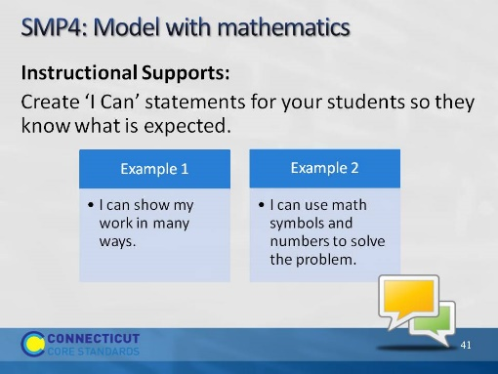
Slide 41
SMP4: Go over the ‘I Can’ statements on the slide. Ask participants if they would add anything to the list that would make these statements more grade level specific. After volunteers have given their statements, move to the next practice.
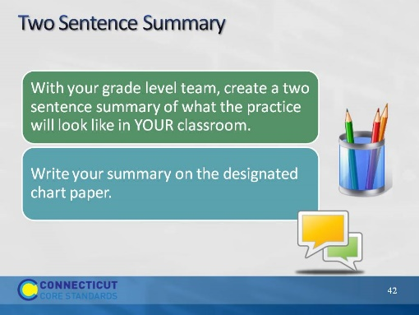
Slide 42
Two Sentence Summary: Around the room, hang pieces of chart paper that are labeled with the first four practices. There will need to be three pieces of chart paper per practice. On the first sheet divide the space in half so that K and 1st grade each have half of the piece on which to write their summary, 2nd grade and 3rd grade on the second sheet, and 4th and 5th on the third sheet. Allow participants 10 minutes to complete this portion of the activity and then move on to the last four practices.
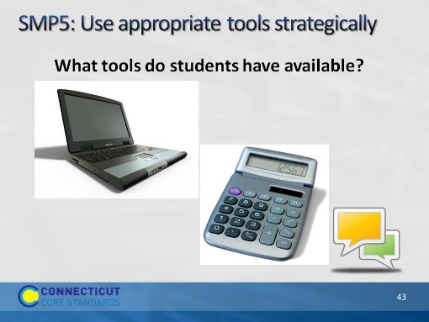
Slide 43
SMP5: Have participants brainstorm a list of the tools that students have available to them in and out of the classroom and chart their responses. If not brought up by participants, suggest tools such as tens frames, number lines, word walls, multiplication charts, their own previous work (fraction scripts, etc.). These are things that we may not normally think of as tools but that can be used strategically when solving problems.
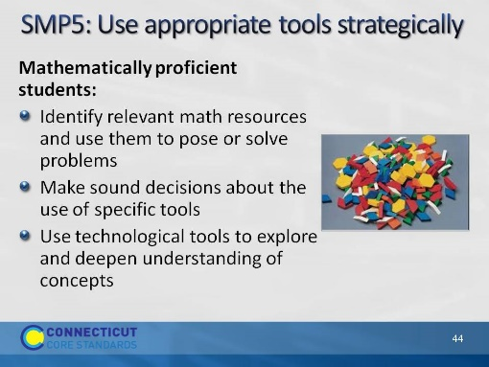
Slide 44
SMP5: Review the points on the slide and ask participants to determine which problem from the Problem Set most closely aligns with this practice.
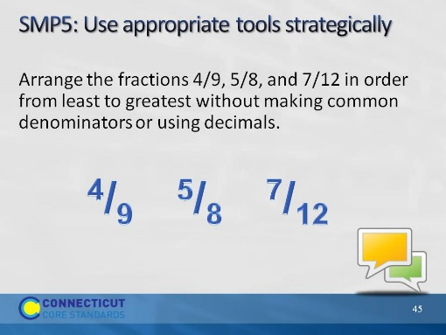
Slide 45
SMP5: Now that participants have had practice looking at four other problems and determining the alignment to the practices, have them talk for a moment at their tables and determine why this problem was chosen to represent the practice of Use appropriate tools strategically. As participants talk, points that you will want to listen for—and raise if not mentioned—include:
- To solve this problem without using common denominators or decimals will require most students to find some sort of tool with which to compare the size of these fractions. This can be in the form of pattern blocks, fraction strips, number lines, etc.
- There are those students that may be able to skip the tool by using common numerators or by reasoning about the size of the fractions. However, most will still need a tool at this point in their mathematical development.
Note to facilitator: Some problems, such as this one, have restrictions put in because participants are solving these as adults and they may automatically go straight to an algorithmic solution. Students may not know these ways, thus the need for the restrictions.
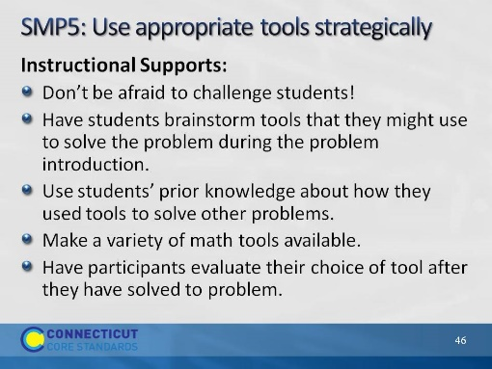
Slide 46
SMP5: Review the instructional supports on the slide.
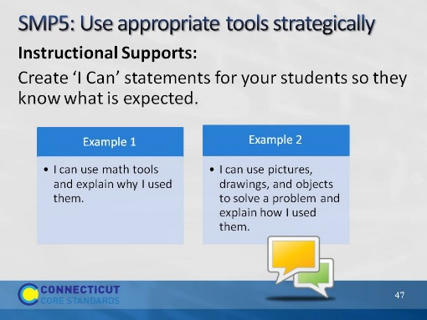
Slide 47
SMP5: Review the ‘I Can’ statements on the slide and ask participants if they want to add anything to make these grade level specific.
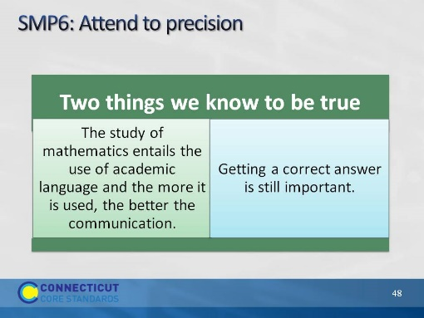
Slide 48
SMP6: Review the two points on the slide. Explain that while we have to focus much of our attention on how students think and reason within mathematics, we do still want them to be precise as well.
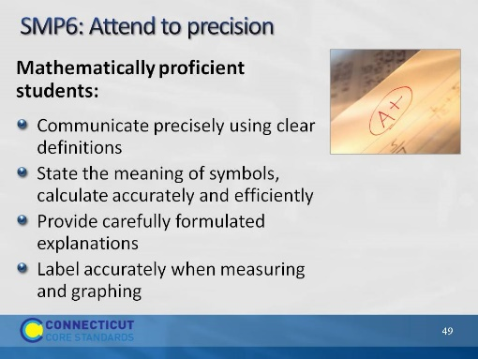
Slide 49
SMP6: Review the points on the slide.
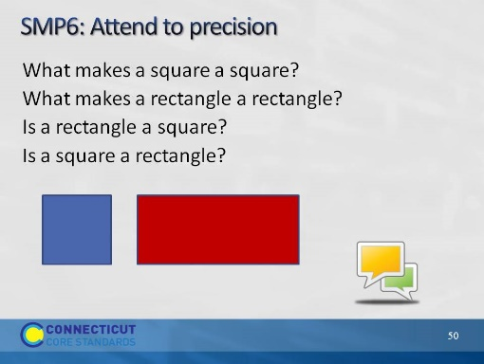
Slide 50
SMP6: Have participants work for 3 minutes in their small group to determine what specific academic language/terms students would need to attend to when answering these questions from the Problem Set.
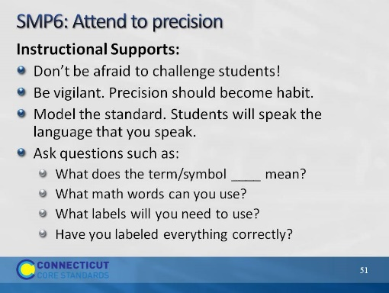
Slide 51
SMP6: Review the instructional supports on the slide.
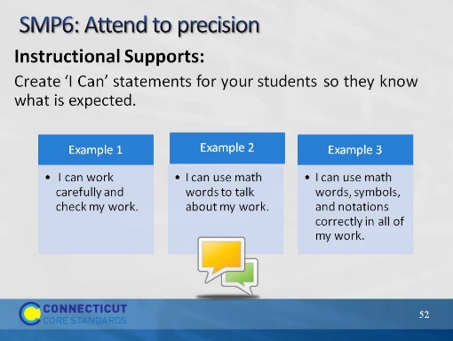
Slide 52
SMP6: Review the ‘I Can’ statements on the slide and ask participants if they would add anything to the slide to make them more grade level specific. After volunteers make suggestions, move to the next practice.
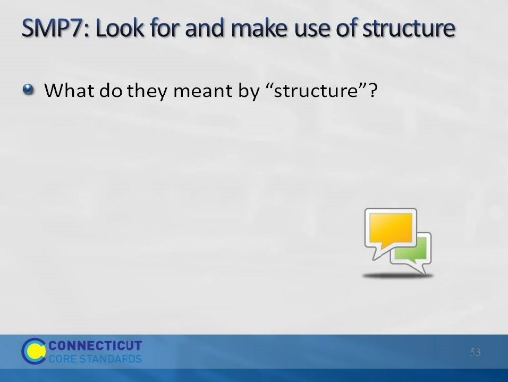
Slide 53
SMP7: Ask participants to think about the question on the slide and in their table groups try to come up with an answer to describe structure in mathematics. If participants struggle with this let them know that it’s ok. Practices 7 and 8 are the two of the most difficult practices for teachers to visualize. This is due in part to the language that is used within the practice which doesn’t always align to the language that would be used at the elementary level. An example to give participants of structure is base ten. Ask participants to think about how our number system is built off of base ten and all of the ‘things’ that we can do in mathematics because of our base ten structure. When students look for and make use of structure, they can see the systems of ‘10s’ in place value or understand regrouping based on 10s. The next four slides will help to better describe this practice.
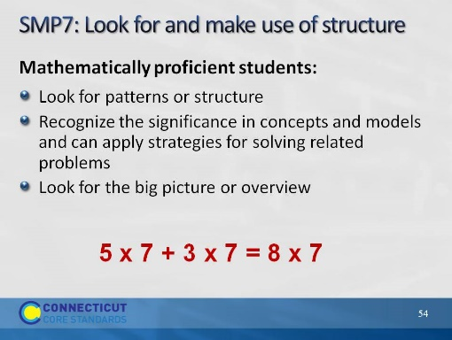
Slide 54
SMP7: Review the points on the slide. Use the example to further describe the idea of using structure. Students use structure when they understand that 8 x 7 is the same as 5 x 7 plus 3 x 7.
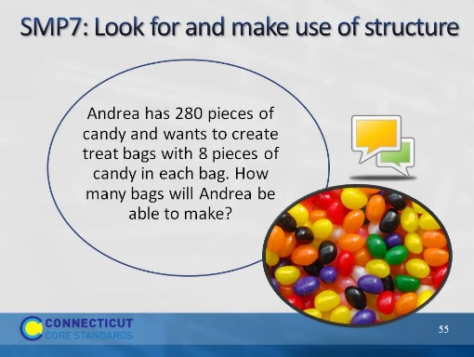
Slide 55
SMP7: Have participants look at their solution to this problem and determine what mathematical structure they used to solve the problem. Most responses will have to do with the use of division.
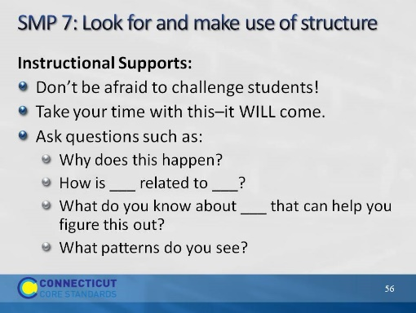
Slide 56
SMP7: Review the instructional supports on the slide.
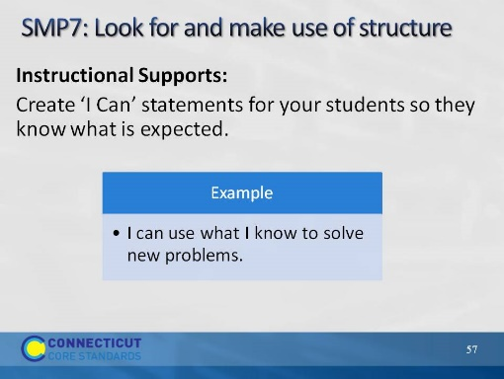
Slide 57
SMP7: Review the ‘I Can’ statement on the slide. Ask participants to come up with at least one other statement that can be used at their grade level. After volunteers have shared their statements, move on to the final practice.
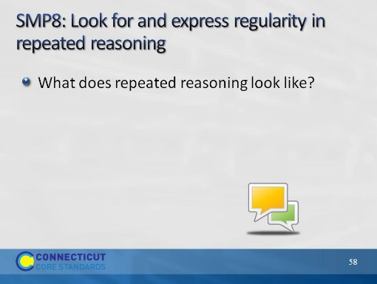
Slide 58
SMP8. To introduce this final, and very challenging practice, have participants think about examples they have seen of students using repeated reasoning in their classroom. This can be as simple as knowing which block comes next based on a pattern, or as complex as being able to determine a function based on the pattern seen in a table, chart, or graph. The next four slides will be used to support this practice.
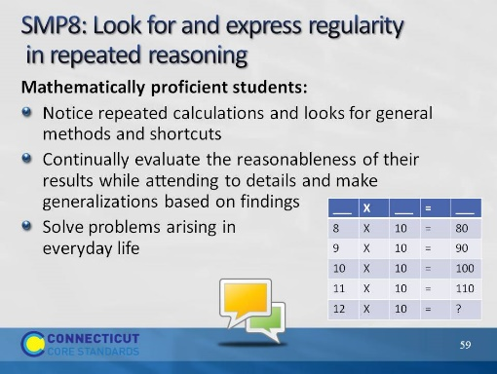
Slide 59
SMP8: Review the points on the slide. Ask participants how students can use repeated reasoning to find the missing value in the chart.
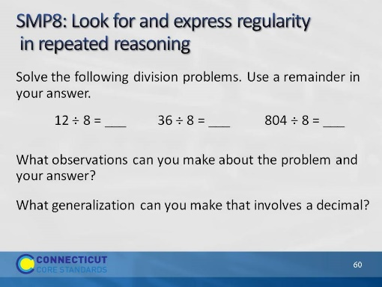
Slide 60
SMP8: Now challenge participants to look at Problem 5 on page 16. Ask for those that worked this problem to share their solution. A generalization to watch for and to bring out, if not raised by participants, is that whenever you have a problem that incorporates the dividend as the divisor times some number plus half of the divisor your answer will always have a .5 in it. Have participants try this for any number they choose and see if it works. Note that problems such as this require the use of repeated reasoning.
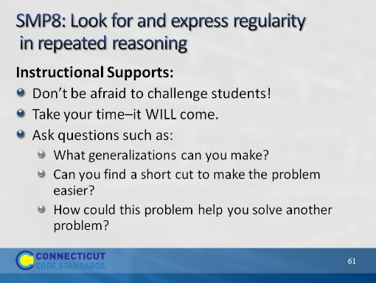
Slide 61
SMP8: Review the instructional supports on the slide.
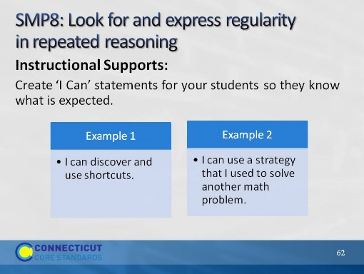
Slide 62
SMP8: Review the ‘I Can’ statements on the slide ask participants one last time to modify these to make them grade level specific. Once volunteers have shared, move to the next slide.
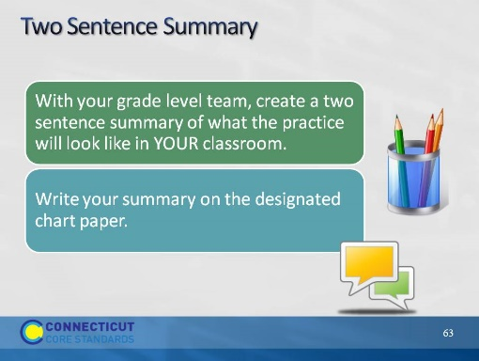
Slide 63
Two Sentence Summary: Around the room, hang pieces of chart paper that are labeled with the last four practices. There will need to be three pieces of chart paper per practice. On the first sheet, divide the space in half so that K and 1st grade each have half of the piece on which to write their summary, 2nd grade and 3rd grade on the second sheet, and 4th and 5th on the third sheet. Allow participants 10 minutes to complete this portion of the activity. Once participants have completed their summaries, have them revisit the chart on which they gave their initial rating of understanding and ask them to change the ratings based on the last hour’s worth of work. Discuss with participants changes in their thinking, what they better understand now, and what they want to do back in their classroom.
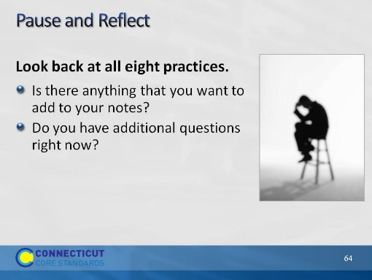
Slide 64
Pause and Reflect: Allow participants two or three minutes to look back over their notes on the practices and make any needed additions. Before moving to the next slide, ask participants how they might group the standards based on the relationships they see and that we have discussed thus far. The next slide will show an example of how the practices have been grouped by some of the writers of the CCSS-Math.
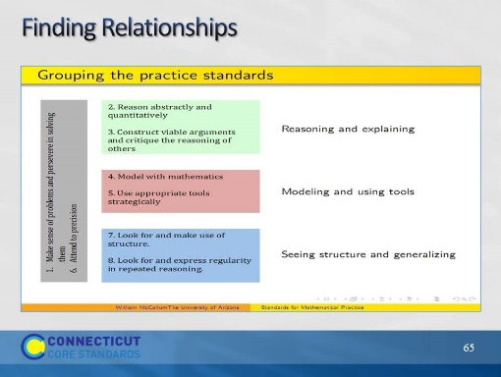
Slide 65
Finding Relationships: Explain to participants that Bill McCallum, one of the writers of the CCSS-Math, put together this chart to show how the practices can be grouped or organized based on their relationships. Ask participants if they would have grouped them differently and why. If participants are unsure of this grouping, have them look for evidence in the standards themselves that support the organization found here. Further explain that Practice 1: “Make sense of problems and persevere in solving them” and Practice 6: “Attend to precision” are considered the overarching habits of mind of mathematical thinkers. This does not mean that these two practices are somehow more important. It means that these two practices are related to each of the other six practices. If needed, go back and look at the sample problems that were completed for each of the eight practices and have participants find evidence of Practice 1 and Practice 6 in each. When participants are ready to move on, let them know that because of the relationship that Practices 1 and 6 have to the other six practices, we are going to look more in-depth at each of those practices.

