Module 1  Facilitator Guide | Focus on Practice Standards

Section 7

Connecticut Core Standards for Mathematics

Grades 6–12

Systems of Professional Learning

Session at-a-Glance

Section 7: Supporting Change (20 minutes)
Common Core Coaches will work in grade-band groups to reflect on the module activities and discuss how big ideas from each will be shared with teachers back at their school. Facilitator will review module outcomes.

Supporting Documents:
- Supporting Change

PowerPoint Slides:
- 80–83
Section 7
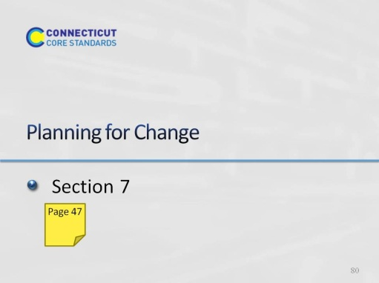
Slide 80
Section 7: Supporting Change
Section 7 Training Objectives:
- To have participants create a plan for disseminating big ideas from the session with teachers at their school.
- To have participants anticipate specific teacher questions and challenges around implementing lessons that incorporate the Standards for Mathematical Practices.
Section 7 Outline:
Participants will work in grade band groups to reflect on the module activities and discuss how big ideas from each will be shared with teachers back at their school. Facilitator will review module outcomes.
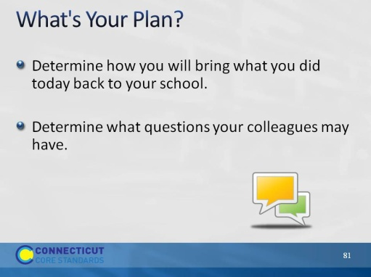
Slide 81
What’s Your Plan? Allow participants the remaining time to plan for disseminating key learning from each of the module sections back at their school.
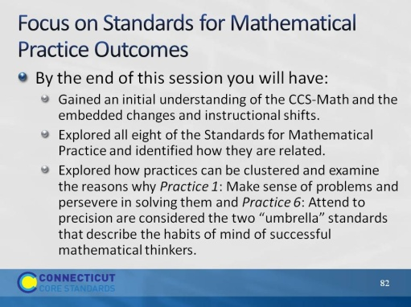
Slide 82
Review the outcomes for the day.
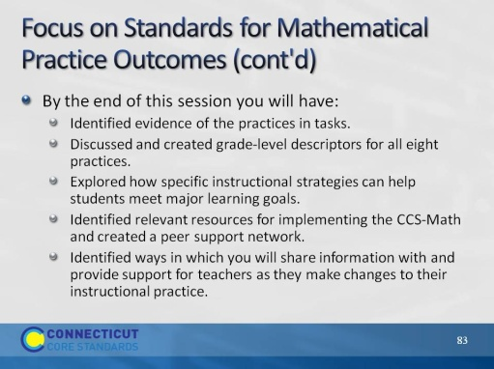
Slide 83
Review the outcomes for the day.

