Module 1  Facilitator Guide | Focus on Practice Standards

Section 5

Connecticut Core Standards for Mathematics

Grades 6–12

Systems of Professional Learning

Session at-a-Glance

Section 5: Attending to Precision in Every Lesson (20 minutes)
Participants will watch a classroom lesson in which the teacher helps students attend to precision. In groups, they will then discuss how this teacher gets students to attend to both the precision of the mathematical language and the calculations needed to complete the work. The facilitator will wrap up Section 5 by charting the instructional strategies identified by the participants and using that list of strategies to transition to Section 6.

Supporting Documents:
- Video Observation Sheet

Materials:
- Chart paper and markers

Video:
- Cathy Humphreys: http://www.insidemathematics.org/index.php/standard-6 (view the 4th video in the grade 9-10 series).

PowerPoint Slides:
- 70–71

Session Implementation
Section 5
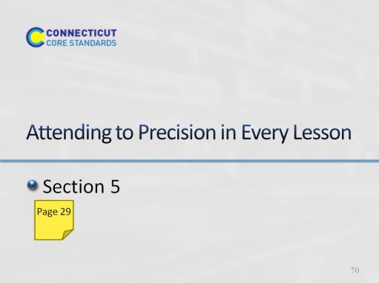
Slide 70
Section 5: Attending to Precision in Every Lesson
Section 5 Training Objectives:
- To provide participants with a deeper understanding of how to help students attend to precision in classroom lessons.
- For participants to begin to identify instructional strategies that can be implemented to help students attend to precision.
Section 5 Outline:
- Participants will watch a classroom lesson in which the teacher helps students attend to precision.
- In groups, they will then discuss how this teacher gets students to attend to both the precision of the mathematical language and the calculations needed to complete the work.
- The facilitator will wrap up Section 5 by charting the instructional strategies identified by the participants and using that list of strategies to transition to Section 6.
Supporting Documents
Video Observations Sheet
Materials
Chart paper, markers
Video
Cathy Humphreys working on the diagonals problem with students. The video can be found here: http://www.insidemathematics.org/index.php/standard-6 (view the 4th video in the grade 9-10 series)
Key Implementation Notes:
Because this is participants’ first time conducting a video observation in this module series, explain to participants that when they watch video of others’ teaching that they need to keep in mind that no one lesson is perfect. The teacher and students sometimes make mistakes, that the teacher may do or say something that the participant may find annoying or not in-line with their personal beliefs. However, each video presented as we go forward has been chosen for a distinct purpose and that purpose is the lens through which the video should be observed. For example, in this section the key things for participants to pay attention to are the strategies that the teacher uses to help her students attend to precision within the lesson.
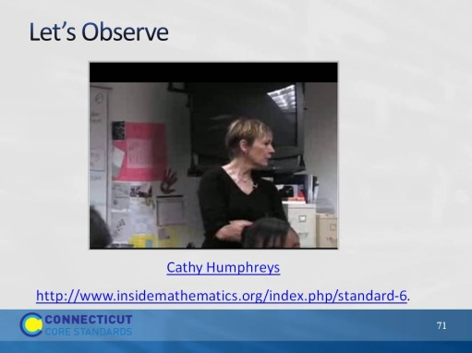
Slide 71
Let’s Observe: Play the video of Cathy Humphreys working on the diagonals problem with students. The video can be found here: http://www.insidemathematics.org/index.php/standard-6 (view the 4th video in the grade 9-10 series). As they watch, ask participants to use the Video Observation handout (page 29) to record how they observe the teacher helping her students to attend to precision. After the video, debrief the participants’ observations as a large group and chart the strategies identified. Before the break, have participants look back at their questions and fill in any answers that have been found thus far.

