Module 1  Facilitator Guide | Focus on Practice Standards

Introduction

Connecticut Core Standards for Mathematics

Grades 6–12

Systems of Professional Learning

Session at-a-Glance

Introduction (10 minutes)
The facilitator will review project goals and activities, module outcomes, and the agenda for the session. Participants will complete a Pre-Assessment.

Supporting Documents:
- Pre-Assessment

PowerPoint Slides:
- 1–5

Session Implementation
Introduction
Title Slide
(Slides 1-5, including the pre-assessment, will take about 10 minutes total.)
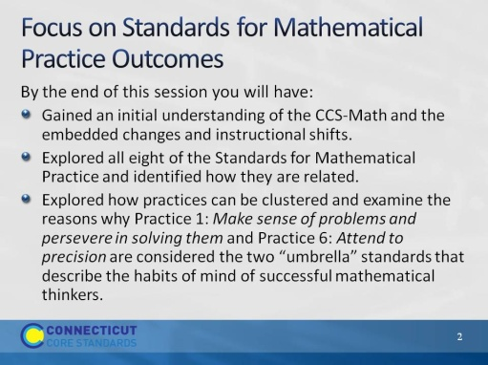
Slide 2
Review the outcomes for the day, sharing what you hope to accomplish throughout the full day session.
These are the outcomes for this session. These are presented to the participants over two slides. Explain that the session will include an in-depth look at all eight Standards for Mathematical Practice but will provide specific insight and depth into Practices 1 and 6.
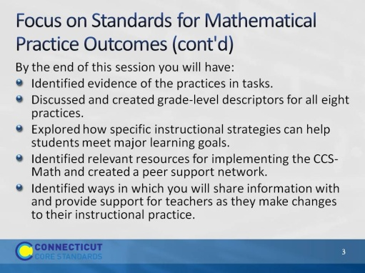
Slide 3
These are the outcomes for this session. These are presented to the participants over two slides.
Slide 4
Review the agenda, letting participants know that this is the pathway they will travel in order accomplish the seven outcomes discussed earlier. Note that in addition to the break for lunch there will also be a morning and afternoon break. Emphasis the importance of coming back from breaks on time to ensure enough time to complete all the work of the day.
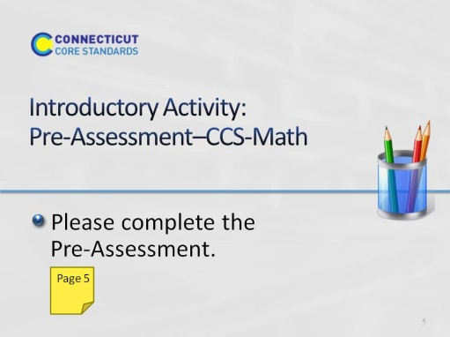
Slide 5
This will be a short self-assessment, which will be found in the participants’ guide on page 5. It will assess where the coaches are now with understanding and implementing the Standards for Mathematical Practice. The participants will complete the same assessment at the end of the session. Allow 3-4 minutes to complete.

