Module 1  Facilitator Guide | Focus on Practice Standards

Closing Activity

Connecticut Core Standards for Mathematics

Grades 6–12

Systems of Professional Learning

Session at-a-Glance

Closing Activities (10 minutes)
Participants will complete a Post-Assessment and a Session Evaluation.

Supporting Documents:
- Post-Assessment
- Session Evaluation (online)

PowerPoint Slides:
- 84–85

Session Implementation
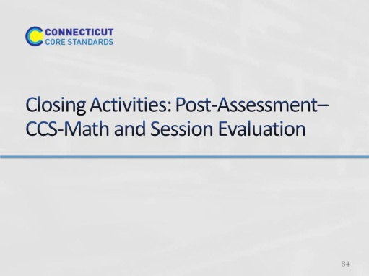
Slide 84
Blank
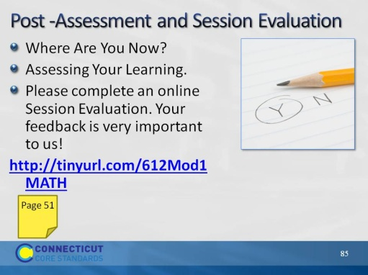
Slide 85
This Post-Assessment will be the same as the Pre-Assessment they took in the beginning of the session. This assessment is to gauge their learning based on the activities of the full day session. Remind the participants to fill out their Session Evaluation survey online.
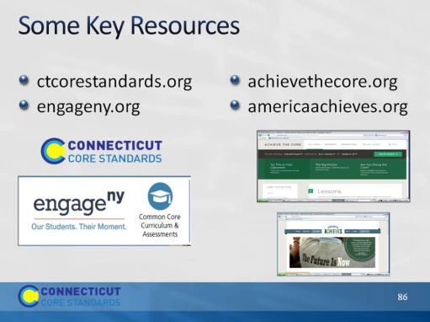
Slide 86
Blank
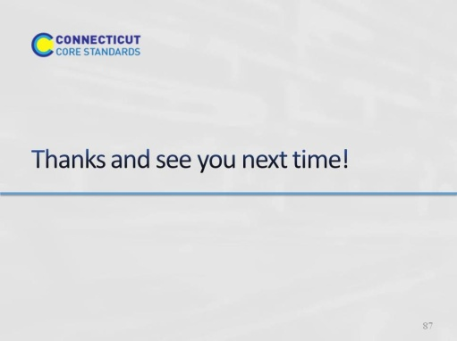
Slide 87
Blank

