Module 1  Facilitator Guide | Focus on Instructional Shifts

Closing Activities

Connecticut Core Standards for English Language Arts and Literacy

Grades K–5

Systems of Professional Learning

Session at-a-Glance

Closing Activities
(5 minutes) Post-Assessment–CCS-ELA & Literacy and Instructional Shifts

Supporting Documents:
- Post-Assessment

(10 minutes) Session Evaluation
Remind participants to complete an online Session Evaluation.

Supporting Documents:
- Link to take online Session Evaluation

PowerPoint Slides:
- 73–76
Post-Assessment and Session Evaluation
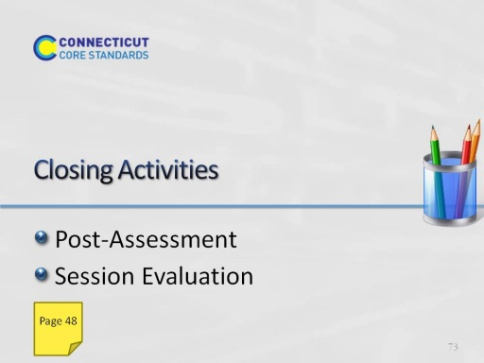
Slide 73
Adjusting for time, you may want to ask groups to share some of their ideas from Activity 8.
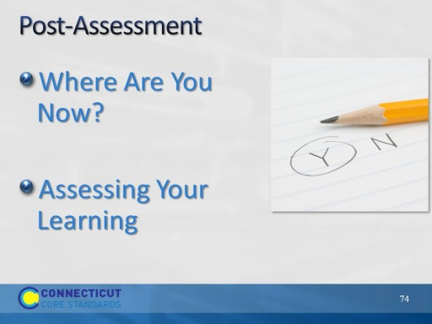
Slide 74
The Post-Assessment will be the same as the Pre-Assessment they took in the beginning of the session. This assessment is to gauge their learning based on the activities of the morning. They will find the Post-Assessment in the Participant Guide (3-4 minutes).
Ask for further thoughts, questions.
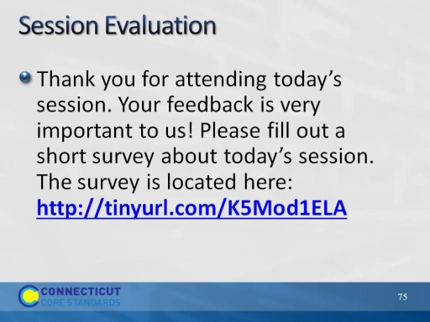
Slide 75
Remind participants to complete on online Session Evaluation before leaving for the day.
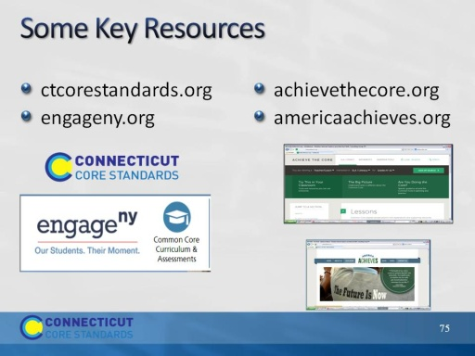
Slide 76

