Module 1  Facilitator Guide | Focus on Instructional Shifts

Activity 6

Connecticut Core Standards for English Language Arts and Literacy

Grades K–5

Systems of Professional Learning

Session at-a-Glance

Activity 6: Activity 6: Myths About Rigor in the Common Core Classroom
(30 minutes) Working in mixed grade groups of five, coaches take a short quiz (anticipation guide) about rigor and the Common Core. They briefly discuss their responses.
Participants read a recent post on middleweb.com by Barbara Blackburn, “Five Myths about Rigor and the Common Core” http://www.middleweb.com/12318/five-myths-rigor-common-core. Each participant reads the entire blog post and underlines information relevant to the rigor quiz. They discuss and revise responses on the quiz, using evidence from the blog post.

Supporting Documents:
- Directions
- Short Quiz
- “Five Myths about Rigor and the Common Core” (Blackburn, 2014)

PowerPoint Slides:
- 67–68
Activity 6
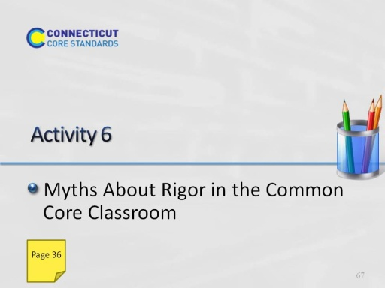
Slide 67
(This activity will take about 30 minutes.)
Explain: Throughout the morning, we looked at and discussed the need for increased rigor (i.e. effort) needed to achieve help all students achieve CCR.
We will now have an opportunity to discuss the concept of rigor as it relates to the Common Core, by considering first our own beliefs about rigor, and then reading and reflecting on a blog post.
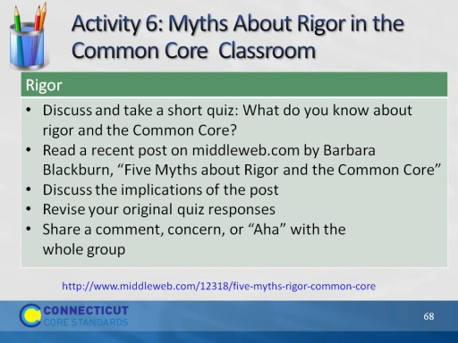
Slide 68
- Complete instructions and article are provided in the participant guide. You may want to briefly review them with participants

