Module 1  Facilitator Guide | Focus on Instructional Shifts

Activity 3

Connecticut Core Standards for English Language Arts and Literacy

Grades K–5

Systems of Professional Learning

Session at-a-Glance

Activity 3: Reading, Writing, and Speaking with Evidence
(65 minutes) In table groups of K–1, 2–3, and 4–5 educators, coaches will reflect on a video of a lesson that is aligned with Shift 2: Reading, writing, and speaking grounded in evidence from text, both literary and informational.
Participants will pay careful attention to text-dependent questions focused on the text’s content.
For application and practice, groups will read a short excerpt of grade appropriate, complex, informational text from Appendix B. They will discuss what teachers would need to do to instruct, support, and scaffold students towards Reading, writing, and speaking grounded in evidence from text.
Table groups will continue adding to the anchor chart, (from Shift 1, Step 3). On the chart, they will record essential take-aways related to Shift 2, questions or areas they would like to explore further, and supports that teachers will need to implement Shift 2 effectively.

Supporting Documents:
- Directions
- Sample Lesson Plan
- Excerpts from CCS Appendix B

PowerPoint Slides:
- 30–44
Activity 3
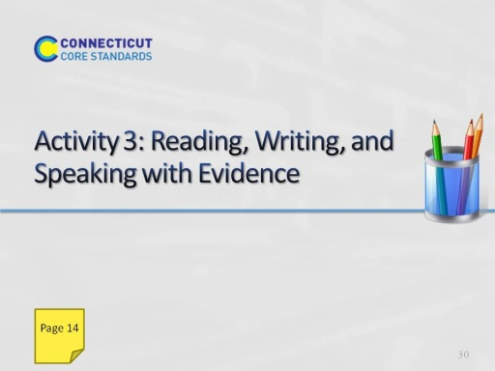
Slide 30
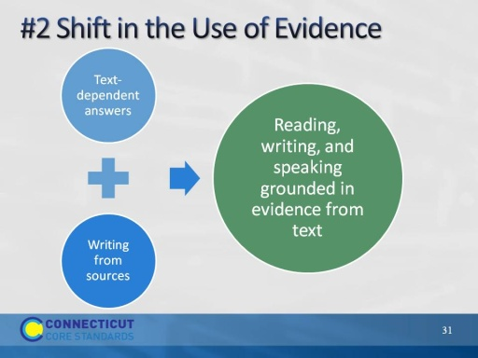
Slide 31
(Slides 31 – 45 will take about 1 hour 5 minutes. Allow 10 minutes for slides 31 – 36.)
Participants may have heard or seen the shifts described as 6 shifts rather than three. This slide shows the relationship between two of the six shifts and Shift 2. When this shift is articulated as two shifts, it emphasizes the “text-dependent” nature of questions and answers. However, it leaves out the very important aspect of speaking. Speaking provides both a means of collaborating with others, learning from others, and rehearsing for writing with evidence.
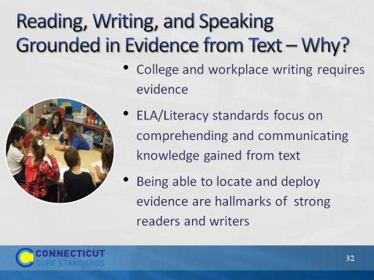
Slide 32
Ability to cite evidence differentiates strong from weak student performance on NAEP.
1st bullet: These standards are standards for college and career readiness, and most college and career writing requires students to take a position or inform others while citing evidence from text, not to provide a personal opinion. This is a sharp departure from much common, current practice where students are asked to relate the text to themselves in narrative expressive pieces, to share their views on various topics.
2nd bullet: Across the grades, and even across the content areas, students need to develop the skill of grounding their responses in evidence from the text. Requiring students to use evidence can and should occur during oral discussions with read aloud in the youngest grades and continue across all grades and content areas.
3rd bullet: Even when students are reading grade-level texts, they are too often being encouraged to write or discuss without using evidence from these texts. It is easier to talk about personal responses than to analyze what the text has to say, hence students - and teachers - are likely to engage in this type of dialogue before a text is fully analyzed. The unintended consequence of all of this? Less time in the text, more outside the text.
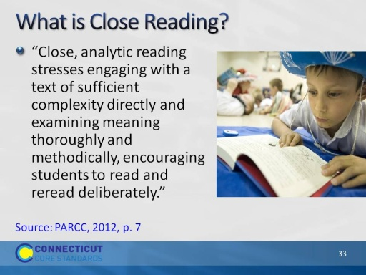
Slide 33
Ask a volunteer to read the quote. The standards require that students read carefully to grasp information, arguments, ideas, and details based on textual evidence. Students should be able to answer a range of text-dependent questions in which answers require inference based upon careful attention to the content of texts as well as to language choices (see Shift 3 for more about text complexity and language choices).
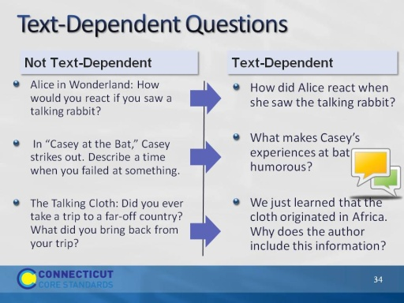
Slide 34
If time allows, ask participants in their table groups to discuss the difference between each pair of questions. Note that good text-dependent questions focus students’ attention on textual evidence to support their text-based answers. Ask volunteers for any insights gained through the conversation at their table. If the point is that “text-dependent” means that the reader needs to return to the text but also that responding to the question adds insight into the meaning of the text or the author’s use of language, then make this point.
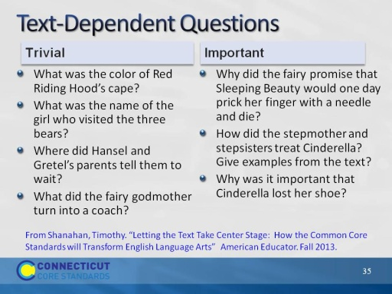
Slide 35
Shanahan, Timothy. Letting the Text Take Center Stage: How the Common Core Standards will Transform English Language Arts American Educator. Fall 2013.
Instruct participants in their table groups to discuss the difference between the questions in each column. Note that good text-dependent questions help students focus on key ideas and details that are important to comprehending the big ideas in the text. While there is a place for “right there” questions to check on basic comprehension and build confidence, most TDQ’s should be aimed at building independent comprehension of text and should be a rehearsal for the questions good readers ask themselves.
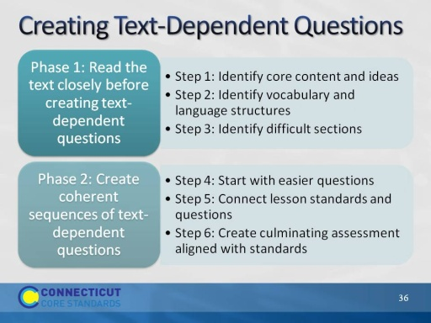
Slide 36
Creating text-dependent questions is a backward design process. See page 20 of the Participant Guide for the handout, “Guide to Creating Text-Dependent Questions.” This is a resource to provide background knowledge for participants, but it will not be read during Activity 3.
Phase 1:
- Read the text closely, taking careful notes as to the important content, concepts, and academic language. Identify the key concepts that students need to understand.
- Specify the content vocabulary and academic vocabulary that will be examined in the lesson. These are words and grammatical choices that are connected to content and ideas. The teacher defines key words and phrases as part of questioning, but students should also be able to define many words in context.
- Identify segments of the text that are most challenging to focus questioning.
Phase 2:
- Create logical sequence of text-dependent questions for each lesson, starting small with easier questions to build confidence.
- Make sure that the standards to be addressed in the lesson are addressed in the questions.
- Create the culminating activity for the lesson, aligned to the standards. Note: Not all lessons need to have culminating activities. Culminating activities for lessons are typically formative. End of unit assessments are typically summative.
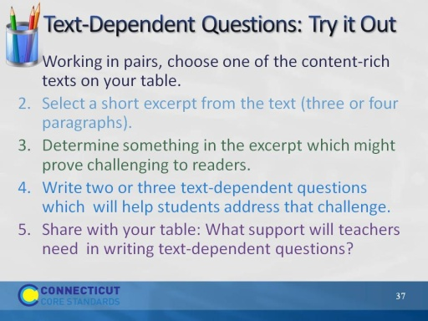
Slide 37
(Allow 15 minutes for this activity.)
This activity is a quick, informal activity, using sticky notes to craft a short series of TDQ’s.
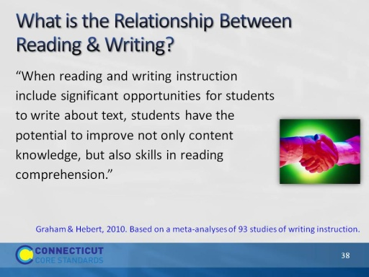
Slide 38
Ask a participant to read the quote aloud. Point out that the research is clear that reinforcing the reading-writing connection is imperative if we are going to develop proficient independent readers and writers of complex text across content areas.
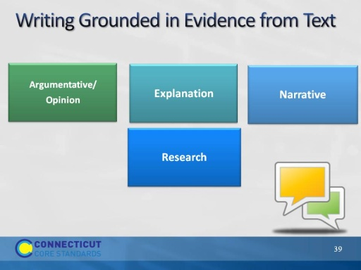
Slide 39
Have participants discuss at their tables which of these they routinely see in classroom ELA/Literacy instruction – and in science and social studies and technical classes. Ask participants which of these types of writing can be grounded in evidence? What does that look like?
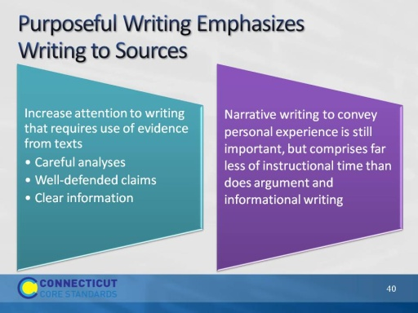
Slide 40
Purposeful writing with evidence:
- Writing to narrate is important, but decreases in emphasis as students advance through the grades.
- Writing to inform and to defend a point of view or claims increases in emphasis through the grades. Writing with sources means that students are expected to support their written arguments with sources.
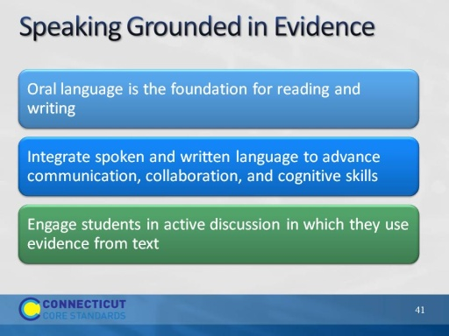
Slide 41
The big idea is that there is a reciprocal relationship between language and literacy. Strong language skills support literacy development, and strong literacy development enhances language skills.
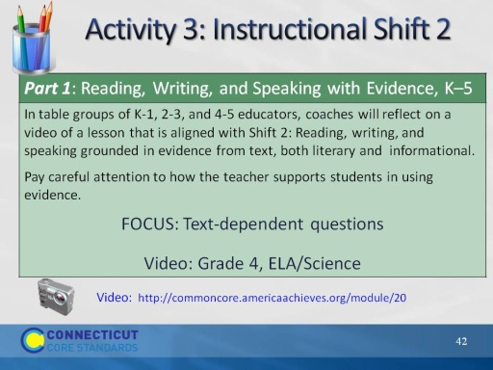
Slide 42
This slide introduces Activity 3. Before participants begin, make sure everyone knows where the directions are located in the Participant Guide for watching and discussing the video exemplar. This time the focus is on reading, writing and talking about the text
View a video of instruction related to Shift 2 and discuss your observations (20 minutes total).
Tell participants that they are going to view a video lesson that shows a fourth grade class reading closely, Discovering Mars: The Amazing Story of the Red Planet by Melvin Berger. The lesson plan and text-dependent questions for the video lesson are included in the resources for this activity. We are focusing on the text-dependent questions that the teachers ask and the student’s text-based answers focused on content-rich text.
Video exemplar lesson plans and student worksheet
Video: Video: http://commoncore.americaachieves.org/module/20
Grade 4, English Language Arts/Science
Segment- 1:30 – 8:30, 7 minutes total
- Tell participants that as they watch the video, they should take notes on the text-dependent questions that the teacher poses and the students’ responses to the questions. Do the questions specifically address content-rich material in the text? What types of questions does the teacher ask? Are students successful in responding to the questions with textual evidence? Ask participants to pay special attention to the way that the teacher helps students become close readers as they build content knowledge (7 minutes to watch the video).
- After watching the video, ask participants to “Turn-and-Talk” to their neighbor to discuss what they observed in the video that exemplifies the value of text-dependent questioning in close reading of meaningful content. Peer pairs then share their ideas with others at the table (10 minutes to discuss).
- One volunteer will share an idea from the table with all participants (3 minutes to share).
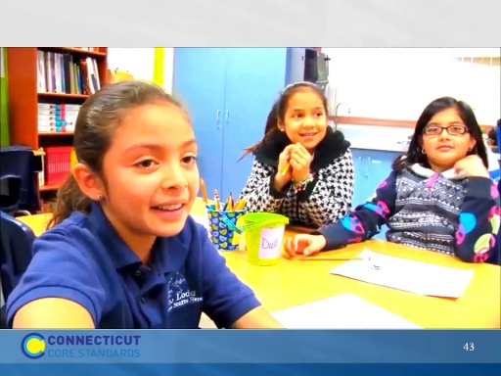
Slide 43
Play video.
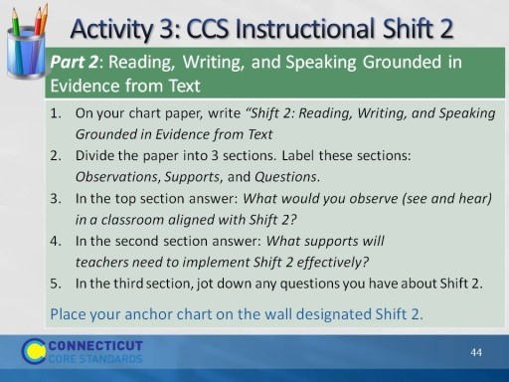
Slide 44
(10 minutes)
The point of an anchor chart is to anchor the teaching and learning that is happening in the classroom. We will create anchor charts to note the key points or “take-aways” from our work with each of the three shifts today. Later on, you’ll have the opportunity to see and comment upon what others have written.

