Module 1  Facilitator Guide | Focus on Instructional Shifts

Closing Activity

Connecticut Core Standards for English Language Arts and Literacy

Grades 6–12

Systems of Professional Learning

Session at-a-Glance

Closing Activities
(5 minutes) Post-Assessment–CCS-ELA & Literacy and Instructional Shifts

Supporting Documents:
- Post-Assessment

(10 minutes) Session Evaluation
Remind participants to complete an online Session Evaluation.

Supporting Documents:
- Link to take online Session Evaluation

PowerPoint Slides:
- 70–73

Session Implementation
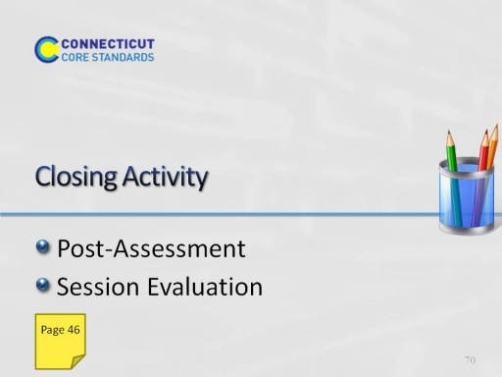
Slide 70
Remind participants that they will have an opportunity at the beginning of Module 2 to share successful PD activities or challenges related to Module 1 at their schools.
Post-Assessment
Session Evaluation
Post-Assessment and Session Evaluation
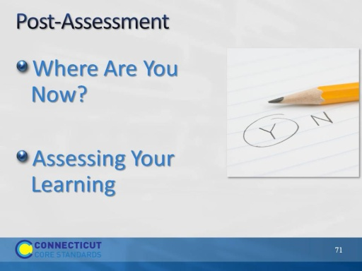
Slide 71
The post-assessment will be the same as the pre-assessment they took in the beginning of the session. This assessment is to gauge their learning based on the activities of the morning. They will find the post-assessment on page 46 of the participant guide 3-4 min. Ask volunteers to share out any insights about the CCS-ELA & Literacy that they gained from this morning’s session.
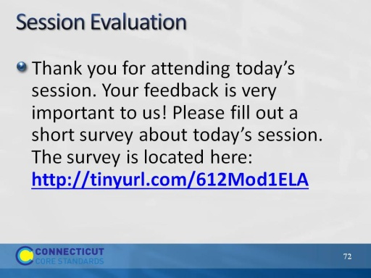
Slide 72
Remind participants to complete an online Session Evaluation. (10 minutes)
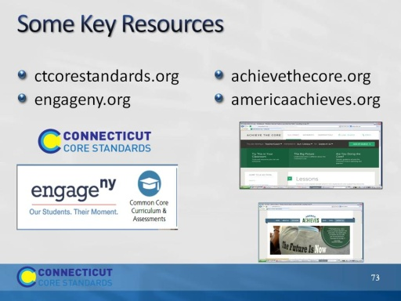
Slide 73

