Module 1  Facilitator Guide | Focus on Instructional Shifts

Activity 8

Connecticut Core Standards for English Language Arts and Literacy

Grades 6–12

Systems of Professional Learning

Session at-a-Glance

Activity 8: Plan for Sharing
(15 minutes) Common Core Coaches will discuss and develop a strategy for sharing Module 1’s key messages and instructional resources (e.g., PowerPoint presentations, videos, resource links, and aligned instructional practices) with colleagues back at their schools.

Supporting Documents:
- Plan for Sharing

PowerPoint Slides:
- 68–69

Session Implementation
Activity 8
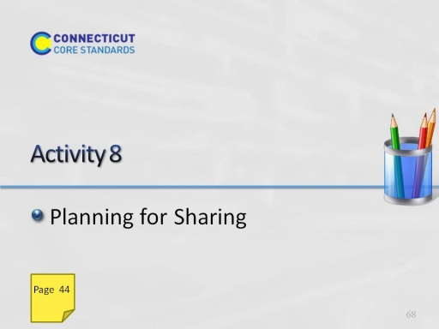
Slide 68
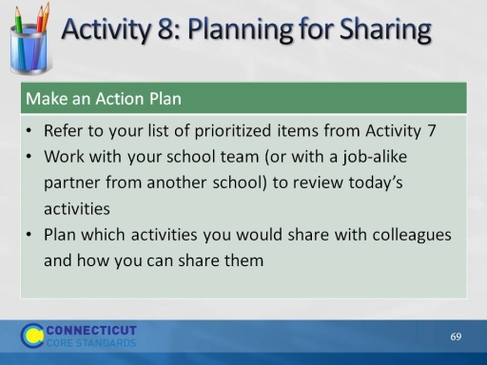
Slide 69
(Allow 15 minutes for this activity; adjust time as needed.)

