Module 1  Facilitator Guide | Focus on Instructional Shifts

Activity 2

Connecticut Core Standards for English Language Arts and Literacy

Grades 6–12

Systems of Professional Learning

Session at-a-Glance

Activity 2: Building Knowledge through Content-Rich Nonfiction
(When sharing this section of the presentation in their schools, Common Core Coaches may choose to present each shift as a separate, shorter work session.)
(35 minutes) Before Activity 2 begins, participants will sort into grade-band (6–8, 9–10, and 11–12) groups of 8. Participants will view/listen to a presentation about each of the three instructional shifts for ELA and will learn about the design of text sets. Following the presentation for each shift, coaches will read a grade-appropriate complex text excerpt from Appendix B and reflecting on the implications for instruction related to that particular shift.
Participants will create an anchor chart to explain what they might observe in classrooms aligned with Shift 1, what supports teachers will need to implement Shift 1, and any questions they have about Shift 1.

Supporting Documents:
- Directions
- Discussion Prompts
- Excerpts from CCS Appendix B

PowerPoint Slides:
- 17–29
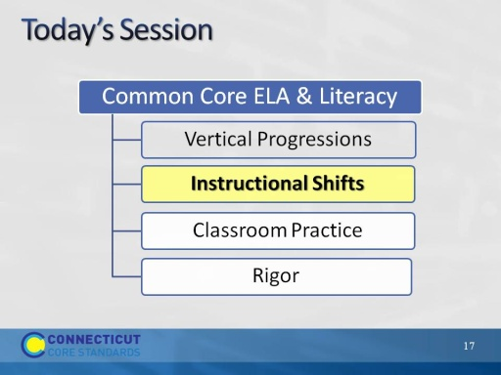
Slide 17
Explain that now we will look carefully at the three instructional shifts associated with the CCS-ELA and related instructional practices. These shifts represent the primary changes in practice from previous standards in order to achieve the CCR goals.
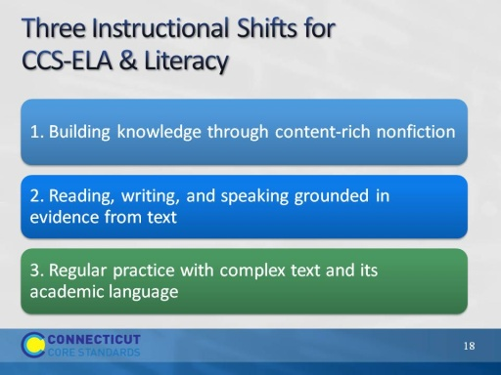
Slide 18
(Slides 18 – 27, introduction to the shifts, should take 10-15 minutes.)
- These shifts are a “high level” view of the major instructional changes that are needed to actualize the standards.
- The shifts point the way toward changes in curriculum, instructional practice, and assessment to achieve alignment with the standards. Disseminating information about the shifts and helping all educators implement the standards is fundamental to achieving the goal of CCS-ELA & Literacy aligned curriculum, instruction, and assessment.
- In this section of today’s workshop, participants will look at aligned instructional practices and examine how a given practices supports the shifts and, in turn, the implementation of the standards.
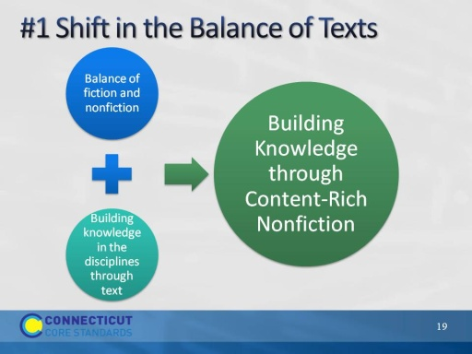Slide 19
- We are starting with Shift 1: Building Knowledge Through Content-Rich Nonfiction. This marks a shift in terms of the types of text emphasized in ELA classes instruction also is expected to have students use texts as a primary vehicle for learning.
- Participants may have heard or seen the shifts described as 6 shifts rather than three.
- This slide shows the relationship between two of the six shifts and Shift 1. When Shift 1 is articulated as two separate shifts, it emphasizes the difference between elementary and secondary grades. In elementary school the classroom teacher is expected to strike a balance between fiction and nonfiction, using reading in the content areas to build knowledge.
- In the secondary grades, literacy is a shared responsibility of content teachers and ELA teachers. While ELA teachers increase their use of nonfiction as it pertains to their disciplines (e.g. essay, biography), each of the other disciplines is responsible for helping students build knowledge in their disciplines through texts rather than teacher talk.
- Teachers can help students understand that text is a source of knowledge and that they can use content knowledge to learn from the past and solve today’s problems around the globe.
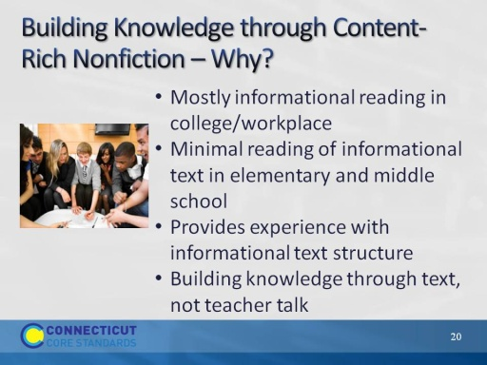
Slide 20
- Recall from Activity 1 that the reading standards specify building knowledge (Reading standards 7-9) , citing evidence using key ideas and details (Reading standards 1-3), and attending to the craft and structure (Reading standards 4-6) of literature and informational text at all grade levels. The content literacy standards for grades 6-12 parallel the reading standards using discipline-specific content.
1st bullet: Even thought reading informational texts proves to be more difficult for students, it is a skill that must be developed for college and career readiness.
2nd bullet: The CCS have followed the NAEP (National Assessment of Educational Progress) guidelines in establishing how much informational text students should read in schools. By high school, the standards call for a 30/70 split between literary texts and informational texts. The 70/30 split in grades 9-12 does not just refer to ELA/Literacy classes – it means the entire school experience for students, across the day, week, and year. To achieve this distribution, instructors of science, socials studies, arts, technical subjects, etc., must integrate literacy into the content of these courses.
This is displayed most prominently in two ways. 1) At every grade level, there are a set of standards for informational text and a set for literary standards. Each discipline has specific guidelines for the type of text to be read 2) Reading Standard 10 calls for students to read a wide range of informational text. It is actually a standard to read informational text.
3rd bullet: Even though reading informational texts proves to be more difficult for students, it is a skill that must be developed for college and career readiness.
4th bullet: Background knowledge has long been connected to comprehension. Reading informational text is essential in building background knowledge. A skill needed in both college and the workplace. Reading a coherent sequence of texts designed to develop content knowledge is also the best way to grow academic vocabulary because students have multiple exposures to words.
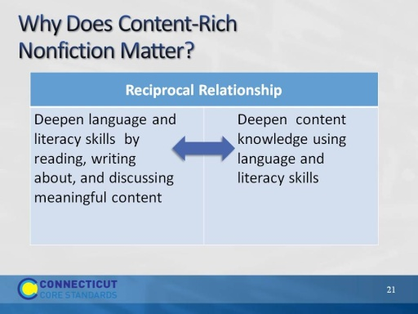
Slide 21
This slide addresses “Why ‘content-rich’ matters?” and the reciprocal relationship between deepening language and literacy skills while simultaneously building content knowledge.
Build background knowledge to prepare students for post-secondary reading in college and careers:
  - In ELA, blend literature and informational text in multi-modal, multi-genre text sets, so texts inform one the content knowledge that is the focus of instruction.
  - In the content disciplines, read textbooks, journals, data including scientific experiments, primary source documents
  - In English, blend literature and literary nonfiction – speeches, essays, literary nonfiction, biography
  - Use content knowledge to learn from the past and solve today’s problems around the globe
  - Text is a source of knowledge
  - The stronger one’s reading skills, the easier it is to learn independently through reading text.
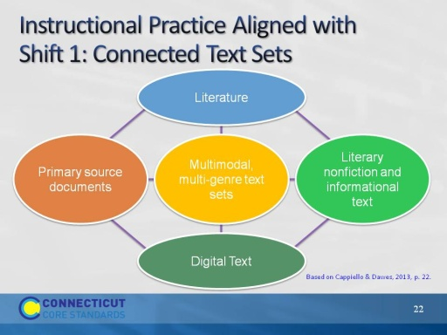
Slide 22
Instructional practice aligned with Shift 1: Texts Talking to Each Other.
To deepen students’ content knowledge, use an integrated, interdisciplinary approach in which informational and literary nonfiction informs the themes of literature and vice-versa. This slide presents one model of how text sets might be organized. (See Cappiello & Dawes, 2013, p. 22 for examples of texts):
- Literature: Realistic fiction, fantasy, historical fiction, mystery, science fiction, poetry, traditional literature, drama.
- Literary nonfiction and Informational Text: Biography, literary criticism, essays, textbooks, newspapers, journals and magazines
- Digital Text: webcasts, podcasts, photographs, websites, online government reports, works of art and music, interviews, blogs
- Primary source documents: speeches, documents, photographs, historical artifacts, newspapers
(See Cappiello & Dawes, 2013, pp. 254-257 for examples of text set structures)
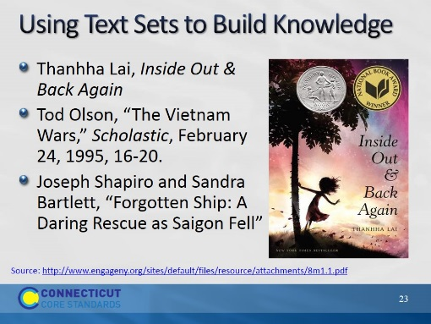
Slide 23
This is an example of a text set. This text set is used in Grade 8, Module 1, written by Expeditionary Learning for EngageNY. In this module, students will develop their ability to read and understand complex text as they consider the challenges of fictional and real refugees. They read the novel, in long verse, Inside Out and Back Again. They also read informational text to learn more about the history of war in Vietnam, and the specific historical context of Ha’s family’s struggle during the fall of Saigon. In Unit 3, work in research groups to study the experiences of refugees from one of several cultures.
As a performance assessment, students will use this knowledge to write two, free verse narrative poems that capture the universal refugee experience.
Notes:
- Not random reading – Text sets should be sequenced to build knowledge
- Students learning to read should exercise their ability to comprehend complex text through read-aloud texts.
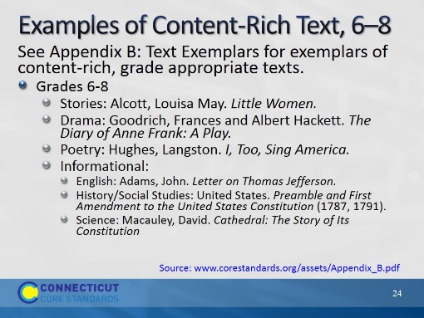
Slide 24
One good source of multi-genre text exemplars (and related performance tasks) is Appendix B of the CCS-ELA & Literacy. Note: We use Appendix B in the Activities.
Reference:
National Governors Association Center for Best Practices & Council of Chief State School Officers (2010). Common Core State Standard for English Language Arts and Literacy in History/Social Studies, Science, and Technical Subjects. Washington, D.C.: Authors. Retrieved from http://www.corestandards.org/ELA-Literacy/; National Governors Association Center for Best Practices & Council of Chief State School Officers (2012). See Appendix B: Text Exemplars and Sample Performance Tasks. http://www.corestandards.org/assets/Appendix_B.pdf.
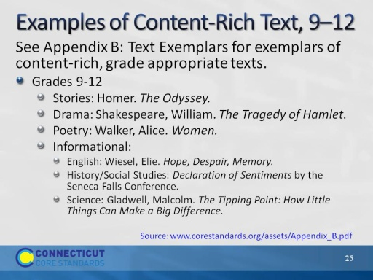
Slide 25
One good source of multi-genre text exemplars (and related performance tasks) is Appendix B of the CCS-ELA & Literacy. Note: We will use excerpts from Appendix B in Activities.
Reference:
National Governors Association Center for Best Practices & Council of Chief State School Officers (2010). Common Core State Standard for English Language Arts and Literacy in History/Social Studies, Science, and Technical Subjects. Washington, D.C.: Authors. Retrieved from http://www.corestandards.org/ELA-Literacy/; National Governors Association Center for Best Practices & Council of Chief State School Officers (2012). See Appendix B: Text Exemplars and Sample Performance Tasks. http://www.corestandards.org/assets/Appendix_B.pdf.
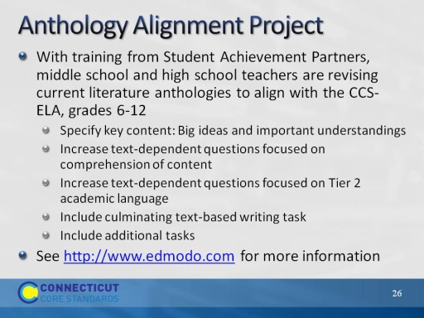
Slide 26
The Anthology Alignment Project is posting current anthology lessons that are aligned to the CCS-ELA for grades 6-12. All major literature series including Houghton Mifflin Harcourt, McGraw Hill, and Holt are included in the emerging set of aligned lessons.
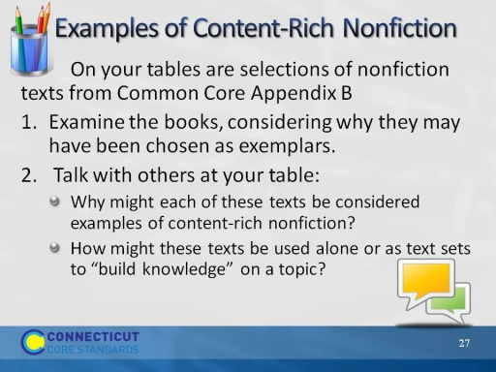
Slide 27
Encourage participants to examine the texts in the back of the Participant Guide. Ask for a few examples of what was discussed at the tables. (Allow 15 minutes to examine the texts and talk about them.)
Activity 2
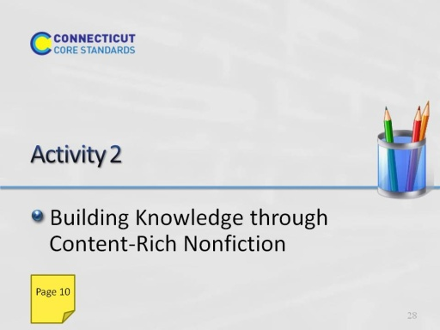
Slide 28
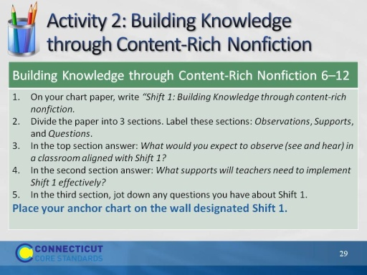
Slide 29
The purpose of an anchor chart is to anchor the teaching and learning that is happening in the classroom and to keep it visible for reference.
We will create anchor charts to note the key points or “take-aways” from our work with each of the three shifts today. Later on you’ll have the opportunity to see and comment upon what others have written.

