Module 1  Facilitator Guide | Focus on Instructional Shifts

Activity 1

Connecticut Core Standards for English Language Arts and Literacy

Grades 6–12

Systems of Professional Learning

Session at-a-Glance

Activity 1: Examining the Vertical Progressions of the CCS-ELA & Literacy
(50 minutes) Participants will listen to an overview of the CCS-ELA & Literacy expectations for grade level proficiency leading to college and career readiness. Topics in the presentation will include: aligning curriculum, instruction, and assessment to the standards; using ELA & Literacy appendices and updated supplemental information from Appendix A in making decisions regarding curriculum and instruction; and the implications of a common set of standards across the U.S.
In mixed grade table groups, pairs of coaches will select a strand to explore: Reading, Writing, Language, Speaking and Listening, or Reading. Pairs will trace a standard from grade-to-grade, examine grade level expectations, think about how the grade level expectations lead to the Anchor Standard, and discuss implications for curriculum and instruction. Pairs will share what they learned at their tables, and volunteers will share with the whole group.

Supporting Documents:
- Directions
- Vertical Progressions Template
- Discussion Prompts
- Connecticut Core Standards 6–12 ELA & Literacy Standards Progression document (separate handout for each participant)

PowerPoint Slides:
- 6–16
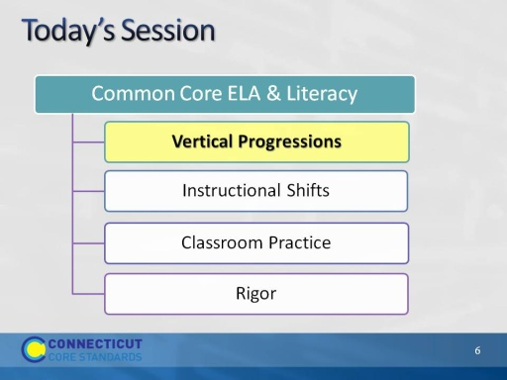
Slide 6
- Activity 1, Slides 6-17, will take about 50 minutes.
- The purpose of the morning is to look closely at the CCS-ELA and Literacy to understand the specific skills and knowledge that students are expected to acquire in order to achieve proficiency on assessments aligned to the standards.
- Central to achieving proficiency is the nature of aligned curriculum and instructional practices.
- It is important that as coaches you understand the standards and their implications for curriculum and instruction.
- First – we will look carefully at the vertical structure of the CCS-ELA & Literacy to understand the connection between the College and Career Readiness Anchor Standards and the grade level standards.
- We will then look at the three instructional shifts associated with the CCS-ELA and related instructional practices.
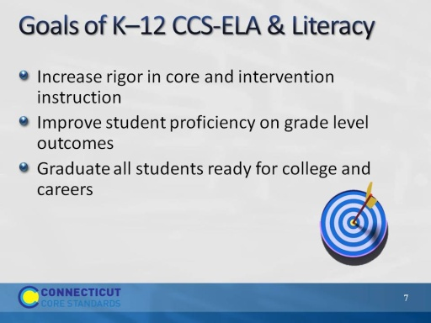
Slide 7
Say: The overriding goals of the CCS are to:
- Increase the rigor in the academic program for core and intervention instruction. While we are focusing on core instruction, the standards also have applicability for intervention as all students work toward proficiency on the CCS-ELA & Literacy. If many more students need support given the increased rigor of the standards, and intervention resources are limited, core instruction itself will need to change to support more students to meet the standards. Intervention programs will also need to be aligned.
- The goal of increasing the rigor and alignment of core instruction and intervention supports is to help all students gain proficiency on grade level and course content standards, so they will graduate from high school with the skills they need for college and careers.
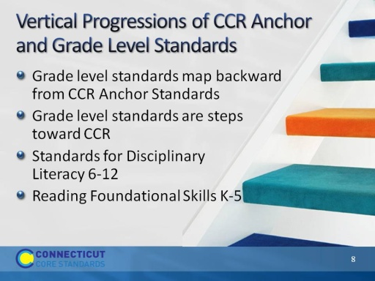
Slide 8
Let’s start by taking a closer look at the vertical progressions of the CT Core Standards for English Language Arts & Literacy.
- CCR means ‘College and Career Ready.’ A core organizing principle of the Common Core State Standards is to begin with the end; that is, a small set of critical standards for success in college and careers. CCS identifies College and Career Ready (CCR) Standards for reading and writing in ELA, History/Social Studies, Science and Technical subjects, and in ELA for speaking and listening and language.
- The CCR anchor standards identify skills necessary for success in College and Career.
- Mapping backward from the CCR, the authors of the CC identified the steps necessary to get to CCR beginning in K.
- The Common Core ELA & Literacy is a set of integrated standards, so as you become familiar with standards in one strand, e.g. reading, you will see how the same skills are cross-referenced in writing, speaking and listening, and language.
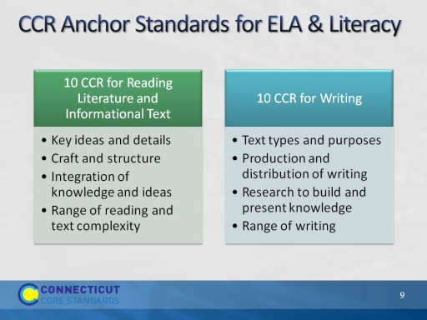
Slide 9
- CCR standards are organized by domains or strands: Reading Informational Text, Literature, Writing, Speaking and Listening, Language.
- Within domains/strands, standards are organized by clusters. For example, the reading standards are divided into four categories: 1) key ideas and details emphasizes close reading to determine meaning, drawing inferences, analyzing themes, and summarizing supporting details; 2) craft and structure emphasizes the author’s word choice, grammatical structures, and point of view as they impact text content and structure; 3) integration of knowledge and ideas emphasizes analysis of textual themes and arguments across varied media and formats; and 4) range of reading and level of text complexity emphasizes the importance of independent and proficient reading of complex text (CCS, p. 10).
- Standard R.10 can be considered the goal of the reading standards, to INDEPENDENTLY read and comprehend increasingly complex texts.
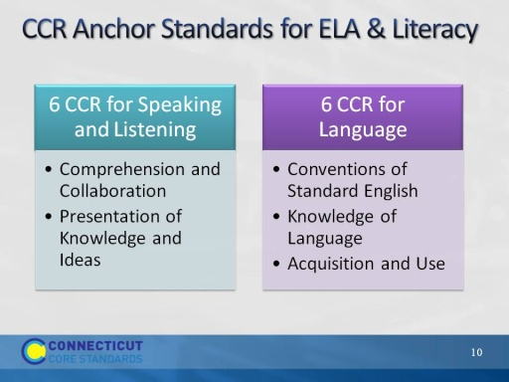
Slide 10
The CC puts a renewed emphasis on the importance of speaking, listening, and collaboration as key to success in school and in College and Career. Students learn from each other as they become capable of reading and writing more complex text.
CCR for language strongly recognizes that language acquisition is the basis for building knowledge and reading comprehension. There is a renewed emphasis on building both general and content specific vocabulary, especially as it can be defined in context.
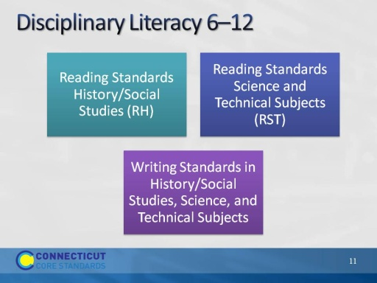
Slide 11
The authors of the CC make the general assumption that literacy will be integrated into all subject areas in the elementary grades and will most often be taught by the same teacher who teaches ELA. .
The CCS Literacy Anchor Standards/Disciplinary Literacy standards for 6-12 are slightly different in a few ways. There are Reading and Writing standards (10 each) for Science, Social Studies and Technical Subjects and only nonfiction reading and argument and explanatory writing is emphasized but no separate speaking and listening or language standards. Instead, vocabulary and speaking about text using evidence is integrated throughout the reading and writing standards. Disciplinary literacy standards describe the specific nature of texts and tasks demanded by the texts in those domains, as well as the nature of writing used by practitioners in the fields.
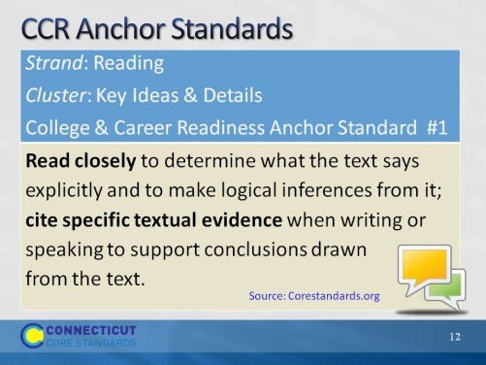
Slide 12
Here is an example of the vertical alignment structure of the CCS-ELA:
Strand: Reading
Cluster 1: Key Ideas and Details
CCR Anchor Standard for Reading 1 establishes the performance expectations that by the time students graduate from high school, they should be able to engage in close reading, citing specific textual evidence in their text-based written or spoken responses. Text-based answers support the reader’s careful reading of the text. Readers use textual evidence to support their interpretation of the author’s intended meaning
Pay close attention to the verbs because it is the verbs that define the actions – what students should know and be able to do:
- Read closely ->directly related to all of the instructional shifts, but especially to shift 2 (text-based answers in response to text-based questions)
- Make logical inferences from text: Be mindful of Bloom’s taxonomy because the CCS expect that students’ responses will reflect higher levels of thinking – analysis, synthesis, and evaluation rather than recall:
- Knowledge (e.g.., recall information – identify, locate, select)
- Comprehension (e.g.., explain, relate, infer)
- Application (e.g.., apply, produce)
- Analysis (e.g.., categorize, analyze, compare)
- Synthesis (e.g.., hypothesize, combine, plan)
- Evaluation (e.g.., justify, critique, assess)
Note integration of reading with writing and speaking – that evidence of comprehension is articulated through spoken language and writing.
Turn and talk: If you were the authors of the CC, and you knew this (R.1) was the CCR goal, what do you think would be the starting point for K students? Here is an example of the vertical alignment structure of the CCS-ELA:
Strand: Reading
Cluster 1: Key Ideas and Details
CCR Anchor Standard for Reading 1 establishes the expectation that, by the time students graduate from high school, they should be able to engage in close reading, citing specific textual evidence in their text-based written or spoken responses. Readers use textual evidence to support their interpretation of the author’s intended meaning.
- Pay close attention to the verbs because it is the verbs that define the actions – what students should be able to do:
- Read closely
- Make logical inferences from text: CCS expect that students’ responses will reflect higher levels of thinking – analysis, synthesis, and evaluation rather than just recall.
- Note integration of reading with writing and speaking – that evidence of comprehension is articulated through spoken language and writing.
Turn-and-talk: If you were the authors of the CC, and you knew this (R.1) was the CCR goal, what do you think would be the starting point for K students?
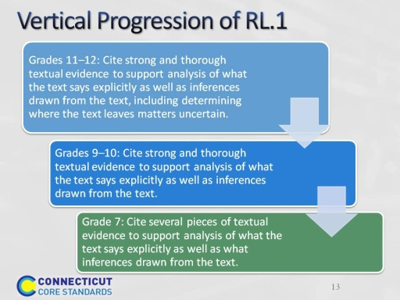
Slide 13
Here is an example of what participants will do in Activity CCCS.ELA-Literacy.RL.6.1
- Refer to CCR Anchor Standard: Cite textual evidence to support analysis of what the text says explicitly as well as inferences drawn from the text.
Activity 1
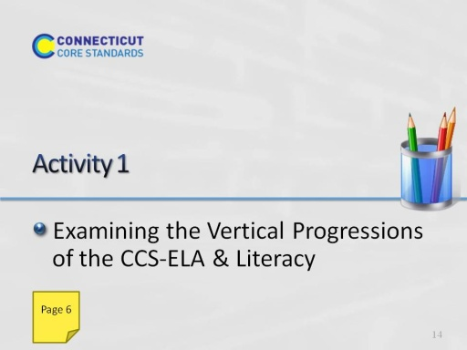
Slide 14

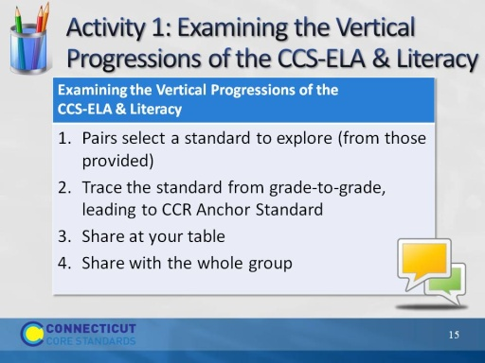
Slide 15
Here is an example of what participants will do in Activity CCCS.ELA-Literacy.RL.6.1
- Refer to CCR Anchor Standard: Cite textual evidence to support analysis of what the text says explicitly as well as inferences drawn from the text.
Activity Resources:
- CCS-ELA & Literacy, 6-12 or 6-12 regrouped by CCR anchor standard and related grade level standards
- Activity Packet: directions, discussion prompts, template

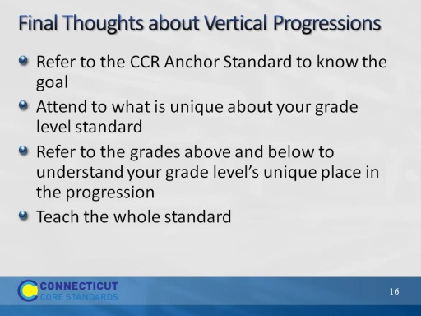
Slide 16
Use this slide to bring closure to the previous discussion. These are reminders. In order to see where the grade level standard is headed, look out at the CCR standard. However, you need to focus on your specific standard; otherwise you risk generalizing and teaching what actually belongs to a different grade level. If you “unpack” a standard, be certain that you don’t artificially break it into micro standards. The sum of all parts is not necessarily equal to the whole. Example: Characters + Plot taught separately does not equal the character’s influence on the plot and vice versa.

