Module 2  Facilitator Guide | Supporting All Students in Close Reading, Academic Language, and Text-Based Discussion

Activity 6

Connecticut Core Standards for English Language Arts and Literacy

Grades 6–12

Systems of Professional Learning

Connecticut Core Standards Systems of Professional Learning
The material in this guide was developed by Public Consulting Group in collaboration with staff from the Connecticut State Department of Education and the RESC Alliance. The development team would like to specifically thank Ellen Cohn, Charlene Tate Nichols, and Jennifer Webb from the Connecticut State Department of Education; Leslie Abbatiello from ACES; and Robb Geier, Elizabeth O’Toole, and Cheryl Liebling from Public Consulting Group.
The Systems of Professional Learning project includes a series of professional learning experiences for Connecticut Core Standards District Coaches in English Language Arts, Mathematics, Humanities, Science, Technology, Engineering, Mathematics (STEM), and Student/Educator Support Staff (SESS).
Participants will have continued support for the implementation of the new standards through virtual networking opportunities and online resources to support the training of educators throughout the state of Connecticut.
Instrumental in the design and development of the Systems of Professional Learning materials from PCG were: Sharon DeCarlo, Debra Berlin, Jennifer McGregor, Judy Buck, Michelle Wade, Nora Kelley, Diane Stump, and Melissa Pierce.
Excerpts, tools, and strategies from Thinkquiry Toolkit 1 © 2011 and Thinkquiry Toolkit 2 © 2014. All rights reserved. Used with permission of Public Consulting Group. Excerpts from PCG Education White Papers Universal Design for Learning © 2013 and Making a Difference in Student Achievement © 2011. All rights reserved. Used with permission of Public Consulting Group.

Published 2014. Available online at http://ctcorestandards.org/

Session at-a-Glance

Activity 6a and 6b: Viewing a Video and Choosing a Protocol (25 minutes)
Participants view a video of a secondary grade class engaged in text-based discussion, and will consider the importance of protocols for creating a productive environment for students. They will also note where formative assessment opportunities arise during the lesson. After viewing and discussing the video, participants select a protocol from a list of discussion protocols, learn about it, and explain it to others. Each pair of participants selects a discussion protocol to use in their close reading lesson.

Supporting Documents:
- Directions
- List of Discussion Protocols
- Lesson Plan Template

Video:
- Students Cite Evidence from Informational and Literary Text from Expeditionary Learning
http://vimeo.com/54871334

PowerPoint Slides:
- 59–62

Session Implementation
Title Slide

Activity 6a
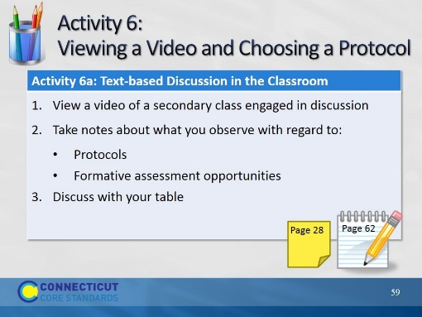Slide 59
Description of the Activity: In Activity 6a, participants will view a video of a secondary class engaged in text-based discussion, and will consider the importance of protocols for creating a productive environment for students. They will also note where formative assessment opportunities arise during the lesson. (The video can be found here: http://vimeo.com/54871334 A Protocol for Learning to Cite Evidence from Expeditionary Learning.)
In Activity 6b, after viewing and discussing the video, participants will select a protocol from a list of discussion protocols, learn about it, and explain to others.
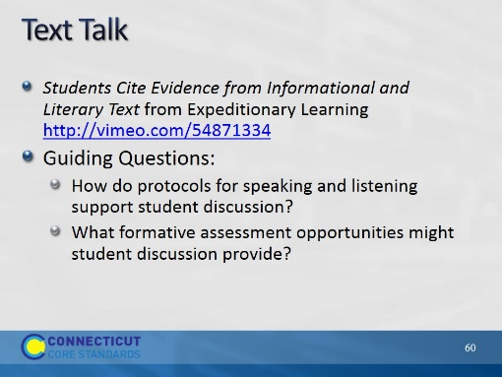Slide 60
Blank.

Activity 6b
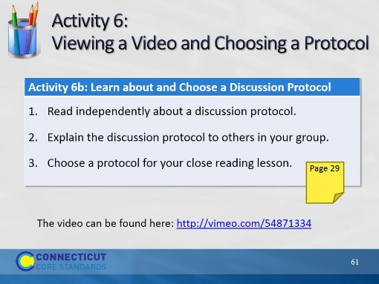Slide 61
Description of the Activity:
In Activity 6a, participants will view a video of a secondary class engaged in text-based discussion, and will consider the importance of protocols for creating a productive environment for students. They will also note where formative assessment opportunities arise during the lesson.
In Activity 6b, after viewing and discussing the video, participants will select a protocol from a list of discussion protocols, learn about it, and explain to others. (The video can be found here: http://vimeo.com/54871334
A Protocol for Learning to Cite Evidence from Expeditionary Learning.)
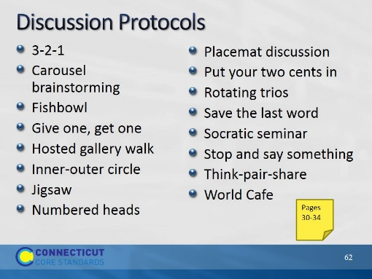Slide 62
Explain to participants that these protocols are described in their Participant Guide. At their table, each of them should choose a different protocol and study it briefly. Then they will describe it to others at their table.

