Module 2  Facilitator Guide | Supporting All Students in Close Reading, Academic Language, and Text-Based Discussion

Activity 5

Connecticut Core Standards for English Language Arts and Literacy

Grades 6–12

Systems of Professional Learning

Connecticut Core Standards Systems of Professional Learning
The material in this guide was developed by Public Consulting Group in collaboration with staff from the Connecticut State Department of Education and the RESC Alliance. The development team would like to specifically thank Ellen Cohn, Charlene Tate Nichols, and Jennifer Webb from the Connecticut State Department of Education; Leslie Abbatiello from ACES; and Robb Geier, Elizabeth O’Toole, and Cheryl Liebling from Public Consulting Group.
The Systems of Professional Learning project includes a series of professional learning experiences for Connecticut Core Standards District Coaches in English Language Arts, Mathematics, Humanities, Science, Technology, Engineering, Mathematics (STEM), and Student/Educator Support Staff (SESS).
Participants will have continued support for the implementation of the new standards through virtual networking opportunities and online resources to support the training of educators throughout the state of Connecticut.
Instrumental in the design and development of the Systems of Professional Learning materials from PCG were: Sharon DeCarlo, Debra Berlin, Jennifer McGregor, Judy Buck, Michelle Wade, Nora Kelley, Diane Stump, and Melissa Pierce.
Excerpts, tools, and strategies from Thinkquiry Toolkit 1 © 2011 and Thinkquiry Toolkit 2 © 2014. All rights reserved. Used with permission of Public Consulting Group. Excerpts from PCG Education White Papers Universal Design for Learning © 2013 and Making a Difference in Student Achievement © 2011. All rights reserved. Used with permission of Public Consulting Group.

Published 2014. Available online at http://ctcorestandards.org/

Session at-a-Glance

Activity 5: Reading about Classroom Discussion (30 minutes)
Participants will read, annotate, and discuss Close reading and far reaching classroom discussion: a vital connection, an article from the International Reading Association.

Supporting Documents:
- Gray, J. (2005) "Four A’s Text Protocol." National School Reform Faculty. Harmony Education Center. http://www.nsrfharmony.org/protocol/doc/4_a_text.pdf
- Snow, C. & O’Connor, C. (2013). Close reading and far reaching classroom discussion: a vital connection. International Reading Association http://www.reading.org/Libraries/lrp/ira-lrp-policy-brief--close-reading--13sept2013.pdf
Video
- Catherine Snow discusses a project in which she is involved through SERP http://ccdd.serpmedia.org/index.php

PowerPoint Slides:
- 55–58

Session Implementation
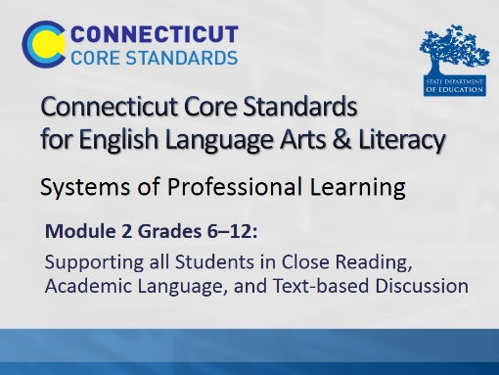Title Slide
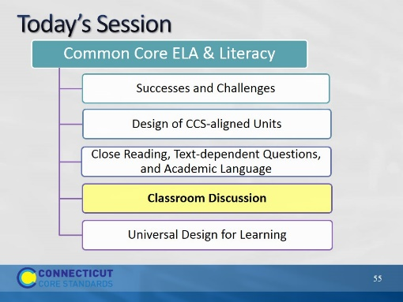Slide 55
Blank.

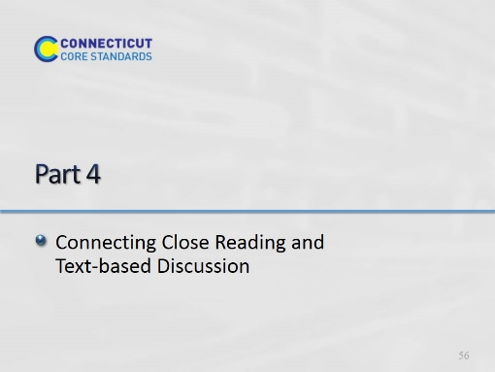Slide 56
(60 minutes) This backward design portion is meant only as general information and guidance so that participants will understand where a close reading lesson might fit into an overall unit. Module 4 will go more deeply into unit design.

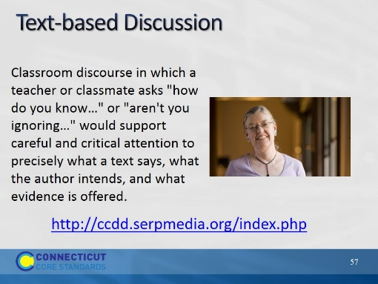Slide 57
Read the quote and show the video as a prelude to the article handout.
In this brief video, Catherine Snow professor and researcher at Harvard University discusses a project in which she is involved through SERP. SERP is an organization that provides a structure for research and research based programs carried out in field sites – schools and school districts, who work in partnership with SERP. In this video, Dr. Snow explains the importance of text-based discussion and what they hope current research on reading comprehension will reveal about text-based discussion and reading comprehension.
http://ccdd.serpmedia.org/index.php
Segment :0.00 – 1.34

Activity 5
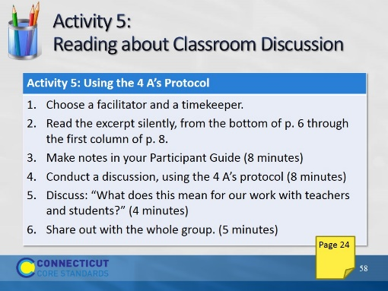Slide 58
Description of the Activity:
Participants read and annotate a handout excerpt from an IRA policy brief, “Close Reading and Far-Reaching Classroom Discussion: Fostering a Vital Connection” (Snow & O’Connor, 2013 retrieved from: http://www.reading.org/Libraries/lrp/ira-lrp-policy-brief--close-reading--13sept2013.pdf). In groups of 4, they use the 4 A’s Protocol, to discuss the article, and prepare to answer the question, What implications does this excerpt have for our work with teachers and students?
Gray, Judith. "Four 'A's Text Protocol." National School Reform Faculty. 2005. Harmony Education Center. http://www.nsrfharmony.org/protocol/doc/4_a_text.pdf
1. Point out the location of the activity in their Participant Guide. This summary is in the Participant Guide. Explain that they are going to read an excerpt from a longer article and discuss it. You will summarize the parts of the article they are not reading.
2. Read this summary: The authors, Snow and O’Connor examine close reading and consider the advantages, as well as the limitations of close reading. They suggest ways in which close reading might be usefully supplemented by other classroom practices, to ensure that it supports comprehension and to avoid problems from an excessive focus on close reading, such as student frustration, a decline in motivation to read, and reduction in opportunities to learn content.
3. Review the directions and point out the location of the protocol grid in their Participant Guide. The sections of the article participants will read address the relationship between classroom discussion and close reading. They read, beginning at the bottom of page 6 through the first column on page 8: “Narrow Close Reading Undermines Valuable Classroom Discussion,” and, “Productive Close Reading.”
Choose a timekeeper and facilitator.
Read the excerpt silently, making notes in the table for each of the 4 A’s and highlighting sentences, phrases, or words in the text as evidence. (8 minutes)
- What Assumptions does the author of the text hold?
- What do you Agree with in the text?
- What do you want to Argue with in the text?
- What part of the text do you want to Aspire to or Act upon?
In a round, have each person identify one assumption in the text, citing the text as evidence. (1 minute per person, 4 minutes total)
In the second round, each participant may choose any one of the remaining 3 A’s to share. (1 minute per person, 4 minutes total) Please note, this is a variation on the original 4 A’s which continues in rounds for each of the remaining A’s.
End the session with an open discussion framed around the questions: What does this mean for our work with teachers and students? (4 minutes)
One person from each table will share briefly about his/her table’s discussion. (5 minutes total)

