Module 2  Facilitator Guide | Supporting All Students in Close Reading, Academic Language, and Text-Based Discussion

Activity 1

Connecticut Core Standards for English Language Arts and Literacy

Grades 6–12

Systems of Professional Learning

Connecticut Core Standards Systems of Professional Learning
The material in this guide was developed by Public Consulting Group in collaboration with staff from the Connecticut State Department of Education and the RESC Alliance. The development team would like to specifically thank Ellen Cohn, Charlene Tate Nichols, and Jennifer Webb from the Connecticut State Department of Education; Leslie Abbatiello from ACES; and Robb Geier, Elizabeth O’Toole, and Cheryl Liebling from Public Consulting Group.
The Systems of Professional Learning project includes a series of professional learning experiences for Connecticut Core Standards District Coaches in English Language Arts, Mathematics, Humanities, Science, Technology, Engineering, Mathematics (STEM), and Student/Educator Support Staff (SESS).
Participants will have continued support for the implementation of the new standards through virtual networking opportunities and online resources to support the training of educators throughout the state of Connecticut.
Instrumental in the design and development of the Systems of Professional Learning materials from PCG were: Sharon DeCarlo, Debra Berlin, Jennifer McGregor, Judy Buck, Michelle Wade, Nora Kelley, Diane Stump, and Melissa Pierce.
Excerpts, tools, and strategies from Thinkquiry Toolkit 1 © 2011 and Thinkquiry Toolkit 2 © 2014. All rights reserved. Used with permission of Public Consulting Group. Excerpts from PCG Education White Papers Universal Design for Learning © 2013 and Making a Difference in Student Achievement © 2011. All rights reserved. Used with permission of Public Consulting Group.

Published 2014. Available online at http://ctcorestandards.org/

Session at-a-Glance

Activity 1: Sharing about Module 1 (20 minutes)
Using a protocol, participants will meet in groups of 3 with others in similar roles (e.g. classroom teacher, principal, literacy coach) and will take turns presenting to the others in their group (2 minutes) how they shared the messages of Module 1 with others in their school or district. They will frame their brief presentation as “Here’s what I did; here’s what worked; and here’s what didn’t. Colleagues will ask questions of the presenter to clarify their own understanding or to help them think about the “Here’s what didn’t” statements. The presenter may choose to respond by reflecting on how the questions asked by their group helped them to think further about their work.

Supporting Documents:
- Directions
- Protocol for Sharing
- Quick Writes that participants produce during the Introductory Activities

PowerPoint Slides:
- 10–13

Session Implementation
Title Slide
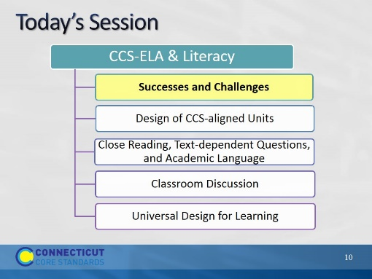Slide 10
The purpose of the morning is to look closely at parts of effective units and lessons that align with the CCS-ELA & Literacy.

- The activities for today will mirror the types of instructional practices which will support students in achieving proficiency on the standards and assessments.
- First, we will review your experiences with sharing the information from Module 1 with your colleagues.
- Then, we will look carefully at structures and protocols for close reading, text-based questions, academic language, and text-based discussions; all parts of effective lesson and unit planning.
- Finally, in the afternoon, we will then look at instructional supports and related instructional practices to assist all students in obtaining proficiency on the CCS-ELA & Literacy.

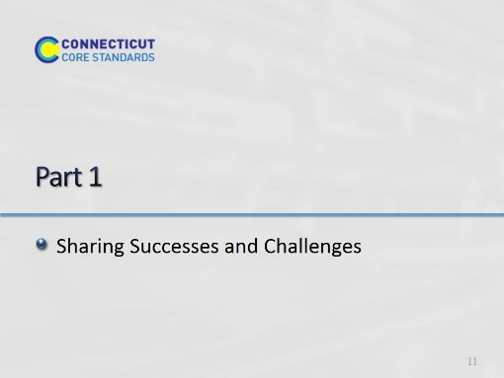Slide 11
20 minutes total: Facilitator, be quick with directions.

Activity 1
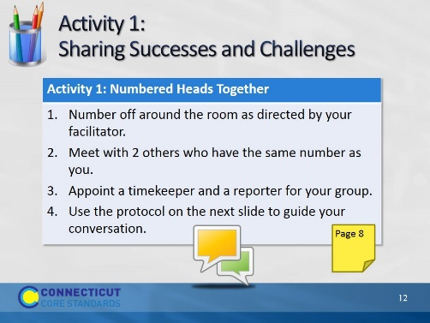Slide 12
20 minutes total for this activity. This slide gives full directions for Activity 1, with prompts on the next slide. Remind the timekeeper that it is really important to keep everyone to the time limits. The reporter will summarize the conversation at the end when the groups come back together.
Facilitator: Ideally, you’d like 3 members in a group, not from the same district. Count the number of participants in the room and divide by 3. Whatever number results, have participants number off by that number. For example, if you have 21 participants, and you divide by 3, the result is 7. Have participants number off by 7’s. That way, when all the participants have numbered off, you can have all the 1’s, 2’s etc. form a group, and there will be 3 participants in each group. If you have an uneven number, it is better to end up with four in some groups than with groups of two.

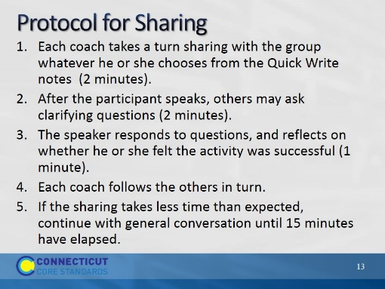Slide 13
Facilitator: Explain that clarifying questions are questions that seek "nuts-and-bolts" information about the information shared. Example: How much time did it take? How were participants grouped?
After 15 minutes have elapsed, bring the group back together and ask each reporter to briefly summarize highlights of the conversation.

