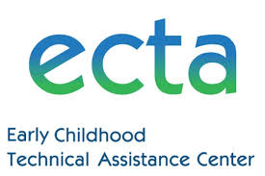

Wednesday, January 20, 2021

Noon–1 p.m.

PreK LRE Decision Making

A Presentation for Connecticut by the Early Childhood Technical Assistance Center (ECTA)

Making sound placement decisions for preschool children with disabilities is dependent on teams following the requirements and procedures detailed in the Individuals with Disabilities Education Act. In this session participants will have an opportunity to discuss the required components, processes, and best practice considerations for making these individualized decisions.

In addition, we will discuss and present a tool (under development) that highlights these considerations for training, and with guiding questions for teams making placement determinations will be shared.

Please hold this date and time on your calendar. Registration information will be available soon.

