[COMPANY NAME]

Distribution Integrity Management Plan
(DIMP)

Introduction - Scope
49 CFR §192.1015(a)

This document is the distribution integrity management plan (DIMP) for [Insert Company Name](Company). It is intended to meet the requirements of 49 CFR Part 192 Subpart P, Gas Distribution Integrity Management (IM) §192.1015.

This plan covers all jurisdictional LPG accounts owned or operated by the Company that serve fewer than 100 customers from a single source of LPG. The plan documents the mechanisms, procedures and methods that will be used by the Company to ensure continued compliance with all requirements of §192.1015 for existing systems and systems acquired or newly installed in the future. Site specific threat assessments, risk rankings, performance measures and specific actions required to mitigate risks for each jurisdictional system (referenced by facility name) are included on the “Individual Jurisdictional System Risk Ranking” form (DIMP-13) located in Appendix A of this plan.

This plan was developed by the Company and is not a commercially produced product. The following references were reviewed while developing this plan:

- American Public Gas Association (APGA) Sample SHRIMP Plan.
- US DOT Pipeline and Hazardous Materials Safety Administration (PHMSA) DIMP Website
- US DOT Pipeline and Hazardous Materials Safety Administration (PHMSA) DIMP Inspection Form 23- Master Meter and Small LPG Operators of Gas Distribution Systems. §192.1015

This plan is effective as of MONTH DD, YYYY. This is the original document and is not a revision or replacement of an existing plan.

All revisions to this plan will be documented on a revision record page included in this plan.

Assignment of Responsibilities
49 CFR 192.1015 (a)

The Company’s Operations Manager (update this title if a different position is responsible for these tasks within your organization):

The Operations Manager is responsible for the implementation, oversight and revisions to the DIMP program. The Operations Manager will meet with District Managers annually, or more frequently if required, to communicate any revisions to the DIMP Program and will be responsible for reviewing and maintaining all written documentation required by the plan.

The Company’s District Manager(s) (update this title if a different position is responsible for these tasks within your organization):

District Managers are responsible for implementation of the processes and procedures outlined in the plan. District Managers will meet annually with all OQ Service Technicians assigned to jurisdictional LPG work to communicate any changes to the DIMP plan and to solicit feedback regarding the effectiveness of the procedures. OQ Service Technicians will be trained in the contents of this plan and will report any changes in the site-specific risk or threat conditions to the District Manager(s) utilizing the processes and procedures outlined in the DIMP plan or the company Operating and Maintenance Manual and Emergency Plan.

Knowledge of Distribution Systems
49 CFR §192.1015(b)(1)

This plan was developed based on the design, construction, operation and maintenance records of all Company’s jurisdictional systems including: incident and leak history, corrosion control records, continuing surveillance records, patrolling records, maintenance history, and excavation damage experience, as well as the judgment and knowledge of the Company’s employees.

Construction records and operation and maintenance records that demonstrate knowledge of the pipeline, to the extent known, are maintained in the individual jurisdictional system binder at the office location where the jurisdictional system is maintained. Information that is incomplete or unknown at the time of the initial Risk Ranking will be documented in the individual jurisdictional system folder at the office location.

Incomplete or unknown information will be captured over the course of time when Operating and Maintenance activities are performed by the company. In addition, whenever the Company becomes aware the pipeline system will be exposed for any reason the Company will send an OQ Technician to the site to inspect the pipe and record any additional information that is available. Examples of the types of additional information to be captured are:

- Type (material) and size of pipe including all information stamped on the pipe,
- Color of pipe, if PE pipe,
- Any types of fittings installed with manufacturer name if available
- How joints were constructed (i.e. fused joints, stab joints, compression joints, etc.)
- If system has tracer wire and warning tape installed
- Depth of line
- Digital Pictures (if camera is available)
- GPS Coordinates or measurements to physical buildings, etc.
- Any other available information

All information gathered from the inspection will be documented on the Company’s LP-Gas Underground Container and Gas Line Inspection form located in Appendix A of this plan. The completed form will be submitted to the District Manager at the end of each work shift.

The District Manager or Propane Operations Manager will review the additional information gained and compare it to the information available on the Individual Jurisdictional System Risk Ranking Form (DIMP-13) for the system. The Propane Operations Manager will re-evaluate the system based on the new available information and adjust the Risk Rankings as necessary.

The Company will capture and document all information for new jurisdictional systems installed after the implementation of this plan. The documentation will include at a minimum:

- Type and size of pipe including all information stamped on the pipe,
- Type and size of tanks installed (UG tanks)
- Date of installation
- Color of pipe, if PE pipe,
- Any types of fittings installed with manufacturer name, part numbers, etc.,
- How joints were constructed (i.e. fused joints, stab joints, compression joints, etc.)
- Depth line was installed,
- CP systems/equipment/coatings installed, etc. (if applicable)
- Digital Pictures (if camera is available)
- GPS Coordinates and a detailed sketch showing all fittings, changes of direction, etc. with physical measurements to permanent structures on the site,
- If any additional buried lines are in close proximity to the gas line,
- OQ Technician(s) that installed the system,
- Any other available information

As a portion of normal business the Company does at times acquire ownership and operation of jurisdictional systems that were installed and operated by other propane suppliers. In addition to complying with the other sections of this written plan, the Company will handle all jurisdictional systems that are gained through acquisition from another LP operator in the following manner:

- The LP operator from whom the system was acquired will be contacted with a formal request to provide any and all records pertaining to the installation, maintenance and operations of the jurisdictional system acquired. A specific request for the documentation of the jurisdictional system DIMP plan should be a part of the request. The date the request was made will be documented and included in the jurisdictional system folder.
- The documents specific to the Distribution Integrity Management Program from the previous LP operator will be reviewed and retained in the individual jurisdictional system folder.
- The District Manger will be responsible to schedule a site visit to review the system and make an assessment of the existing and potential threats to the system.
- The District Manger will complete an Individual Jurisdictional System Risk Ranking Form (DIMP -13) for the system based on the findings of the site visit and the information received from the previous LP operator. The date the Company assumed operation of the system MUST be recorded on the form.
- A copy of the completed Individual System Risk Ranking Form will be forwarded to the Propane Operations Manager for review and approval.

Threat Assessment and Risk Ranking
49 CFR §192.1015(b)(2-3)

Each Jurisdictional LPG system operated by the Company will be individually reviewed to determine a threat (likelihood) risk ranking. The process will evaluate each of the seven (7) minimum required categories for threats (likelihood) and assign a threat factor. The minimum required categories are Corrosion, Natural Forces, Excavation Damage, Other Outside Force Damage, Material or Weld Failure, Equipment Failure, and Incorrect Operation. The Other threat category can be used for any identified threats that do not belong in one of the seven required threat categories. The threat ranking factors will be a 1 through 5 numeric system with five (5) being the highest threat factor and one (1) being the lowest threat factor.

In addition, each system will be reviewed to determine a consequence risk factor. The consequence ranking factors will be a 1 through 3 numeric system with three (3) being the highest consequence risk ranking and one (1) being the lowest consequence risk factor.

[The Operator should explain in more detail in the procedure as to how the questions relate to the threat factor (1-5) and consequence factor that is given for a particular threat and consequence (1-3) for a system by the SME. Some additional guidance should be given as to when to rank a 1 versus 2 versus 3 and so on. This will help maintain consistency among the systems.]

The “Total System Risk Ranking” will be determined by totaling the (7) threat ranking factors and multiplying the total Threat Ranking Number by the consequence ranking number to determine a “total system risk ranking” score. The “total system risk ranking” scores should be compiled and ranked to show the riskiest system.

At a minimum, the following factors will be considered when determining threat and consequence risk rankings:

[The Plan should explain what the “total system risk ranking score” means. Is there a value below or above which the operator reacts differently? The Total Risk Ranking Scores should be ranked to determine higher / lower risk systems.]

Threat Assessment Questions

Corrosion
Has the system experienced any leaks?
Has any portion of a section of steel or copper piping been replaced due to leaks?
Is the system served by aboveground or underground tanks?
Underground piping – Is the material steel or plastic?
Underground Piping – Is all metallic piping coated?
Are Cathodic Protection system(s) in place?
Do all Cathodic Protection readings meet the minimum criteria?
Is all aboveground piping coated or painted?
Are all piping hangers and supports painted or coated?
Are all areas of metal-to-metal contact insulated to prevent corrosion?
Are regulators, meters or other appurtenances showing signs of corrosion?

Natural Forces
Is the system located or exposed to waterways or shorelines where flooding can be expected?
Is the system located near any wooded areas that may be susceptible to wildfires?
Is the system located in areas where soil subsidence or ground movement could be an issue?
Is the system located in an area that is subject to tornados or hurricanes?
Is there adequate protection from snow and ice falling from roof of building?
Is the system located where water/ice accumulates during winter months?
Does the service line pass through areas with tree roots that could affect it during high winds?
Is piping located in an area that is susceptible to lighting strikes?
Is the system grounded/bonded to protect from lightning strikes? (CSST)

Excavation Damage
Is the system registered with the Dig Safe One Call System?
Is system in an area likely to have digging occur without One-Call
notification? (private property, farmland, etc.)
Does the system have tracer wire installed?
Is the system able to be located with electronic line locating equipment?
Does the system have warning tape installed?
Have the appropriate Public Awareness messages been sent to property owners?
Are accurate plot plans, sketches or diagrams of the system location available?
Is there a history of excavation damage to the system?
Are the tanks and lines equipped with excess flow valve protection?

Other Outside Force Damage
Is the system properly protected from vehicle damage?
Is the system properly protected from seasonal maintenance? (Snow plowing, commercial lawnmowers, etc.)
Is the system located in an area with a history of vandalism?
Does the system have security fencing or other protection in place?
Are underground facilities marked properly for seasonal risks? (Snow, etc.)

Material Failure
Does any material in the system have a history of failure?
Is the system constructed with compression types of couplings?
Has any recall information from manufacturers been received?
Have any code updates been issued regarding certain materials?
How accurate is the system information regarding types of materials?

Equipment Failure
Is there any history or experience with equipment failure(s)?
Is there good knowledge of equipment reliability?
Have the manufacturer’s life expectancy/ replacement recommendations for equipment been reviewed?
Is the information on equipment age and/or model serial numbers available?
Are there other specific materials to consider other than valves, meters, or regulators?

Incorrect Operations
Is there knowledge of the person(s)/company that installed the equipment?
Is there any history of discovering improperly installed equipment?
Is there any history of improperly installed equipment caused by employee error? Is the special equipment more complex requiring additional training to perform proper maintenance?
Has the employee(s) assigned to install more complex equipment been trained?
Is it possible the customer may attempt to modify or adjust equipment?
Were any failures attributed to employee use of drugs or alcohol?
Have any OQ technicians been disqualified from performing OQ tasks due to errors?

Consequence Assessment Questions

Population Density
Does the area have a high population density?
Does the population density vary by time of day or day of week?
Does population density change due to seasonal activity?

Types of Facilities
Is the system serving predominately residential areas?
Is the system serving commercial/business districts?
Is the system serving a combination of residential and commercial areas?
Does the system serve schools, hospitals, nursing homes or other assisted-living facilities?

Loss of Supply/ Facility Use
Will an incident potentially cause the loss of building usage?
Will loss of building use require relocation of remaining tenants?
Will an incident result in possible loss of heating, hot water, cooking?

The following are the definitions of Threat and Consequence Ranking Factors.

Threat (Likelihood) Ranking Factors
- Very Low
- Low
- Medium
- High
- Very High

Consequence Ranking Factors
- Low
- Medium
- High

An example of a System Risk Ranking form DIMP-13 is provided below:

Total Threat (Likelihood) Rating (7 threats categories added together) = 12
Total Consequence Rating = 3

Total System Risk Ranking: Likelihood x Consequence 12 x 3 = 36

Identify and Implement measures to mitigate risks
49 CFR §192.1015(b)(4)

The Company will identify and rank all existing and potential risks for each of its jurisdictional propane systems as explained in the “Threat Assessment and Ranking Risks” section of the plan. Each Threat Factor of three (3) or higher will be evaluated to determine if additional action beyond minimum code requirements will be required. The determination if any further action is necessary will be listed on the Individual Jurisdictional System Risk Ranking Form attached to this plan.

When determined that additional actions beyond normal code compliance are required to mitigate specific risks these measures will be listed on the Individual Jurisdictional System Risk Ranking Form in the “Measures to Mitigate Risks” section. The actions to be taken will be listed in detail and will provide the specific measures selected, the risk they are addressing and how the actions will be implemented.

Measure performance, monitor results, and evaluate effectiveness
49 CFR § 192.1015(b)(5)

The Company will measure performance, monitor results and evaluate effectiveness for each of the actions identified and implemented to reduce risk of failure of the pipeline system. At a minimum the Company will monitor and record the number of leaks eliminated or repaired on each individual pipeline system and their causes. Additional performance measures that will be monitored for effectiveness are listed on the Individual Jurisdictional System Risk Ranking Form in the “Measure Performance, Monitor Results, and Evaluate Effectiveness” section. At a minimum the following items will be monitored or measured to evaluate the Total Risking Ranking on a continuing basis:

- The number of Hazardous Leaks repaired and categorized by cause.
- The number of Excavation Tickets received for the individual system.
- The number of System Mark-outs completed for the individual system.
- The number of Excavation Damages that occur on the individual system.
- Any incident that occurs on the system.
- Records for any materials/pipe that were replaced on the system for any reason.

Periodic Evaluation and Improvement
49 CFR § 192.1015(b)(6)

The jurisdictional pipeline systems covered under this plan are systems that serve very small, well-defined areas. Many of the systems are located on private property and lack the complexity of larger systems constructed with various types of piping and appurtenances. Since many of the systems are not located in public rights of way, they are easier to monitor for threats and risk of failure. Due to the types of systems operated, the Company will conduct a program evaluation once every 5 years. The program evaluation will consider all performance information gathered to determine if significant risk factors have changed. Based on the available information the Company will determine if more frequent program evaluations will be required in the future. All updates or revisions to the Plan will be documented on the “Record of Review and Revisions” page of the written plan. All revised information will be communicated to all District Managers, OQ Service Technicians, and office support staff by means of a documented training session. Also, all revisions that contain significant changes to the DIMP plan will be provided to the Authority Having Jurisdiction (Public Utilities Regulatory Authority - Gas Pipeline Safety Unit) within 30 days of the final revision being issued.

Recordkeeping
49 CFR 192.1015(c) (1)-(2)-(3)

The Company will maintain a current Distribution Integrity Management Plan (DIMP) as required by 49 CFR Part § 192.1015. In addition, copies of all superseded or revised DIMP plans will be maintained for a minimum of ten (10) years together with all documents supporting the information used to determine threat identification. Complete detailed documentation of all materials and appurtenances for systems installed after the effective date of this plan and, to the extent known, the location and material of all pipe and appurtenances that existed on the effective date of this plan will be maintained in the individual jurisdictional system folder.

[The DIMP specifies retention of procedures and records for a minimum of 10 years. The Operator should review their O&M plan to ensure the record retention policies in the O&M plan are consistent with the DIMP 10-year retention requirement.]

Appendix A

System Risk Ranking Form - DIMP Form - 13 (Blank)

LP-Gas Underground Container and Gas Line Inspection (Blank)

(12)- Individual Jurisdictional System Risk Ranking Forms

- [List systems from highest to lowest risk here…]

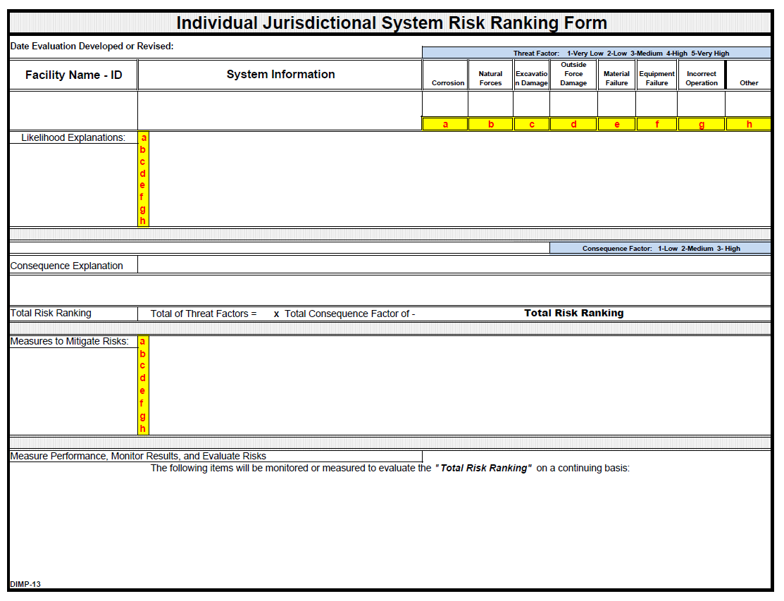

LP-Gas Underground Container and Gas Line Inspection

This form is to be completed each time an LP-gas line or container is uncovered for any reason. For example: making service connections, main extensions, replacements, coating condition inspections, etc.

Frequency: Each time a container, main or service line is uncovered.

System Name:

System Location:

Designation: Container Main Service

Age of Pipe/Container: Years Line/Container Size: inches/gals.

Maximum Operating Pressure:

Pipe Specification: Steel Plastic Copper

Cathodic Protection Container/Line: Yes No

Coating: Yes No

External Condition: Smooth Pitted Depth of Pits

Internal Condition: Smooth Pitted Depth of Pits

Bury Depth: ___________________

Name any existing conditions that could cause harm to the LP-gas system.

Corrective Measures Taken if Needed:

Anodes Installed: How many? Size Location

Soil conditions surrounding container/pipe:

Remarks:

Inspected By: __________________________________________ Date:

