Connecticut Distributed Generated Interconnection Working Group Meeting Summary

State of Connecticut Public Utilities Regulatory Authority Office of Education, Outreach & Enforcement
**December 13, 2023**
Notetaker: Mike Trahan, ConnSSA

December 2023 IX WG Meeting Topic: Identifying and prioritizing cost allocation topics of interest/issues to be addressed

Introduction
- Aileen Cole from the Great Plains Institute (GPI) opened the meeting at 9:02.
  - There were 51 attendees on the call at this time.
  - Aileen Cole (GPI) provided an overview of the meeting agenda and the meeting goals and ground rules
  - Meeting goals:
    - Identify topics related to cost allocation that participants would like to explore and discuss with the IX WG as time allows.​
    - Establish priority cost allocation topics to discuss.​
    - Clarify next steps and highlight upcoming meeting topics.
  - Meeting ground rules:
    - Respect each other. Help us to collectively uphold respect for each other’s experiences and opinions, even in difficult conversations. We need everyone’s wisdom to understand complex problems.
    - Be receptive and adaptive. Recognize and allow opportunities for participants’ opinions to change based on new information, insights, and perspectives.
    - Make resources available. Facilitators will ensure that meeting materials and resources are available to participants. Participants are encouraged to identify resources, such as reports, that can help to increase the collective knowledge of the group.
- Aileen Cole (GPI) reviewed the November meeting discussion and outlined options for future meetings at a high level

Discussion: Cost allocation topics of interest
Val Stori (GPI) provided an overview of cost allocation topics identified in the November meeting that will be discussed and prioritized today, for further discussion at future meetings.
- Better aligning payments with the construction process/timeline​
- Innovative payment mechanisms (e.g., payments at different milestones, “non-cash” financial instruments)​
- NRES cost sharing docket (22-06-29 PURA Investigation into DER Interconnection Cost Allocation)​
- MA Capital Investment Plan approach​
- Strategies that could reduce costs in general, thus reducing the costs that must be allocated (e.g., flexible interconnection)
From the November meeting, parties expressed the most interest in further discussion on Items 3) NRES cost allocation issues and 4) MA’s approach to cost allocation. Parties provided additional feedback and detail on these items to further establish related topics of interest.
NRES/commercial cost sharing: James Talbert-Slagle (CT Office of Consumer Counsel) noted that PURA has issued a proposed Final Decision on the cost allocation docket for systems up to 25kW and that a similar cost allocation docket was opened by PURA to address commercial system upgrade cost allocation (NOTE: there is no schedule for this docket on the PURA website).
Joe Debs from Eversource (Eversource) noted that the Company has previously offered a commercial DG cost allocation (NRES docket, 22-06-29-REO-1) presentation to the IX WG and offered to update that presentation. The Office of Consumer Counsel (OCC) has a consultant retained to help with the NRES docket that may also be able to present to the group. OCC also identified that in November, parties also expressed interest in RRES cost allocation issues. A proposed final decision on RRES issues was issued in docket No. 22-06-29, with exceptions to that proposed final decision being filed today
Mike Trahan (CT Solar & Storage Association, CONNSSA) asked Joe Debs (Eversource) whether the commercial DG cost allocation plan that Eversource has in mind is similar to what the Company is involved with in MA. Joe Debs said that Eversource is aware of the MA cost allocation planning.
Amanda Trinsey (CEIC) sought clarification on commercial vs. residential aspects of cost allocation and whether the costs would be associated with distribution system upgrades (direct to residential consumers) or transmission line infrastructure (that may feed commercial customers). Brian Rice (Eversource) provided clarification on substation upgrade cost allocation issues in CT and outlined how upgrades issues might be approached in CT.
Brian Rice (Eversource) questioned whether the 160MW of NRES/SCEF capacity called for in current state law could be put into service onto the existing grid. Brian Rice reminded the group that developing a cost allocation process is not a PURA mandate.
MA approach: Kate Tohme (New Leaf Energy) expressed support for proactive cost allocation methodology that’s being pursued in MA (as opposed to “reactive” strategies). She stated that a proactive approach can help drive development to meet State goals. She later went into some detail on the MA’s Capital Investment Plan approach to planning, which currently remains provisional (pilots, limited in scope), with a program extension proposed.
Amanda Trinsey (CEIC) also sought clarity on how changes to cost allocation will impact base rates when associated with system upgrades, what analysis needs to be done, etc. Joe Debs (Eversource) stated that the Company can update their presentation to provide this sort of information, to the extent feasible. Kate Tohme (New Leaf Energy) stated that in MA, the found that there was a need to immediately address cost allocation issues before deploying wide-scale proactive system upgrades. MA DPU received six cost allocation methodology proposals in Docket 20-75.
Amanda Trinsey (Connecticut Energy Industry Consumers, CEIC) asked whether it is established that CT will follow the MA cost allocation process or start a separate process from scratch (see Kate Tohme response above). Kate Tohme (New Leaf Energy) said that MA, NY and CA are the jurisdictions that are most likely applicable to CT. Though it has not been established that CT will follow MA’s approach, MA has worked on this issue for several years and does offer potentially valuable lessons learned.

Discussion: Other timely items
Aileen Cole (GPI) identified that parties reached out to her with an interest in discussing the following timely items.
- Eversource’s updates to the 2018 I&R Guidelines book
  - Michael DiPanfilo (Earthlight Technologies) asked about Eversource’s updates to the 2018 I&R Guidelines (also a PURA order).
  - Robert Cote (Eversource) said to expect a January update.
  - Michael DiPanfilo (Earthlight Technologies) asked if he or other interested parties could see Eversource’s updates before they are finalized in January. Robert Cote (Eversource) said that this would be ok.
- Communications between EDCs and developers about FERC 2023 updates
  - Joe Debs (Eversource) spoke to FERC cluster studies.
    - It was suggested that an ISO-NE rep attend a future IX WG meeting.
  - Note: This topic of interest pertains specifically to utility–developer and developer–utility communication about achieving compliance with FERC Order 2023, in advance of the changes going into effect.
- Near-term PURA-required filings: MSA proposals and trough-type connection plans
  - Aileen Cole (GPI) shared a timeline of upcoming meetings highlighting when utilities will be presenting and receiving feedback on their MSA proposals and trough-type connection plans to comply with established PURA Orders.
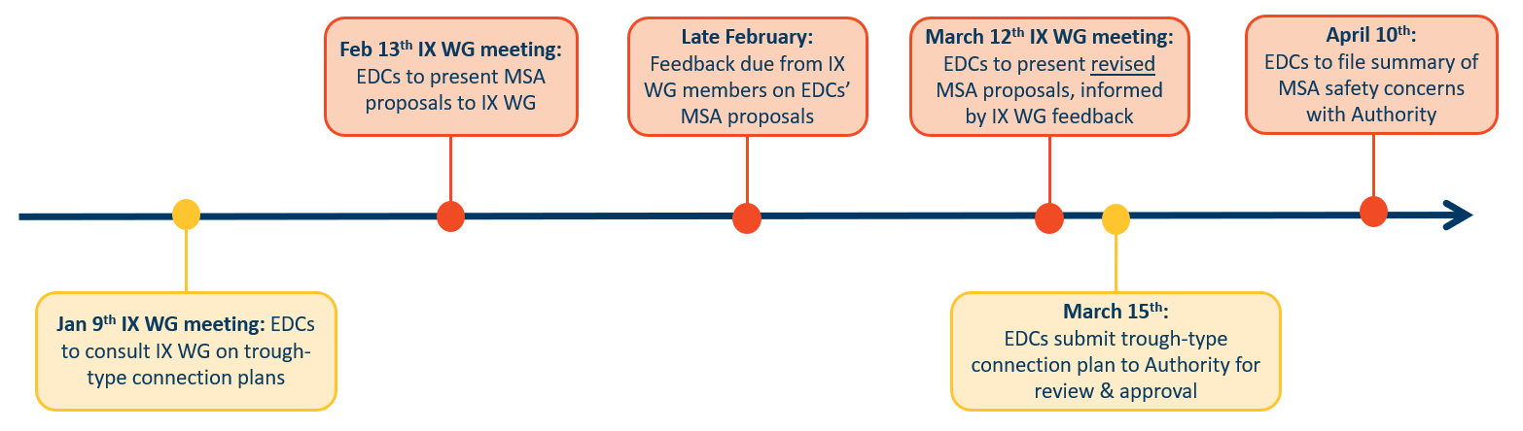

Administrative Items/Next Steps
- No opposition to 2-hour meetings in the future.
- 2024 meeting schedule 2nd Tuesday of the month, 1:30-3:30 ET
- Aileen introduced a SmartSuite tracking sheet showing all issues the IX WG is working on. The database/tracker is still in-progress but will be populated moving forward.
  - IX WG members think the tracker is valuable.
  - Suggestion made to post the SmartSuite list to the IX WG website.
- After all attendees issues were addressed, Aileen adjourned the meeting at 10:07am

