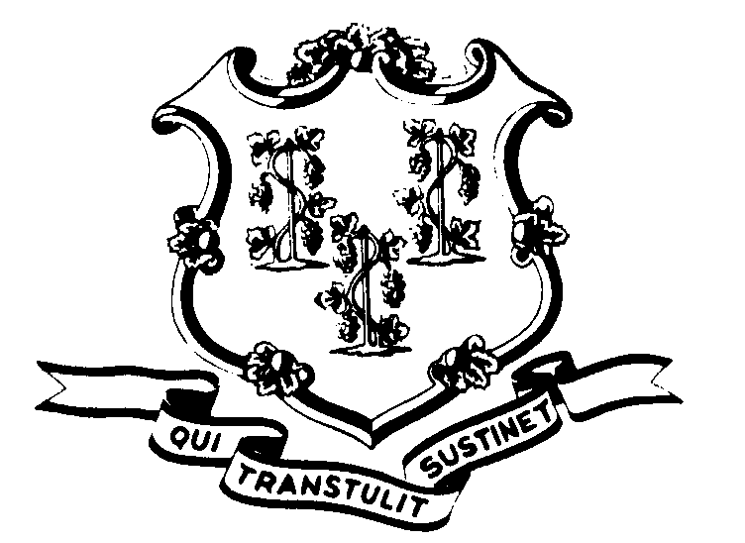STATE OF CONNECTICUT

OFFICE OF POLICY AND MANAGEMENT

Office of Labor Relations

January 4, 2017

General Notice 2017-01

TO: Labor Relations Designees

SUBJECT: Mileage Reimbursement Decrease

In accordance with the provisions of the following collective bargaining agreements, the mileage reimbursement rate is to be adjusted.

NP-2 Maintenance and Service
NP-3 Administrative Clerical
NP-4 Corrections
NP-5 Protective Services
NP-6 Para-Professional Health Care
NP-8 Correction Supervisors
P-1 Professional Health Care
P-2 Social and Human Services
P-3A Education Administrators
P-3B Education Professions
P-4 Engineering and Scientific
P-5 Administrative and Residual

Additionally, the mileage reimbursement rate for Managers, Confidential and other non-represented employees will be adjusted.

For travel on or after January 4, 2017 the mileage reimbursement rate to employees using personally owned vehicles for official State business will decrease from 54 cents per mile to 53.5 cents per mile. This decrease is a direct result of a downward readjustment by the U.S. General Services Administration.

______________________________
Lisa Grasso Egan
Undersecretary for Labor Relations

