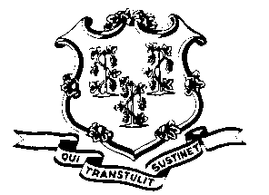
STATE OF CONNECTICUT

OFFICE OF POLICY AND MANAGEMENT

Office of Labor Relations

September 2, 2011

General Notice 2011-24

TO: Labor Relations Designees

SUBJECT: P-4 Unit Employee List and Signatures

The United Public Service Employees Union has submitted a petition to represent the Engineering & Scientific (P-4) bargaining unit. As part of the processing of determining if there has been the required thirty (30) percent “showing of interest” to warrant a representation election, the Board of Labor Relations needs a list of all of the employees on the payroll as of the date of the petition (August 26, 2011) and copies of official documents that contain the signatures of those employees, such as tax withholding forms, employee benefit forms, etc.

Therefore, we must request that you review the attached list of P-4 employee names coded to your agency and delete any who left state service prior to 8/26/2011 and add any who were omitted from the list. Employees did not have to receive pay for 8/26/2011 to be on the list; employees on workers compensation, military leave or unpaid leave (position held) are also included. (Please note dates and reasons for separations and hire dates or other possible reason for omissions.) We must also request that your agency provide this Office with copies of documents which have the employee’s name (typed or printed) and the employee’s signature. These documents will be used by the Labor Board staff to privately compare with the signatures on the UPSEU-submitted cards and will then be shredded. We appreciate the effort that will be necessary to gather and provide these documents but it is part of the legal process of determining whether there will be a union election in this bargaining unit and must be completed promptly.

The documents should be sent to Tammy Kowalski of this Office. Agency Labor Relations Designees with questions may contact Tammy Kowalski at 860-418-6289 (tammy.kowalski@ct.gov) or Ellen Carter at 860-418-6218 (ellen.carter@ct.gov). Thank you for your assistance.

Linda J. Yelmini
Linda J. Yelmini
Director of Labor Relations

