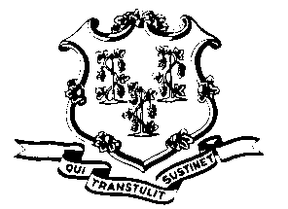
STATE OF CONNECTICUT

OFFICE OF POLICY AND MANAGEMENT

Office of Labor Relations

September 2, 2011

General Notice 2011-23

TO: Labor Relations Designees

SUBJECT: Posting of P-4 Unit Representation Petition

Enclosed is the petition filed by the United Public Service Employees Union seeking to represent the Engineering & Scientific (P-4) bargaining unit. Copies of the petition must be posted “in conspicuous places where the employee in the unit customarily assemble, and leave posted for a period of thirty (30) days.” We suggest that the copies be posted on the agency bulletin boards used for Human Resources postings or other official notices. The petition should not be posted on bulletin board space designated for the current union.

Agency Labor Relations Designees with questions may contact the Office of Labor Relations at 418-6447.

Linda J. Yelmini
Linda J. Yelmini
Director of Labor Relations

